SOFT CORPORATE OFFER

REFINED SUNFLOWER OIL - ORIGIN UKRAINE

Date: 25/03/2017

After conferring with our suppliers of REFINED SUNFLOWER OIL, CPH Asia Ltd are delighted to confirm the following offer:

PRODUCT AND SPECIFICATIONS
ORIGIN: Ukraine
Product: refined sunflower oil specifications

REFINED SUNFLOWER OIL
Quality: fit for human consumption, free from foreign matter, any other oil or animal fats, color (51/4
lovibond), 3.5 red and 30 yellow maximum, light yellow, clear and transparent, odor: neutral odor without any
artificial odor additive.
Visibility: without any deposition and blurriness
Taste: neutral, without artificial taste, free from rancidity or any strange or bad taste and smell, shelf life: 12
months, can be up to 24 months with addition.

Physical and chemical analysis: (the values may vary within standards) Free fatty acid, % M/M oleic acid: 0.3 max
Acid number, MG KOH/G: 0.6 max Peroxide value, MEQ 02/KG: 10.0 max Iodine value: WIJS: 94-141
Moisture and volatile matter, %: 0.2 max Saponification value, MG KOH/G. 188-194 Unsaponification substances, G/KG: 1.5 max insoluble substances in ether: %: 0.05 max refractive index at 400 C: 1.461 – 1.471 specific gravity, G at 200C: 0.914 – 0.923 soap content: %: 0.005 max
halphen test: negative mineral oil test: negative sesame oil test: negative
cold test, 5.5 hours at 00C: clear

heavy metals analysis: Iron (FE) 1.5 PPM max Copper (CU) 0.1 PPM max Lead (PB) 0.1 PPM max Arsenic (AS) 0.1 PPM max Fatty acid composition (%)
Kaproic acid: C 6:0: 0.05 max
Kaprilic acid: C 8:0: 0.05 max
Kapric acid: C 10:0: 0.05 max
Lauric acid: C 12:0: 0.1 max
Meristic acid: C 14:0: 1.0 max
Palmitic acid: C 16:0: 4.0 – 7.6
Palmitoleic acid: C 16:1: 0.1 max

Margaric acid: C 17:0: 0.2 max
Heptadecenoic acid: C 17:1: 0.1 max
Stearic acid: C 18:0: 2.1 – 6.5
Oleic acid: C 18:1: 14.0 – 71.8

Linoleic acid: C 18:2: 18.7 – 74.0
Linolenic acid: C 18:3: 0.05 max
Archadic acid: C 20:0: 0.1 – 0.5
Eicosenoic (gadoleic) acid: C 20:1: 0.3
Eicosadienoic acid: C 20:2: 0.05 max
Behenic acid: C 22:0: 0.3 – 1.5
Docosenoic (erusic) acid: C 22:1: 0.3 max
Docosadienoic acid: C 22:2: 0.3 max
Lignoseric acid: C 24:0: 0.05 max
Nervonic acid: C 24:1: 0.05 max

Nutrition facts in 100 gr
Energy value: 886 kcal /3641 kjoule
Total fats: 100 gr

Saturated fats: 11 gr Monounsaturated fats: 27 gr Polyunsaturated fats: 62 gr Trans fat: 0 gr
Protein: 0 gr
Carbohydrate: 0 gr
Sodium: 0 gr
Cholesterol: 0 gr

*any other specification which are not mentioned shall be in accordance with the international specifications

PACKING IN FLEXI TANKS OF 24.5 MT

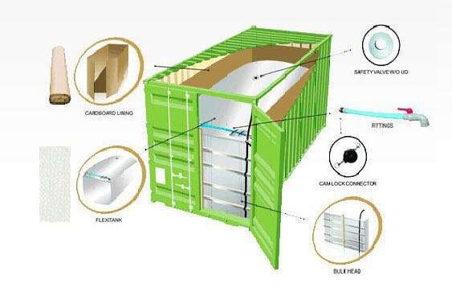

PRODUCT PRICE PER MT
Price: 930 USD (nine hundred and thirty United States dollars only) per metric ton CIF shipment.
Included in the price: cost of packing, transportation, insurance (110%) and loading.

SHIPMENT IS CIF PORT OF ALEXANDRIA, EGYPT
In flexi tank of 24.5 MT start loading period during 20-25 days after receipt and acceptance of the
IRREVOCABLE, CONFIRMED, OPERATIVE, NON-TRANSFERABLE, AUTO REVOLVING LETTER OF CREDIT 100% AT
SIGHT by buyer side.
Vessels must not be older than 20 (twenty) years, Lloyds register or equivalent

CONTRACT QUANTITY AND CONTRACT PERIOD
12.495 MT/month (12.500 MT x 12 months)
510 FLEXITANKS

TOTAL CONTRACT VALUE FOR ONE SHIPMENT
USD 11.620.350 (Eleven million six hundred and twenty thousand three hundred fifty United States dollars
only) per month
USD 139.444.200 (One hundred thirty-nine million and four hundred forty-four thousand and two hundred
United States dollars only) per 12 months’ contract

PAYMENT TERMS:
Irrevocable, confirmed, transferable, auto revolving letter of credit at sight against shipping scanned
documents.
Seller´s bank presents shipping documents to buyer´s bank. Buyer pays shipment value amount to seller´s
bank within 48 hours.

NOTES:

All taxes or levies imposed by the country of destination having effect in this contract are on the BUYER’S account and his sole responsibility. Buyer must have all import permissions and permits in writing, and copy sent to seller and BUYER bears the sole responsibility of securing all permits, licenses or any other documents required by the government of the importing nation. SELLER will bear no responsibility to provide such documentation. BUYER will bear all cost and penalties if such documents are not secure.
In no case, shall the seller be held liable for missing or improper documentation the buyer is required to provide.

Confidentiality

In connection with the negotiations for the purchase agreement both parties submit commercial, financial and/or other information, data, etc. which are classified as confidential. Any usage of the data provided is exclusively for the purchase agreement. Any other usage requires written approval by the other party.

Final Clause

This offer constitutes the entire understanding and agreement between the parties hereto and their affiliates with respect to its subject matter and supersede all prior or contemporaneous agreements, representations, warranties and understandings of such parties (whether oral or written). This offer may be amended only by written agreement, signed by the parties to be bound by the amendment.

Evidence shall be inadmissible to show agreement by and between such parties to any term or condition contrary to or in addition to the terms and conditions contained in this letter. This offer shall be construed according to its fair meaning and not strictly for or against either party. This offer shall be governed by the substantive laws of the Seychelles, or the United Kingdom without regard to conflict of law principles. VALIDITY OF OFFER 48 HOURS

