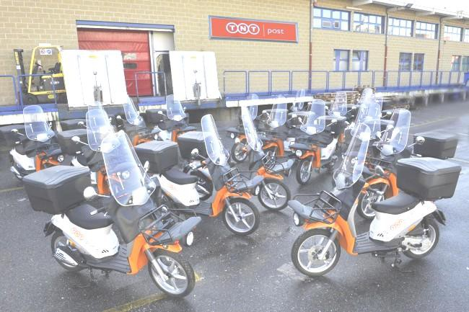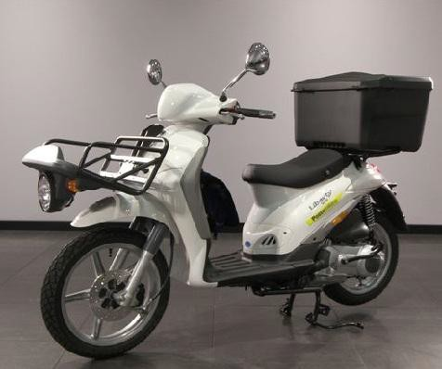PIAGGIO LIBERTY 125 DELIVERY
Young and stylish
Economic engine and respectful of the environment
Safe and comfortable, due to its 16 inch tires

Suitable for people looking for saving and with many spaces to load goods
Large Trunk and front carrier included
Technically reliable, as used by the Italian Post Office since decades.

Chibo is a trading company with years of experience in powered two wheel business, expecially those scooters manufactured by the Group Piaggio Srl.

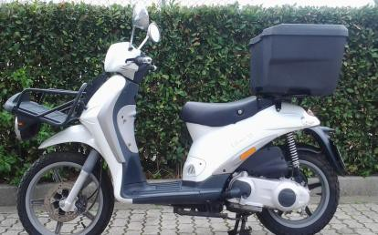
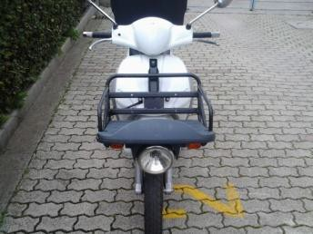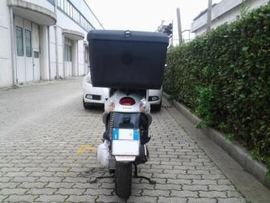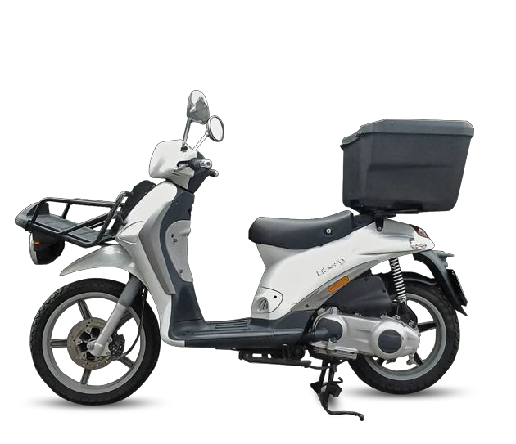Used PIAGGIO LIBERTY 125 DELIVERY
Young and stylish, the Italian Poste Office has been using this model for decades, because it is fuel saving, technically reliable and nimble in the traffic. It is a perfect work compaign, plenty of spaces to carry goods: front carrier, rear trunk and wide footrest.

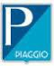
TECHNICAL SPECIFICATION

Piaggio Liberty 125 Delivery

Engine Type 4T
Front Tires | 90/80-16 51J
Rear Tires | 110/80-14 59J
Seat | 1 Person
Length | 1930mm
Width | 780mm
Height | 1650mm
Weight | 131kg
Included Accessories | Front carrier, rear trunk
Rearn Trunk Capacity | 80 L

Displacement 124cc
Cooling Air Cooling
Max Power 7,7kW at 8000rpm
Max Speed 92km/h
Fuel Capacity 10±0,5L
Fuel Unleaded Fuel
Brakes Disc Drum
Brake Diameter 220x140mm
Transmission Meccanic
Gearbox Automatic

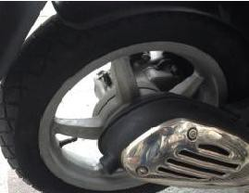
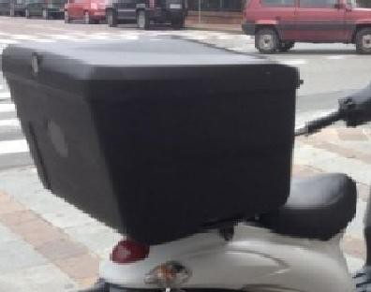
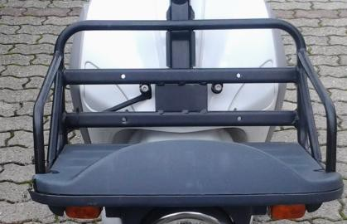
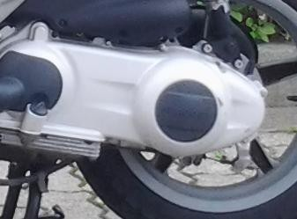
16 inch high wheel Rear trunk, 80 L Front Carrier Economic Engine,
3,57L/100km

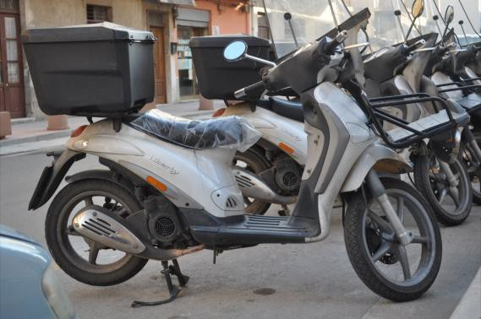
WHY CHOOSE CHIBO Company as PARTNER
Although no warranty is offered to the used scooter, the Chibo understands well the importance of the spare parts supply and a maintenance service for those customer, that purchases an used vehicles.

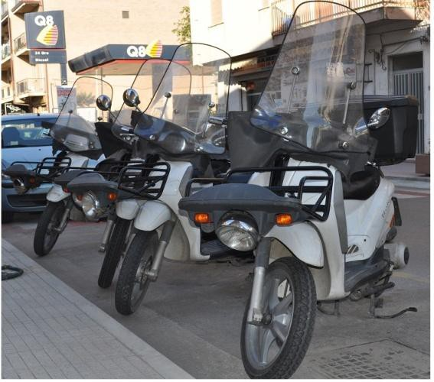
- CHIBO can supply a kit of spare parts to replace the most often worn parts at a price, that is lower than the market price.

- Vehicles restoration with the replacement of worn parts
- Customize the colour of the vehicle on customer request;

- CHIBO can offer different kind of vehicles loading solution to
satisfy the number of needs of a buyer.
-52 vehicles in a container 40 HC;
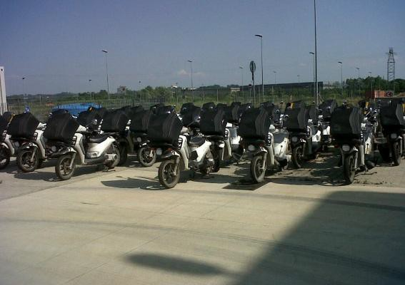
-120 units in a 40 HC container, if partially disassembled
- 56 units in a truck with metal frames for each vehicle
- 35 units in a truck without metal frame

and…..( see next slide)

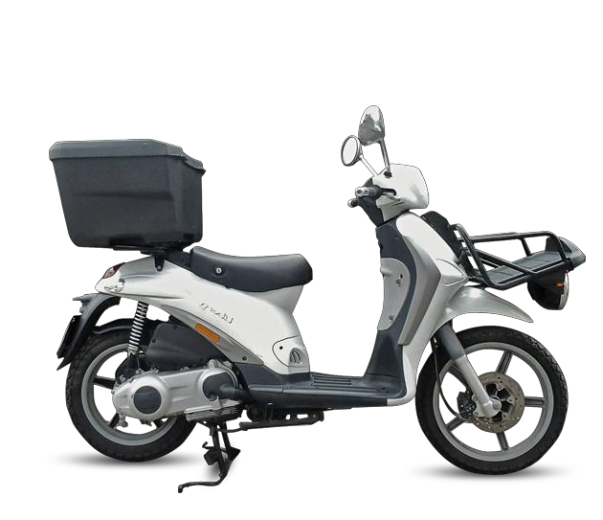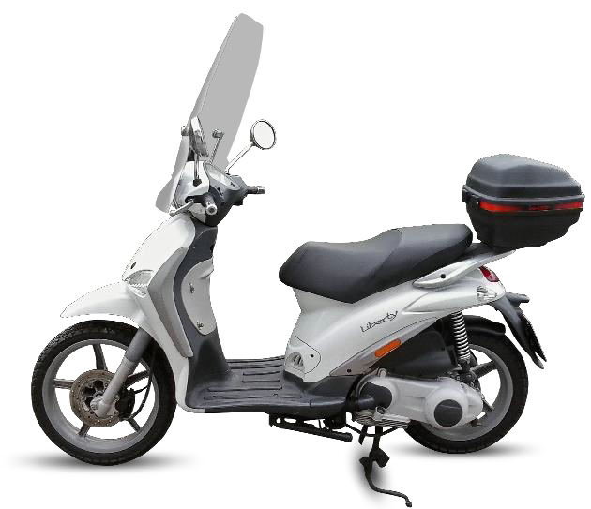
ACCESSORIES KIT to Transform the Liberty 125 from
DELIVERY
URBAN
TO
WHICH STYLE DO
YOU LIKE MORE?
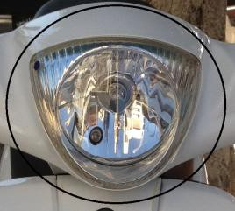
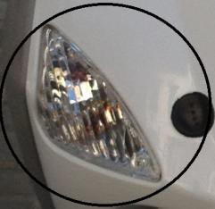
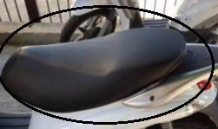
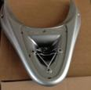

Headlight Flashes Seat for two persons Spoiler

In order to satisfy customers different needs, Chibo can supply the
above kit of accessories.

