- In the quotation, I recommended 25 to 55 HP tractors to you. Per our experience, these HP tractors are popular.
- Re the packing, the pictures are CKD packing. Easy to reassemble.

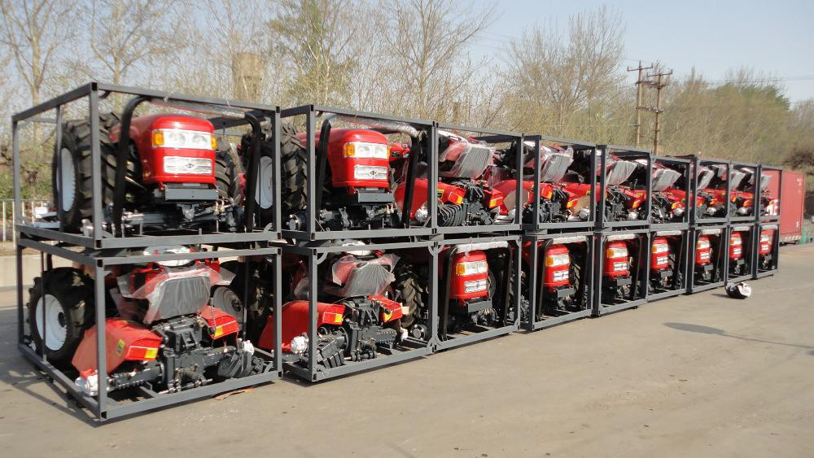

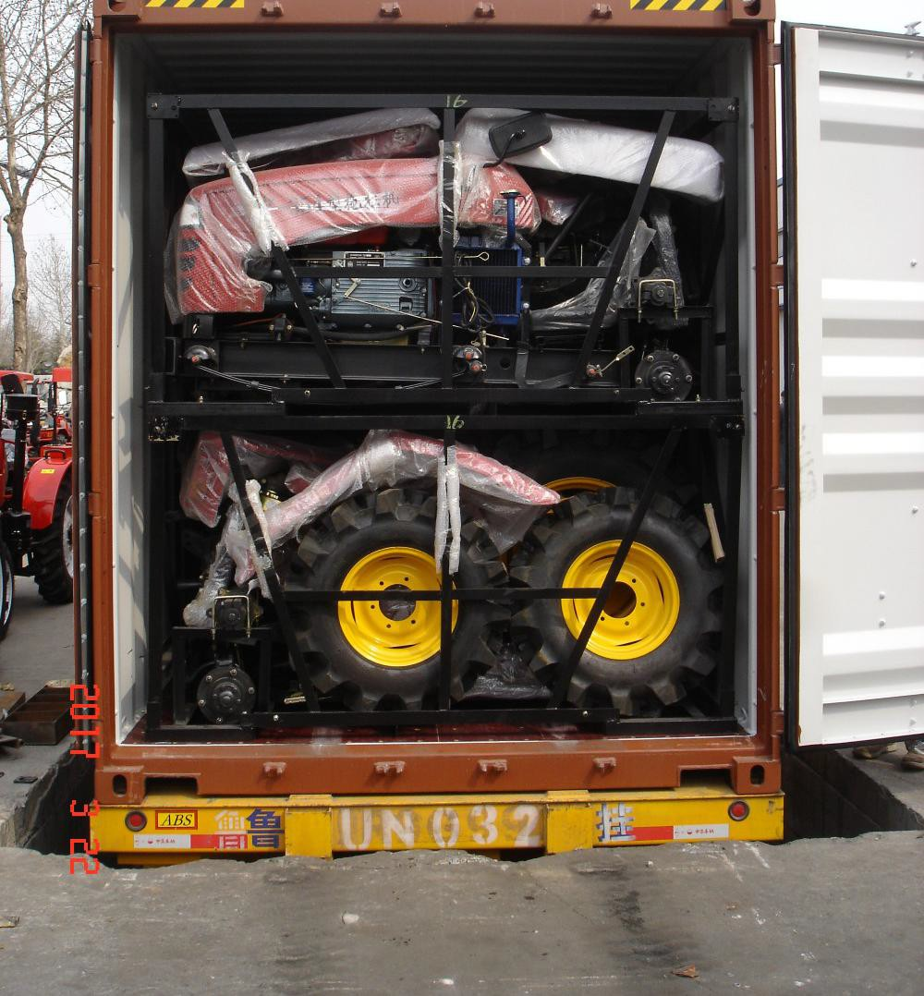

- Re the quantity in one 40HQ container, 25-35HP, 16units
40HP, 14 units

45-55HP, 8 units

- We can supply from 25HP to 185HP tractor, so if you have any other requirement, we can support you too.
- Re the CE certificate, if OEM for you, you should reapply your CE certificate. And the ordinary version is very easy and cheap, if not E-mark.
- Re the warranty, one year.

- RE the engineering on site supporting, no problem, but need you to pay the cost.

