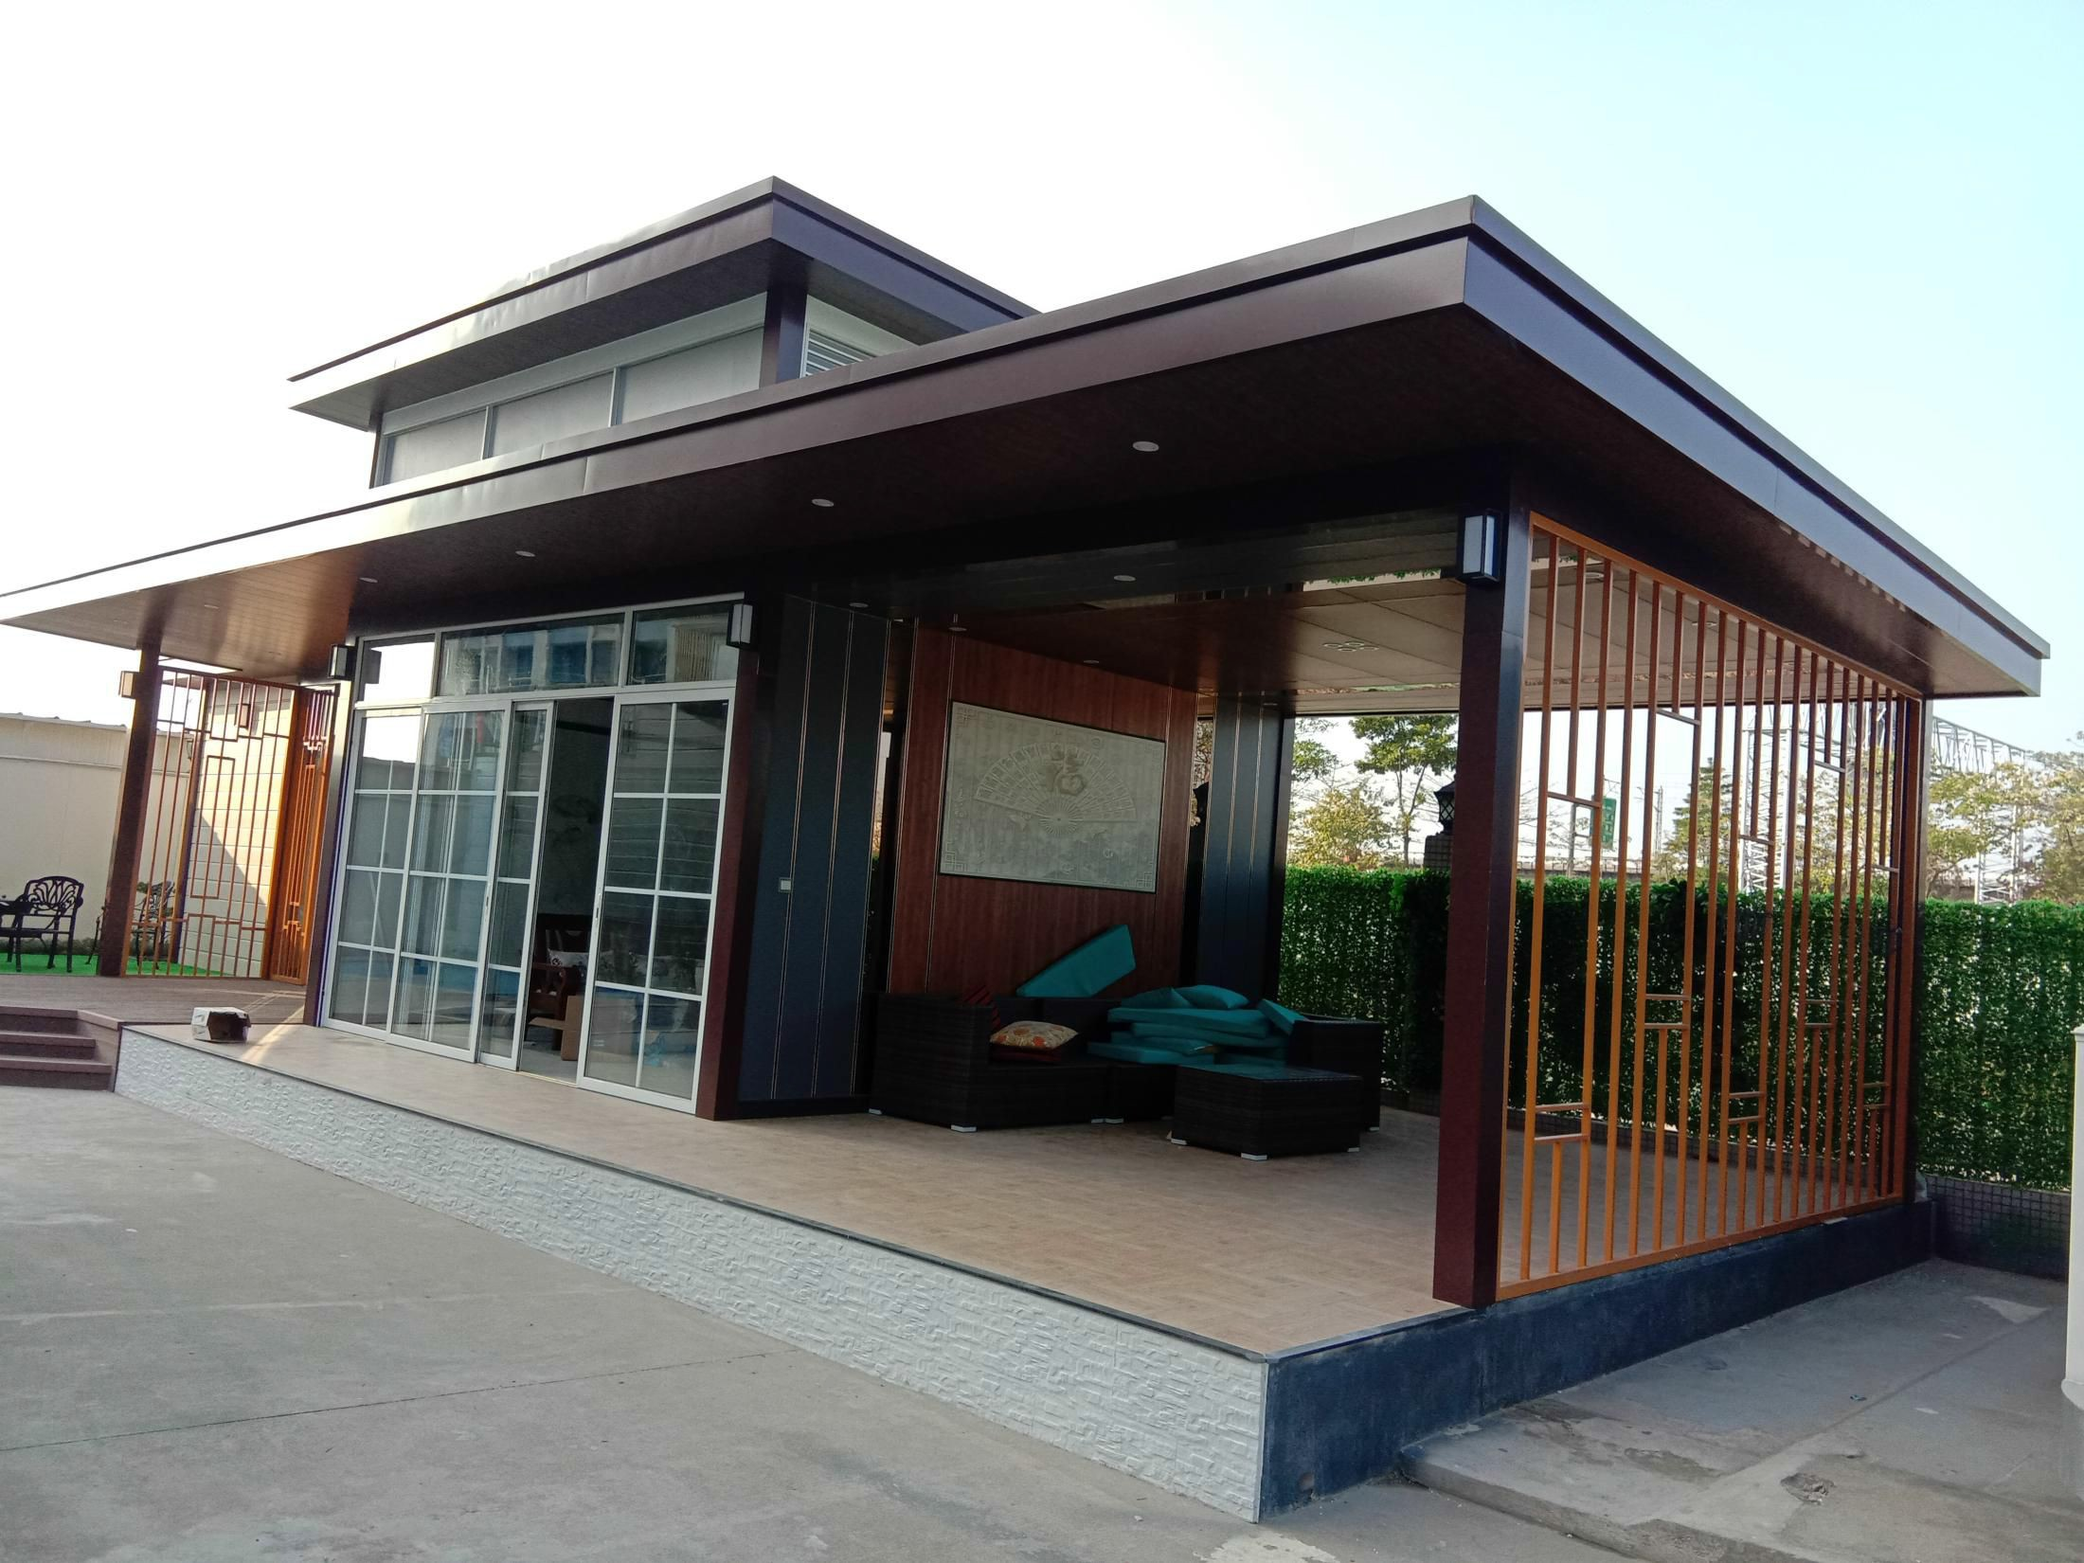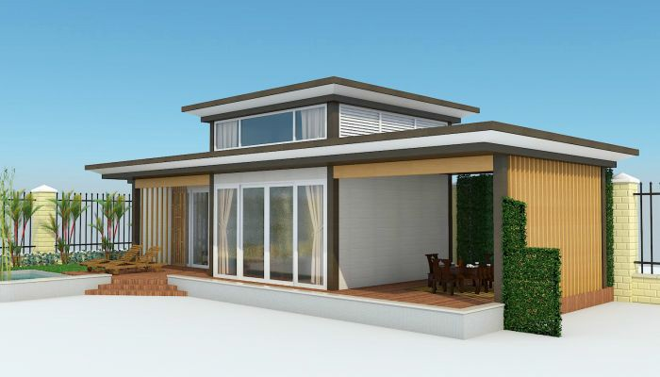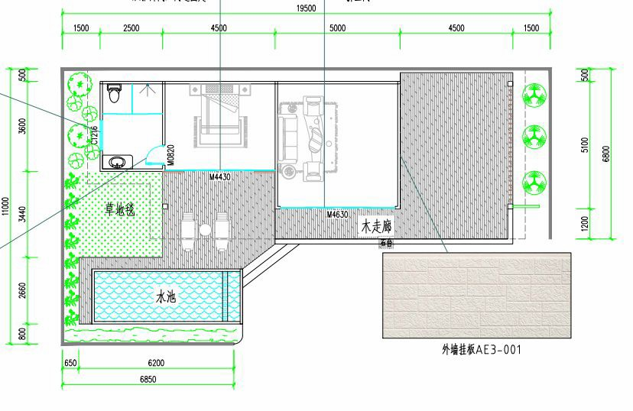
QUOTATION
Quotation date (valid time: 15days) |  |  |  | 2018.12.10
Project : Modern Prefab House
(HS code:9406000090 ;picture just for reference )
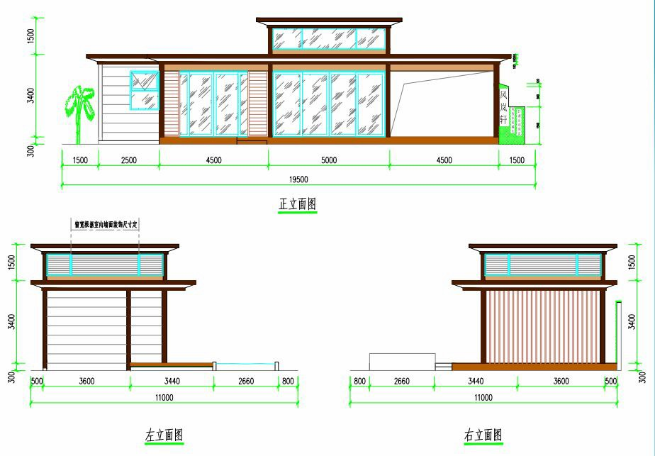

House Cost
Item | Dimension | Area(㎡) |  | Single Building Price ($) | Quantity (set) | Total price($)

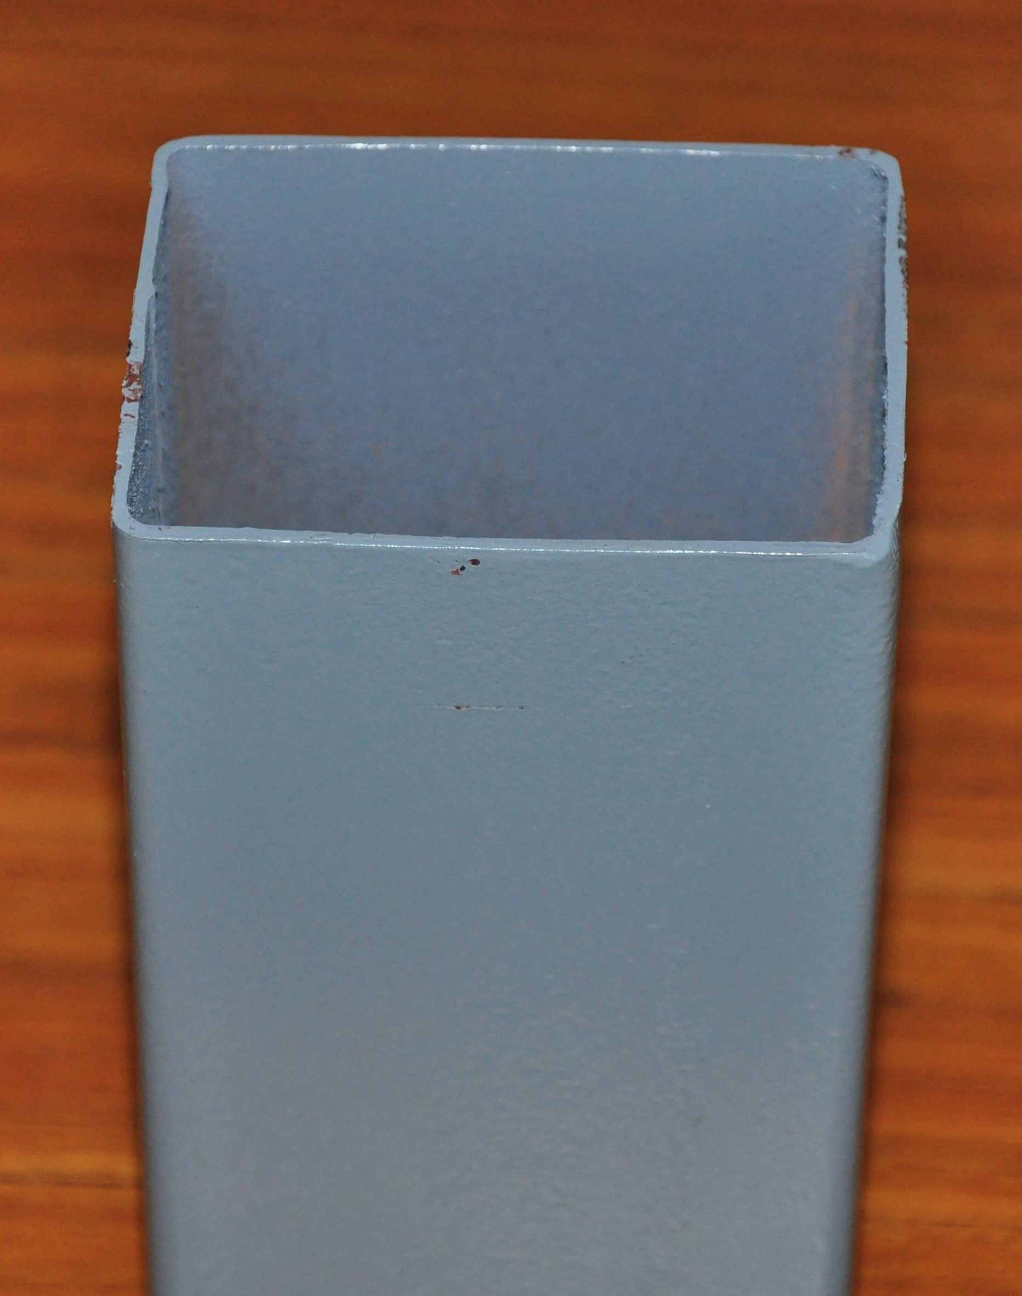
House | 16.5*7*4.9m | 110 |  | $50,369.00 | 1 | $55,000.00
Total Cost |  |  |  |  |  | $55,000.00
Theporice is CIF ASWP.
Remark |  | Delivery Time: 10 days after received 50% deposit, need final confirmation
 |  | Payment: T/T 50% as deposit, 50% balance before loading from factory
 |  | Loading: it need final confirmation.
Installation |  | - We can give you the processing drawing to guide the installation.  - We can send our skill worker to your country to guide work,you need to provide return air tickets; visa cost,accommodation ,salary USD120/day.need to final confirmation  - You can send your worker to our factory to learn installation.
Main Material Lists
No. | Component | Materials  (need to final confirmation ,according to design) |  |  | Thickness (mm) | Photo
1 | Pillar | 150 * 150mm Square Tube |  |  | 4mm | 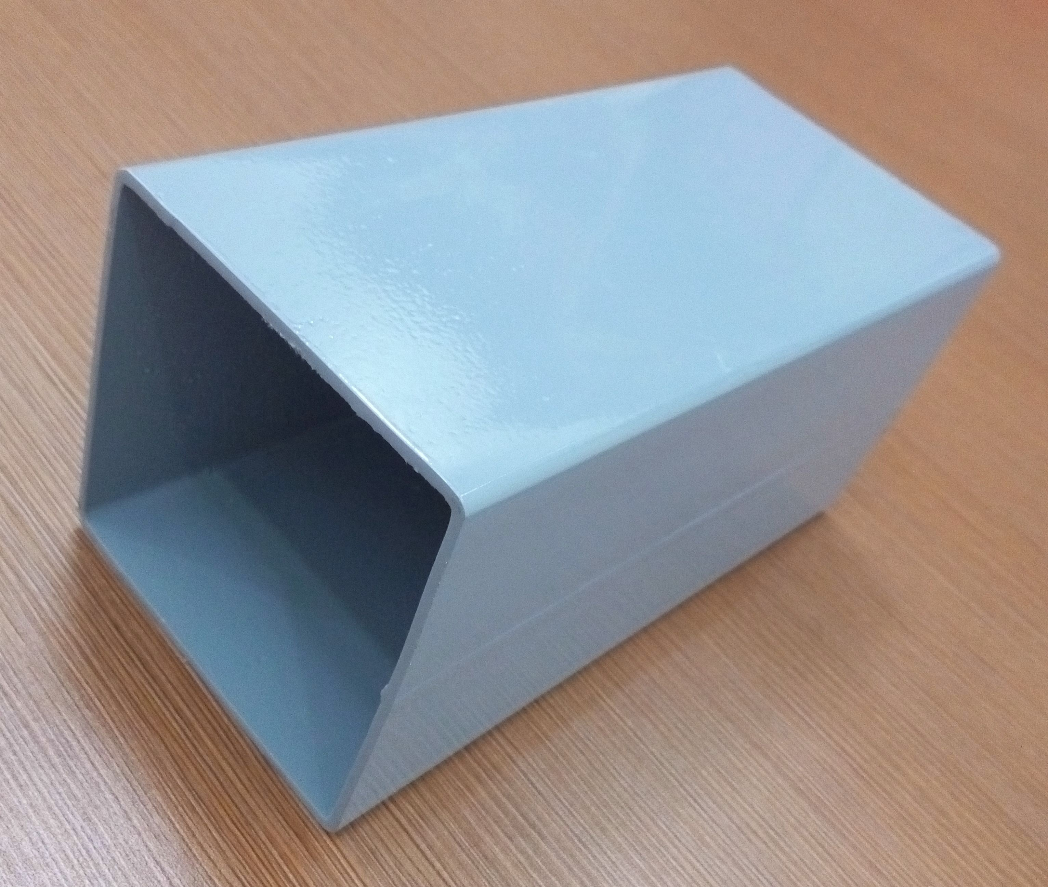
2 | Ring Beam | 100*100mm Square Tube |  |  | 3mm
3 | Roof Purlin | 40*80mm Square Tube |  |  | 2mm | 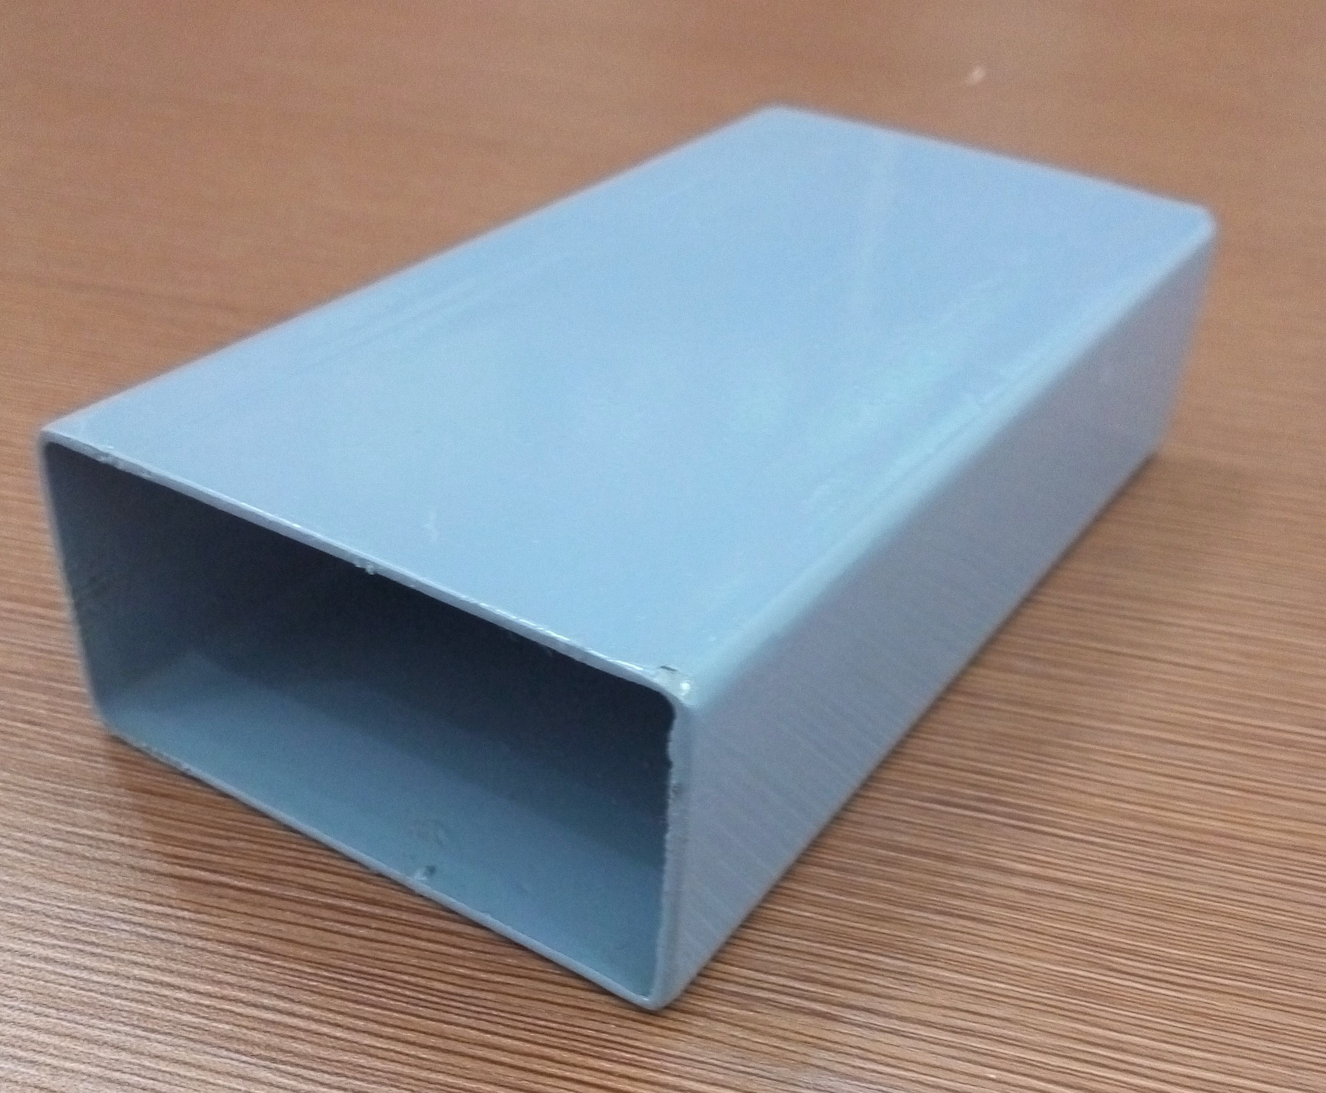
4 | Roof Beam | 80*80mm Square Tube |  |  | 3mm | 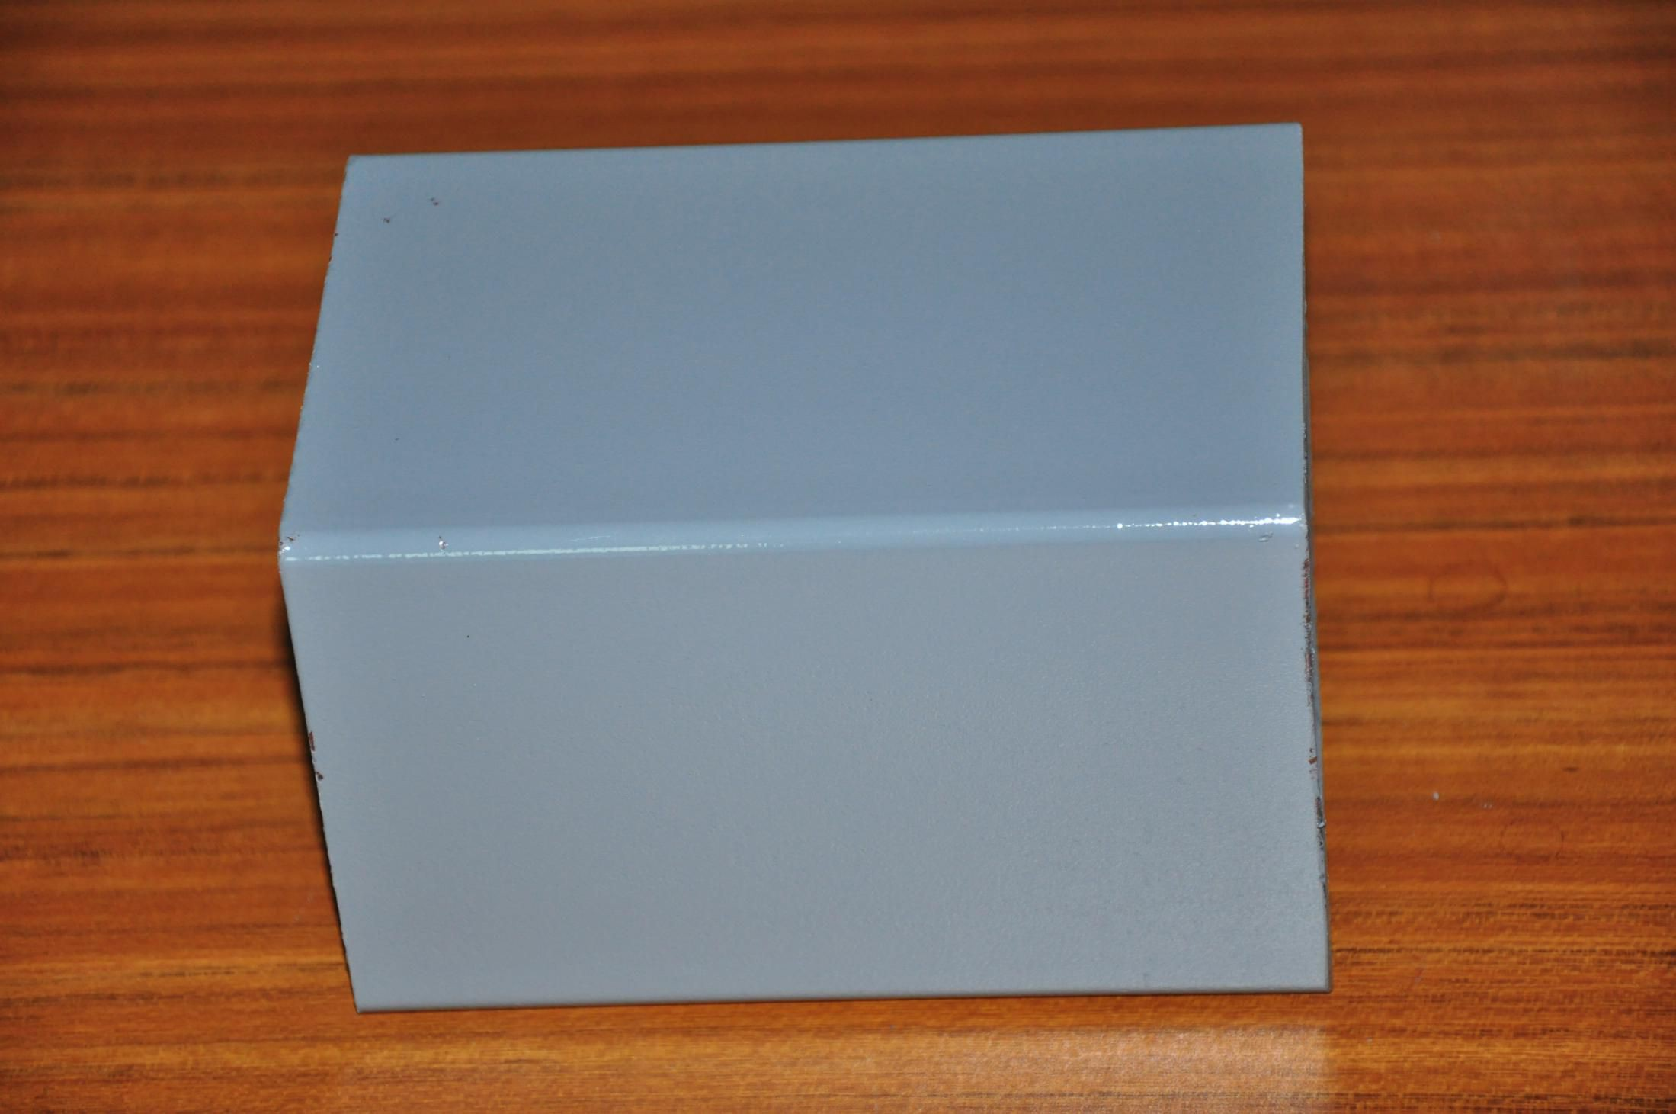

5 | Wall Panel | PU Sandwich Panel | 100*950mm | 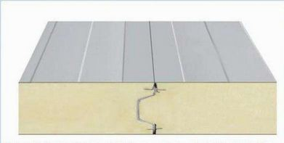
6 | Partition Wall Panel | PU Sandwich Panel | 100*950mm
7 | Roof Panel | PU Sandwich Panel | 50*950mm
8 | Roof Tile | Steel Sheet | 0.476mm | 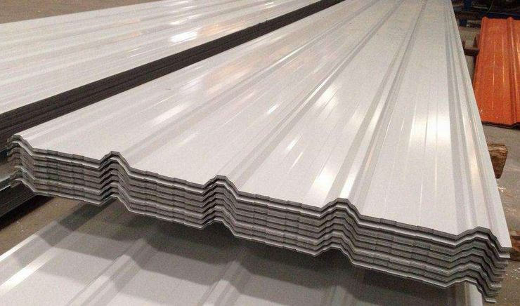
9 | Ceiling Decoration | Charcoal fiber decoration panel | 200 *10mm | 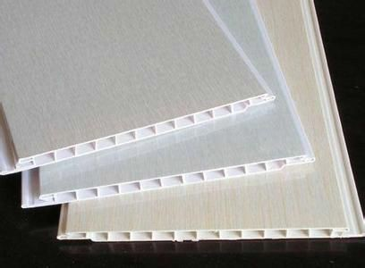
10 | Exterior Wall Decoration | PU Decoration Wall Panel | 3080 *380mm | 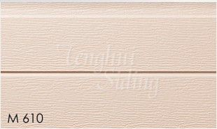
11 | Interior Wall Decoration | Charcoal fiber decoration panel | 300*3000mm
12 | Floor Decoration | Ceramic TIile | 800*800mm | 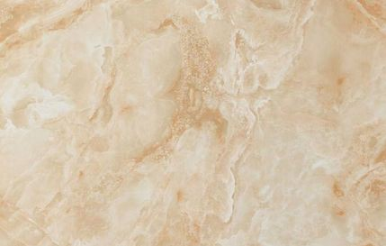
13 | Door | Glass Aluminum Sliding Door | 4500*3000mm | 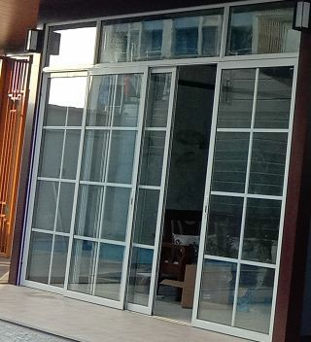
14 | Window | Glass Aluminum Sliding Window | 1500*1000mm | 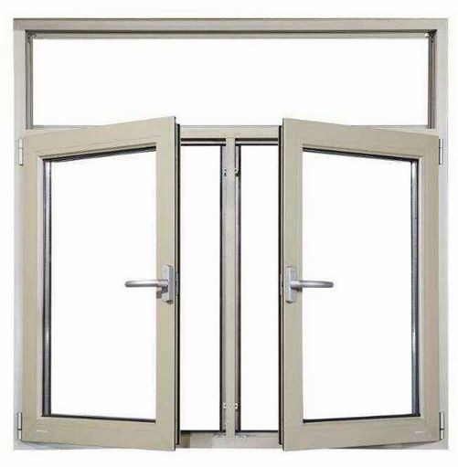

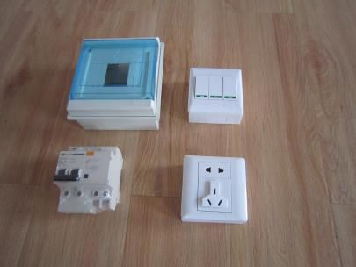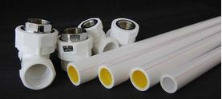
15 | Toilet Door | Ecological Door |  | 700*2000mm | 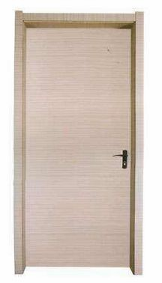
16 | Accessories | screw,rivet,bolt and sealant etc |  |  | 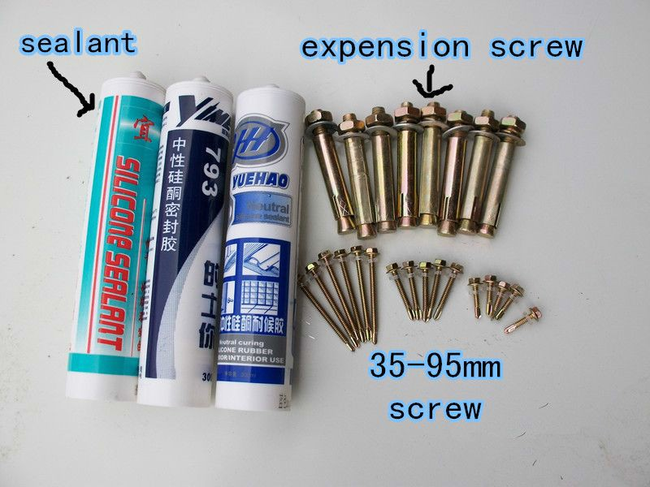
17 | Water & Eletricity | Wires, tubes, sockets, switches
Exported Countries
Asia : Korea，India ,malaysia ,Thailad,Kuwait, Jordan ,Indonesia,Qatar,Oman,Philippines |  |  | Europe: Spain,England
Africa: Cameroon, mozambique, Mauritius,Ethiopia Angola,South Africa,Djibouti,Congo |  |  | South America: Trinidad andTobago,Chile, Brazil,Colombia,Bolivia,Suriname,Uruguay, venezuela
Oceania:Australia ，Kiribati
Technical Parameter
No | Project Name | Value | No | Project Name | Value
1 | Roof load | ≧65kilograms/m2 | 5 | Wall deformation | ≦65kilograms/m2
2 | Flooring load | ≧150kilograms/m2 | 6 | Seismic grade | 7-magnitude
3 | Aisle load | ≧200kilograms/m2 | 7 | Wind loading | ≧100km/h
4 | Wall side stress | ≧80kilograms/m2 | 8 | Fire proof | B1 grade

