1、Project Installation：

- ), Installation Instruction (PDF/WORD file): free charge.

- ), Sending Technician: The client affords all fees include the round trip air ticket/hotel/food/wage.

2、Area calculation rules:
- )、Room area: Length x Width （㎡）.
- )、Canopy area: half of the canopy horizontal projection area （㎡）. Total area is: 1)+2).
3、Quotations: Date: OCT.11, 2017

Quotation: Prefab House School and Toilet (75mm color steel EPS sandwich panel）
 | Description | Dimension of per classroom | Pic | Area  ㎡ | TTL Area Per Unit  ㎡ | Unit | Unit Price usd/unit (FOB) | Total Amount USD (FOB) | REMARK
1 | K-type 5 classrooms | 45.70*6.57M (L x W) | 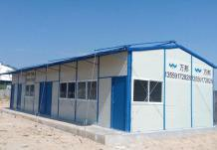 | 300.25 | 323.10 | 5 | $17,800.00 | $91,000.00 | 3P*3.5K*25K,1  unit with 5 classrooms.
 | K-type 5 classrooms canopy | 45.70*1M/2 (L x W) | 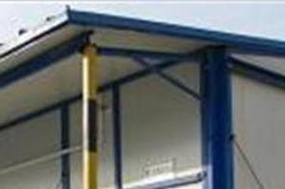 | 22.85 |  |  |  |  | 1 unit canopy in 1 building (5 classrooms)
2 | K-type toilet | 5.66*5.66M (L x W) |  | 32.03 | 34.86 | 1 | $2,950.00 | $2,950.00 | 3P*3K*3K
 | K-type toilet canopy | 5.66*1M/2 (L x W) |  | 2.83
3 | Moisturepr oof partition  board | for squatting pot |  |  |  | 10 sets | $95.00 | $950.00 | include the door for each sqatting pan
 | Squatting Pan Sets |  |  |  |  | 10 sets | $45.00 | $450.00 | include the water tank,triangular valve and
 | Staniless steel Urinal slot | 3.6 m |  |  |  | 1 | $580.00 | $580.00 | Men's room
 | Pedestal Basin |  | 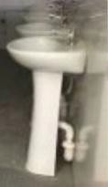 |  |  | 2 sets | $38.00 | $76.00 | include the faucet
 | Indoor water supply and drainage | include pipe connector and accessories |  |  |  | 1 | $675.00 | $675.00 | for toilet

4 | Housing installation tools |  |  |  | 1 sets | $650.00 | $650.00 | Optional
5 | indoor electricity distributions | wire、switchs、socket、 lamps |  | 1650.36m2 |  | $6.80/m2 | $11,222.45 | for all classrooms and toilet.
Total amount include tool (FOB): |  |  |  |  |  |  | $106,653.45
Remark:

1, Price term: FOB FUZHOU, CHINA.

2, Payment Term: 50% TT deposit, balance 50% TT paid before delivery. 3, Lead time: within 30 days after receive the 50% T/T deposit.
4, Quotation Expiry Date: OCT. 26, 2017.

5, The above price is only for the house body and the items listed, does not include foundation, installation and other items unlisted in the above quotation sheet.
Material Specifications of K-type prefab house (dimensions tolerance:0~±5%)：
1、Pillar：C100*1.8 mm section steel；
2、Roof Purline/Ring Beam：L40*2.0mm angle steel；
3、Roof Truss：C60*1.5mm + 口40*30*1.0mm Square tube combination；
4、Ground beam： C100*1.8 mm section steel；
5、Outer wall panel：75mm double color steel (0.25mm) EPS sandwich panel；

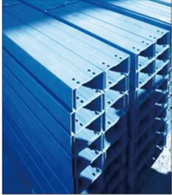

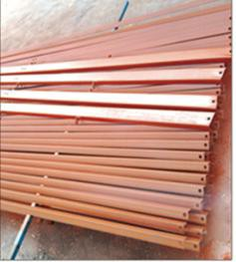

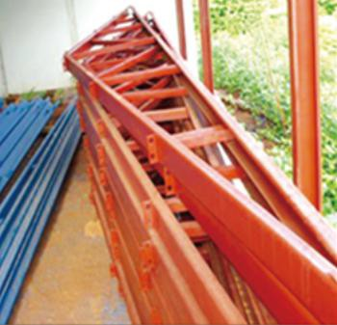

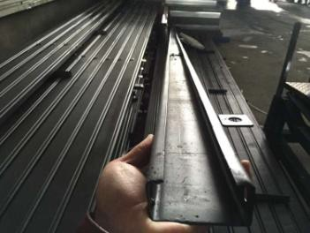

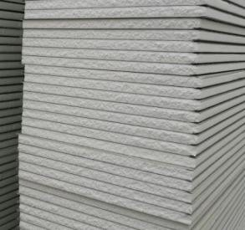

6、Inner wall panel：75mm double color steel (0.25mm) EPS sandwich panel；
7、Roof Panel：75mm double color steel (0.25mm) EPS corrugate sandwich panel； | 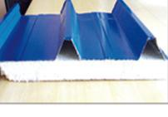
8、Door：Steel sandwich panel door； | 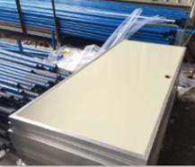
9、Window/Shutter ：PVC sliding widows； | 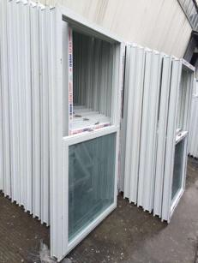

Design drawing of 5 classrooms:
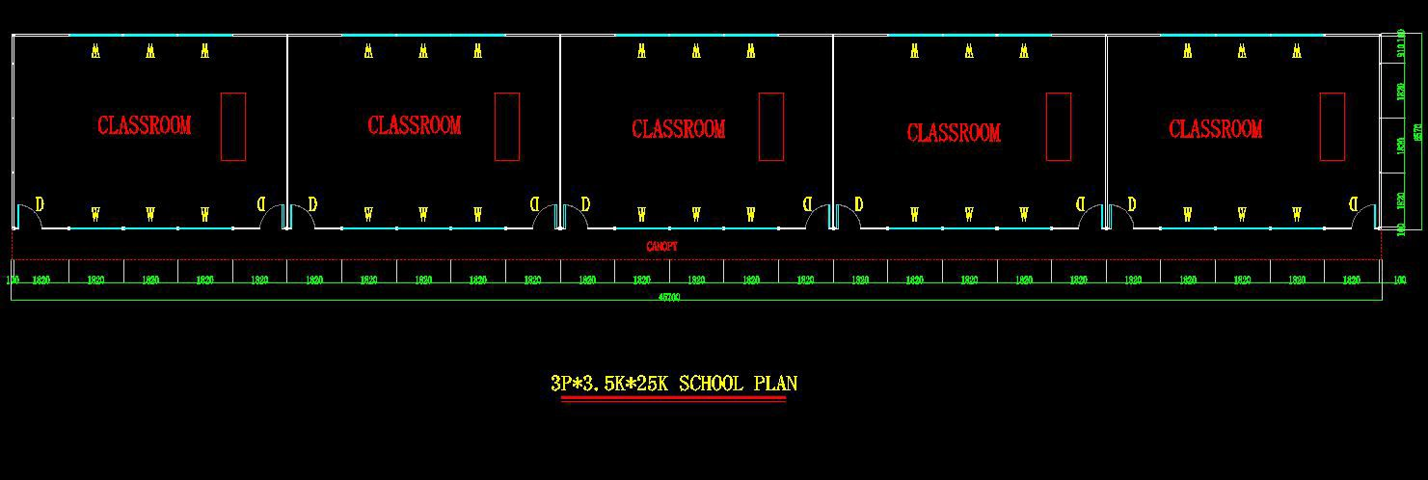

Design drawing of Toilet:

