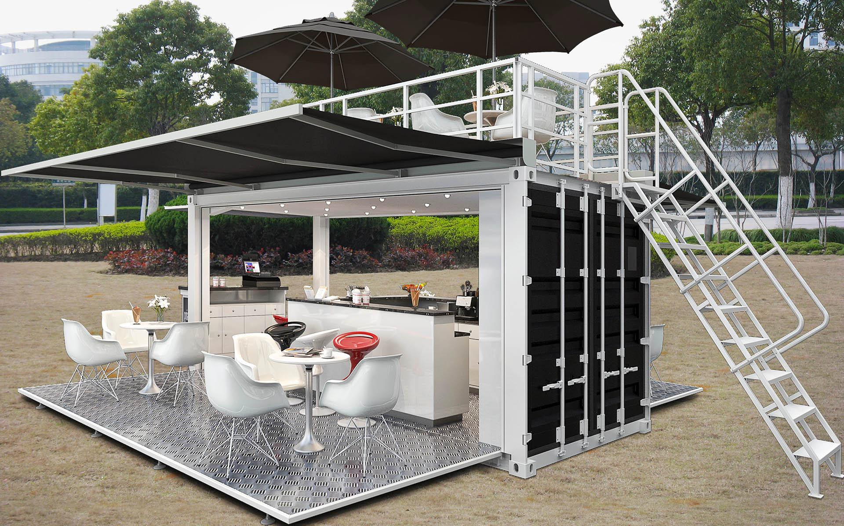
 | Quotation List (Jan-Feb 2018)
Sector | No. | Item | Size（mm） | Specification | Picture | MOQ (Set/40HQ) | FOB Nansha
Standard | 1 | Standard Flat Pack | 5800*2438*2800 | Flame: Galvanized steel frame+steel bending Wall: 50mm EPS Wall panel  Roof: 100mm Rockwool Floor: 16mm MGO Board  Configuration: 2 PVC window with Security net (130*1200mm), 1 steel door (800mm*2000mm), drainage for roof  Max:3~5Layers | 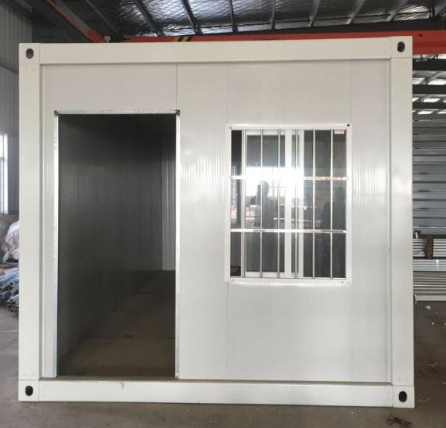 | 8 | $2,953.25
 | 2 | Luxury Flat Pack | 5800*2438*2800 | Flame: Galvanized steel frame+steel bending Wall: 50mm EPS Wooden Wall panel  Roof: 100mm Rockwool  Floor: 16mm MGO Board  Configuration: 2 PVC window with Security net (130*1200mm), 1 steel door (800mm*2000mm), drainage for roof  Max:3~5Layers | 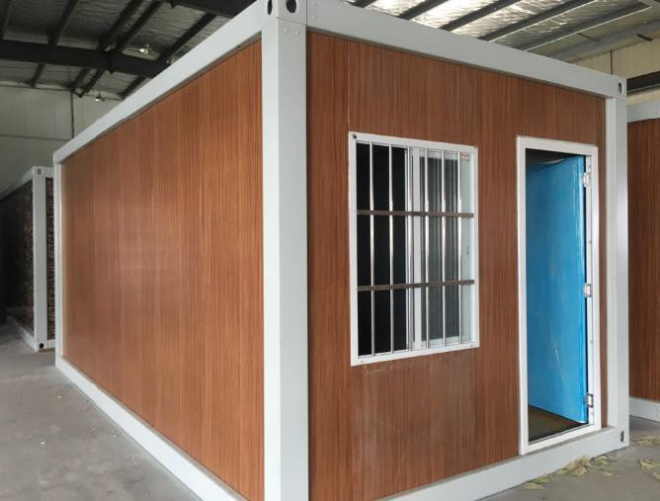 | 8 | $3,556.00
 | 3 | Standard Detachable | 5950*2400*2870 | Flame: Normal steel frame Max take apart for 20 times  Configuration: 2 windows and 1 door  Fit for the contry which labor cost is low  The size is customized ,but the max length is 11m | 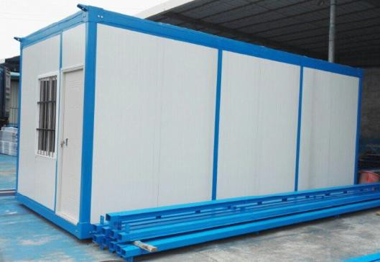 | 12 | $1,990.00
 | 4 | Luxury Detachable | 5800*2438*2800 | Flame: galvanized steel frame Max take apart for 20 times  Configuration: 2 windows and 1 door  Fit for the contry which labor cost is low  The size is customized ,but the max length is 11m | 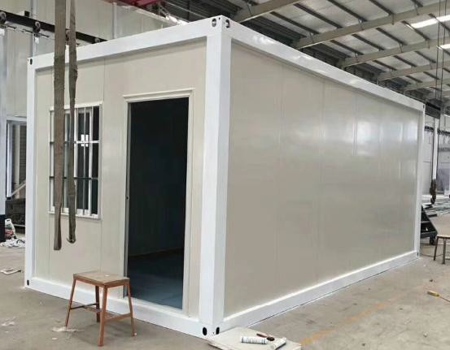 | 15 | $2,520.00
 | 5 | Expandable | 5850*6300*2500 | Flame:Normal steel frame  Configuration :Four windows and one door | 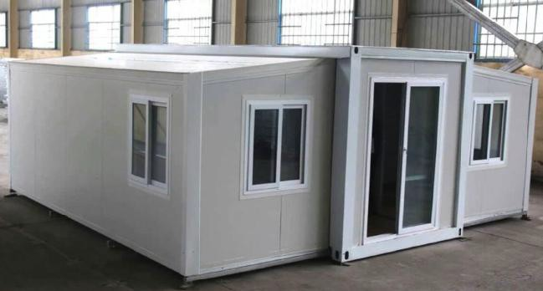 | 2 | $11,025.00
 | 6 | Standard Folding | 5800*2500*2650 | Flame: galvanized steel frame Configuration: 2 windows and 1 door Roof: EPS panel roof  Max: 1 Layers  The folded position is hinge 折叠的部位用的是合页 ， 活动墙板与顶部之间使用 lock连接,安装好后需要涂 | 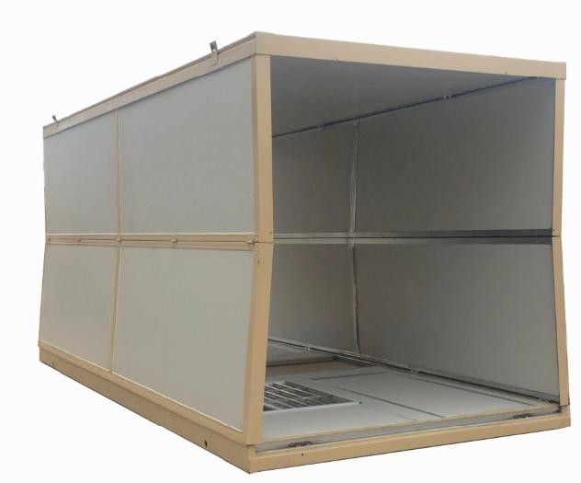 | 12 | $2,169.00
 | 7 | Luxury Folding | 5800*2440*2620 | Flame: Galvanized steel frame+steel bending Configuration: 2 windows and 1 door  Roof: EPS panel roof Max: 2 Layers  The folded position is hinge 折叠的部位用的是合页 ，  活动墙板与顶部之间使用 lock连接,安装好后需要涂 上防水胶 | 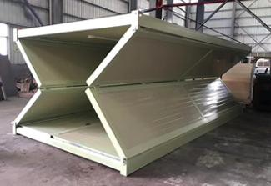 | 8 | $2,356.00
Coffee Shop | 8 | Modify Coffee Shop | 6058*2438*2591 | Wall:30mmPU+FCB+Pattern Aluminium Board Floor:FCB+Pattern Aluminium Board |  | SOC | $38,850.00

Special Items sold in bulk
Sector | No. | Item | Size（mm） | Specifacation | Picture | QTY | AMT Price
Special Order | 9 | 100 Sets Foldable Container Project | 2440*5800*2620 | 50mm EPS wall and roof panel, Steel door 1 set, PVC window 2 sets, GB standard electrical device, fireproof MGO board, waterproof material. | 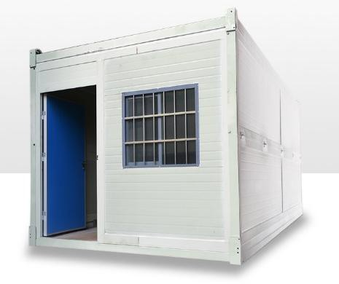 | 100 | US$185,000.00
 | 10 | 100 Sets Detachable Container Project | 2438*5800*2800 | 50mm EPS wall and roof panel, Steel door 1 set, PVC window 2 sets, fireproof MGO board, waterproof material. | 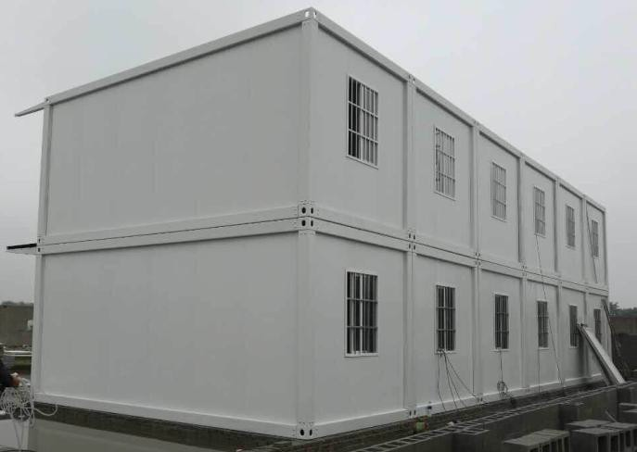 | 100 | US$165,000.00
 | 11 | 100 Sets Flat Pack Container Project | 2438*5800*2800 | 50mm EPS wall and roof panel, Steel door 1 set, PVC window 2 sets, fireproof MGO board, waterproof material, PVC skirting and edge. |  | 100 | US$195,000.00
 | 12 | Economic Prefab House( Labor camp,construction site dormitory) | 3K*11K*3P (123.5SQM) | 50mm EPS roof and wall,EPS door, PVC window, Rain cover,Walkway,Partition wall,  Optional: Electrical device, water system, toilet | 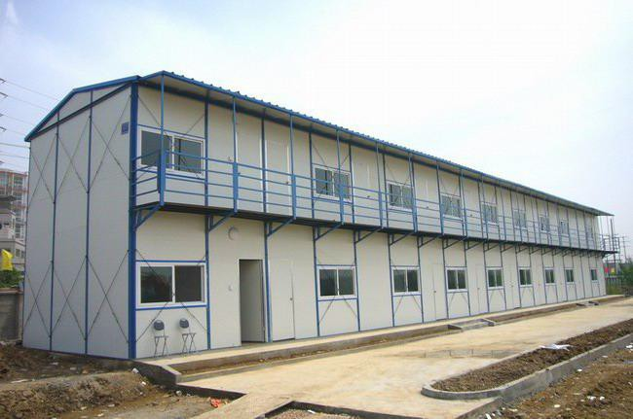 | 123.5 | $4,993.00
 |  |  | 3K*16K*6P (266.09SQM) |  |  | 266.09 | $11,111.42
 | 13 | Standard Prefab House(Site office,housing) | 3T*11T*3H (182.37SQM) | 50mm EPS roof and wall,EPS door, PVC window, Rain cover,Walkway,Partition wall,  Optional: Electrical device, water system, toilet | 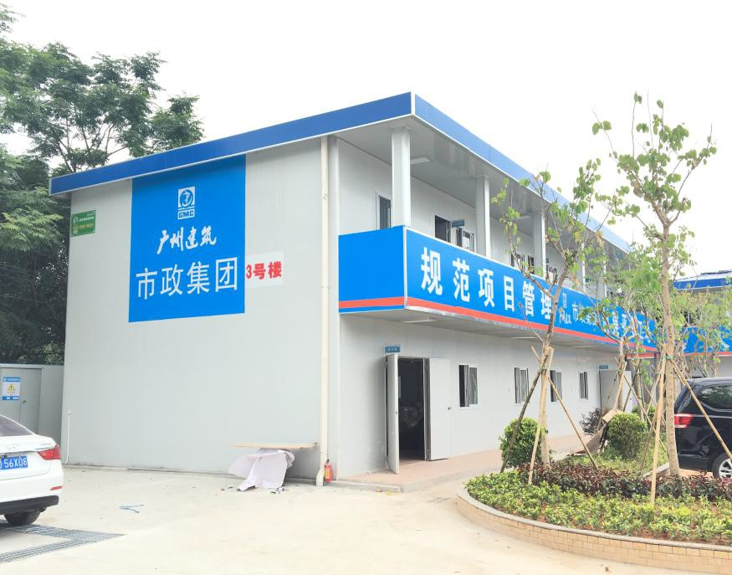 | 182.37 | $11,030.35
 |  |  | 3T*16T*6H (545.88SQM) |  |  | 545.88 | $28,294.00
 | 14 | Standard Villa | 70 | Layout and interior exterior decoration is custom design | 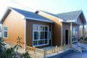 | 70SQM | US$14,950.00
 |  | Luxury Galvanized Villa | 70 | Layout and interior exterior decoration is custom design |  | 70SQM | US$27,450.00
 | 15 | Standard Villa | 100 | Layout and interior exterior decoration is custom design |  | 100SQM | US$19,200.00
 |  | Luxury Galvanized Villa | 100 | Layout and interior exterior decoration is custom design |  | 100SQM | US$49,800.00
 | 16 | Standard Villa | 150 | Layout and interior exterior decoration is custom design |  | 150SQM | US$26,750.00
 |  | Luxury Galvanized Villa | 150 | Layout and interior exterior decoration is custom design |  | 150SQM | US$49,885.00
 | 17 | Standard Villa | 300 | Layout and interior exterior decoration is custom design |  | 300SQM | US$47,000.00
 |  | Luxury Galvanized Villa | 300 | Layout and interior exterior decoration is custom design |  | 300SQM | US$77,450.00

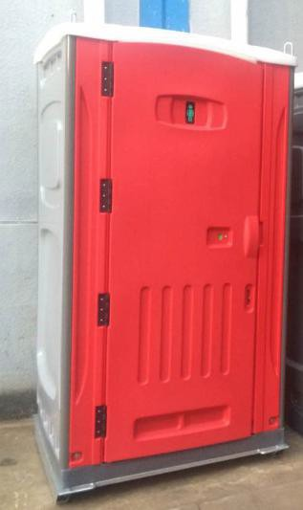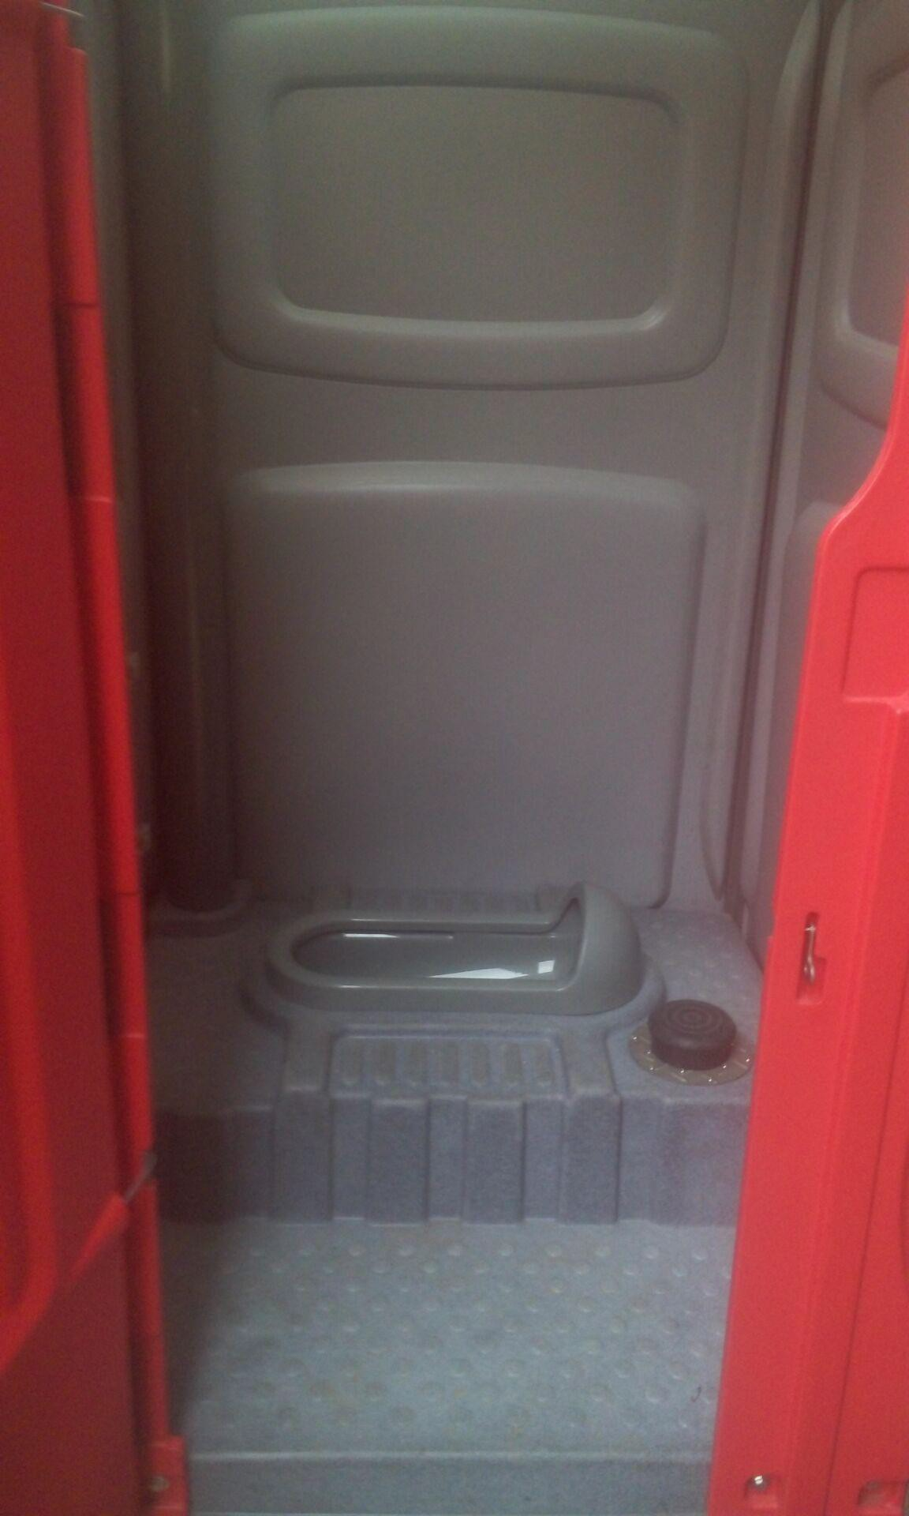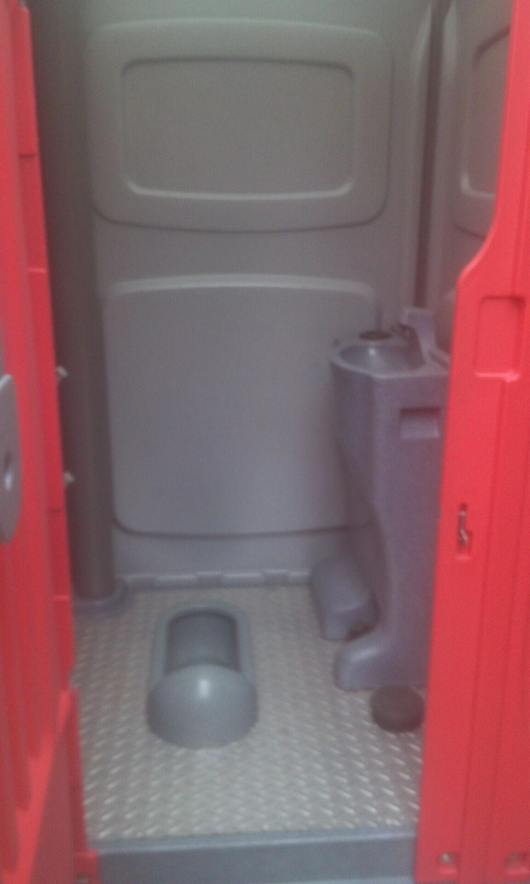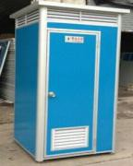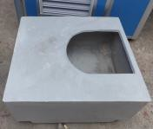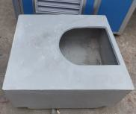Quotation List (Jan-Feb 2018)

No. | Item | Size（mm） | Specification | Picture | Qty (Set/40HQ) | FOB Nansha
1 | HDPE Portable Toilet PT100 | 1200*1130*2350 | Configuration: HDPE Sitting Flushing Toilet,Hand Wash Basin, Mirror,Tissue Holder,Hook,Metal Base for Forklift Water Tank:130L Waste Tank:320L  G.W.:111Kg N.W.:110KG  Packing:Plastic film wrapping 塑料薄膜包装 | 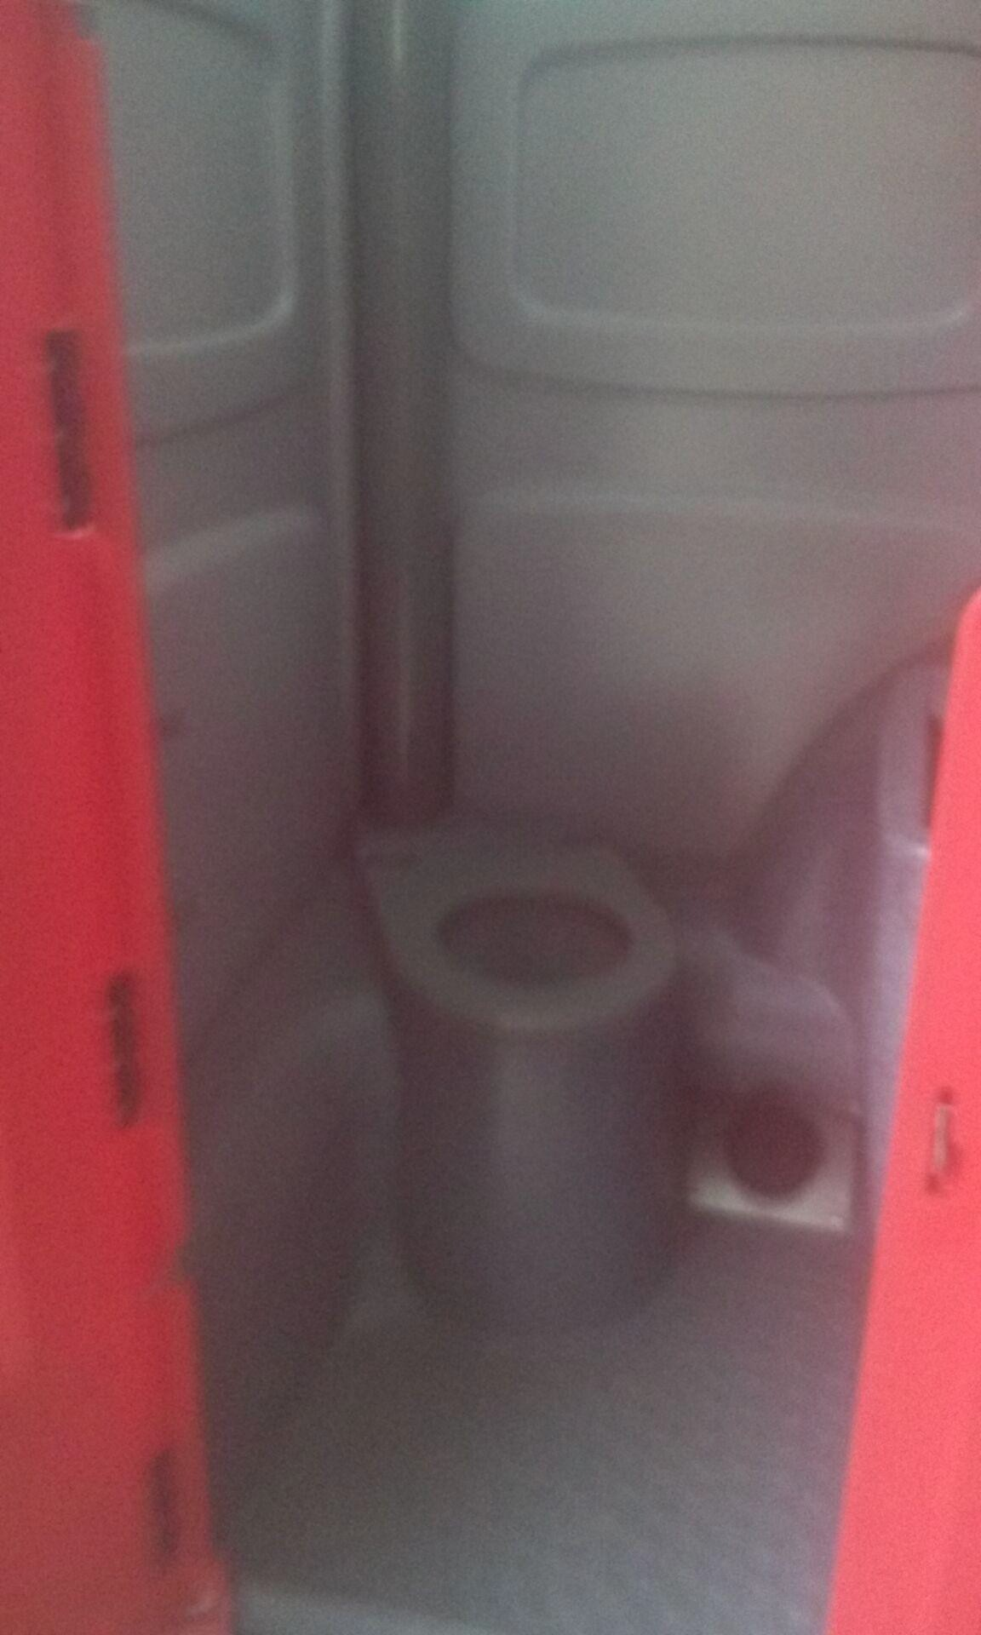 | 40 | $1,041.00
2 | HDPE Portable Toilet PT200 | 1160*1120*2300 | Configuration :HDPE Squal Flushing Toilet,Hand Wash Basin, Mirror,Tissue Holder,Hook,Metal Base for Forklift Water Tank:80L Waste Tank:280L  G.W.:111Kg N.W.:110KG  Packing:Plastic film wrapping 塑料薄膜包装 | 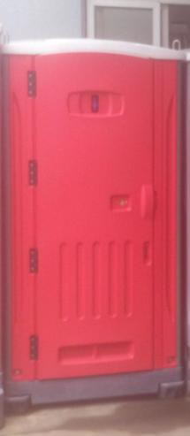 | 40 | $941.00
3 | HDPE Portable Toilet PT350 | 1100*1350*2450 | Configuration :HDPE Squal Flushing Toilet,Hand Wash Basin, Mirror,Tissue Holder,Hook,Metal Base for Forklift Water Tank:100L Waste Tank:320L  G.W.:111Kg N.W.:110KG  Packing:Plastic film wrapping 塑料薄膜包装 | 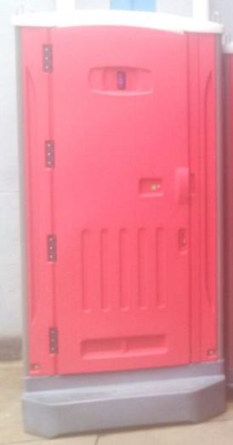 | 40 | $1,041.00
4 | MBS- PT001 | 1100*1100*2300 | EPS sitting  toilet, and hand washing sink(With waste tank) |  | 60 | $393.00
5 | MBS- PT002 | 1100*1100*2300 | EPS sitting  toilet, and hand washing sink(Without waste tank) | 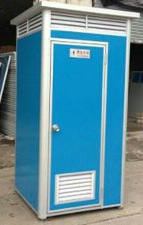 | 60 | $394.00
6 | MBS- PT003 | 1100*1100*2300 | EPS squat  toilet, and hand washing sink(With waste tank) |  | 65 | $390.00
7 | MBS- PT004 | 1100*1100*2300 | EPS squat  toilet, and hand washing sink(Without waste tank) |  | 65 | $393.00
8 | MBS-PT600 | 1150*1150*2300 | 坐便器(Seated toilet pan)； 洗手盆(washing facilities)； 水龙头(water tap)； 门锁（lock）； 镜子（mirror）； 储污箱（waste tank）240L; 储水箱(water tank)200L； 排气管(ven pipe)； 性别指示牌 (gender indicator) ； 使用指示 (in-use sign) | 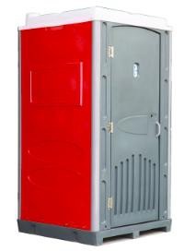 | 60 | $799.00
9 | MBS-PT700 | 1150*1150*2300 | 蹲便器(Squat toilet pan)； 洗手盆(washing facilities)； 水龙头(water tap)； 门锁（lock）； 镜子（mirror）； 储污箱（waste tank）290L; 储水箱(water tank)200L； 排气管(ven pipe)； 性别指示牌 (gender indicator) ； 使用指示 (in-use sign) | 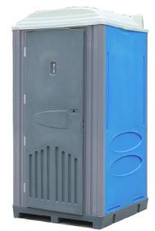 | 60 | $799.00
10 | MBS-PT800 | 1150*1150*2300 | 瓷坐便器 (Ceramic seated toilet pan)； 洗手盆(washing facilities)； 水龙头(water tap)；  门锁（lock）； 镜子（mirror）； 排气管(ven pipe)；  性别指示牌 (gender indicator) ；  使用指示 (in-use sign)。  注：该产品需要直接连接自来水系统和排污系统 。 | 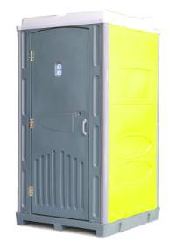 | 55 | $830.00

11 | MBS-PT900 | 1150*1150*2300 | 蹲便器(Squat toilet pan)； 门锁(lock)；  排气管(ven pipe)；  使用指示 (in-use sign). 储污箱(waste tank); 储水箱(water tank). | 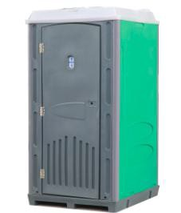 | 60 | $699.00
12 | K1 | 1200*1200*2300 | 1.Columns: ɸ160 1/4 aluminum profiles; 2.Roof/Wall:color steel EPS sandwich panel 3.Window:Plastic Steel with 4mm Glass; 4.Base Frame: Plywood with Aluminum Floor;  - with working Platform  - Electric: 20w Light, Switch, socket, with rotary overhead warning light; 7.with Lock | 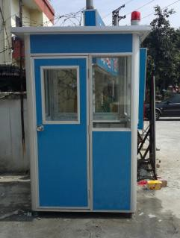 | 65 | $393.00
13 | K2 | 1200*1500*2300 | 1.Columns:ɸ160 1/4 aluminum profiles; 2.Roof/Wall:color steel EPS sandwich panel 3.Window:Plastic Steel with 4mm Glass; 4.Base Frame: Plywood with Aluminum Floor;  - with working Platform  - Electric: 20w Light, Switch, socket, with rotary overhead warning light; 7.with Lock |  | 65 | $423.00
14 | K3 | 1200*1500*2300 | 1.Columns:ɸ160 1/4 aluminum profiles; 2.Roof/Wall:color steel EPS sandwich panel 3.Window:Plastic Steel with 4mm Glass; 4.Base Frame: Plywood with Aluminum Floor;  - with working Platform  - Electric: 20w Light, Switch, socket, with rotary overhead warning light; 7.with Lock |  | 60 | $674.00
15 | K4 | 2200*1500*2300 | 1.Columns:ɸ160 1/4 aluminum profiles; 2.Roof/Wall:color steel EPS sandwich panel 3.Window:Plastic Steel with 4mm Glass; 4.Base Frame: Plywood with Aluminum Floor;  - with working Platform  - Electric: 20w Light, Switch, socket, with rotary overhead warning light; 7.with Lock |  | 50 | $827.00
16 | K5 | 1500*2000*2300 | 201-Stainless steel With workbench Size:costomzied  Fire-proofing,sound insulation life time:15 years  resist 12 grades typhoons and 9 earthquake requirement | 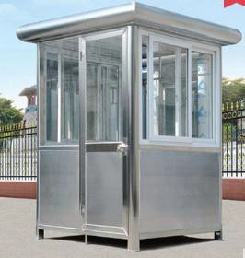 | 45 | $1,418.00
17 | K6 | 1500*2000*2300 | 304-Stainless steel With workbench Size:costomzied  Fire-proofing,sound insulation  life time:15 years  resist 12 grades typhoons and 9 earthquake requirement |  | 45 | $1,709.00
18 | K7 | 2000*2000*2800 | stoving varnish kiosk | 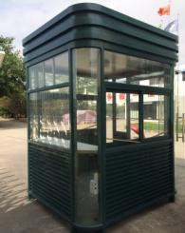 | 40 | $2,971.00
19 | K8 | 2000*2000*2500 | stoving varnish kiosk |  | 40 | $2,596.00
20 | K9 | 12sqm | Galvanized steel kiosk | 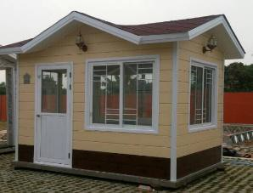 | 1 | $8,985.00
21 | K10 | 15sqm | Galvanized steel kiosk | 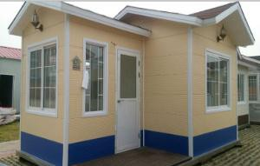 | 1 | $11,500.00

