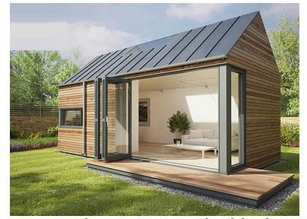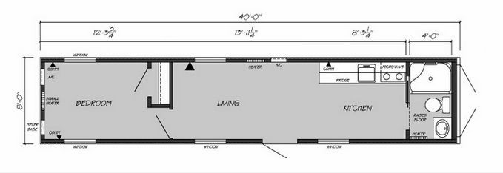
QUOTATION
 |  |  | Contact person |  | Myla Baracina
 |  |  | E-mail |  | sales@asiandragonintl.com
 |  |  | Quotation date (valid time:20 days) |  | 2018.3.19
Project : Container House
(HS code:9406900090 ;Picture just for reference )
Container House Cost
No. | Item | Dimension | FOB Huangpu USD$/set | Quantity | Total price
1 | Container House | 11.8*2.5*2.6m | $7,300.00 | 1 | $7,300.00
Total Price |  |  |  |  | $7,300.00

FOB Huangpu Price include the house price, towing fee and custom fee, do not include other costs.
Remark |  | delivery time: 30 days after received 30% deposit
 |  | Payment: T/T 50% as deposit, 50% balance before loading from factory
 |  | Loading: Need final confirmation
Installation |  | - We can give you the processing drawing to guide the installation.  - We can send our skill worker to your country to guide work, you need to provide return air tickets; visa cost, accommodation ,salary USD100/day.need to final confirmation
Main Material Lists
No. | Component | Materials  (need to final confirmation ,according to design) | Thickness (mm) | Photo
Steel Structure
1 | Pillar | 100*100mm Square tube | 3mm | 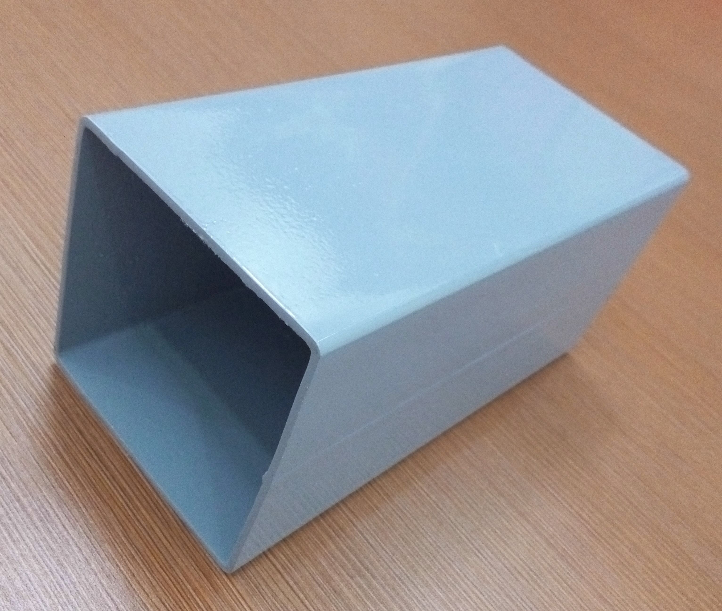
2 | Roof Ring Beam | 100*100mm Square tube | 3mm
3 | Ground Ring Beam | 100*100mm Square tube | 3mm
4 | Purlin | 8#C section steel | 1.7mm | 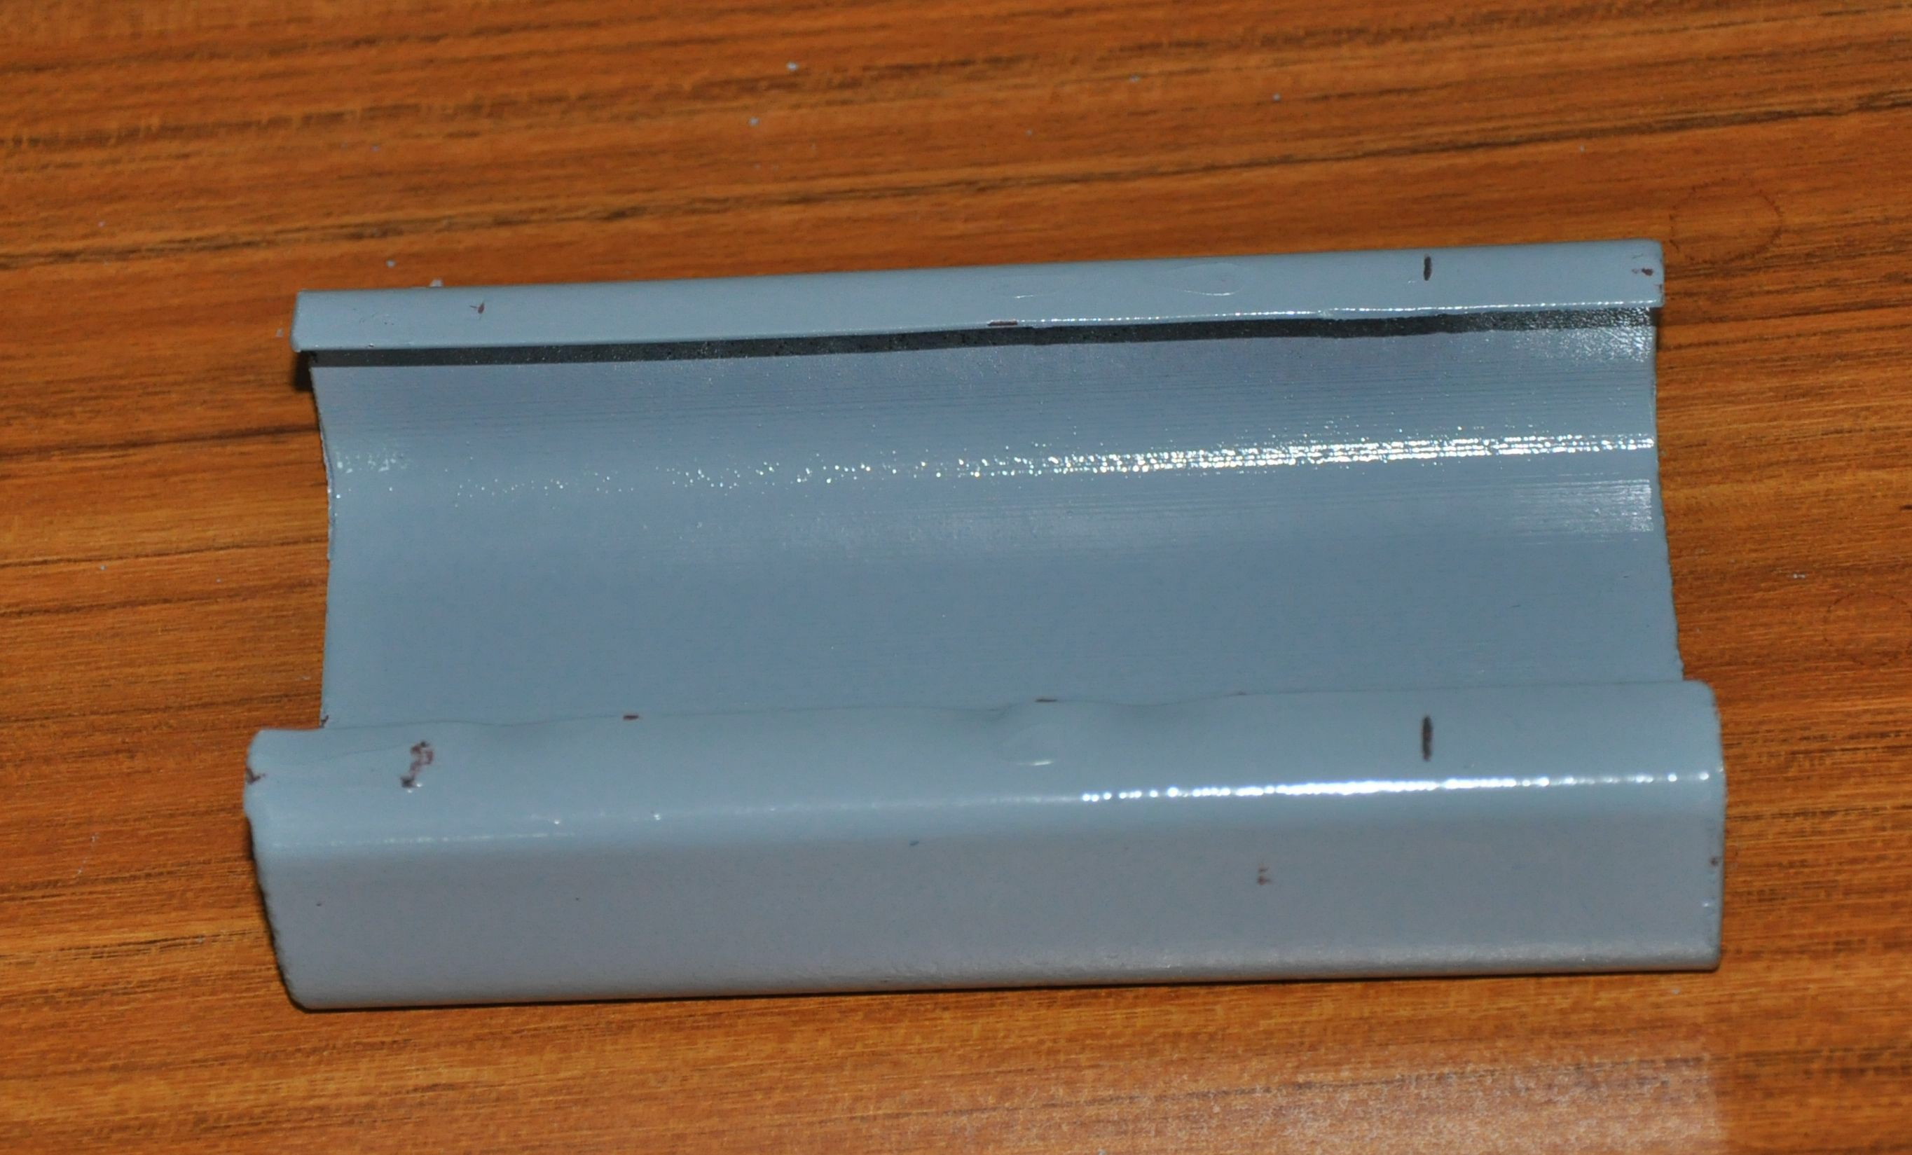
Wall Panel
5 | Wall Panel | Glass Wool Sandwich Panel | 50*950*0.326mm 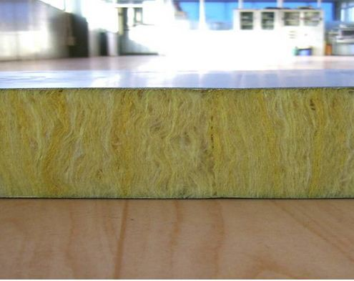

6 | Partition Wall Panel | Glass Wool Sandwich Panel | 50*950*0.326mm
7 | Roof Tile | Glass Wool Sandwich Panel | 50*950*0.326mm 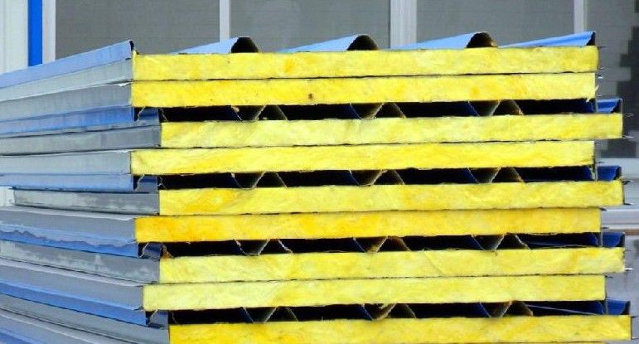
Floor & Ceiling
8 | Floor | Fiber Cement Board | 15mm 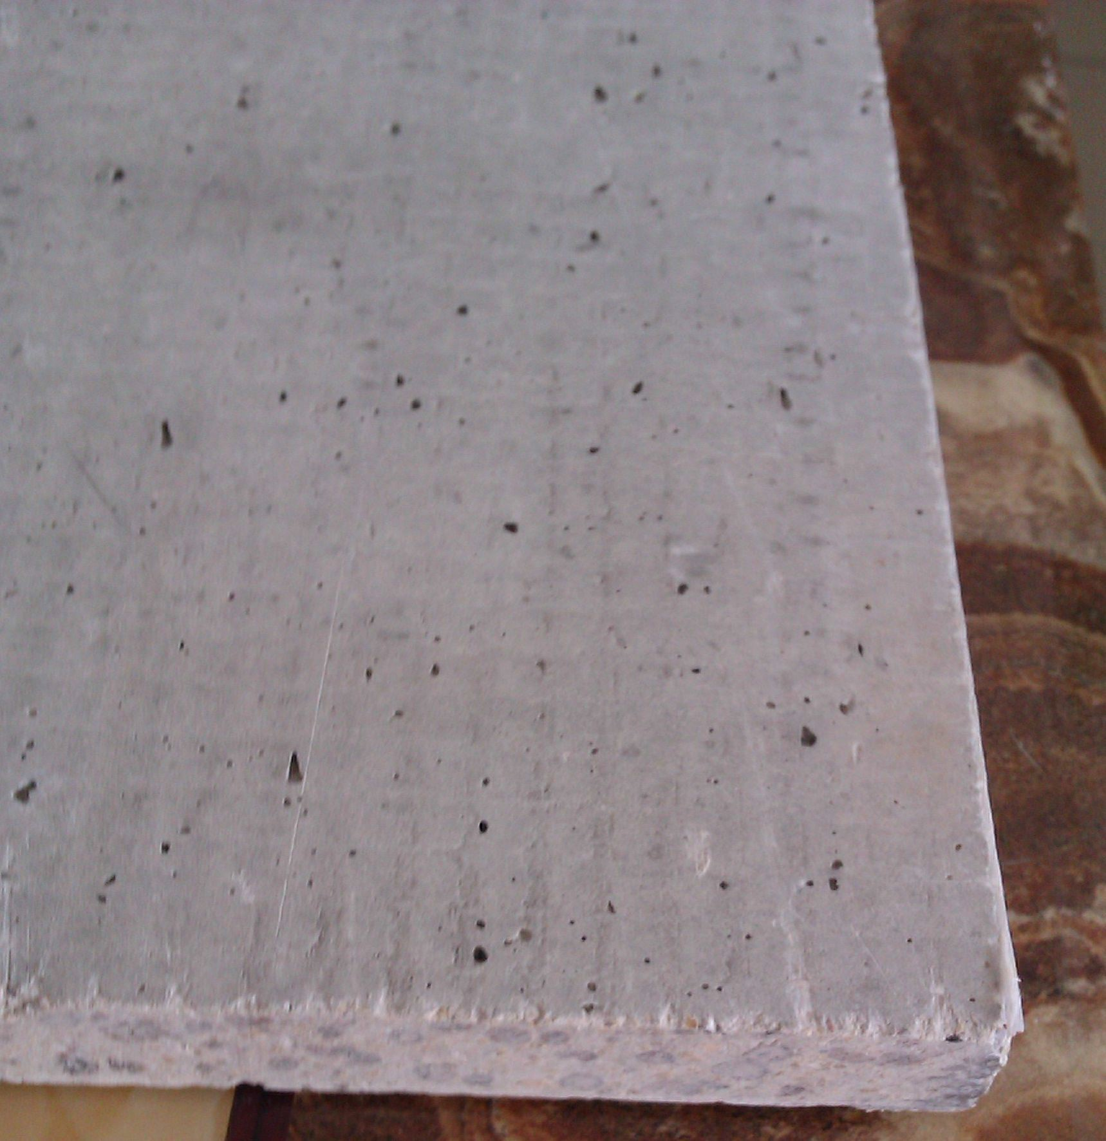
9 | Interior Floor Decoration | Ceramic | 6mm 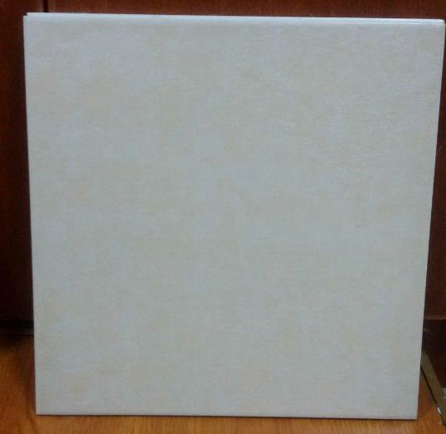
10 | Exterior Floor Decoration | Wood Plastic Floor Panel | 15mm 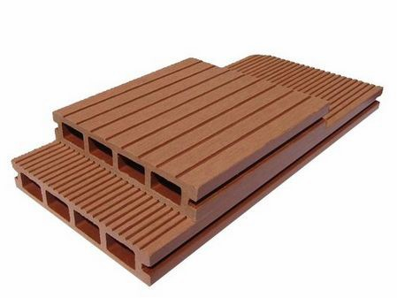
11 | Ceiling Decoration | PVC Ceiling | 7mm 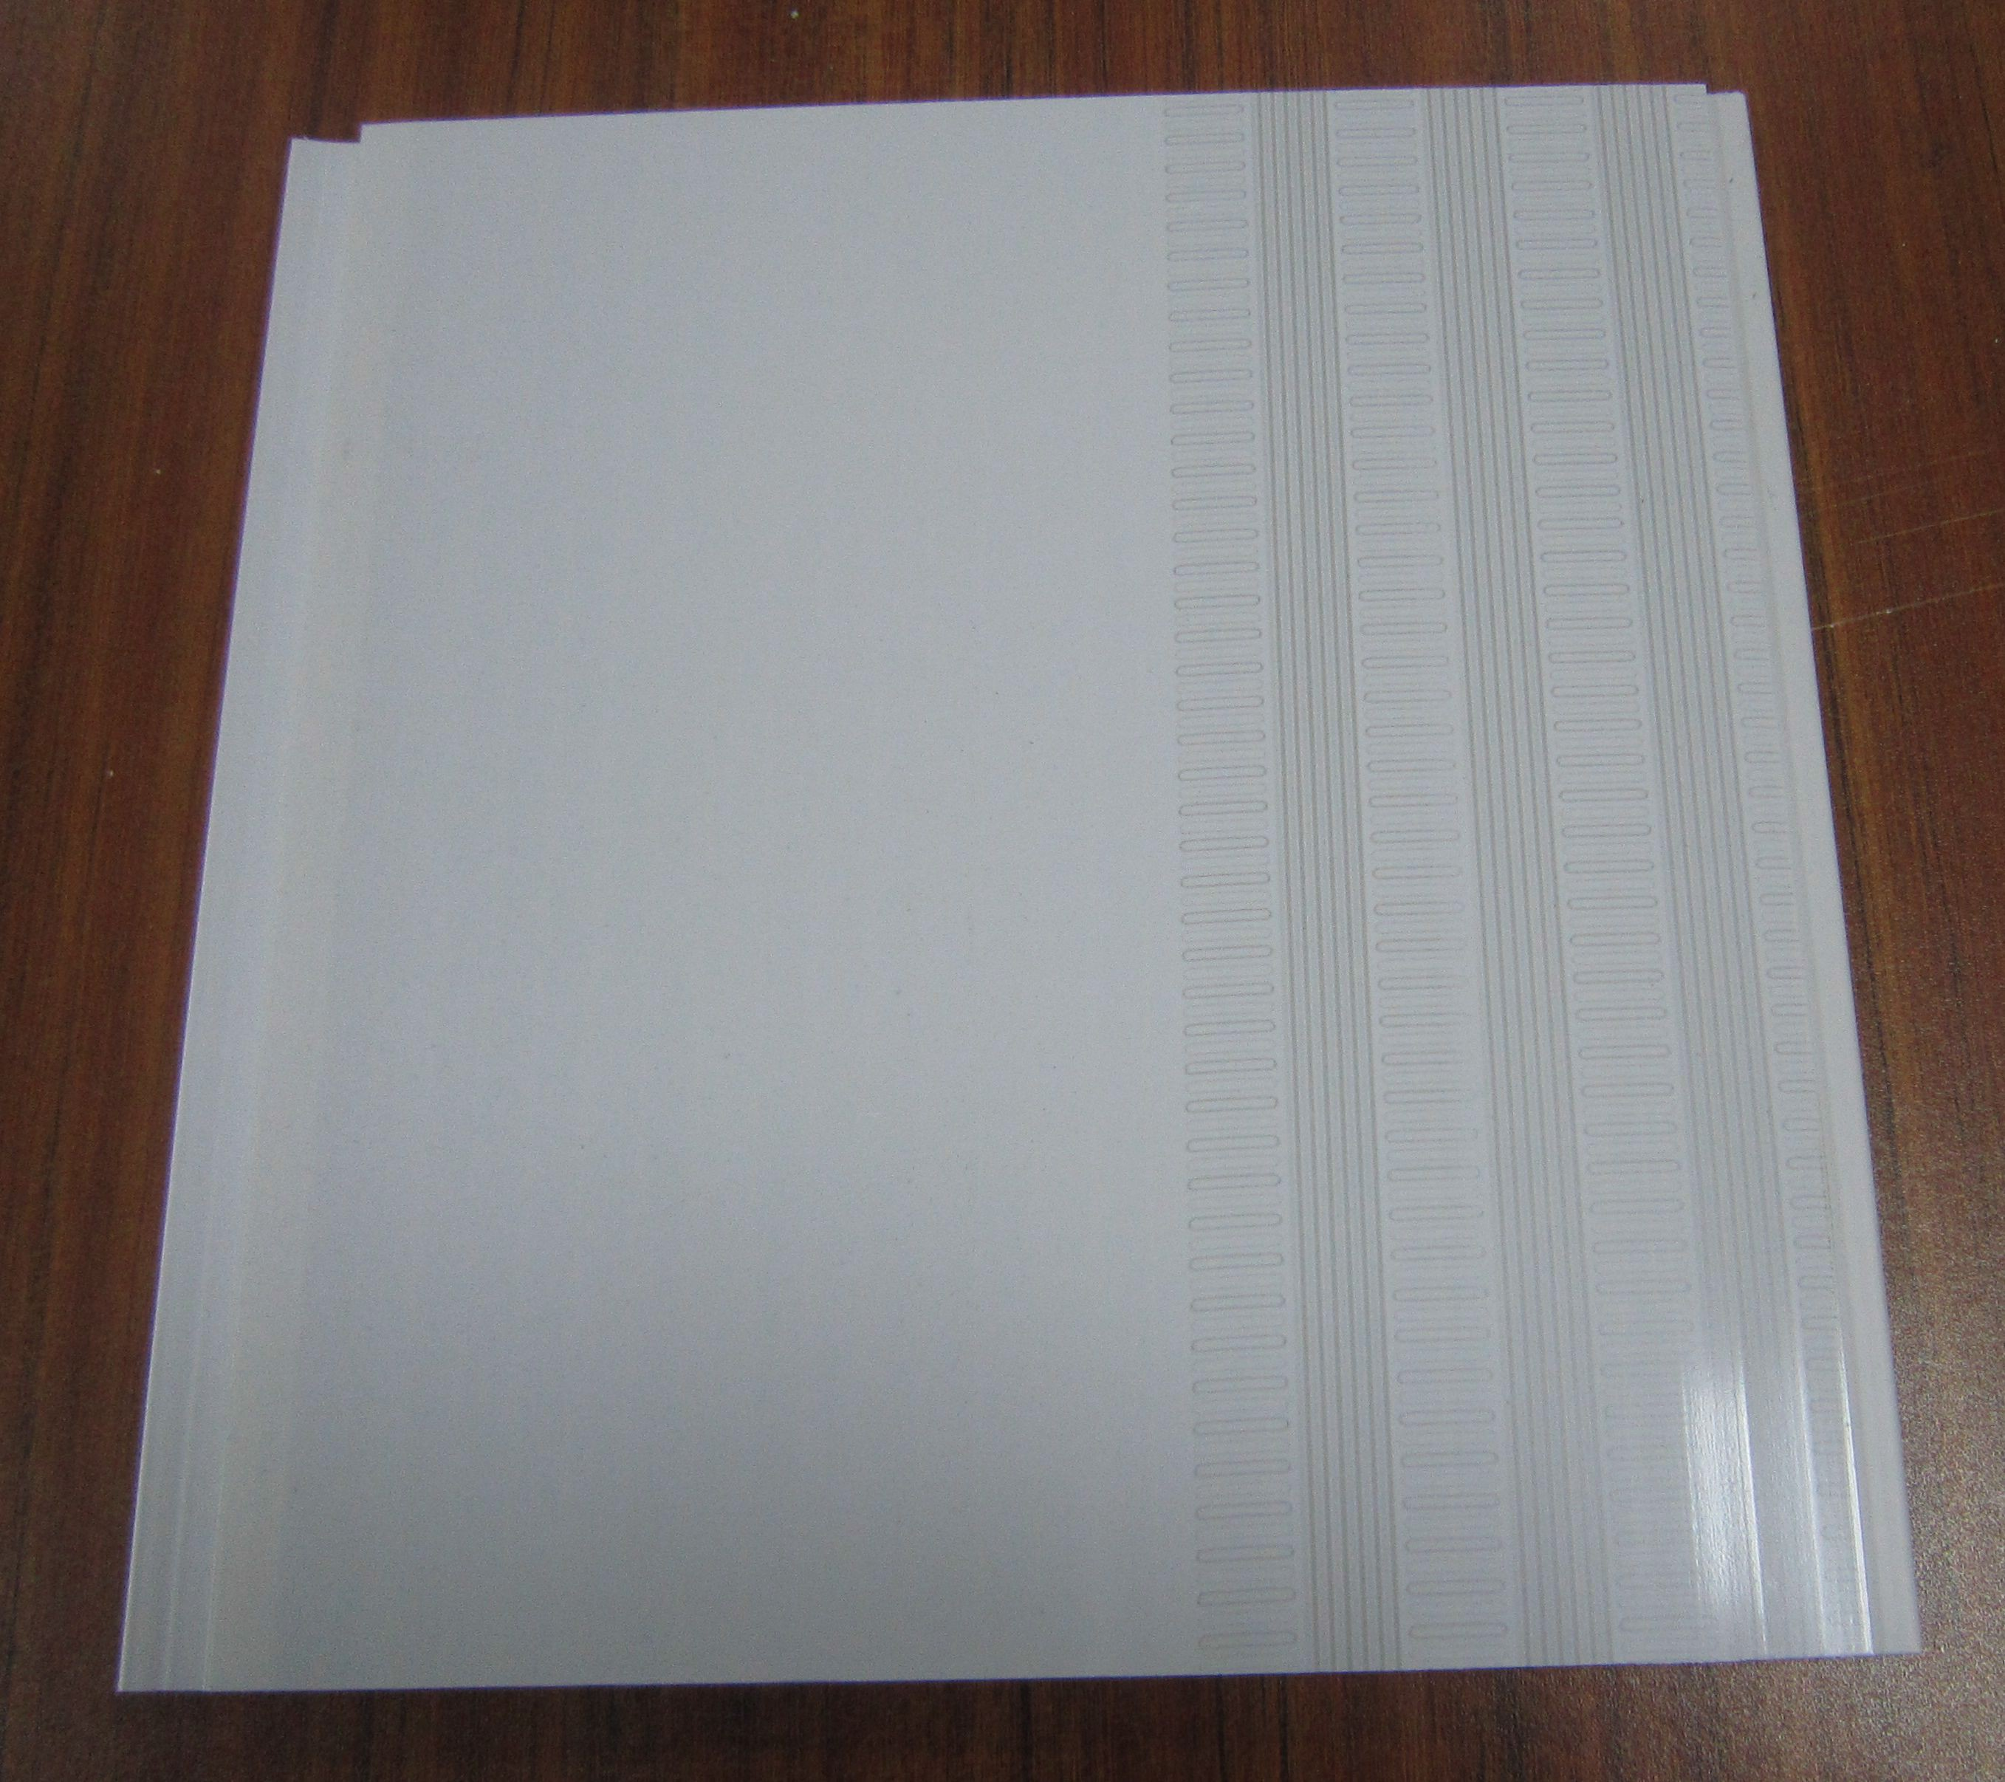
12 | Interior Decoration Wall Panel | Decoration Panel | 10mm 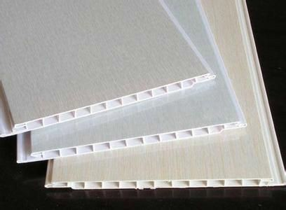
13 | Exterior Decoration Wall Panel | PU decoration board | 3080 *380 *16mm 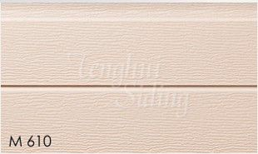
Window & Door

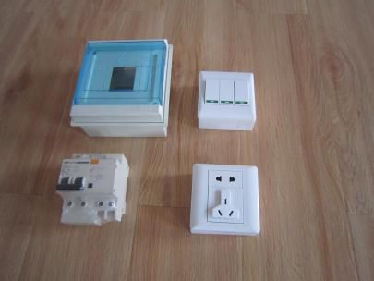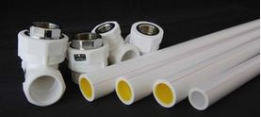
14 | Door | Aluminum Sliding Door |  | 1600*2000mm 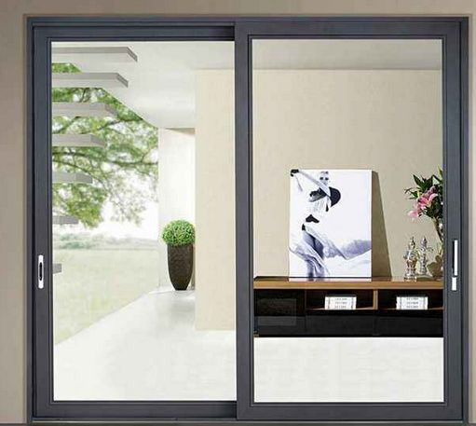
15 | Window | Aluminum Sliding Window |  | 1000*1200mm 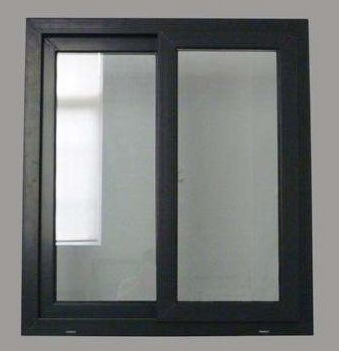
16 | Toilet Window | PVC Louver |  | 800*600mm 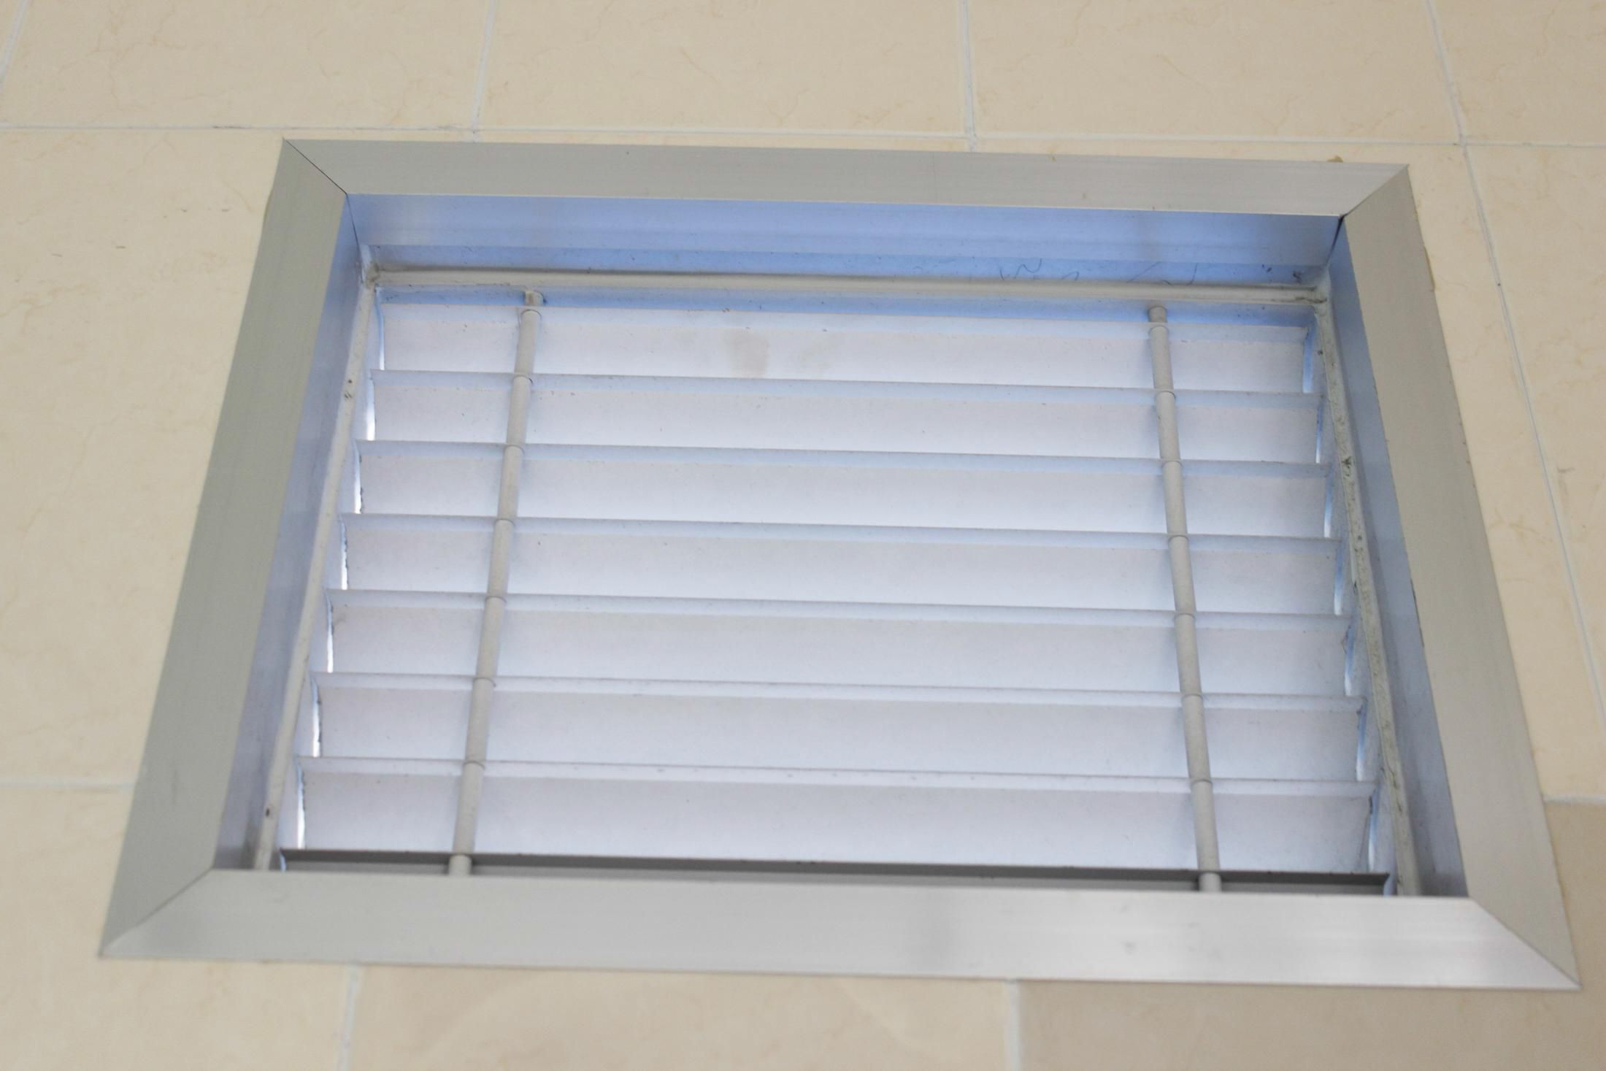
Accessories
17 | Electric  &water system | pipe,tap, wire,switch, socket, lamp
18 | Accessories | screw,rivet,bolt and sealant etc |  |  | 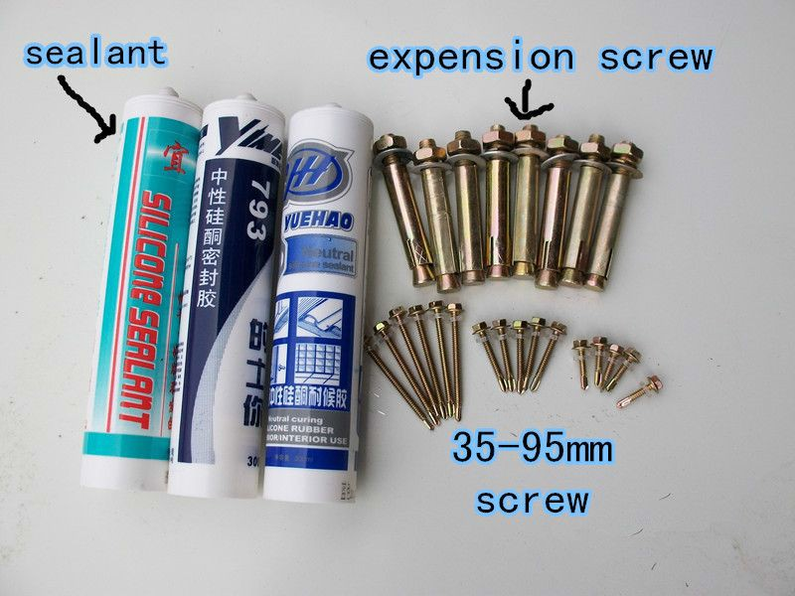
Exported Countries
Asia : Korea，India ,malaysia ,Thailad,Kuwait, Jordan ,Indonesia,Qatar,Oman,Philippines |  |  | Europe: Spain,England
Africa: Cameroon, mozambique, Mauritius, Angola,South Africa,Djibouti,Congo |  |  | South America: Trinidad andTobago,Chile, Brazil,Colombia,Bolivia,Suriname,Uruguay, venezuela
Oceania: Australia ，Kiribati
Technical Parameter
No | Project Name | Value | No | Project Name | Value
1 | Roof load | ≧65kilograms/m2 | 5 | Wall deformation | ≦65kilograms/m2
2 | Flooring load | ≧150kilograms/m2 | 6 | Seismic grade | 7-magnitude
3 | Aisle load | ≧200kilograms/m2 | 7 | Wind loading | ≧100km/h
4 | Wall side stress | ≧80kilograms/m2 | 8 | Fire proof | B1 grade

