ASIAN DRAGON INTERNATIONAL

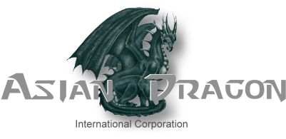
D.E.A.L.S.com Project Phnom Penh Phnom Penh Cambodia
DEALS = Dragon Excess And Liquidation Sales

PHNOM PENHPROJECT

Statement of Purpose
Asian Dragon International (ADI) and a local Phnom Penh Phnom Penh Cambodia JV partner aims to build a highly profitable business dedicated to:

Providing our customers in PHNOM PENH PHNOM PENH CAMBODIA with quality, excess and liquidated consumer goods from USA and other premium western markets at affordable prices.

Reducing global wastage by ensuring a useful life for distressed, excess and liquidation stock from around the world while helping to maintain brand integrity for our suppliers in their key markets.

Managing our business to provide a healthy return to a joint venture partner while operating in a fair and decent manner with our employees, customers and suppliers.

ADI Intl is seeking planning to:
- secure a warehouse facility in PHNOM PENH CAMBODIA ,
- establish appropriate infrastructure and perform necessary improvements to create a retail premises, online store and wholesale operation at the site
- maintain sufficient cash reserves to provide adequate working capital to support the business through an initial start-up period (of 12 months?)

Background
USA is experiencing an increase in the volume of excess and distressed stock due to an unprecedented closure of dozens of major department stores including but not limited to Wall Mart, JC Penny etc,. influx of store returns, warranty claims and an increase in unsold stock through the major retail chains. Similar conditions are being experienced in markets around the world – particularly 1st world/developed markets such as Australia the UK and Europe. Volumes of liquidation stock continue to increase, and with domestic and global retail spending weak, this is forecast to continue.

Suppliers who find their stock back in the supply chain are looking to find new markets. Some stock can be moved in the domestic market, much of it through auction houses and online stores such as Grays,Ebay etc . However, to maintain brand equity and premium product pricing they are seeking to move the majority of stock off-shore in order to minimise commercial impact. This trend is evident throughout premium markets around the world.

This document outlines the proposal to establish a warehousing facility, retail store, online store and wholesaling operation in Phnom Penh.
Phnom Penh is a unique site for the business, providing proximity to a significant shipping port and airport with reasonable duties payable on imports and exports of this kind. The Phnom Penh warehouse facility would be used as a base to import, refurbish, repackage (where necessary) and sell stock to a variety of buyers including wholesalers, retailers and distributors as well as end consumers . Distribution channels include the warehouse retail store, telesales and online.

Asian Dragon International can provide the venture partners an endless supply of unbelievably discounted stock lots and distressed stock from warehouses around the world, prices are substantially discounted (80+%) from wholesale, packed and shipped at economical rates to the Phnom Penh facility for immediate sale, repair or refurbishment and/or rebranding and repackaging. In addition, all stock can be sourced through the Asian Dragon network we are direct to the biggest and best tested suppliers
warehousing like this is ideal depending on location
Warehouse for Rent
Size: 13x25m
Price: $ 950 / month
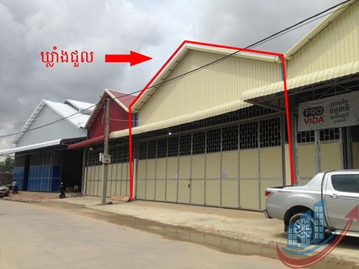

Business Goals
- Expand operations to include a workshop and technicians to make improvements to stock items that require repair, replacement parts, repackaging or rebranding.
- Expand sales channels to include an online store
- Stock turnover target of X (60?) days
- Payback initial capital investment of $250,000 by year 2
- Realise sustainable earnings by year 2
- Establish basic operations, including receipt and sale of imported goods at the proposed site one potential site has been located in street 29 and rent warehouse site in Phnom Penh.
- below is deemed a suitable site and available now https://www.khmer24.com/en/homes/shop-on-big-street-for-rent-adid-2460687.html one block from our existing office
- 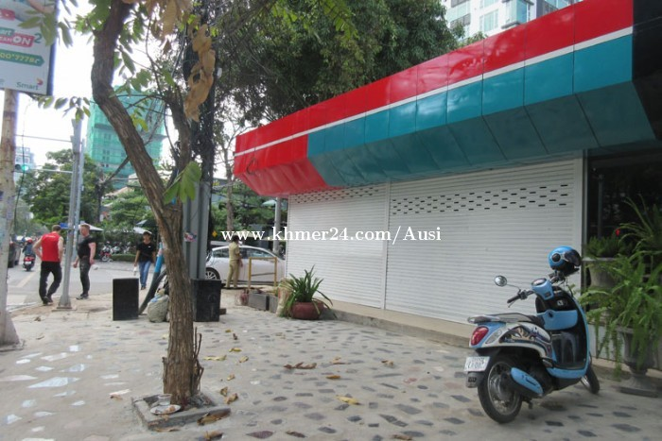

Strengths
- Location at Phnom Penh ,:
- Deep sea port in Sihanoukville.
- Young adult, Family orientated local community with an unsurpassed growing middle class
- No known established competition industry
- US$ is recognised currency
- Access to skilled, low cost, English speaking labour force. Highly trainable workforce
- Industrial peace
- Quality, sophisticated infrastructure
- Geographically the Phnom Penh is home to about 1.5 million of Cambodia's population of over 14.8 million.
- Supply chain: guaranteed supply containers of stock. Access to distressed, excess and liquidation stock from around the world via Asian Dragon
- Production capacity – warehouse with room to grow, good supply of local labour
- Cost advantages – inexpensive warehouse cost
- Experience of key management personnel
- Rob Sullivan – 30 years experience running various businesses in Asia etc. President/CEO of Asian Dragon International specialising in brokering sales of excess and liquidation stock around the world.
- Competitive pricing: Prices will be extremely competitive and could be offered at 50% of retail on many products however many products could be sold at retail given they are simply not available in Cambodia now.
- Desirable consumer product mix – offering consumer goods that are in demand by the market and of high perceived quality and value.

Weaknesses
- Somewhat limited knowledge of the industry in Cambodia, particularly logistics and customs requires a strong local partner with the connectivity to assist on the importation side
- Limited financial resources for purchase of initial stocks (due to investments elsewhere)
- No direct shipping line to Phnom Penh (have to go via another Asian port e.g Kuala Lumpur , Tiawain)
- No existing resources in place – everything is from scratch. E.g. All operating staff to be recruited and trained, warehouse to be fitted out, inventory, sales and software systems implemented. Premises under consideration requires complete renovation.

Opportunities
- Increasing consumer price sensitivity in the ‘middle’ market and a move to seek out bargains
- Leverage ability to compare prices online e.g. brand exposure, package deals, differentiated offers e.g. free delivery, money back guarantee.
- Expanding aspirational middle class demanding more branded consumer goods at competitive prices
- Booming mobile and SMS usage ie, word of mouth allowing cheaper location to be discovered and with payment functionality on phone devices (and growing)
- Online retailing still in a developing stage – scope to offer global ‘best practice’ experience and lead the market
- Increasing confidence to buy online from reputable local sites
- Government focus on increasing tourism – investing in infrastructure and marketing (especially via social media)

Threats
- additional large malls to be built in Phnom Penh City attracting customers
- Possible corruption affecting the supply chain – customs stock shipped
- Weak world economy
- Political change impacting legislation and causing local unrest

Matrix
 | Strengths | Weaknesses
Opportunities | S-O strategies (good opps that play to our strengths) | W-O strategies (overcoming weaknesses to pursue opps)
Threats | S-T strategies (use strengths to reduce vulnerability to threats) | W-T strategies (to prevent weaknesses from making us too vulnerable to threats)

our Proposition

Customer Proposition:
We provide a wide range of qquality, discounted, imported consumer goods for price sensitive shoppers.

Supplier Proposition:
We are a unique and new solution for excess and unwanted consumer goods. Reduce write-offs while maintaining both brand equity and relationships with retailers in a growing premium market.

THE MARKET

PHNOM PENH CAMBODIA
Phnom Penh was relatively unaffected by the 2008 financial crisis. Riding on the back of a robust domestic market, it remains relatively unscathed.
- A £135 million Japanese-built mall is just one of dozens of new projects
- Luxury high-rise condos are popping up with names like 'Diamond Island'
- From glitzy malls and high-rise flats to five-star hotels, a luxury building boom in Phnom Penh is transforming a capital once reduced to a ghost town into one of Asia's fastest growing cities.
- Inside the recently opened Aeon Mall in the heart of Phnom Penh, Cambodia's first mega shopping centre, shoppers and curious residents flock to see the latest Levi's and Giordano handbags, snapping selfies in front of a giant Christmas tree.
- It is a common scene across much of Southeast Asia but was previously unimaginable
a fast-growing middle class and elite are increasingly looking for local ways to spend their cash.

ie
'I am glad we have such a modern mall in Phnom Penh. It shows the city is growing,' says 20-year-old Bopha, a well-heeled university student who said her family made more than £700,000 ($1 million) in a recent land sale. Bopha said she used to have to travel to Thailand and Singapore for her shopping trips but that was now changing. 'Their cities are crowded with high-rise towers. I think we are heading in the same direction to be like them,' she beamed.
The £135 million ($200 million) Japanese-built mall is just one of dozens of new shopping complexes, condominium projects and hotels springing up in Phnom Penh as Cambodia rides a wave of high economic growth rates in recent years.
The capital is second only to Laos in East Asia for the fastest rate of urban spatial expansion, according to the World Bank, and its economy is expected to grow at 6.9 per cent this year.
All across the city luxury high-rise condos are popping up with names like 'The Peak' and 'Diamond Island', complete with billboards promising aspirational taglines such as 'Sophisticated Urban Living'.
According to the government, Cambodia drew construction investment worth £1.15 billion ($1.75 billion) in the first nine months of 2015, a 13.7 per cent rise from a year earlier.
Many of the new entrants into the kingdom's building market are developers from Japan, China, South Korea and Singapore.
The 39-storey Vattanac Capital Tower, Cambodia's first skyscraper which was finished in 2014, is designed in the shape of a dragon and incorporates Chinese traditional feng shui principles.
wealthy Cambodians are lining up for a chance to live in some of the city's most coveted new addresses and with it wanting better quality imported good NOT from China but USA and world known brands.

Following more than two decades of strong economic growth, Cambodia has attained the lower-middle-income status as of 2015, with gross national income (GNI) per capita reaching US$1,070. The garment sector, construction, and services have been the main drivers of the economy. Growth is expected to remain strong in 2016, as recovering internal demand and dynamic garment exports slow growth in agriculture and easing construction and tourism activity.

GDP is relatively high among ASEAN economies in fact 2nd to Laos, higher than that of Indonesia, Thailand, Malaysia, Philippines or Vietnam.

Engines of growth are in place. English is recognized as an official language. Along with relatively good education and low labor costs, Phnom Penh has seen a surge in local business fueling domestic consumption.

Retail channels are not yet that well developed giving our proposal still time to get a foothold in the market with excellent franchising potential.

However, if the external environment further deteriorates, the country’s economic growth will be somewhat compromised. Importers have noted that consumers are being more cautious, while showing exceptional preference for discounted branded products. It appears many consumers will likely adopt a more conservative attitude towards spending and should be attracted to our discounted high end products that have right now almost no competition.

Our customers
Retail
Our retail and online store offering will appeal to a primary market of lower-middle to middle income households (C & mid to upper D). The broad product range will have a strong appeal to parents/families and young adults. The common attitude across all primary targets is the desire for a better deal on ‘western’ goods than what is provided by retail chain stores even in Aeon Mall.

Wholesale customers
will include Aeon Mall and Lucky etc who will be interested to take entire lots of items such as appliances and cooking items etc .

Suppliers
product can be seen on our web site here http://asiandragonintl.com/asp/welcome.asp we often receive direct offers from firms like amazon who recently offered us over $1,300,000 worth of brand new branded items (6 containers) for only $85,000. http://asiandragonintl.com/asp/invent.asp?Action=Item&Ident=68075
http://asiandragonintl.com/asp/invent.asp?Action=Item&Ident=73730
http://asiandragonintl.com/asp/invent.asp?Action=Item&Ident=71012
http://asiandragonintl.com/asp/invent.asp?Action=Item&Ident=66084
http://asiandragonintl.com/asp/invent.asp?Action=Item&Ident=70711

Brand new Italian made complete kitchen with appliances which wholesale in Europe for over Euro 5,000 for just $850.00 each

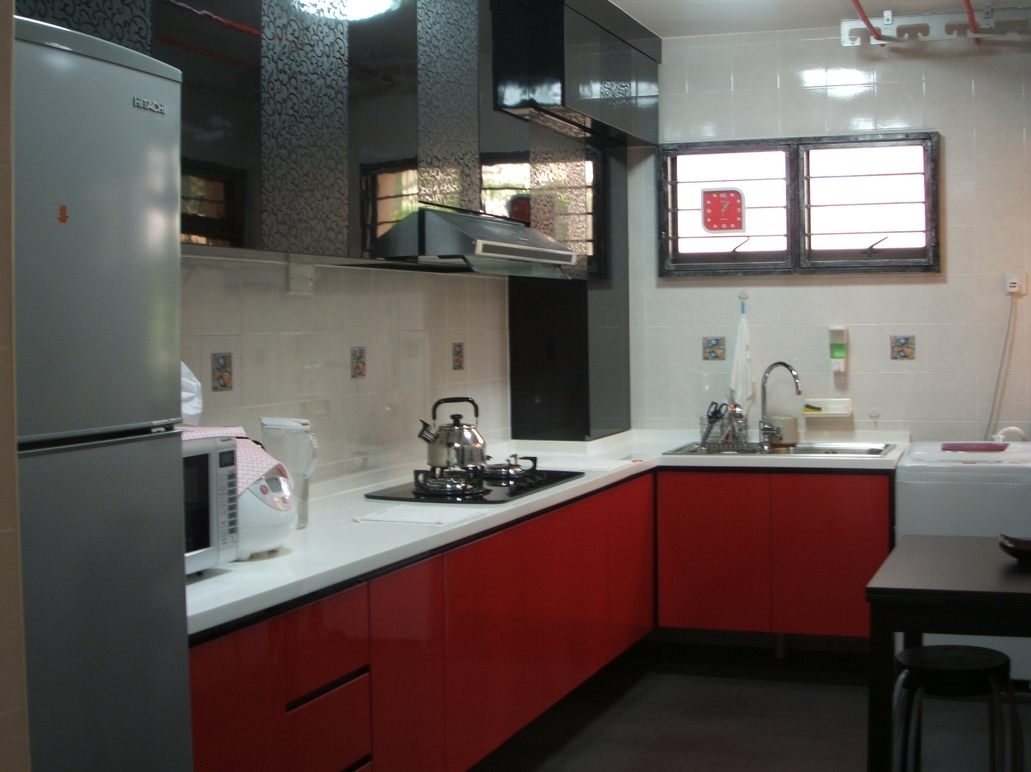

Marketing Strategy

Advertising & Promotion

Branding and Corporate Identity
A logo and corporate identity (colours, fonts etc) will be developed for DEALS for use in all company collateral and communications. To ensure optimal appeal and recognition in consumer markets, we will develop an easily recognisable retail logo developed for use in retail signage, advertising, online etc.

Advertising
Our advertising approach will utilise primarily direct communication including online, email and SMS
FACEBOOK channels. Online advertising on 3rd party sites will drive awareness and online sales. Highly targeted press advertising in key publications and flyer drops

Customers will be invited to receive regular email offers and notifications.

Promotions
Daily/weekly/monthly deals will promote website visits and foot traffic. Phnom Penh and Phnom Penh Airport transport incentives for those who meet a certain spend level.

On-going wholesale customer promotions. Offer subsidised or complimentary accommodation and hospitality for key customers – from places such as Siem Reap joint venture with local hotel.

PR

Social media channels such as Twitter, Facebook and blogs will be used to communicate offers and build brand awareness and engagement. Blogs in particular will be a powerful medium and will require ongoing management and engagement.

Signage
Clear, engaging external and internal signage of warehouse. To be consistent with online brand identity. There is scope to position our business apart from the mainstream while still communicating offering in a way that ‘makes sense’ to the market.

Online and Telesales
Communication to the existing Asian Dragon database of 10,000 wholesale sales contacts will focus on direct telesales and email. Additional channels such as SMS alerts will also be explored.

Product Selection
although some stock from USA is 110 volt the majority is multi volt and a free transformer can be supplied for 110 volt .
we can supply to business items like
- Something Sam Walton once said best explains it:
"The feeling our customers have when they leave our stores determines how soon they’ll be bac The same thing applies to our concept. When we communicate our incredible offers, we want that message to be clear. By creating consistent images and messages that welcome and appeal, customers will come back – again and again we can purchase all these and much , much more for around 20% of WHOLESALE !!!!
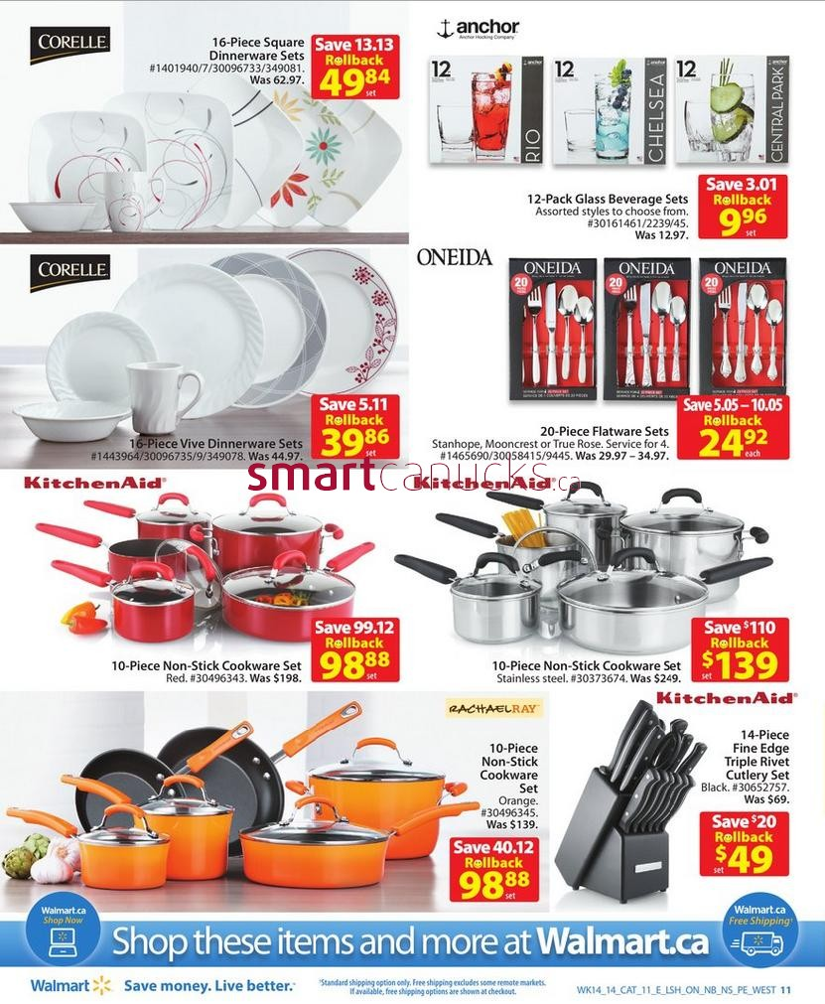

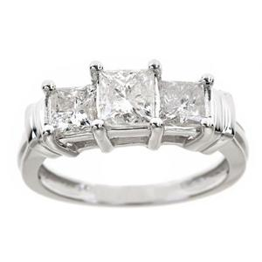Fine Jewelry

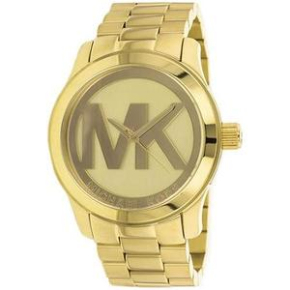Watches

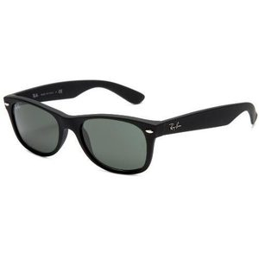Designer Sunglasses

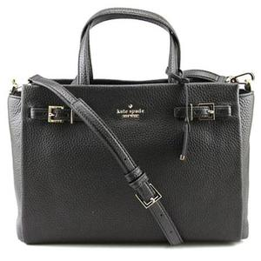Designer Handbags

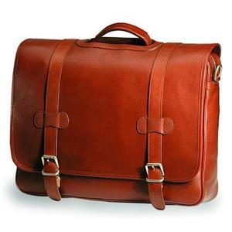Men's Accessories

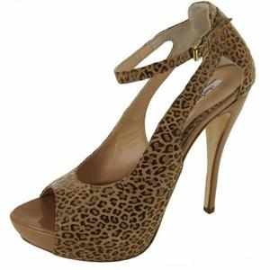Women's Shoes

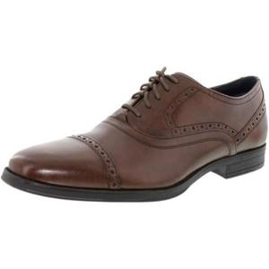Men's Shoes

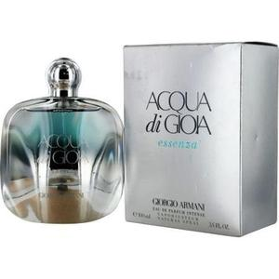Fragrance

Pricing
Our target market is extremely price sensitive. Cambodian’s are among the most aware of grocery prices of any Asian country.

In addition, our supply chain differs from a regular retailer. For these reasons a blanket ‘cost-plus’ pricing methodology is inappropriate. In most instances the recommended retail price will be checked against the general market and a margin applied to our cost price that puts our products in a competitive position while providing maximum gross profit for the business. We will use a range of available resources including local advertising, store visits and online sites to market check our pricing.

The wholesale market demands sharp prices. On large orders prices stated will be negotiable. Negotiating may only be conducted by a senior manager (namely….).

Anticipated margins for inventory is as follows (based on wholesale value in Aust)
- 15% of stock @120% of wholesale
- 15% of stock @100% of wholesale
- 20% of stock @80% of wholesale
- 15% of stock @60% of wholesale
- 15% of stock @40% of wholesale
- 10% spare parts
- 10% shrinkage/charity

Distribution
  - Showroom sales – retail
  - Warehouse sales – wholesale
  - Online

OPERATIONS
- Logistics
- Production Characteristics – Process & Capacity
- Labour
- Suppliers
- Equipment Requirements
- Facility Requirements
- Cost Data

KEY PEOPLE
- Mgt Team and Directors
- Remuneration
- Shareholders
- Consultants

FINANCING PROGRAM
- Reasons for JV Financing
- Timing of Financing
- Equity, Control and Valuation-Pricing

The Numbers

Income streams
- Retail sales (in-store and online)
- Wholesale sales (retailer’s other wholesalers and clearance sites, bulk purchases)

Cash Flows
In:
- Capital injections
- Sales (payment terms?)

Out:
- Outgoings/ Expenses
- Dividends
- Director fees
- Shipping costs
- Rent
- Utilities
- Salaries

Profit & Loss Forecast – Year 1

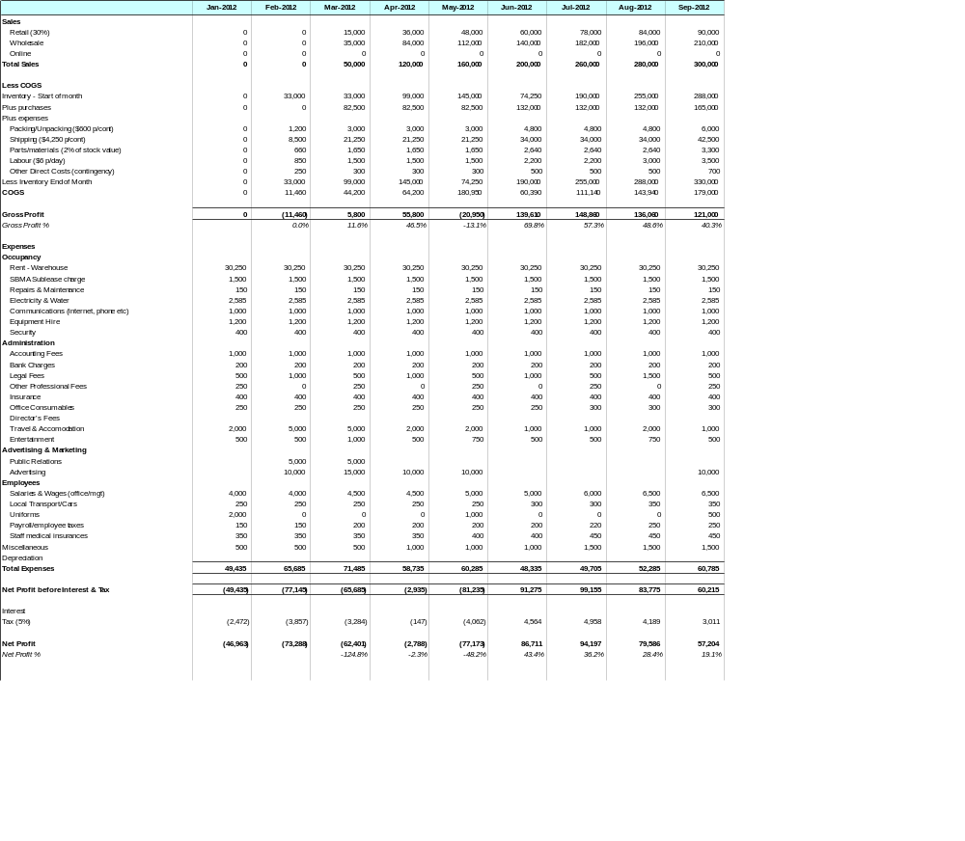

Start Up Requirements

Day 1 (6 mth period)
Administration
Incorporate offshore/HK company |  |  |  |  |  |  |  | 5,000
Incorporate in Phnom Penh |  |  |  |  |  |  |  | 5,000
Min working capital requirement |  |  |  |  |  |  |  | 100,000 |  |  |  | Maintain min balance $20K for
Legal Fees |  |  |  |  |  |  |  | 1,000
Accounting Fees (Aust & HK) |  |  |  |  |  |  |  | 50,000
Insurance |  |  |  |  |  |  |  | 2,000
Warehouse
Warehouse |  |  |  |  |  |  |  | 4,500
showroom lease charge |  |  |  |  |  |  |  | 10,000 |  |  |  | lease cost & deposit
renovation  Utilities |  |  |  |  |  |  |  | 20,000
Communications (phones, Internet computers) |  |  |  |  |  |  |  | 5,000
Essentials (unforseens) |  |  |  |  |  |  |  | 2,000
Offices Furniture/Fitout |  |  |  |  |  |  |  | 5,000
Showroom Furniture/ Fitout |  |  |  |  |  |  |  | 5,000
Software – WMS website |  |  |  |  |  |  |  | 5,000
Software - Office |  |  |  |  |  |  |  | 1,000
Equipment (forklift, delivery truck and pick up) |  |  |  |  |  |  |  | 30,000
Marketing
Signage |  |  |  |  |  |  |  | 2,000
Advertising |  |  |  |  |  |  |  | 5,000
Staff
Uniforms  Medical insurance (keyman) |  |  |  |  |  |  |  | 1,000  2,000
TOTAL ……….. |  |  |  |  |  |  |  | $260,500.00
Other employee admin
Wages - Technicians
Wages - Security
Wages - Management ($2,500/mth)
Management housing – (on site)
Sub Total
Stock ( 6 containers) |  |  |  |  |  |  |  | 80,000
Potential revenue (assumes 80% of stock is sold) |  |  |  |  |  |  |  | 1,024,000
Furniture
Store fittings & fixtures (shelves, displays etc)
Cash registers
Warehouse fittings & fixtures
Workshop fittings & fixtures
Workshop tools and equipment
Office equipment (PCs, fax, printers etc)
Office Software
Warehouse management & sales system (software & hardware)
Vehicles

Appendix 1: Governance

Our Approach to Risk Management
Risk management is about identifying and responding to risks in a way that creates value for a company and its shareholders. For any company that hopes to compete and grow, a long-term strategy needs to involve risk-taking for reward. Ignoring material business risks on the basis of cost restrictions is not justifiable. We should gear ourselves for appropriately managing risk and understand ‘if not, why not’?

Our risk management policy will document the company’s risk management approach, its willingness to accept risk, accountabilities for managing risk, and the resources and processes dedicated to the management of risk and how performance will be measured.

Our company has a high tolerance for risk – demonstrated by:
An eagerness to be innovative and to choose options offering potentially higher business rewards despite some greater risks.
A desire to invest for the best possible reward and accept the possibility of financial loss.
We view new technology as a key enabler of operational and strategic delivery.
We are willing to allocate only essential (and somewhat limited) resources to risk mitigation
We have a tolerance for making decisions that are likely to bring scrutiny and attention of external stakeholders but where potential benefits outweigh the risks.
Our shareholders are capable of tolerating increased risk levels as part of generating additional shareholder value.

We will document a series of operational risks, which we believe to be inherent in the industry in which the company operates. These include:
Fluctuations in exchange rates
Fluctuations in demand and supply volumes
Fluctuations in prices
Political instability/sovereignty risk, particularly in Phnom Penh
The occurrence of force majeure events impacting the supply chain (e.g. natural disaster or Act of God, labour strike, criminal activity)
Increasing costs of operations, including labour costs
Changed operating, market or regulatory environments as a result of climate change (e.g. carbon tax).

Documentation and Contracts
At the outset, our approach will include the following documentation:

Shareholders agreement – Hong Kong
It is proposed a shareholders agreement be established the offshore (Hong Kong) entity. The shareholders’ agreement is intended to ensure that shareholders are treated fairly and that there is agreement on how the company will be managed. The agreement would include provisions such as:
regulating the ownership, buying/selling and voting rights of the shares in the company,
control and management of the company, which may include
the resolution of any future disputes between shareholders
the nature and amount of initial contribution (whether capital contribution or other) to the company
how any future capital contributions are to be made
ethical practices

Employee/Labour contracts and policies

Insurances
- Note: a brief is required and a broker engaged to recommend and quote on insurances.

The company will look at policies for basic insurances such as Public Liability, Theft, Stock in Transit, Natural Disasters etc. But here’s a little bit about less common insurances that may be applicable when we set up operations in Phnom Penh…

Political Risk Insurance
When dealing in overseas trade, secured transactions can be disrupted by embargo, license cancellation or government acts which frustrate completion of a contract. Even when trading activity proceeds smoothly, complications can arise with payment. Currency non-convertibility (although we will deal in US$ wherever possible), exchange restrictions or war can delay or altogether prevent the recovery of funds due. Insurance can be structured to cover losses due to events that occur before, during or after goods and can include key political perils such as:
Confiscation, expropriation and nationalisation
Currency inconvertibility and non-transfer
Political violence
Contract repudiation

Supplier contracts

The general payment terms will include:

Letters of Credit
Letters of credit (LCs) are among the most secure instruments available to international traders. An LC is a commitment by a bank on behalf of the buyer that payment will be made to the exporter provided that the terms and conditions have been met, as verified through the presentation of all required documents. The buyer pays its bank to render this service. An LC also protects the buyer since no payment obligation arises until the goods have been shipped or delivered as promised. The letters of credit can take many forms: irrevocable or revocable, confirmed, or special (transferable, revolving or standby).

Consignment sales
The goods are shipped to a foreign distributor or re-seller who sells them on behalf of the exporter. The exporter retains title to the goods until they are sold, at which point payment is sent to the exporter. The exporter has the greatest risk and least control over the goods with this method. Additionally, receiving payment may take some time. If we feel a stock item may be difficult to shift, we will consider consignment deals with suppliers. It is unlikely we would consider consignment deals with customers.

Insurance is a key consideration for consignment purchases. The contract should clarify who is responsible for property risk insurance that will cover the merchandise until it is sold and payment is passed on to the supplier.

Cash-in-Advance
The supplier/exporter can avoid credit risk, since payment is received prior to the transfer of ownership of the goods however, requiring payment in advance is the least attractive option for us as the buyer as it impacts our cash flow. There are three types of cash-in-advance payment methods: EFT/wire transfer, credit card, and payment by cheque. EFT? Wire transfers and credit cards are the most commonly used options. Any cash in advance stock purchases will be carefully considered before proceeding. Conversely, we may only offer this method of payment for some customers (e.g. that carry higher risk).

Currency fluctuations
One of the risks associated with foreign trade is the uncertainty of the future exchange rates. The relative value between two currencies including AU$ and US$ or Euro could change between the time the deal is concluded and the time payment is received. To manage this risk we will deal in US$ wherever possible – requesting quotes and making payment in US$. We will have US$ bank accounts in Phnom Penh and HK.

Proposed Corporate Structure


Hong Kong entity
Local investor
45%
Asian Dragon
55%
Phinom penh
Trading Company
Funding
IN
Profit
OUT
C
o
n
s
i
d
e
r

H
K

a
c
o
u
n
t
s

f
o
r

e
a
c
h

T
r
u
s
t

t
o

r
e
c
e
i
v
e

d
i
s
t
r
i
b
u
t
i
o
n
s

o
f
f
s
h
o
r
e
Proposed Organisational Structure

The following key elements informed the proposed structure:

Risk Management
It is well known that conditions in Phnom Penh are vastly different from those in Australia and result in greater operating risks for those doing business in the country. Political uncertainty and challenges with ethical standards justifies a structure that provides some disassociation between the local trading company and the individuals behind the business. For this reason, we propose to establish a certified offshore company to trade in Phnom Penh, which is wholly owned by an offshore Hong Kong entity in which investor shares are held. In addition, Hong Kong provides a more stable political environment in which to hold the company.

Long Term Growth
Incorporating the holding company in Hong Kong provides the business with geographic and political proximity to significant growth opportunities with China.

Autonomy
The dynamics of the global market provide opportunities that may not suitable or consistent with our strategic plan for DEALS but are of value to both the investor and Asian Dragon. For this reason, the structure will allow for both companies to trade as entities independent DEALS Cambodia. For example, Asian Dragon has a significant interest in Trident electric cars , solar products etc,. which is not part of the strategic plan for DEALS and will be managed independently although investor would be given first right of refusal to participate and areas of the showroom maybe valuable to market these items if so rent will be paid or profit will be shared.

Capital Raising
The proposal to expand the scope of Asian Dragon’s activities to incorporate Phnom Penh project will require admittance of additional investor/s. Under the proposed structure shares in the Hong Kong entity can be issued and traded as required to facilitate growth and delivery on our strategic plan.

Accounting requirements
accounting standards and company law in Cambodia will be followed

Levels of delegated authority

Endorsement and approval processes

Schedule of meetings
- Annual Board Meeting
- Quarterly shareholder meeting
- Monthly Management Meeting
- Weekly Sales Update

Reporting
- Cashflow
- Sales Reports/ Debtors Reports
- Expense Reports/ Creditors Reports
- Employees (headcount, cost, entitlements etc)
- Purchase Orders
- Others??

The Market

Competition
What does the competition look like?

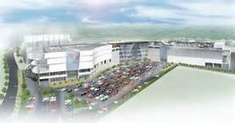

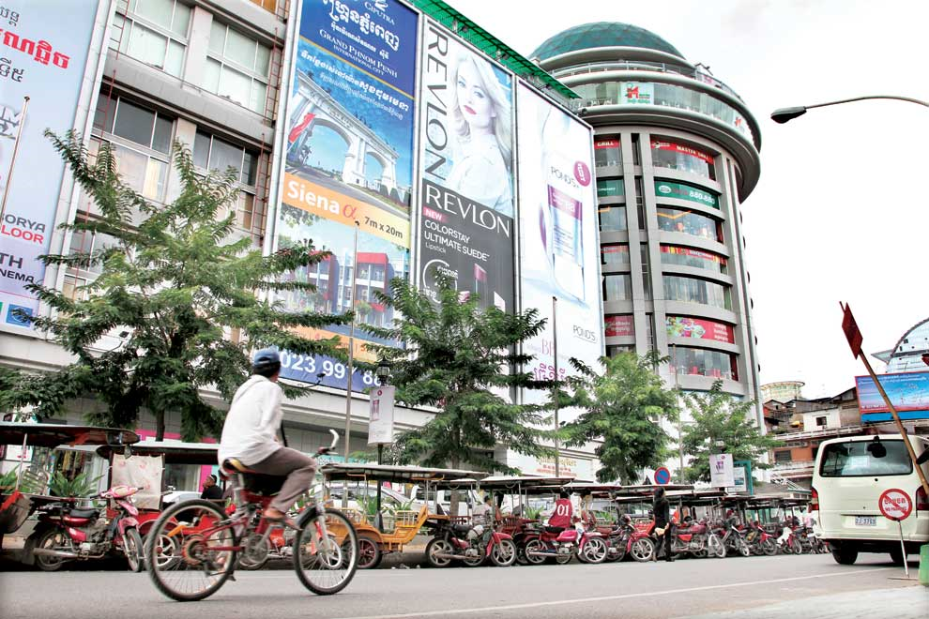

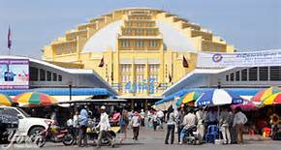

DEALS Outlet.com.

Outlet shops and Malls are springing up all over the world. They specialize in excess stock, so the name Outlet added to DEALS makes sense. The .com is due to my thoughts laid out below.

DEALS is a terrific marketing name and retains the mother company name
we feel the best way to encourage the investor who is needed to put up $250,000, is to form this new company offshore in HK and register it here in Phnom Penh.
we would offer the investor 45% of the company ownership.
However, the investor would enjoy 60% of the profits until his investment is returned in full.
once this is achieved which is estimated to be easily done within the first years trading he would drop down to 45% of profits

Following are my thoughts for the start up to work hand in hand with the showroom which have come to me from much research, study and discussions, this needs to be expanded on but our web master (Richard) who can do the web site work, travel to Cambodia to do training on site for as long as it takes and create phone apps. This will cost around $20,00-. Plus approx $10,000 to set up the call center
In my opinion this needs to be done and included in the budget from the investment.
The more the Internet, yahoo and Google develop the more effect this will have on trading companies like us.
We are fortunate in that we are well established and Cambodia is behind the times with on line shopping. However, this is changing rapidly and the few on line shops now starting to spring up are doing exceptionally well.
Still, the market is massive, and there is certainly still room to grab the ‘lions share’ of this market . There is no point in reinventing the wheel either the guidelines to success are there in other successful online stores in other countries. DEALS Cambodia must have a “homely” boutique and professional look and feel to it but must also have a very professional on line marketplace /store.

