Model | Picture | Basic Configuration | Function | Price (FOB:Qing dao)
DION ADISRDL-M3 | 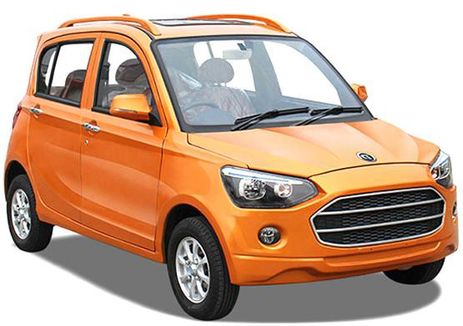 | Size:3400*1550*1560mm Motor:3500W/4000W  Capacity:1 driver + 3 passengers  Wheelbase:2185mm  Wheel-track:1360mm/1350mm Ground clearance:150mm  Kerb Weight:830kg  Brake system:front disc, rear drum Tyre:155/70R12  Battery:72V 100AH/72V 120AH  Mileage:80-150km Charging time:8-12h Max speed:55km/h Color:Optional | Brake booster:YES Control door lock:YES Remote key:YES  LED reading lamp:YES Aluminum alloy wheels:YES Rear View Camera:YES  12V power supply interface:YES Cell phone charging interface:YES Speaker:2  Dipped headlight/High beam:YES  Daytime Running Light:YES Power windows:YES | US $6,200
DION ADISRDL-M2 | 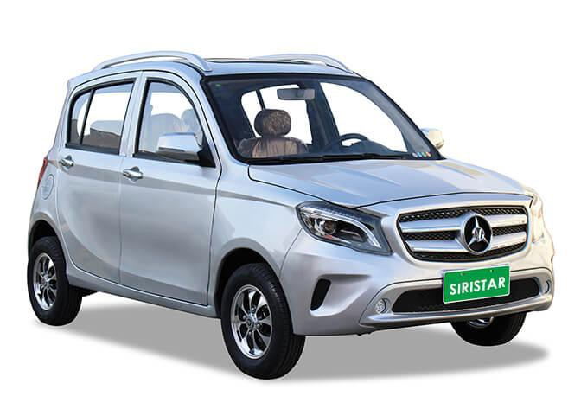 | Certificate:CCC/ISO9001 etc Size:3400*1550*1560mm Motor:3500W/4000W  Capacity:1 driver + 3 passengers Wheelbase:2185mm  Wheel-track:1360mm/1350mm  Ground clearance:150mm Weight:830kg  Brake system:front disc, rear drum  Tyre:155/70R12  Battery:72V 100AH/72V 120AH  Mileage:80-150km Charging time:8-12h Max speed:55km/h Color:Optional | Brake booster:YES Control door lock:YES Remote key:YES  LED reading lamp:YES  Aluminum alloy wheels:YES Rear View Camera:YES  12V power supply interface:YES  Cell phone charging interface:YES Speaker:2  Dipped headlight/High beam:YES Daytime Running Light:YES Power windows:YES | US $6,200
Payment Terms: 1.T/T: 50% deposit in advance, 50% before shipment.
2.L/C: irrevocable LC at sight. Trade Assurance Order Alibaba Online 3.Delivery Time: 25 working days after receiving the 50% down payment. 4.Quotation validity: Within 30 days.
5.After-service: 1%-2% easily damage parts be sent out as order quantity.

