Integrated Solar Garden Light-June-2018
Item No. | Picture | LED Chips | Power | Solar Panel | Lithium Battery | PackageSize | Control Method |  | Unit Price (QTY>100) | Unit Price (QTY>500)
AN-ISGL08-12W | 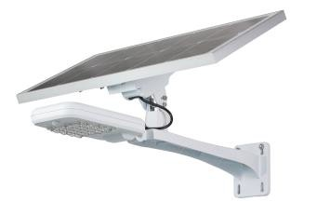 | Bridgelux | 12W | 25W | 7.4V8AH | 665*285*465mm | Light+Motion Sensor Control |  | $89.21 | $87.14
AN-ISGL08-20W |  | Bridgelux | 20W | 30W | 7.4V14AH | 735*285*465mm | Light+Motion Sensor Control |  | $118.89 | $115.08
AN-ISGL08-30W |  | Bridgelux | 30W | 40W | 7.4V24AH | 735*285*465mm | Light+Motion Sensor Control |  | $148.73 | $140.63
AN-ISGL08  Solar light+monitor system | 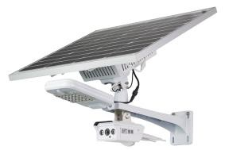 | Bridgelux | 20W+8W | 60W | 12V30AH | 745*305*660mm | Wifi / Network cable |  | $287.62 | $283.81
AN-ISGL08  Solar light+monitor system |  | Bridgelux | 20W+8W | 60W | 12V30AH | 745*305*660mm | Wifi / Network cable  / 4G |  | $327.30 | $323.33
Terms and Quotation:

- Above prices are based on EXW.

- MOQ: 100pcs.

- Warranty: 2 years.

- Delivery time: For 500pcs, goods can be finished within 15 days upon down payment receiving.

- This price keeps valid for one month.

