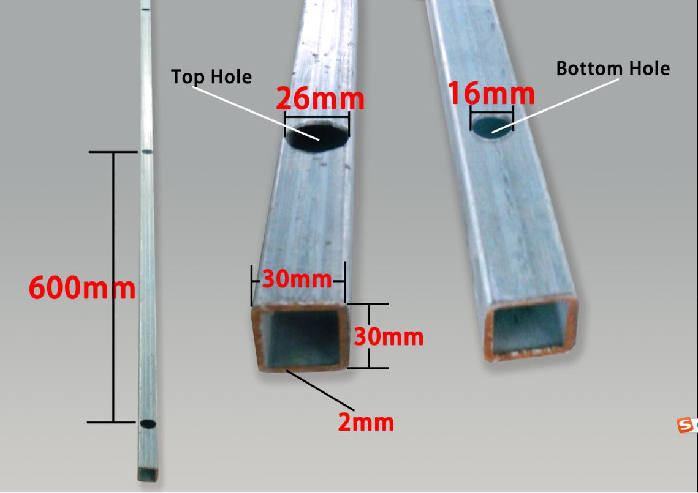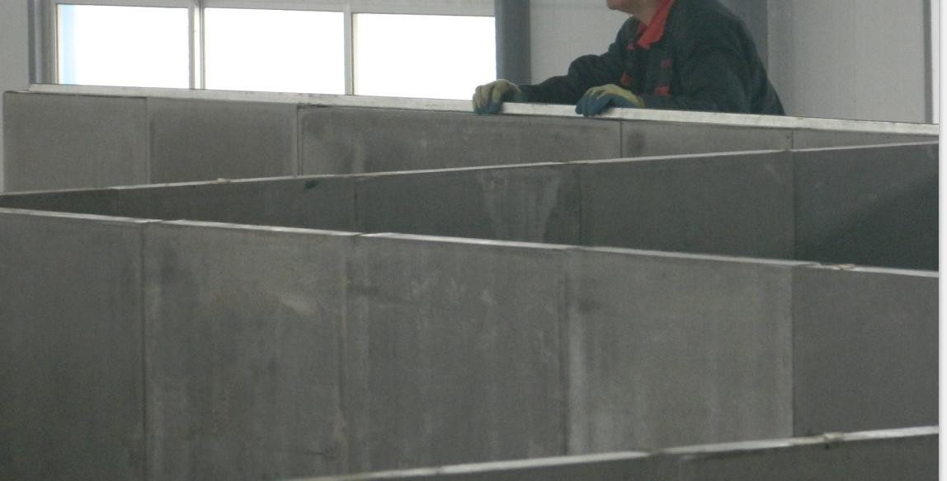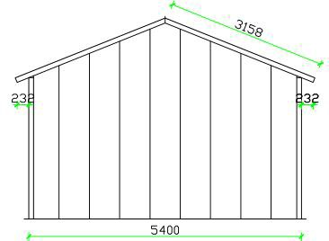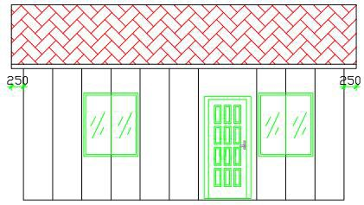
Quotation for 36m2 Foam Cement House
PRICE DETAIL
NO. | PART | DESCRIPTION |  | QUANTITY |  | UNIT
Cement House Main Body
1 | Mainbody | Cement House Main Body |  | 36 |  | M2
Doors and Windows
2 | Doors | Steel Security Door for Entrance（D1） |  | 1 |  | SET
 |  | Composite Wood Door for Bedroom(D2) |  | 3 |  | SET
 | Windows | Aluminum Sliding Window W1 |  | 4 |  | PCS
 |  | Aluminum Sliding Window W2 |  | 1 |  | PCS
 | Total Doors and Windows Price
Decoration Materials
3 | Floor Decoration | Cermic Tile |  | 96 |  | PCS
 | Total Decoration Price
DESCRIPTION |  |  | QUANTITY |  | UNIT
4 | 40'HQ Qingdao Port Inland Shipping and Port Charges |  |  | 2 |  | Container
 | Total Inland Shipping and Port Charges
 | House Design Draw
5 | 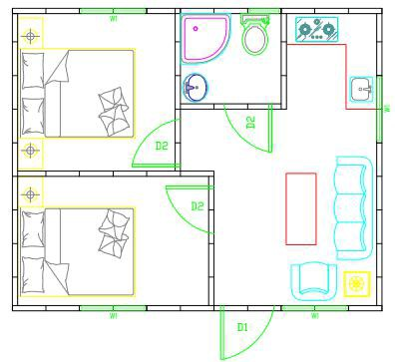
6 | Payment Terms | 100% T/T before loading
7 | Validity of Quotation | 15 days
8 | Shipping | By Sea, the Loading Port, Qingdao, China
9 | Packing | 1*40'HQGP containers can load 2 unit of this house with all above
10 | Size | SPEC: 6.6m*5.4m*2.8m
Materials List
No. | PART | First Part (Main Part of House) |  | Material |  | Specification |  | Quantity |  | Unit | Picture
1 | Mainbody Panel | 94mm External Wall Panel |  | Foamed Cement Panel |  | 8mm Fiber Cement Board on two surface; 78mm thickness Foam Cement Core; Build-in Steel Structure |  | 73.1 |  | M2 | 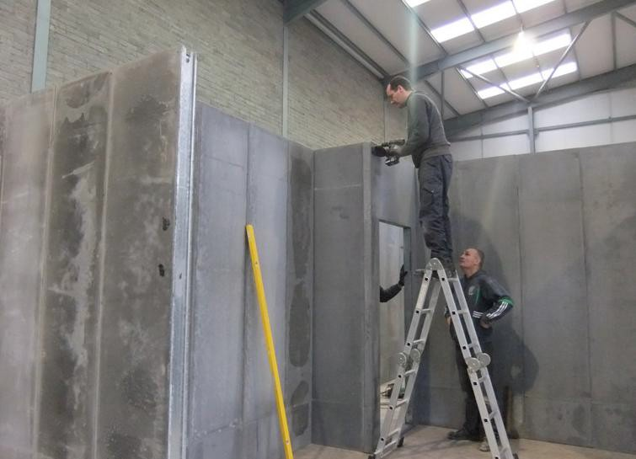
2 |  | 94mm Internal Wall Panel |  |  |  |  |  | 35.3 |  | M2
3 |  | 94mm Roof Panel |  |  |  |  |  | 44.9 |  | M2
4 | Structure to Fix Pane | Square Tube(Using for Basement,Use Expansion Bolt to fix it,then Wall Panel sit on the Square Tube) |  | Square Tube |  | 30mm*30mm*2mm |  | 36.6 |  | M
5 |  | Square Tube (Using for Ring Beam to strength the Whole Steel Structure) |  | Square Tube |  | 30mm*30mm*2mm |  | 25.8 |  | M

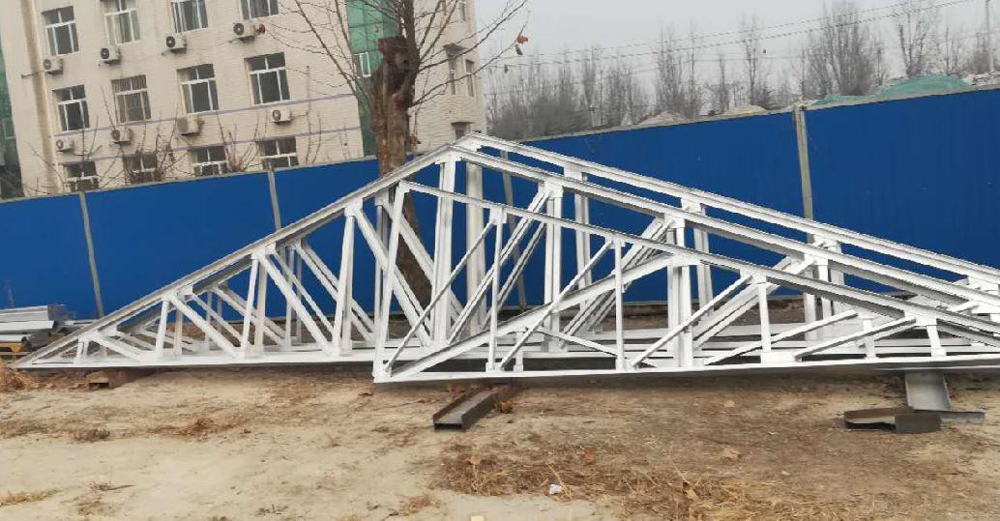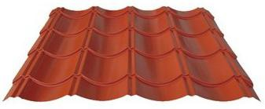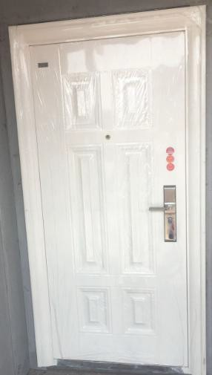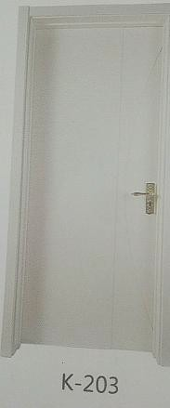
6 | Panel Gap Painting | Plaster for External Wall | White | 11.5m2 Use One Bag | 10 | BAG | 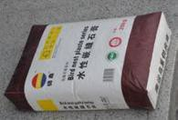
7 |  | Plaster for Internal Wall |  |  | 12 | BAG
8 |  | Sealing Tape for Gap Fixing | White | Standard | 23 | PCS | 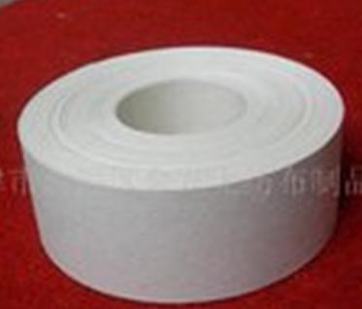
9 |  | Undercoat | Standard | Standard | 27 | KG
10 | `Beam | A-Beam | Hot Galvanized Steel 5400m(Length) | L50*50*3 | 2 | PCS
11 | Roof | Glazed tile | Galvanize Steel | 828mm*0.5mm | 57.6 | M
12 |  | Ridge tile |  | 0.5mm | 7.5 | M | 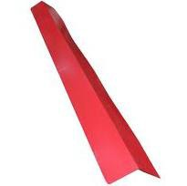
NO. | PART | Second Part (Doors and Windows) | Material | Specification | Quantity | Unit | Picture
1 | Doors | Steel Security Door for Entrance | Steel | 960mm*2050mm (W*L) | 1 | SET
2 |  | Composite Wood Door for Bedroom | Wood | 860mm*2050mm (W*L) | 2 | SET
3 |  | Aluminum Alloy Door | Aluminum Alloy | 750mm*2050mm (W*L) | 1 | SET | 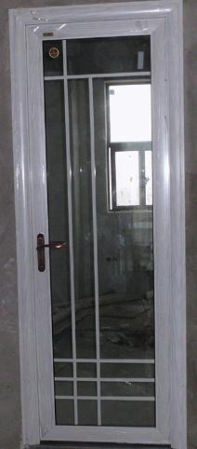
4 | Windows | Aluminum Sliding Window(white and single glass) | Aluminum Alloy | 1140mm*1300mm (L*W) | 6 | PCS | 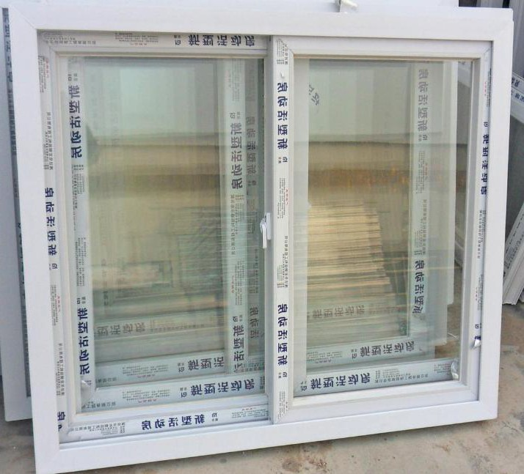
6 |  |  |  | 1140mm*900mm (L*W) | 1 | PCS
7 |  |  |  | 540mm*900mm (L*W) | 1 | PCS
NO. | PART | Third Part (Decoration Materials) | Material | Specification | Quantity | Unit | Picture
1 | Floor Decoration | Ceramic Tiles for Internal Floor | Ceramic Tile | 600mm*600mm*10 mm  (L*W*T) | 96 | PCS | 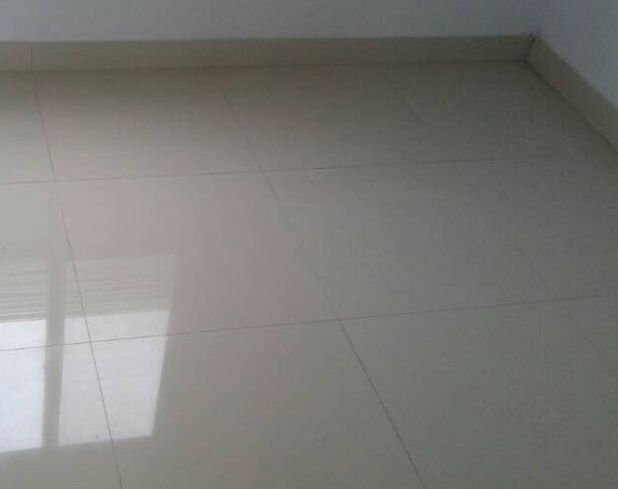
Note: This offer for current materials market; The Price is not including installation expenses
2018-6-19

