ПАЭС-2500

Моbile automatic electricity producing station

“PAES – 2500”
For giving electricity to industrial plants and the population. For covering the lack of electricity at the pick consumption periods and as spare electric station in case of necessity .  This is an ideal mobile electric station with automatic start, system of defense against overloading, with detailed signalization , noise reduction systems ,etc.  The special gaz-turbine engine can work with gaz or liquid fuels and their mixtures, and also can pass funder the command otf the operator from one to another fuel without stopping the station or diminishing the load. | 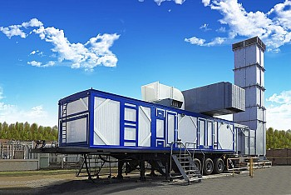

Main Advantages :
- – High reliability
- – Stable work in autonomic regime or in parallel with the main energy set of the country
- - Easy servicing and repair works
- - Easy command
- - Does not need big capital and expenses to be erected and started to work
- – Easy changing of place , because it is fuilly mobile

Technical characteristics::
Power, kW ( KVA) :
Nominal | 2500 ( 3125 )
Maximum | 2750 ( 3440)
Kind of electricity | Alternating current
Voltage,Volt | 6300/10500/13800
Frequency, Hz | 50/60
Fuel | Liquid or gaz
Dimensions ( without the exaust system ) upon the chassi , meters | 12,62х2,62х3,79
Weight ( without the exaust system) , kg | 30900

Engine of the Mobile electricity generating

station - “PAES -2500 “

AИ-20 ДМЭ/ДКЭ/ДМН/ДКН/ДМЭЧ/ДМНЧ
This engine is used as engine in the electric generator station with power 2500 kW ( 3125 KVA) | 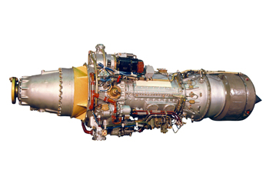

Main advantages :
- – high efficiency
- – high safety
- – low maintainance costs

Technical characteristics :
Model | АИ-20 ДМЭ/ДКЭ | АИ-20 ДМЭЧ | АИ-20 ДМН/ДКН | АИ-20 ДМНЧ
Nominal power ( kW) | 2500
Number ot tours of the main shaft (minute) | 1000 | 1200 | 1000 | 1200
Used fuel | Natural gaz or gaz from the petroleum sources |  | Kerocene or fue oil
Fuel consumption , maximum per hour | 836 |  | 995
Dimensions , мм | 3500x890x1180
Own weight ,kg | 1200

