All-In-One Solar LED Street Light 2018
Model No. | Photos | Description | Packing Information | EXW Price  (3 Years Warranty) Lifepo4 Battery
AL-220 | 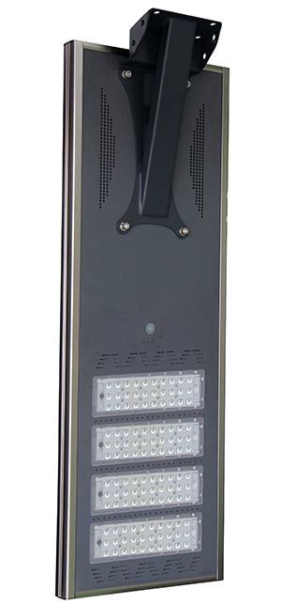  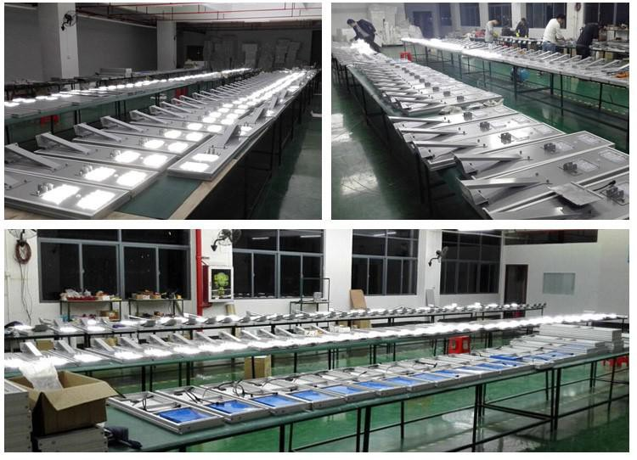  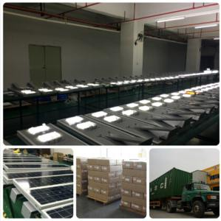  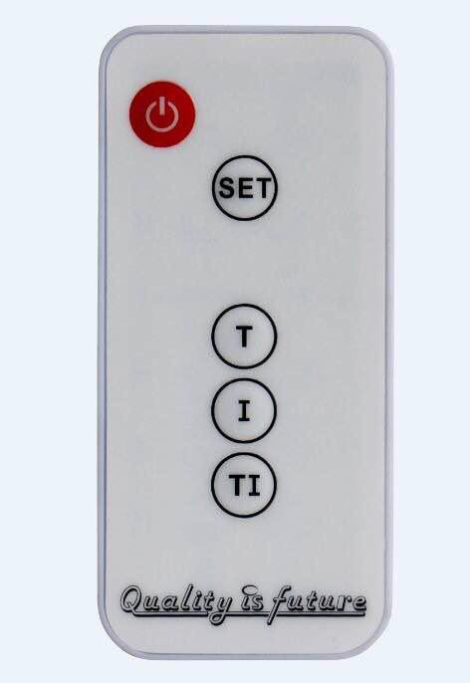 | - Material: Aluminum alloy  - Solar Panel:18V25W (high efficiency monocrystalline silicon)  LED Brand: 20W High Brightness Bridgelux LED  - Output Lumen: 2000-2200lm  Batterylithium battery 12V/10AH (Lifepo4 Lithium)  - Mounting Height: 3-4m  - Work time: 12 hours and 5-7 rain days  - Work temperature: -25℃~+65℃  Protection Grade: IP65  - Certificates: CE/ROHS/TUV | Packing Size: 600*415*135mm Net Weight: 5.5KG  Gross Weight: 6.5KG Carton Packing: 1 set / ctn Container Loading:  20GP: 800 pcs  40GP: 1660 pcs | US$190.00
AL-230 |  | - Material:Aluminum alloy  - Solar Panel:18V30W (high efficiency monocrystalline silicon)  - LED Brand: 30W High Brightness Bridgelux LED  Output Lumen: 3000-3300lm  - Batterylithium battery 12V/12AH (Lifepo4 Lithium)  - Mounting Height: 5-6m  - Work time: 12 hours and 5-7 rain days  Work temperature:-25℃~+65℃  - Protection Grade: IP65  - Certificates: CE/ROHS/TUV | Packing Size: 660*415*135mm Net Weight: 6.0KG  Gross Weight: 7.0KG  Carton Packing: 1 set / ctn Container Loading:  20GP: 730 pcs  40GP:1510 pcs | US$240.00
AL-240 |  | - Material:Aluminum alloy  - Solar Panel:18V36W (high efficiency monocrystalline silicon)  - LED Brand: 40W High Brightness Bridgelux LED  Output Lumen: 4000-4400lm  - Batterylithium battery 12V/15AH (Lifepo4 Lithium)  Mounting Height: 6-7m  - Work time: 12 hours and 5-7 rain days  Work temperature:-25℃~+65℃  - Protection Grade: IP65  - Certificates: CE/ROHS/TUV | Packing Size: 750*415*220mm Net Weight: 9.8KG  Gross Weight:11.0KG  Carton Packing: 1 set / ctn Container Loading:  20GP: 395 pcs  40GP: 825 pcs | US$278.00
AL-250 |  | Material:Aluminum alloy  - Solar Panel:18V40W (high efficiency monocrystalline silicon)  LED Brand: 50W High Brightness Bridgelux LED  - Output Lumen: 5000-5500lm  - Batterylithium battery 12/18AH (Lifepo4 Lithium)  Mounting Height: 6-7m  - Work time: 12 hours and 5-7 rain days  - Work temperature: -25℃~+65℃  Protection Grade: IP65  - Certificates: CE/ROHS/TUV | Packing Size: 880*415*230mm  Net Weight: 11.0KG  Gross Weight: 12.0KG Carton Packing: 1 set / ctn Container Loading:  20GP: 320 pcs  40GP: 666 pcs | US$332.00
AL-260 |  | Material:Aluminum alloy  - Solar Panel:18V45W (high efficiency monocrystalline silicon)  - LED Brand: 60W High Brightness Bridgelux LED  Output Lumen: 6000-6600lm  - Batterylithium battery 12V/21AH (Lifepo4 Lithium)  - Mounting Height: 7-8m  Work time: 12 hours and 5-7 rain days  - Work temperature: -25℃~+65℃  - Protection Grade: IP65  - Certificates: CE/ROHS/TUV | Packing Size: 880*415*230mm  Net Weight: 11.5KG Gross Weight: 12.5KG  Carton Packing: 1 set / ctn  Container Loading: 20GP: 320 pcs  40GP: 666 pcs | US$360.00
AL-270 |  | Material:Aluminum alloy  - Solar Panel:18V55W (high efficiency monocrystalline silicon)  LED Brand: 70W High Brightness Bridgelux LED  - Output Lumen: 7000-7700lm  - Batterylithium battery 12V/24AH (Lifepo4 Lithium)  Mounting Height: 8-9m  - Work time: 12 hours and 5-7 rain days  Work temperature:-25℃~+65℃  - Protection Grade: IP65  - Certificates: CE/ROHS/TUV | Packing Size: 1100*415*230mm  Net Weight: 12.5KG  Gross Weight: 15.0KG Carton Packing: 1 set / ctn Container Loading:  20GP: 270 pcs  40GP: 560 pcs | US$395.00
AL-280 |  | Material:Aluminum alloy  - Solar Panel:18V60W (high efficiency monocrystalline silicon)  LED Brand: 80W High Brightness Bridgelux LED  - Output Lumen: 8000-8800lm  Batterylithium battery 12V/27AH (Lifepo4 Lithium)  - Mounting Height: 8-9m  - Work time: 12 hours and 5-7 rain days  Work temperature:-25℃~+65℃  - Protection Grade: IP65  - Certificates: CE/ROHS/TUV | Packing Size: 1100*415*230mm  Net Weight: 13.0KG  Gross Weight: 15.5KG Carton Packing: 1 set / ctn Container Loading:  20GP: 270 pcs  40GP: 560 pcs | US$420.00

RRMARK:

1: Above prices are based on EXW. Valid date to 31st Aug 2018. 2: 1~2 days for samples, 5~7 days for standard orders add 100% plus courier fee.
3: The solar controller and battery are built inside of light head.
4 : The controller needs extra 5.0USD, 10pcs of solar led street light need 1pc controller 5: Lighting mode can be changed by remote controller.

