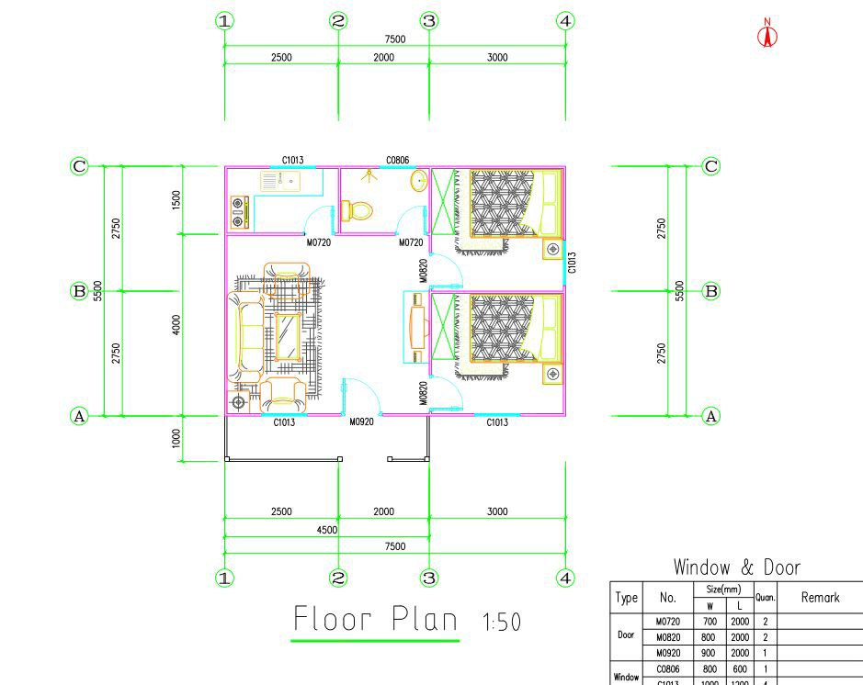
QUOTATION
E-mail |  | sales@asiandragonintl.com
 |  |  |  | Quotation date  (valid time: 15 days) |  | 2018.7.25
Project :Prefab House
(HS code:9406900090 ;Picture just for reference )
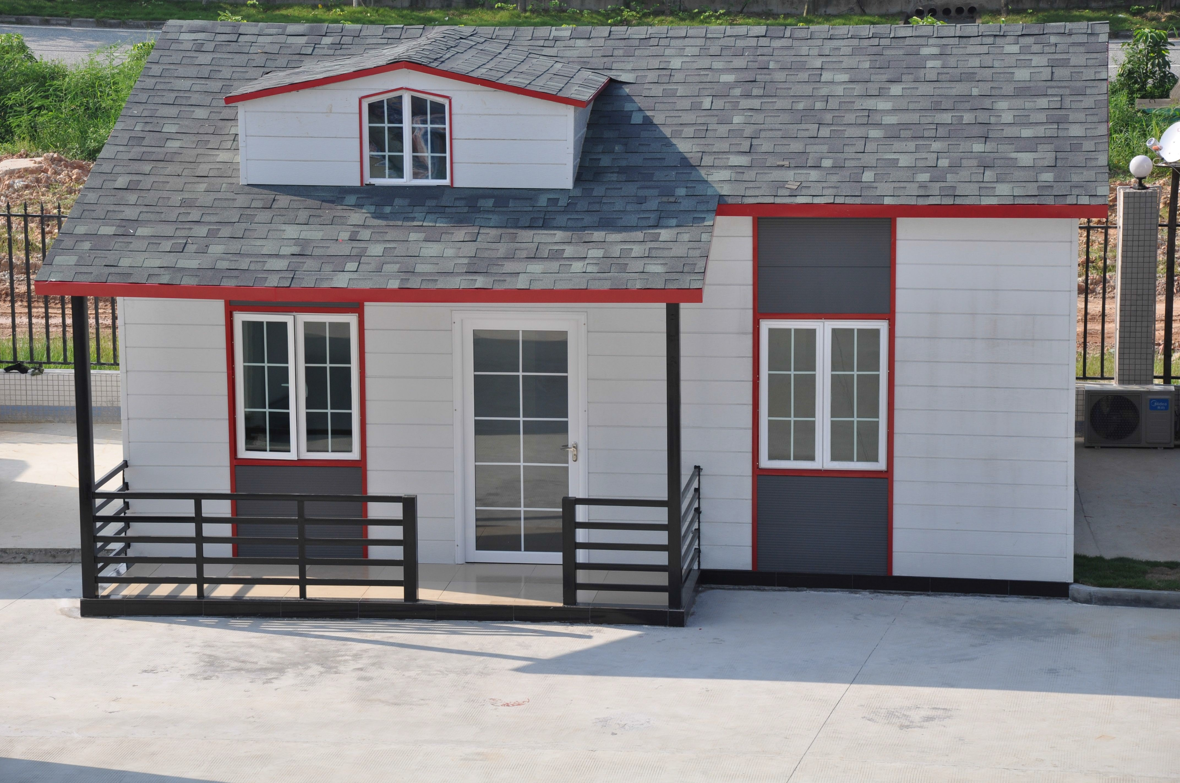

House cost
Item | Dimension | Area(㎡) | FOB Huangpu Price (/㎡) | Single Building Price ($) | Quantity(set) | Total price($)
House | 7.5 *5.5 *3m | 45.75 | $225.30 | $10,307.48 | 1 | $12,990.00
Total Price |  |  |  |  |  | $12,990.00
The above is FOB Price
The price includes all the material show of the quotation.

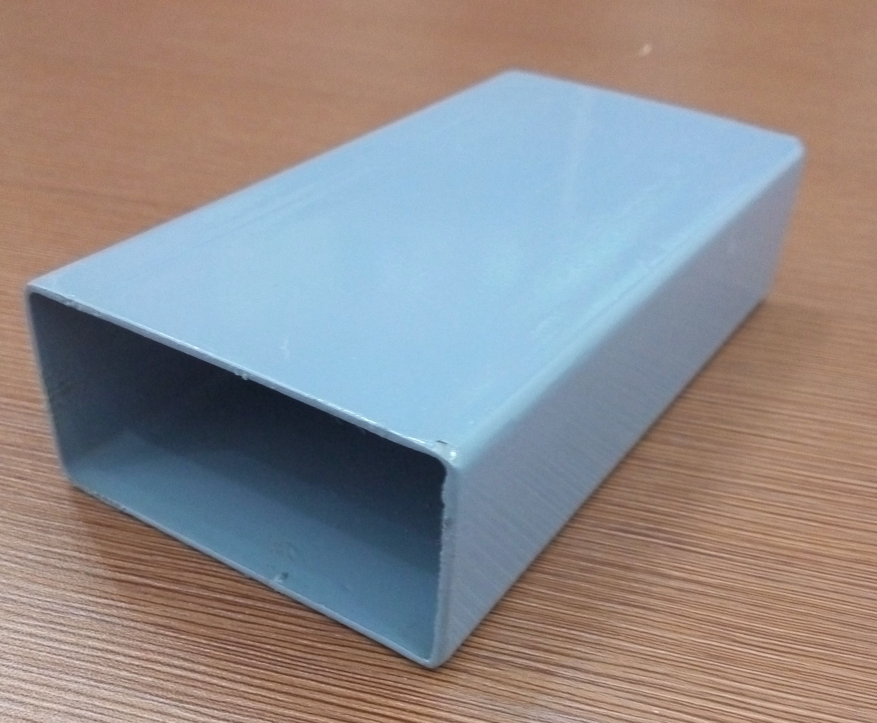
Remark |  | Delivery Time: 15 days after received 50% deposit, need final confirmation
 |  | Payment: T/T 50% as deposit, 50% balance before loading from factory
 |  | Loading: 1 x 20GP shipping containers. need final confirmation.
Installation |  | - We can give you the processing drawing to guide the installation.  - We can send our skill worker to your country to guide work,you need to provide return air tickets; visa cost,accommodation ,salary USD120/day.need to final confirmation
Main Material Lists
No. | Component | Materials  (need to final confirmation ,according to design) | Thickness (mm) | Photo
Steel Structure
1 | Pillar | 100 * 100mm square tube | 3mm | 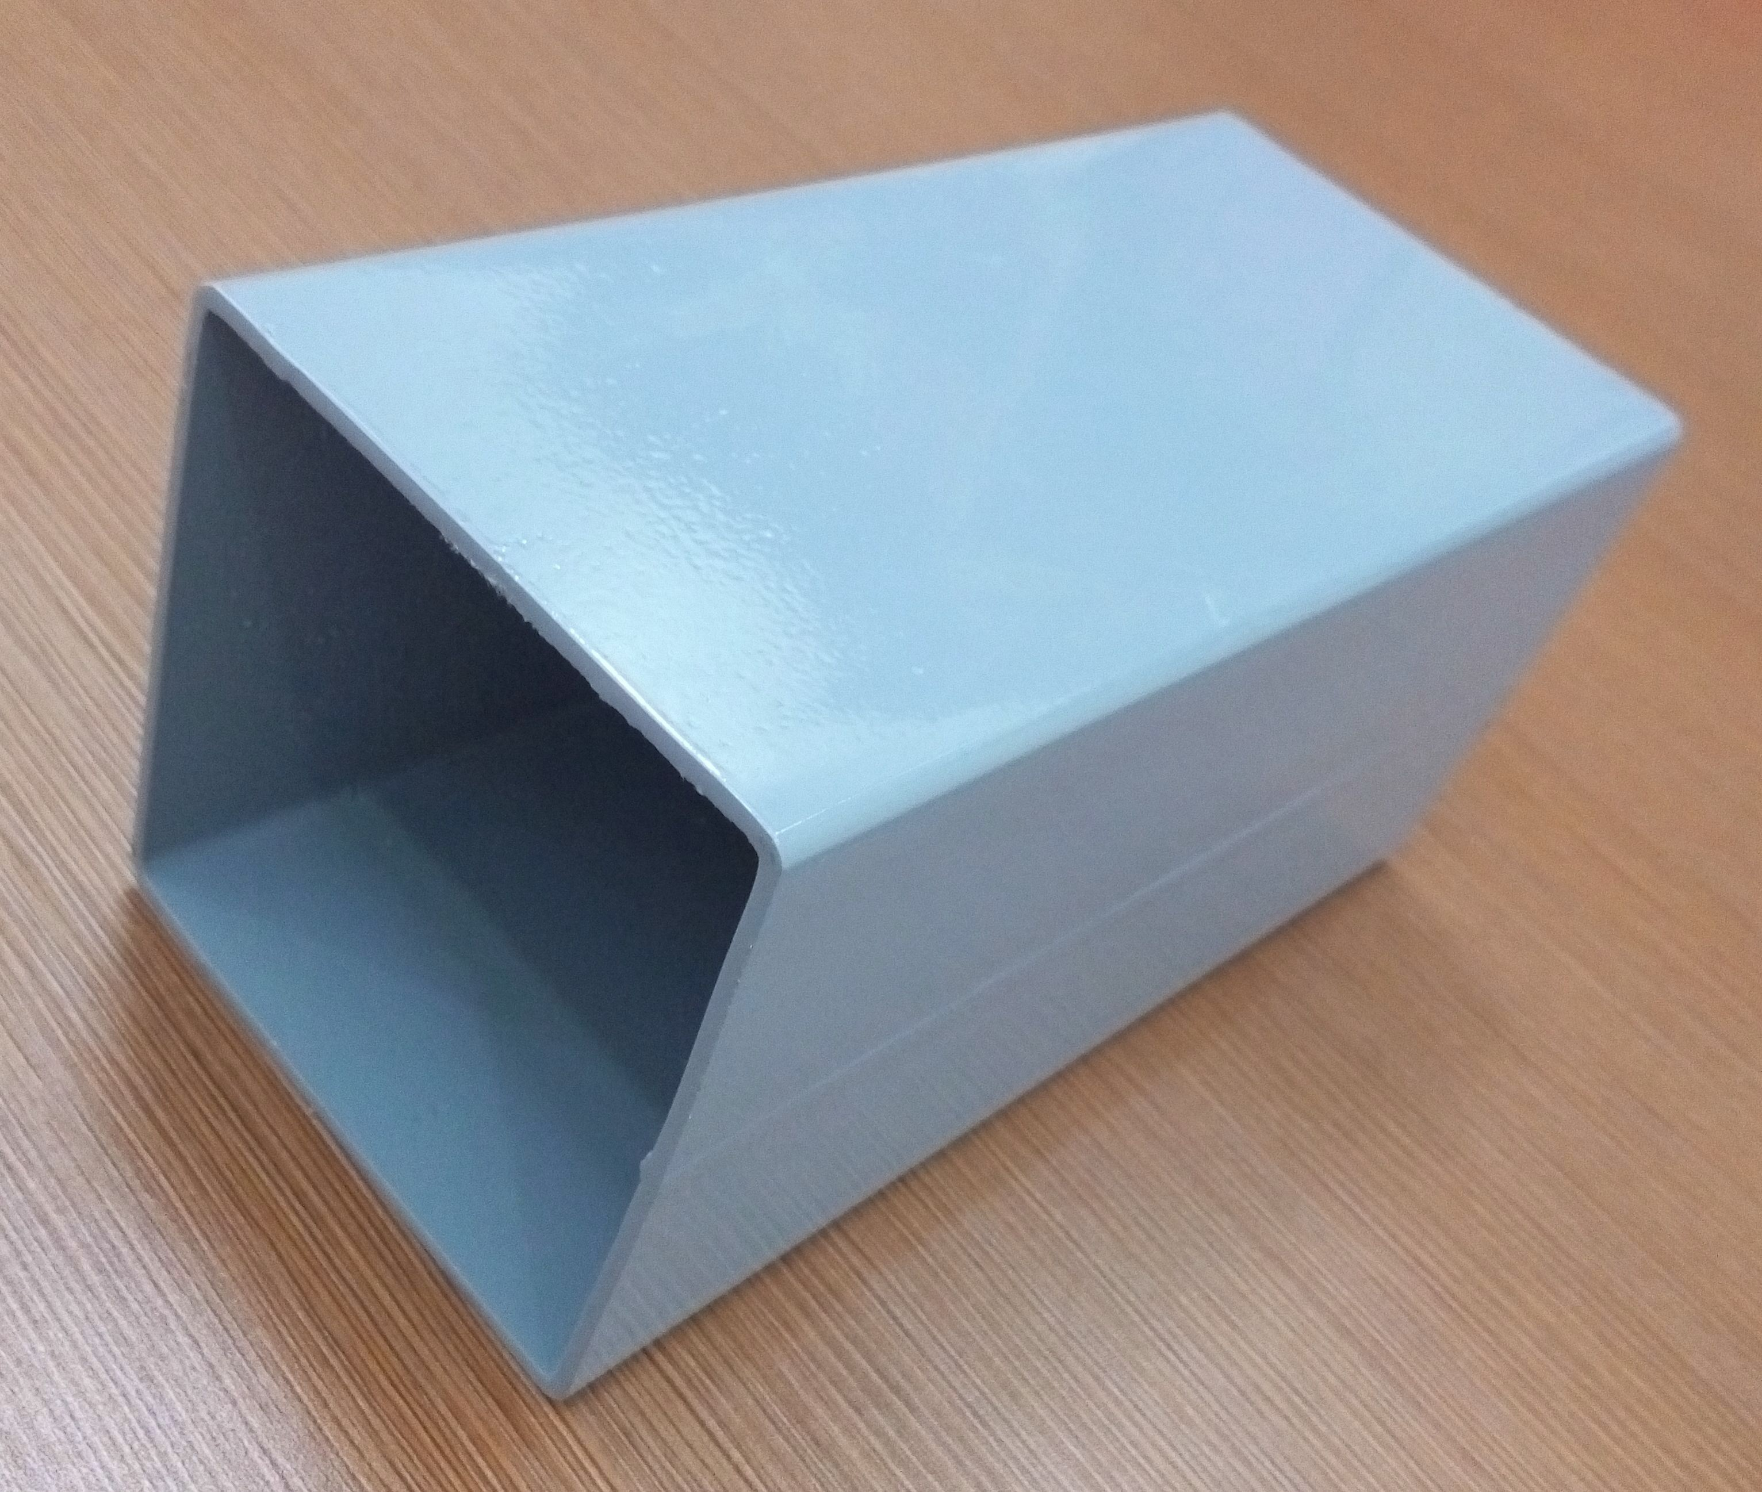
2 | Ring Beam | 80*80mm square tube | 2mm | 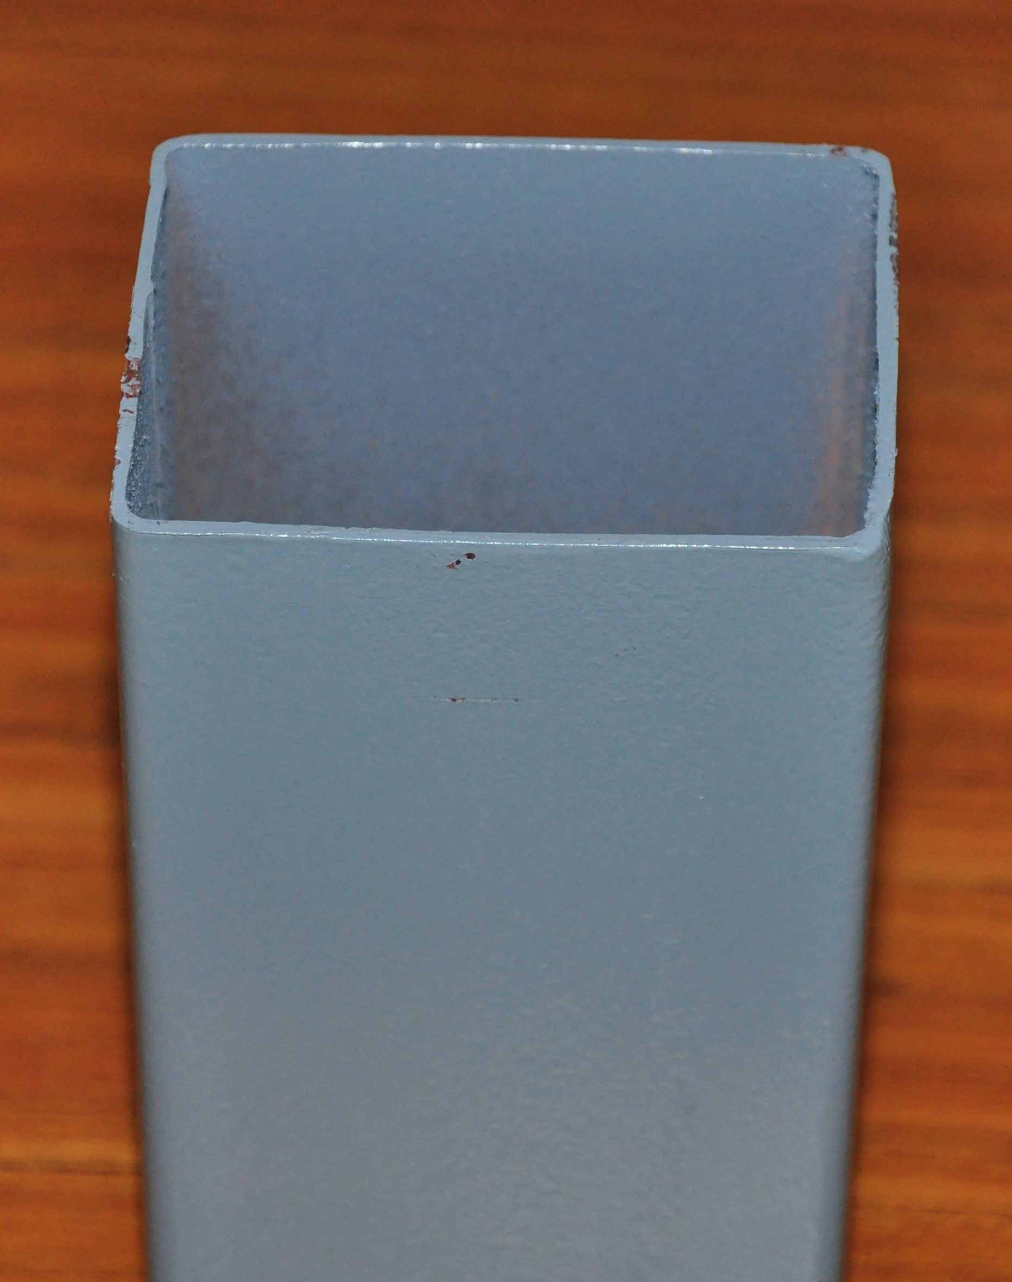
3 | Roof Purlin | 40*80mm square tube | 1.8mm
4 | Herringbone Beam | 8#C Steel | 1.8mm | 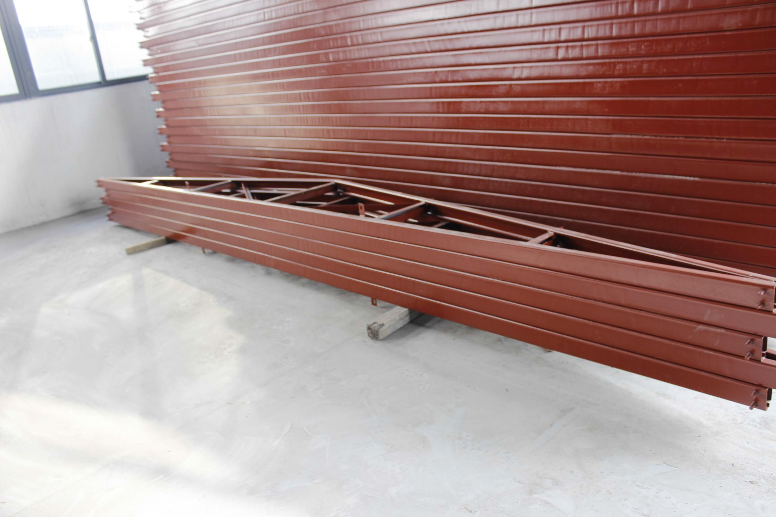
Wall Panel & Roof panel
5 | Wall Panel | EPS Sandwich Panel | 50*950mm | 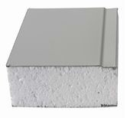

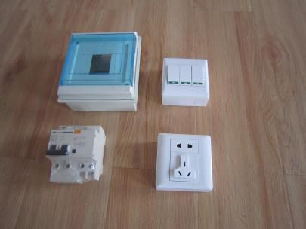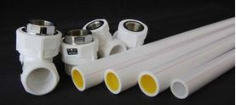
6 | Partition Wall Panel | EPS Sandwich Panel | 50*950mm
7 | Roof Panel | EPS Sandwich Panel | 50*950mm
8 | Roof Tile | Asphalt Shingle | 3mm | 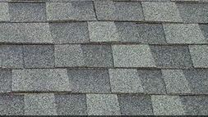
Decoration Ceiling & Wall Panel
9 | Ceiling Decoration | PVC ceiling board | 10mm 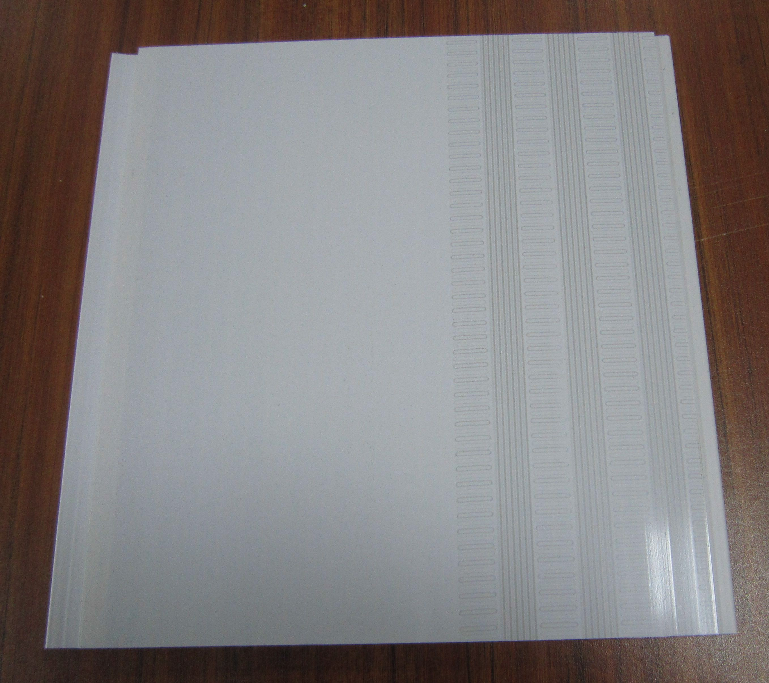
10 | Exterior Wall Decoration | PU decoration board | 16mm 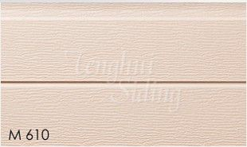
11 | Interior Wall Decoration | Decoration Wall Panel | 300*3000mm 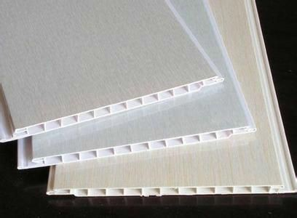
12 | Floor Decoration | Ceramic Tile | 6mm 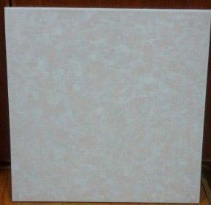
13 | Electric &water System | pipe,tap, wire,switch, socket, lamp
Window & Door
11 | Door | Alluminum Alloy Door | 800*2000mm 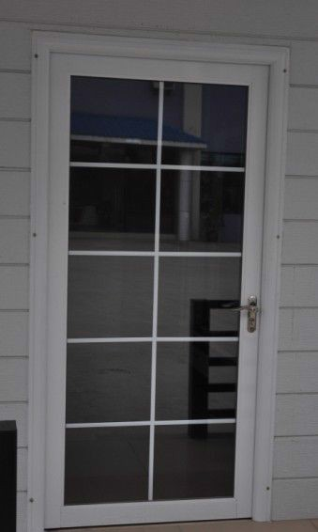

12 | Window | Aluminum Alloy Window |  | 1000*1200mm 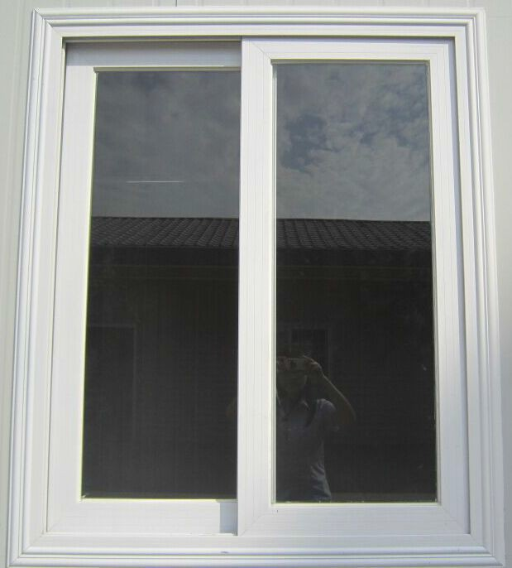
Accessories
13 | Accessories | screw,rivet,bolt and sealant etc |  |  | 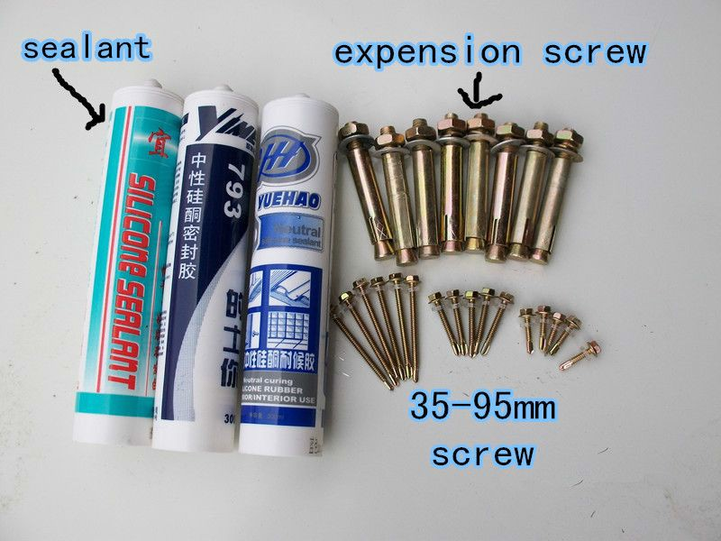
Exported Countries
Asia : Korea，India ,Malaysia ,Thailand,Kuwait, Jordan ,Indonesia,Qatar,Oman,Philippines |  |  | Europe: Spain,England
Africa: Cameroon, mozambique, Mauritius,Ethiopia Angola,South Africa,Djibouti,Congo |  |  | South America: Trinidad andTobago,Chile, Brazil,Colombia,Bolivia,Suriname,Uruguay, venezuela
Oceania:Australia ，Kiribati
Technical Parameter
No | Project Name | Value | No | Project Name | Value
1 | Roof load | ≧65kilograms/m2 | 5 | Wall deformation | ≦65kilograms/m2
2 | Flooring load | ≧150kilograms/m2 | 6 | Seismic grade | 7-magnitude
3 | Aisle load | ≧200kilograms/m2 | 7 | Wind loading | ≧100km/h
4 | Wall side stress | ≧80kilograms/m2 | 8 | Fire proof | B1 grade

