Top speed: below 40km/h
Maximum power: 1000W(inclusive)-1500W(excluding)
Authorized strength: 2 persons
Voltage: 72V and above
Range: 65km or above
Applicable group: adults
Color classification: classic pearl white sport orange gray
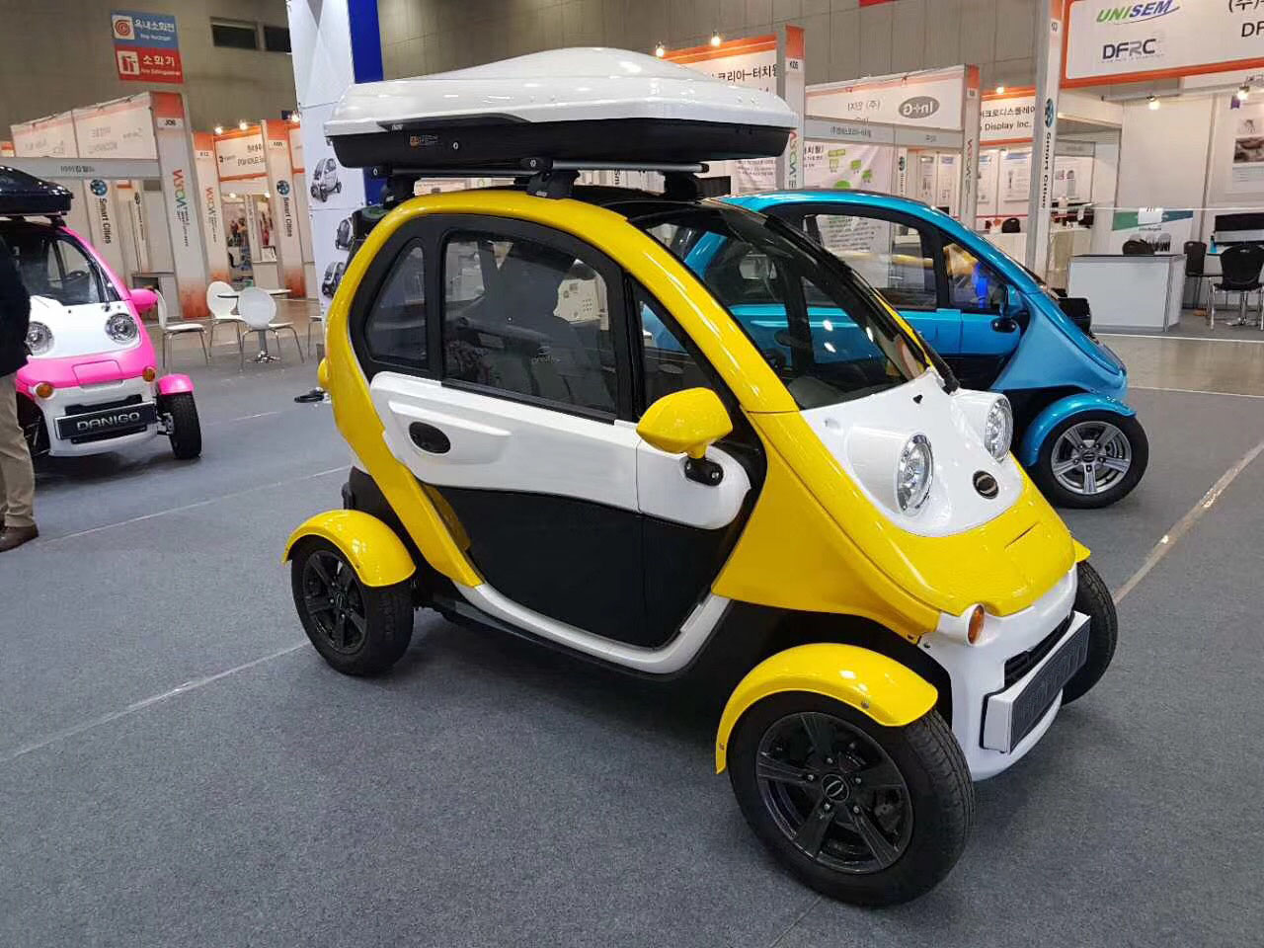
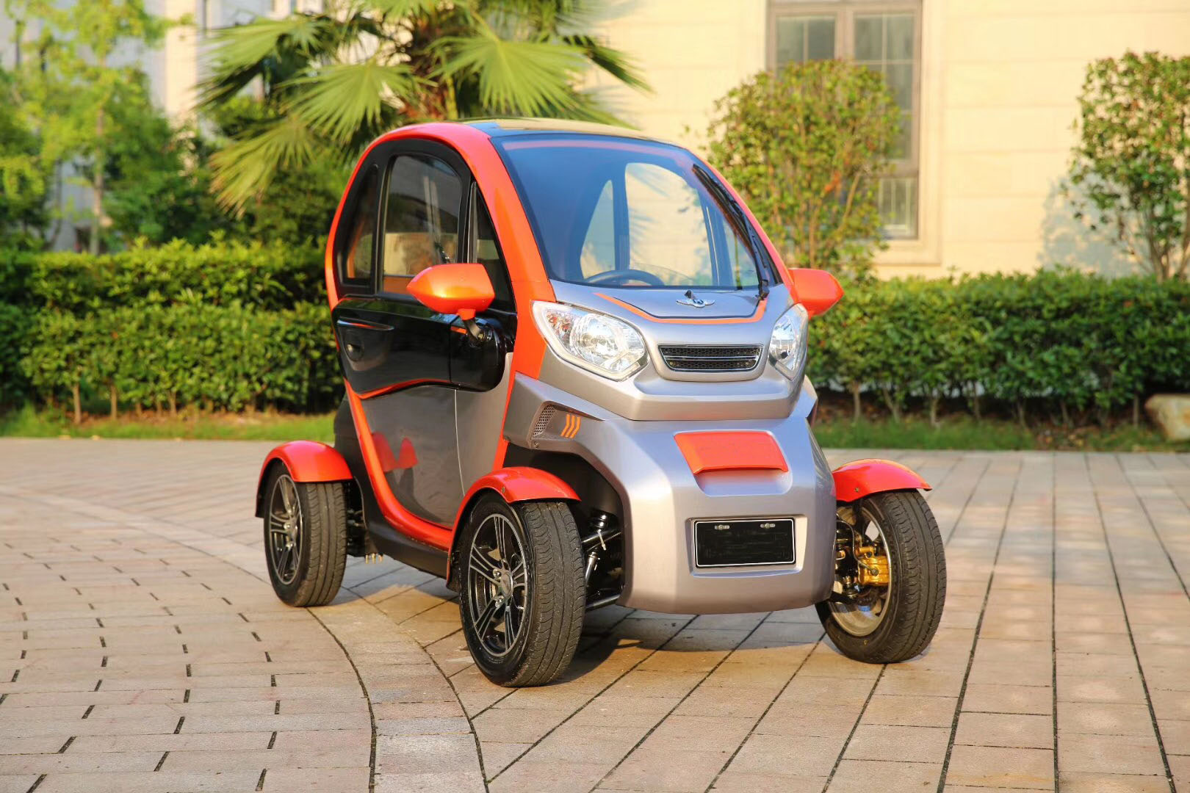

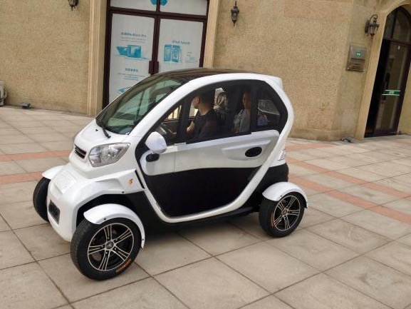
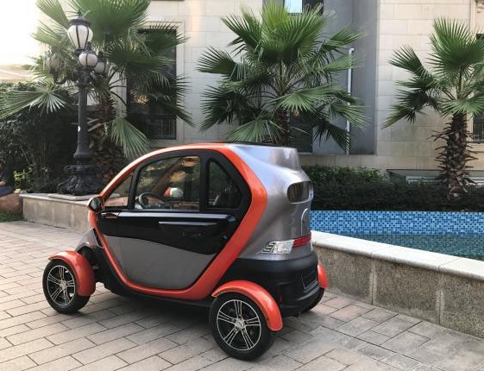
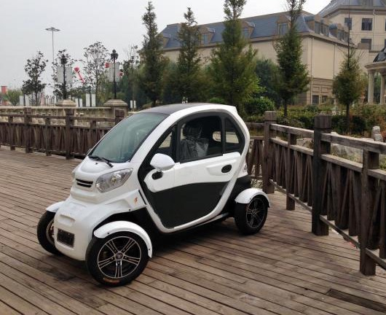
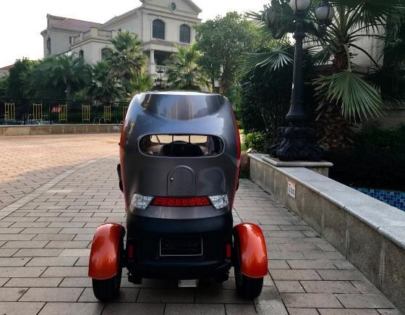
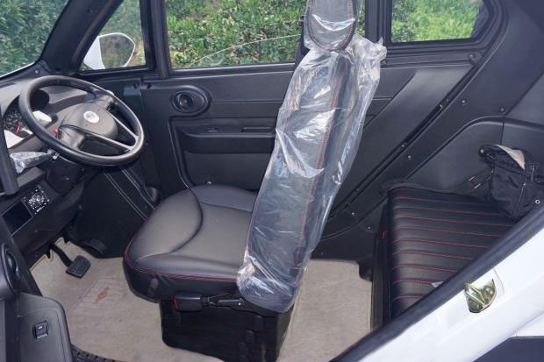
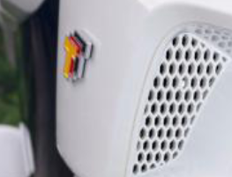
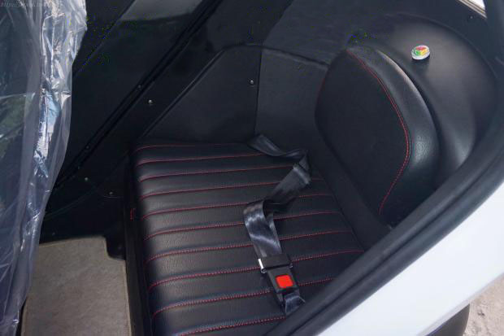
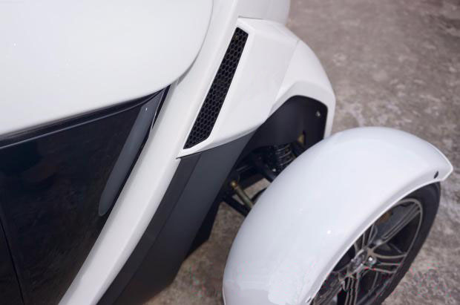
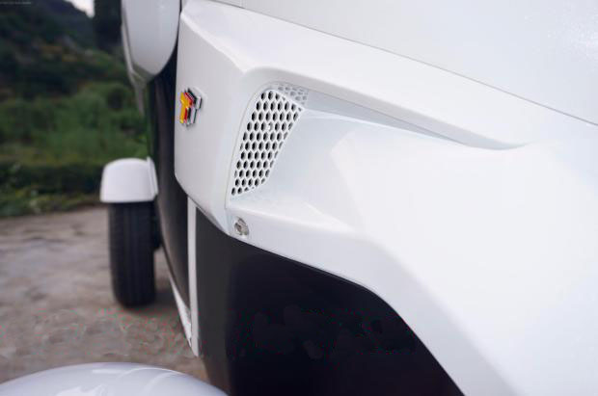
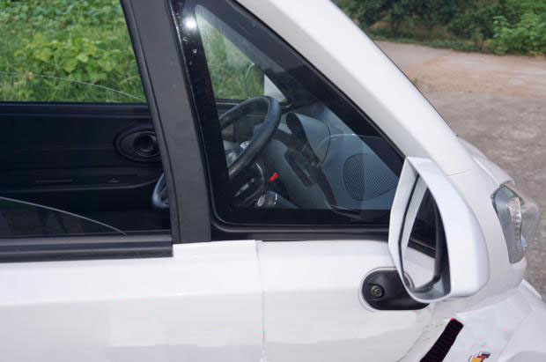
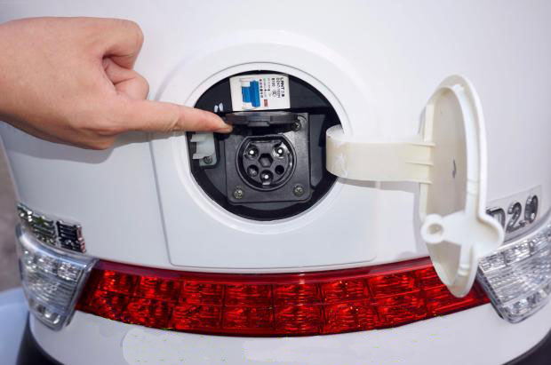
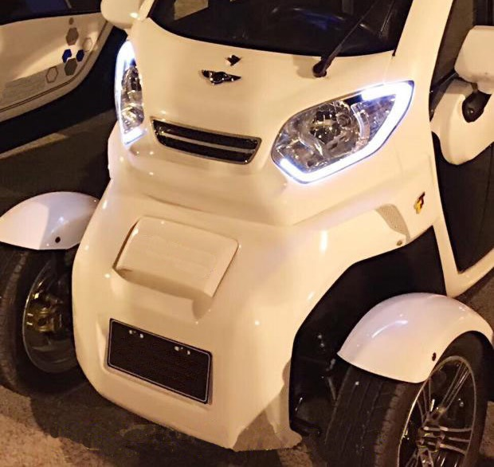
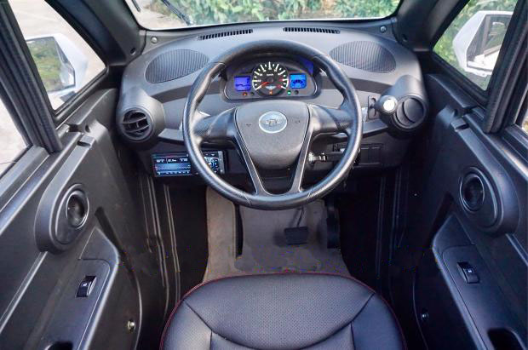
Four-wheel, can sit two adults, the front one rear one seat layout, can replace the two-wheel electric vehicle, a more safe compact compact small scooter. The car is 2.23 meters long, 1.19 meters wide and 1.45 meters high. New electric doors and Windows lifting glass. 2000 watt dc brushless motor. 72 volt vector controller. It's approaching 50 an hour. It is equipped with a lead-acid battery without maintenance. It can last about 80 kilometers. The actual capacity of the battery is 45 ampere 72 volt ultra vide free maintenance lead-acid battery (6 pieces of 12 volt 45 ampere hour). The charging time is six to eight hours. The battery should be changed every two to three years. The battery is not easy to take out because it is too heavy. Mechanical power steering wheel control is very light. Can upgrade stereo bluetooth stereo sound, reverse image, remote central control lock. Built-in warm air, external circulation natural air, adjustable driving seat, electric doors and Windows lifting glass. The shell is made of engineering plastic automobile bumper material, which is not aged for 20 years. Safe, firm and not deformed.

