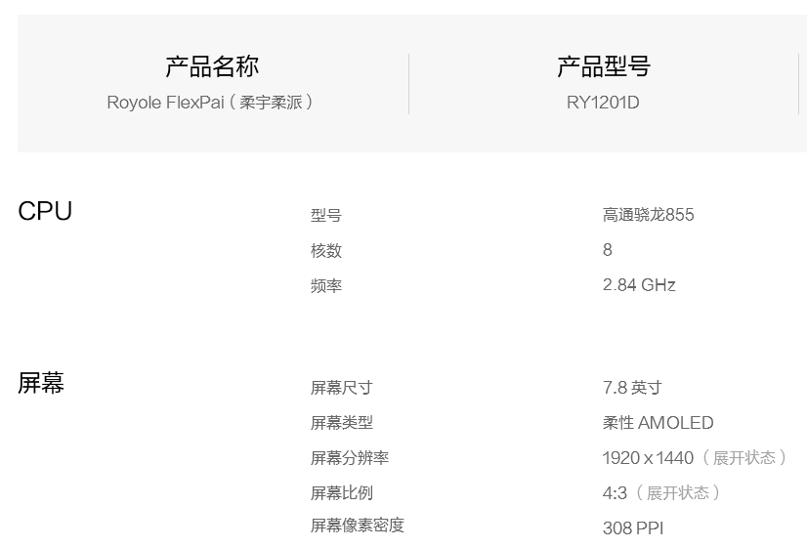

CPU
Model Qualcomm snapdragon 855
8 cores
2.84GHz

Screen
Size 7.8”
Type of screen flexible Amoled
Screen resolution 1920*1440 (in deployment state)
Screen scale 4:3 (in deployment state)
Screen Pixel Density 308PPI
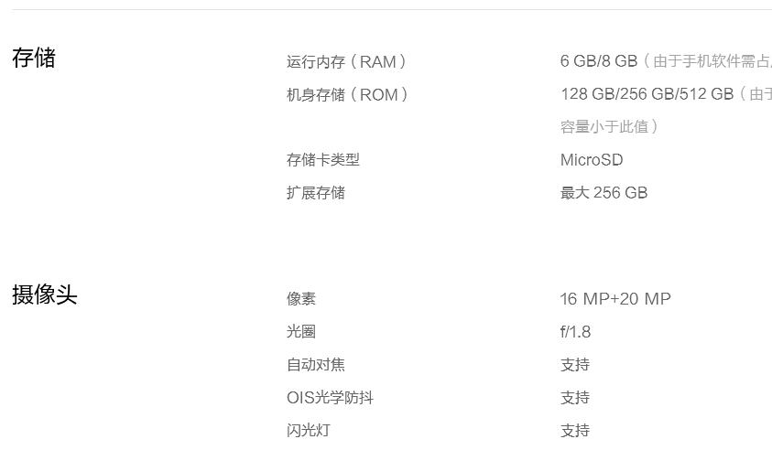

Storage
RAM 6GB (for model-1 foldable mobilphone)/
8GB (for model-2 foldable mobilphone)
ROM 128GB/ 256GB (for model-1 foldable mobilphone),
256GB/ 512GB (for model-2 foldable mobilphone)
Memory card type Micro SD
Extended storage max.256GB

Camera
Pixel 16MP + 20MP
Aperture f/1.8
Autofocus support
OIS optical anti-shake support
Flash support

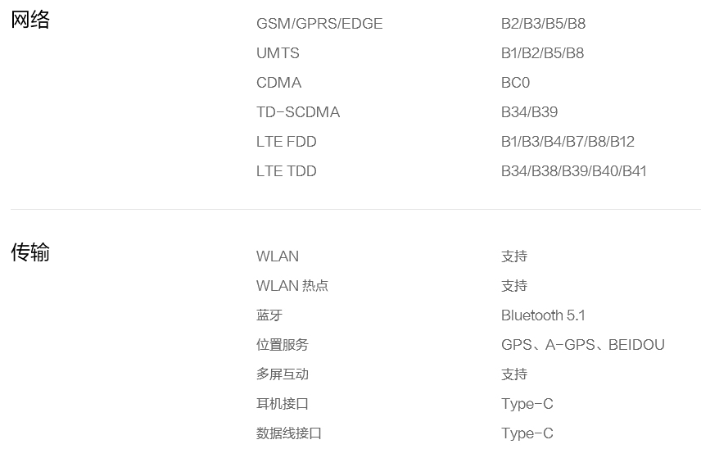
Net
GSM/ GPRS/ EDGE B2/ B3/ B5/ B8
UMTS B1/ B2/ B5/ N8
CDMA BC0
TD-SCDMA B34/ B39
LTE EDD B1/ B3/ B4/ B7/ B8/ B12
LTE TDD B34/ B38/ B39/ B40/ B41
Android Android 9.0 and upgrading automatically

Transmission
WlAN support
WlAN hotsport support
Bluetooth Bluetooth 5.1
Position service GPS, A-GPS, Beidou
Multi screen interaction support
Headphone jack Type-C
Data Line Interface Type-C
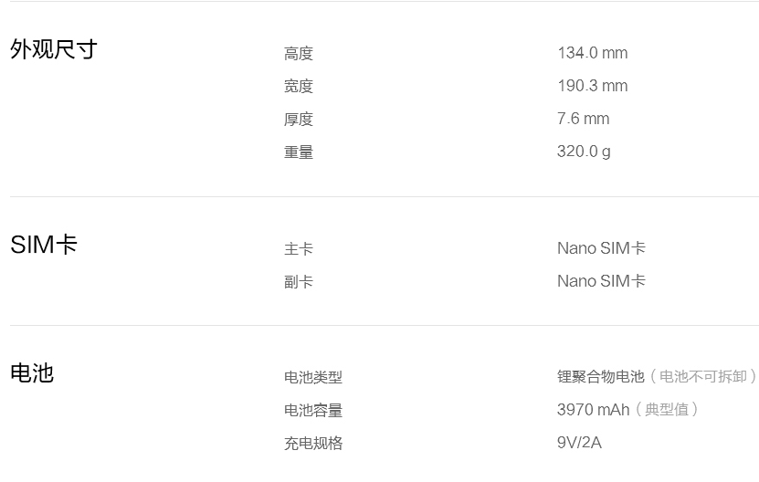
Appearance size
Height 134.0mm
Width 190.3mm
Thickness 7.6mm
Net weight 320.0g

SIM card
Main card Nano SIM card
supplemental card Nano SIM card

Battery
Type of battery Lithium polymer battery (non-removable battery)
Capacity of battery 3970mAh (Typical value)

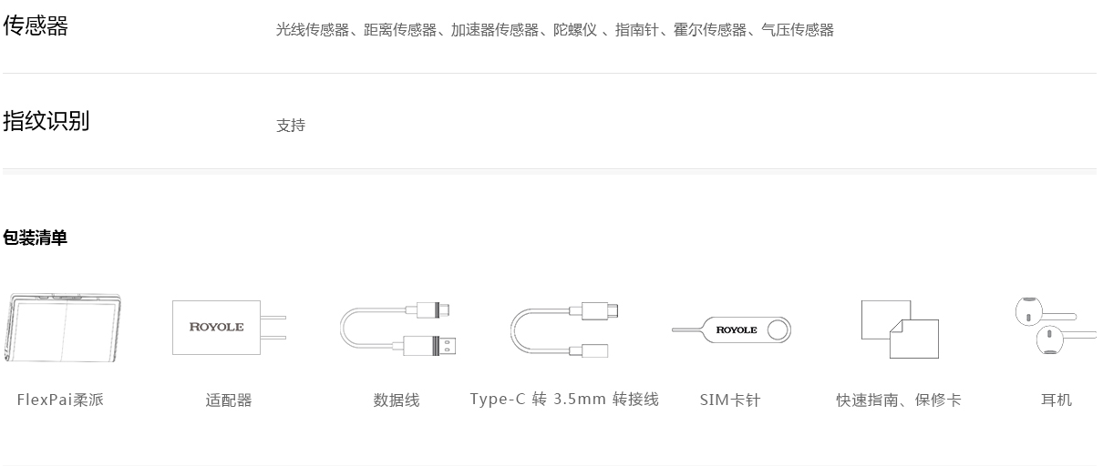

Sensors: Light sensor, Distance sensor, Acceleration sensor, Gyroscope, Compass, Hall sensor, Pressure sensor

Fingerprint identification support

Packing List
Flexible mobilphone, Adapter, Data line, Type-C transferring 3.5mm connecting line, SIM clip, Quick Guide + Warranty Card, Earphone

