DELIVERY BED, OBSTETRIC TABLE AND GYNECOLOGY CHAIR PRICE LIST

Product | Model | Photo | Technical Parameter | EXW Unit Price$ | Packing Information
LDR BED
Electric LDR BED,Linak Motor | BT-LD001 | 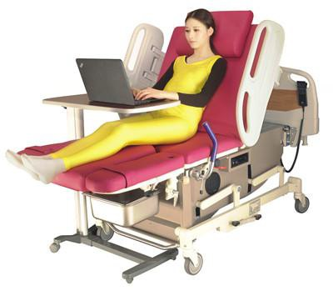 | Technical Parameters:  Bed dimension including bed end and bumper wheel: Length 1930mm, width 940mm  Bed dimension: Length 1815mm, width 800mm  Min. & Max. table height: 700-996mm(exclude the cushion) Back section turning: ≥75°  Trendelenburg and reverse trendelenburg: trend≥15° Foot rest swing out: ≥90°  Foot rest folding: ≥50°  Handrail up/down movement: 360mm Castor Diameter: 125mm  Standard Accessories: Leg holder 1 pair  Filth Basin 1 piece  I.V. Stand 1 piece Hand control 1piece Power cord 1 piece | 5,096 | 1820*1080*1120mm;  1pc/plywood case; N.W.: 225KG G.W.:312KG

Electric LDR BED (Ordinary),Linak Motor | BT-LD002 | 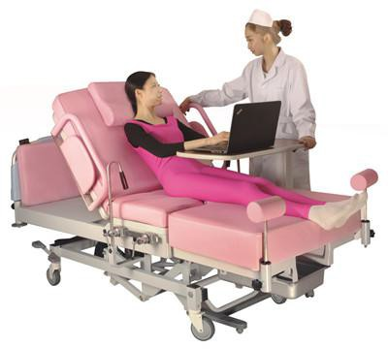 | Technical Parameters: Bed dimension includ width 980mm  Bed dimension: Lengt Min. & Max. table hei Back section turning: Trendelenburg and re Leg section telescope: Castor Diameter: 125  Standard Accessories: | ing bed end and bumper wheel: Length 2050mm, h 1815mm, width 880mm  ght: 580mm~950mm(exclude the cushion)  ≥70°  verse trendelenburg: reverse trend≥5° trend≥12°  550mm mm  Clamp 1 pair Foot rest 1 pair  Water proof cushion 1 set  baby 1 piece  ding back cushion, seat cushion and assist platform  ce  control) 1 piece (optional) | 5,096 | 1870*1120*1100mm;  1pc/plywood case; N.W.: 197KG G.W.: 287KG
Leg holder 1 pair Grab handle 1 pair Filth Basin 1 piece
I.V. Stand 1 piece Cushion for newborn Cushion 1 set (Inclu cushion)
Power cord 1 pie Foot switch (or hand
Manual LDR BED (Ordinary) | BT-LD002B | 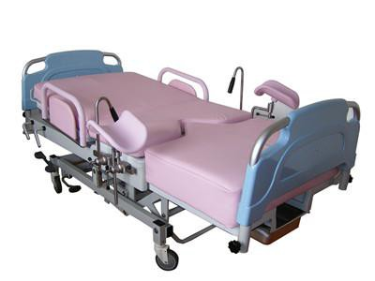 | Technical Parameters:  Bed dimension including bed end and bumper wheel: Length 2050mm, width 980mm  Bed dimension: Length 1815mm, width 880mm  Min. & Max. table height: 580mm~950mm(exclude the cushion) Back section turning: ≥70°  Trendelenburg and reverse trendelenburg: reverse trend≥5° trend≥12° Leg section telescope: 550mm  Castor Diameter: 125mm  Standard Accessories:  Leg holder 1 pair Clamp 1 pair Grab handle 1 pair Foot rest 1 pair  Filth Basin 1 piece Water proof cushion 1 set  I.V. Stand 1 piece  Cushion for newborn baby 1 piece  Cushion 1 set (Including back cushion, seat cushion and assist platform cushion) |  | 3,266 | 1870*1120*1100mm;  1pc/plywood case; N.W.: 197KG G.W.: 287KG

Electric LDR BED (Low Starting Position),Linak Motor | BT-LD003 | 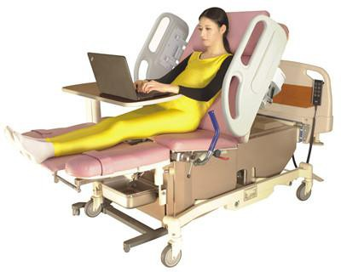 | Technical Parameters:  Bed dimension including bed end and bumper wheel: Length 1930mm, width 940mm  Bed dimension: Length 1815mm, width 780mm  Min. & Max. table height: 580mm~860mm(exclude the cushion) Back section turning: ≥60°  Seat section turning: ≥10° Trendelenburg: ≥8°  Leg section up/down movement: 100mm Footrest swing out:≥45°  Footrest folding: ≥45°  Guard rail up/down movement: 360mm Castor Diameter: 150mm  Standard Accessories: Leg holder 1 pair  Filth basin 1 piece  I.V. Stand 1 piece Hand control 1 piece Power cord 1 piece | 5,836 | 1920*1080*1020mm;  1pc/plywood case; N.W.: 260KG G.W.:340KG
Electric LDR BED (Intelligent),Linak Motor | BT-LD004 | 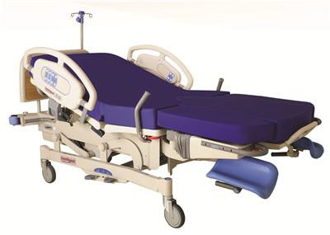 | Technical Parameters:  Bed dimension including bed end and bumper wheel: Length 2350mm, width 940mm  Bed dimension: Length 1950mm, width 880mm  Min. & Max. table height: 540mm~890mm(exclude the cushion) Back section turning: ≥65°  Seat section turning: ≥12° Trendelenburg: ≥8°  Leg section lifting distance: 110mm Footrest swing out:≥50°  Footrest folding: ≥75°  Guard rail up/down movement: 360mm Castor Diameter: 150mm  Standard Accessories:  Bed cushion 1 suit Filth basin 1 piece I.V. Stand 1 piece Power cord 1 piece | 7,462 | 2180*1130*1140mm;  1pc/plywood case; N.W.:252KG; G.W.:353KG

Electric LDR BED,Linak Motor | BT-LD005 | 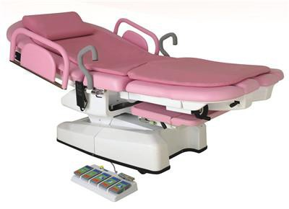 | Technical Parameters:  Bed dimension: Length 2000mm, width 920mm  Assist platform dimension: Length 500mm Width 540mm Assist platform lifting distance: 110mm  Min. & Max. table height: 590mm~1000mm Back section turning: down ≥5°, up ≥65° Seat section turning: ≥20°  Leg section swing out: ≥30° Leg section adjusting: ≥20°  Leg section sliding: 60mm Footrest folding:≥35° Footrest folding: ≥45°  Guard rail turn over: 180°  Standard Accessories:  Sliding platform for newborn baby 1 piece; Guardrail 1 pair  Pillow (Low elasticity) 1 set ; Soft bed cushion 1 set  Foot Switch 1 piece; Seat Cover 1 piece | 9,485 | 2130*1080*920mm;  1pc/plywood case; N.W.: 310KG; G.W.:410KG
Electric LDR Bed,Linak Motor | BT-LD009 | 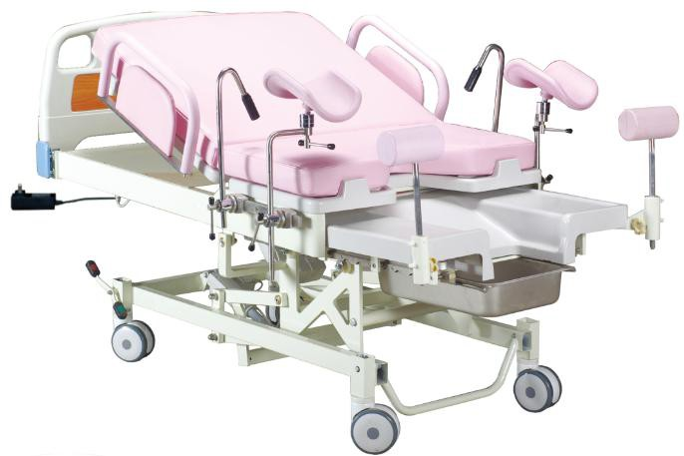 | Technical Parameters:  Bed dimension : Length 2050mm, width 980mm Bedboard dimension: Length 1815mm, width 880mm  Min. & Max. table height: 580mm~950mm(exclude the cushion) Back section turning: ≥70°  Trendelenburg and reverse trendelenburg: reverse trend≥5° trend≥12° Length of chair position: 1450mm  Castor Diameter: 125mm  Standard Accessories:  Leg holder 1 pair Clamp 1 pair Grab handle 1 pair Foot rest 1 pair  Filth Basin 1 piece Water proof cushion 1 set  I.V. Stand 1 piece  Cushion for newborn baby 1 piece  Cushion 1 set (Including back cushion, seat cushion and assist platform cushion)  Power cord 1 piece hand control | 3,308

OBSTETRIC TABLE
Multifunction Electric Obstetric Table, Linak motor | BT-OE029 | 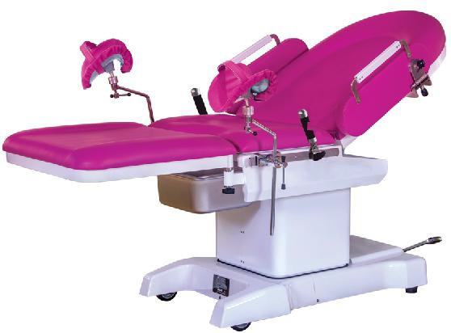 | - Imported Denmark Linak gear engine  - up & down / forward & backward / backboard forward&backboard are electric  - Base & Table-board are stainless steel  Technical parameter: length:2000±50mm Width:800±20mm Height:(650-900)±50mm Backboard upwards: ≥60°  Trendelenburg/Rev-Trend:12°/15° Back section:800×600mm  Seat section:410×600mm  Working area/Height adjustment: 800*700/700-860mm | 5,616 | 1470*870*900mm,330KG  , 1pc/plywood case
Multifunction Electric Obstetric Table, Linak motor | BT-OE001 | 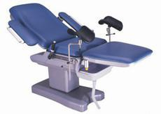 | Technical Parameters  Table top dimension: Length 1920mm, Width 610mm Table Height: 790-1040mm  Trendelenburg & Reverse Trendelenburg:≥12°(optional)  Back section turning: -5°-75°  Seat Section turn up: 0°-15°(optional)  Assit Platform Dimension: length 580mm, width 610mm Assist platform swing out: 0°-90°  Arm Rest Swing out: ≥90°（Can be at upright position as guaid rail）  Filth Basin Dimension: 468*338*125mm (can be equipped with soft pipe)  Standard accessories Waterproof cushion 1 set Waist grab handle 1 pair Leg holder 1 pair  Filth basin 1 piece  Arm rest 1 pair | 4,189 | Packing size:160*83*102cm N.W./G.W.:190/258kg  1pc/plywood case

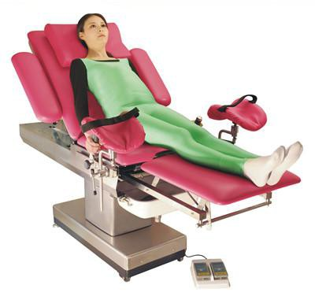
Multifunction Electric Obstetric Table, Linak motor | BT-OE002 |  | Technical Parameter:  - Table top dimension: length 1900mm, width 610mm  - Min.& Max. table height: 750mm~1000mm  - Trendelenburg & reverse trendelenburg: reverse trend ≥ 15°, trend ≥  15°  - Back section turning: 0~75°  - Assist platform dimension: length 550mm, width 550mm  - Arm rest swing out: ≥ 90°  - Filth basin dimension:468×338×125mm(can be equipped with soft pipe)  - Power: AC 220V 50HZ  Standard accessories  - Waterproof cushion 1 set  - Waist grab handle 1 pair  - Leg holder 1 pair  - Filth basin 1 piece  - Arm rest 1 pair  - Foot switch 1 piece  - Clamp 1 pair | 3,735 | Packing size:150*83*100cm N.W./G.W.:242/310kg  1pc/plywood case
Multifunction Electric Obstetric Table, Linak motor | BT-OE003 | 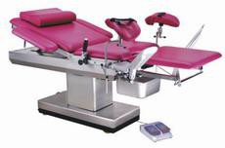 | Technical Parameter:  - Table top dimension: length 1900mm, width 610mm  - Min.& Max. table height: 750mm~1000mm  - Trendelenburg & reverse trendelenburg: reverse trend ≥ 15°, trend ≥  15°  - Back section turning: 0~75°  - Assist platform dimension: length 550mm, width 550mm  - Arm rest swing out: ≥ 90°  - Footrest swing out: 0~45°  - Footrest turn up: 0~45°  - Filth basin dimension:468×338×125mm(can be equipped with soft pipe)  - Power: AC 220V 50HZ  Standard accessories  - Waterproof cushion 1 set  - Waist grab handle 1 pair  - Leg holder 1 pair  - Filth basin 1 piece  - Arm rest 1 pair  - Foot switch 1 piece  - Clamp 1 pair | 3,985 | Packing size:160*82*100cm N.W./G.W.:252/320kg  1pc/plywood case

Multifunction Electric Obstetric Table, Linak motor | BT-OE004 | 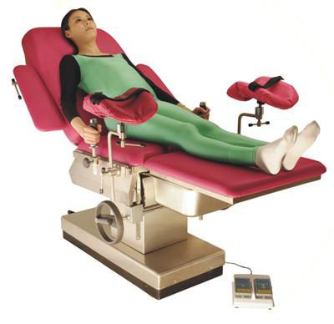 | Technical Parameters  Table top dimension: length 1900mm, width 610mm Min.& Max. table height: 660mm~910mm  Trendelenburg & reverse trendelenburg: reverse trend ≥ 10°, trend ≥  15°  Back section turning: -10°~75°  Assist platform dimension: length 550mm, width 550mm Arm rest swing out: ≥ 90°  Filth basin dimension:468×338×125mm(can be equipped with soft pipe)  Standard accessories Waterproof cushion 1 set Waist grab handle 1 pair Leg holder 1 pair  Filth basin 1 piece  Arm rest 1 pair  Foot switch 1 piece | 2,777 | Packing size:150*83*100cm N.W./G.W.:250/318kg  1pc/plywood case
Multifunction manual hydraulic Obstetric Table | BT-OE005 | 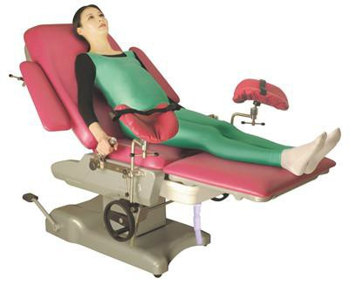 | Technical Parameters  Table top dimension: Length 1850mm, Width 610mm Table Height: 650-900mm  Trendelenburg:≥10°  Reverse Trendelenburg:≥20°  Back section turning: -10°-75°  Assit Platform Dimension: length 540mm, width 610mm Arm Rest Swing out: ≥90°  Filth Basin Dimension: 468*338*125mm(can be equipped with soft pipe)  Standard accessories Waterproof Cushion 1 Set Waist Grab Handle 1 Pair Leg Holder 1 Pair  Filth Basin 1 Piece  Arm Rest 1 Pair  Clamp 1 Pair | 2,355 | Packing size:138.5*81*83cm N.W./G.W.:133/160kg  1pc/plywood case

Multifunction Electric Obstetric Table, Linak motor | BT-OE018 | 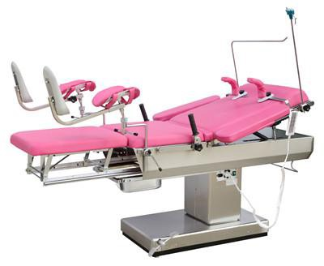 | Specification:  Overall Length 1900mm, Width 600 mm  Up and down：750～1000mm Adujst ≥250mm Reversed Trendelenburg ≥12°, Trendelenburg ≥12°  Back Section Raised from the horizontal≥60° Secondary table size：Length 550mm width 500mm  Power：（AC）220V，50Hz Safe working load: 135kg  Standard accessories: Electric operation bed 1 Shoulder support 2  Anaesthetic Screen 1  handle 2  Knee crutch 2  Arm rest 2  Cushion 1 | 3,253 | Packing size:158×94×103cm N.W./G.W.:180/240kg  1pc/plywood case
Multifunction Electric Obstetric Table, Linak motor | BT-OE019 | 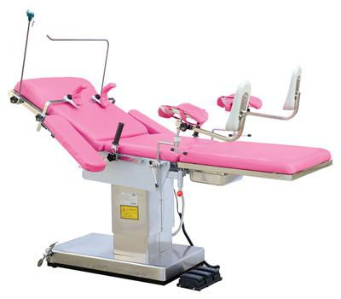 | Specification:  Overall length:1900mm Width:600mm  Dimensions of Leg Section：Length:650mm, Width:600mm  Table Top from floor:Max. Height:930mm, Min. Height:680mm Back section raised from the horizontal:≥75°  Back section lowered from the horizontaI: ≥5° Reversed Tendelenburg:≥15°, Trendelenburg:≥15° Supple： AC220±10％，50Hz±1Hz  Device safety sort：I B  Standard Accessories: Shoulder Rest 2  Anesthetic Screen 1  Arm support 2  Knee Crutch 2  Handle 2  Cushion 1  Contaminative Basin 1 | 2,791 | Packing size:152×94×105cm N.W./G.W.:180/240kg  1pc/plywood case

Multifunction Electric Obstetric Table, Linak motor | BT-OE020 | 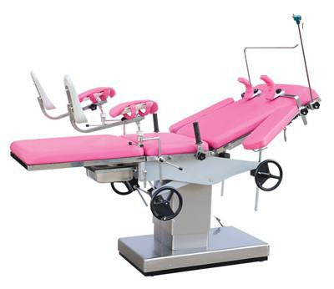 | Specification：  Overall length:1250mm Width:600mm  Dimensions of Leg Section：Length:650mm, Width:600mm Table Top from floor:Max. Height:990mm, Min. Height:750mm  Back section raised from the horizontal:≥55° Back section lowered from the horizontaI: ≥10°  Reversed Tendelenburg:≥8°, Trendelenburg:≥20° Supple： AC220±10％，50Hz±1Hz  Device safety sort：I B  Standard Accessories: Shoulder Rest 2  Anesthetic Screen 1  Arm support 2  Knee Crutch 2  Handle 2  Cushion 1  Contaminative Basin 1 | 2,399 | Packing size:152×94×105cm N.W./G.W.:180/240kg  1pc/plywood case
Multifunction Electric Obstetric Table, Linak motor | BT-OE021 | 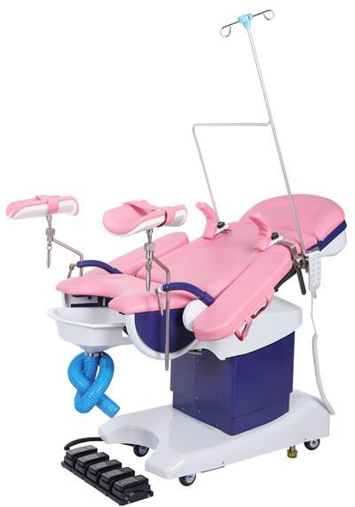 | Specification:  Length：1250mm Width:550 mm  Height adjustment：650～950mm  Reversed Trendelenburg: ≥15°, Trendelenburg:≥15° Back up:≥45°  Power: AC220V，50Hz Height hold: ≥135kg  Standard Accessories: Leg support: 2sets Pedal foot stand 2sets Basin 1  Curved handle 2sets  Mattress 1 | 3,677 | Packing size:148×91×130cm N.W./G.W.:180/240kg  1pc/plywood case

Multifunction Electric Obstetric Table, Linak motor | BT-OE022 | 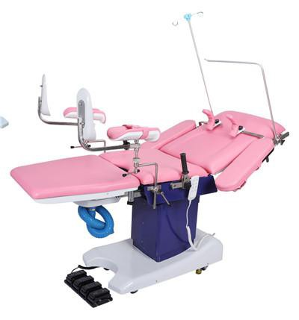 | Specification:  Floor size: length 1900mm width 600 mm  Bed lifting range: ≥ 250mm free lift 680~930mm lift, lock  Four main technical parameters: Fold on the back panel: ≥ 45 ° Fold under the back panel: ≥ 6 ° Fold on the base plate: ≥ 30 °  Power supply: AC220V,50Hz Safe working load: ≥ 135kg"  Standard Accessories: Leg support: 2sets Pedal foot stand 2sets Basin 1  Curved handle 2sets  Mattress 1 | 4,693 | Packing size:148×91×130cm N.W./G.W.:180/240kg  1pc/plywood case
Multifunction Manual hydraulic Obstetric Table | BT-OE023 | 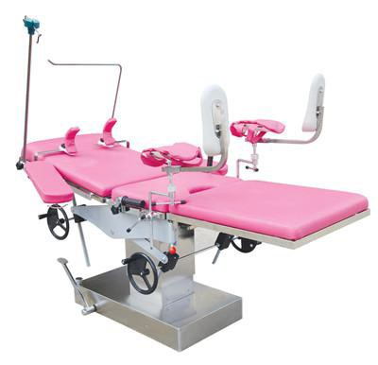 | Specifications：  Overall length:1250～1900mm, Width:600mm  Back Section:800×600mm Seat Section:400×600mm Leg Section:650×600mm  Max. Height:920mm, Min. Height:680mm Rising Distance:≥240mm  Back section raised from the horizontal:≥45° Back section lowered from the horizontal:≥10°  Reversed Trendelenburg:≥8°, Trendelenburg:≥20° Safe working load:135kg  Accessories：  - Stand for anaesthetic and for hanging intravenous drip bottle 1 set  - Shoulder rest and mattress 2set  - Arm rest and mattress 2set  - Handle 2set  - Leg support,foot board and mattress 2set  - Mattress on the table top 1set：  - The contaminative basin 1set | 2,160 | Packing size:148×91×130cm N.W./G.W.:180/240kg  1pc/plywood case

Multi-function manual hydraulic obstetric table, stainless steel | BT-OE013 | 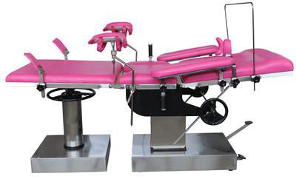 | Specification:  Overall length:2000*600*720-960mm Back board folding up ≥70°  Back board folding down ≥10° Leg board lifting range≥245mm  Accessories Anesthesia screen Shoulder supporter Leg supporter  Arm supporter Mattress  Pedal | 2,110
Multi-function manual hydraulic obstetric table, stainless steel | BT-OE014 | 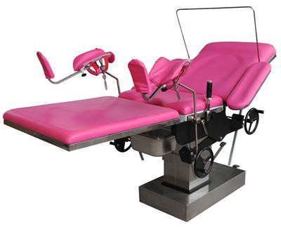 | Specification:  Overall length:2000*600*620-860mm Table top lean forward ≥22°  Table top lean backward ≥8° Back board folding up ≥70°  Back board folding down ≥10°  Accessories Anesthesia screen Shoulder supporter Leg supporter  Arm supporter  Mattress Pedal | 2,088 | Packing size:141*88*93cm N.W./G.W.:153/195kg  1pc/plywood case
Gynecology Examination Chair

Electric Gynecology Chair, Linak motor | BT-GC001 | 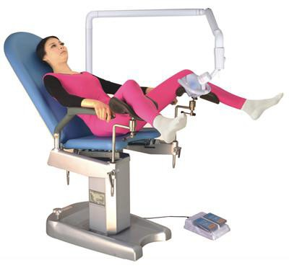 | Technical Parameters  Table top dimension: length 1700mm, width 500mm Min. & Max. table height: 660mm～910mm  Back section turning: 25°～75° Seat section turning: -12°～32°  Arm rest swing out:90°  Foot rest pedal swing: down≤5°,up≥75°  Foot rest swing out: ≥30° Lamp adjust angle: 60°  Power: AC 220V 50HZ  Standard accessories Shadowless lamp 1set Foot switch 1piece  Leg holder 1pair | 3,962 | Packing size:125*85*167cm N.W./G.W.:205/275kg  1pc/plywood case
Electric Gynecology Chair, Linak motor | BT-GC002A | 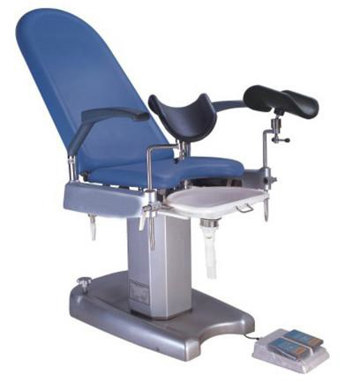 | Technical Parameters  Table top dimension: length 1700mm, width 500mm Min. & Max. table height: 660mm～910mm  Back section turning: 25°～75° Seat section turning: -12°～32°  Arm rest swing out:90°  Foot rest pedal swing: down≤5°,up≥75°  Foot rest swing out: ≥30°  Lamp adjust angle: 60° Power: AC 220V 50HZ  Standard accessories Leg holder 1pair  Stainless steel Basin 1 set | 3,797 | Packing size:125*85*167cm N.W./G.W.:205/275kg  1pc/plywood case
Manual Gynecology Chair | BT-GC002B | 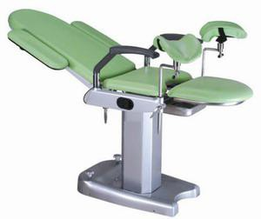 | Technical Parameters  Table top dimension: length 1700mm, width 500mm Fixed table height: 820mm(optional height)  Back section turning: -12°～75°  Seat section turning: -10°～15°  Arm rest swing out:90° Handrail swing:90°  Foot rest swing out: ≥30°  Standard accessories Leg holder 1pair  Stainless steel Basin 1 set | 2,646 | Packing size:125*85*187cm N.W./G.W.:205/285kg  1pc/plywood case

Electric Gynecology Chair, Linak motor | BT-GC003 | 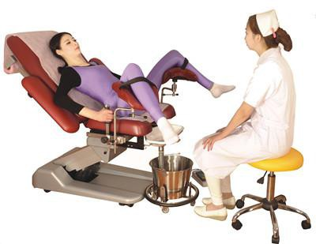 | Technical Parameter Table top dimension: Min & Max. table hei Back section turning: Arm rest swing out:9 Foot rest swing: dow Foot rest swing out: Power: AC 220V 50HZ  Standard accessories | s  length 1800mm, width 610mm ght: 510mm-810mm  -15°～85°  0°  n≤0,up≥90°  ≥30°  r  t  ece | 4,097 | Packing size:145*86*72cm N.W./G.W.:143/186kg  1pc/plywood case
Foot switch 1 unit Arm rest 1 set
Leg holder 1pai
Clamp 1 pair Foot rest 1 pair
Assist platform 1 uni Filth basin 1 piece Paper roll holder 1 pi Electric Wire 1 piece
Electric Gynecology Chair, Linak motor | BT-GC004A | 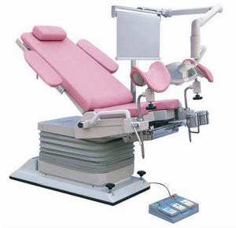 | Technical Parameters  Table top dimension: length 1145mm, width 500mm Min. & Max. table height: 550mm～970mm  Back section turning: down≥8°up≥50° Seat section turning: ≥25°  Arm rest swing out:0～90°  Foot rest swing out: ≥45°  Lamp adjust angle: 60° Power: AC 220V 50HZ  Standard accessories Arm rest 1 pair  Leg holder 1 pair Foot rest 1 pair  Foot switch 1 piece |  | 6,060 | Packing size:132*85*157cm N.W./G.W.:130/210kg  1pc/plywood case

Electric Gynecology Chair, Linak motor | BT-GC004B | 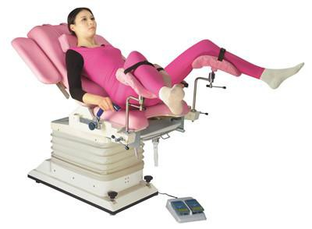 | Technical Parameters  Table top dimension: length 1700mm, width 550mm Min. & Max. table height: 600mm～920mm  Back section turning: down≥8°up≥60° Seat section turning: down≥8°up≥16°  Arm rest swing out:0～90° Handle slide distance: 140mm  Filth basin slide distance: 150mm Power: AC 220V 50HZ  Standard accessories Foot switch 1 piece Shoulder holder 1 pair Pillow 1 unit |  | 3,468 | Packing size:131*82*82cm N.W./G.W.:205/275kg  1pc/plywood case
Electric Gynecology Chair, Linak motor | BT-GC005A | 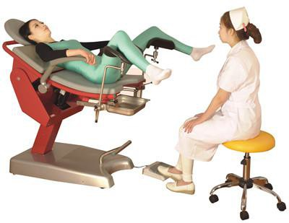 | Technical P Dimension: Height: 560 Filth basin s Power: 220  Accessories | arameters 1110mm*565mm mm-1130mm  lide distance:160mm AC, 50HZ  1 pair  1 pair  older 1 piece  1 piece  e 1 piece 1piece | 3,221 | Packing size:135*91*152cm N.W./G.W.:173.5/271.5kg  1pc/plywood case
 |  |  | Leg holder Clamp Paper roll h Basin Electric wir Foot switch
Electric Gynecology Chair, Linak motor | BT-GC005B | 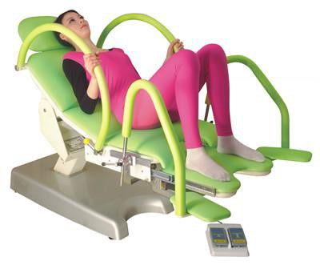 | Specification:  Table top dimension: length 1450mm, width 520mm Min. & Max. table height: 420mm～1070mm Trendelenburg&anit-trendelenburge:≥30°,≤30°  Footrest slide distance:100mm Auxiliary table slide distance:360mm Power: AC 220V 50HZ  Standard accessories Foot switch 1 pair Leg holder 1 pair Clamp 1 pair  Filth Basin 1 unit |  | 3,370 | Packing size:148*93*135cm N.W./G.W.:142/207kg  1pc/plywood case

Electric Gynecology Chair, Linak motor | BT-GC006 | 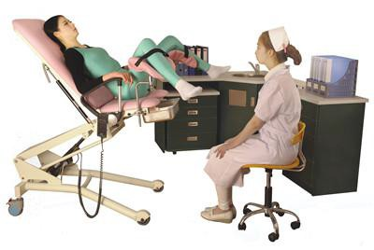 | Specification:  Table top dimension: length 1800mm, width 550mm Min. & Max. table height: 450mm～1000mm  Back section turning:-10°～75° Seat section turning:-5°～ 25°  Arm rest swing out: 0°～90°  Filth basin slide distance: 150mm Power: AC 220V 50HZ  Standard accessories Foot switch 1 pair  Leg holder 1 pair Clamp 1 pair  Filth Basin 1 unit Waterproof cushion 1 set | 3,419 | Packing size:146*79*74cm N.W./G.W.:107/153kg  1pc/plywood case
Electric Gynecology Chair, Linak motor | BT-GC007 | 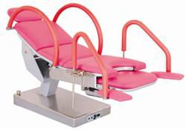 | Specifications：  Overall Length: 1250±50mmWidth: 520±20mm  Max Height of table top: 1200mm, Min Height of table top: 480mm Height of seating plate: 520mm  Reversed Trendelenburg: ≥20°, Trendelenburg: ≥5°  Lifting speed: 10±5mm/s Safe Working Load: 135kg  Supply： AC220±10％，50Hz±1Hz  Internal electric source:（DC）24V Battery capacity ≥ 2.4AH  Device safety sort：I B Ingress Protection：IPX4  Standard Accessories: Handle 2pcs  Cushion 1 set  Contaminative Basin 1 set Foot board 2pcs | 2,399 | Packing size:148×91×130cm N.W./G.W.:180/240kg  1pc/plywood case

Electric Gynecology Chair, Linak motor | BT-GC008 | 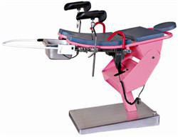 | Specification:  Overall length: 1200mm , Width:550mm Max.Height:1200mm, Min.Height:480mm  Reversed Trendelenburg:≥15°, Trendelenburg:≥20°  Supple： AC220±10％，50Hz  Device safety sort：I B  Standard Accessories: Knee Crutch 2pcs Handle 2pcs  Contaminative basin 1pc | 2,285 | Packing size:148×91×130cm N.W./G.W.:180/240kg  1pc/plywood case
Electric Gynecology Chair, Chinese motor | BT-OE009 | 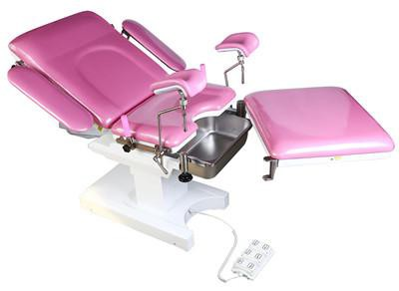 | Specification:  Overall Length 1980mm, Width 720 mm Up and down：630-880 Adujst ≥250mm  Back section up:≥55° Back setion down:≥18° Seat section up:≥35° Seat section down:≥5° Footrest swing out:≥90° Armrest swing out::≥90°  Standard accessories: Electric operation bed 1 Shoulder support 2  Anaesthetic Screen 1  handle 2  Knee crutch 2  Arm rest 2  Cushion 1 | 3,036 | 1550*820*875mm,  148KG/216KG
Electric Gynecology Chair, Chinese motor | BT-OE010 | 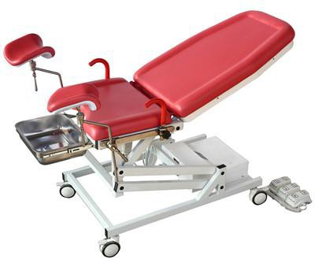 | Specification:  Overall length:1450mm Width: 600mm  Min height: ≤630mm Max height: ≥1000mm  Back board folding up ≥70° Back board folding down ≥17° Seat board folding up ≥35° Accessories  Pull handle Leg supporter | 2,667 | Packing size:1500*820*770mm, N.W.:93KG, G.W.:148KG,  1pc/plywood case.

Electric Gynecology Chair, Chinese motor | BT-OE011 | 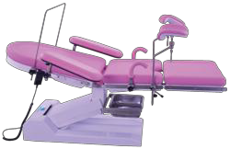 | Specification:  Overall length:2000*600*550-950mm Back board folding up ≥70°  Back board folding down ≥10° Seat board folding up ≥28°  Seat board folding down ≥10°  Accessories Pull handle Leg supporter  Arm supporter | 3,511 | 1550*820*870mm,  158KG/221KG
Electric Gynecology Chair, Chinese motor | BT-OE012 | 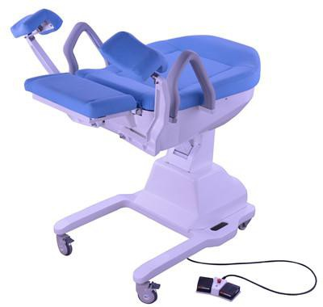 | Specification:  Min height: ≤480mm Max height: ≥1070mm  Back board folding: 5°-75°  Seat board folding  Back board, seat board link Leg supporter open: 0°-30° Accessories  Foot switch | 3,770 | 1420*840*1260mm,  130KG/180KG
Electric Gynecology chair,linak motor | BT-GC009 | 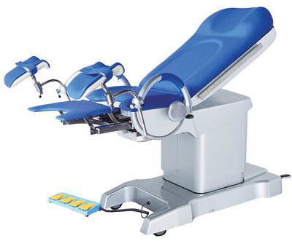 | - Imported Denmark Linak motor  - Leg support frame can fold up and down electriclly 3.Standard accessories:  leg holder(1 set)  arc-shaped armrest(1set) basin(1pc)  hand remote controller(1pc)  foot pedal remote controller(1pc)  length: 1300mm±50mm width: 550mm±20mm  height: (700mm-1000mm)±50mm Backboard upwards: 50° Trendelenburg/Rev-Trend:10°/12° Leg support reflx: 30°  auxiliary table: (length:350mm width:450mm)±20mm power voltage: 220V 50Hz | 5,431 | 1470*770*980mm,  240KG,1pc/plywood case

Electric Gynecology chair,linak motor | BT-GC010 | 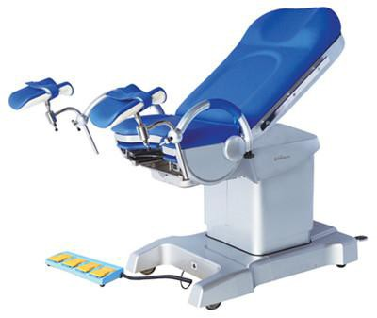 | - Auto-restoring function  - Imported Denmark Linak motor  - Leg support frame can fold up and down electriclly 3.Standard accessories:  leg holder(1 set)  arc-shaped armrest(1set) basin(1pc)  hand remote controller(1pc)  foot pedal remote controller(1pc)  length: 1300mm±50mm width: 550mm±20mm  height: (700mm-1000mm)±50mm  Trendelenburg/Rev-Trend:10°/12° Backboard upwards: 50°  Leg support reflx: 30°  auxiliary table: (length:350mm width:450mm)±20mm power voltage: 220V 50Hz | 5,800 | 1470*870*980mm,  240KG, 1pc/plywood case
Gynecology Examination Couch | BT-EA020 | 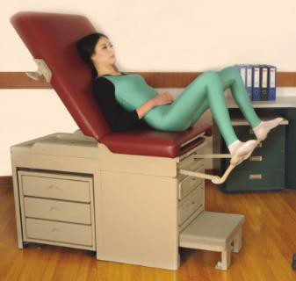 | - Chair Dimension: 117.8(Curve Length)*52mm*52cm  - Max Back section adjust: 0 ~ 70°  - Max leg section adjust: 7°  - Step stool dimension: 42*23cm  - Max patient weight: 226KG  - Standard accessories: foot support 1 pair; waste pan 1pc; paper roll rod 1pc; side drawer 3pcs; front drawer: 2pcs; step stool 1pc; cusion 1 pc; | 2,290 | Packing: 126*63.5*96cm, 130.1KG ;  148.5*73*23.5cm,  23.3kg;  1pc/2 packages
Simple Gynecology Bed

Manual Gynecology Bed | BT-OE015B | 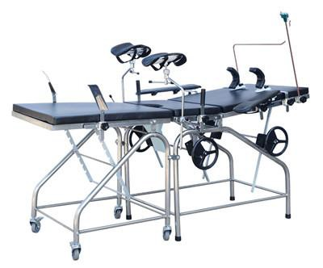 | Specification:  The bed is made of stainless steel. Overall Size:1900*600*780mm Back Section:750×600mm  Seat Section:340×600mm Leg Section:750×600mm  Back section raised from the horizontal:≥45°  Back section lowered from the horizontal≥10° Seat section raised from the horizontal≥25° Seat section lowered from the horizontal≥8° Leg section raised from the horizontal≥25°  Leg section lowered from the horizontal≥25°  Accessories:  Anesthesia screen 1pc Shoulder supporter 1pcs Leg supporter 2pcs  Arm supporter 2pcs pull handle 2pcs Mattress 1 set  IV pole 1pc | 1,110 | Packing size:1220*815*965mm N.W./G.W.:56/104kg  2pcs/carton
Manual Gynecology Bed | BT-OE016B | 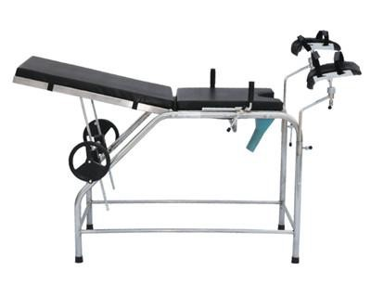 | Specification:  Overall length:1300mm Width: 500mm  Height: 750mm  Back board folding up ≥45° Back board folding down ≥15° Accessories  Leg supporter  pull handle Mattress | 986 | Packing size:102*85*26cm N.W./G.W.:26/33kg  1pc/carton

Manual Gynecology Table | BT-OE017B | 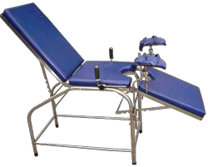 | Specification:  Overall length:1900mm Width: 500mm  Height: 750mm  Back board folding up ≥60° Back board folding down ≥15° Leg board folding down ≥90° Accessories  Leg supporter  pull handle Mattress | 897 | Packing size:104*84*26.5cm N.W./G.W.:28/35kg  1pc/carton
Gynaecological Examination Bed | BT-OE025 | 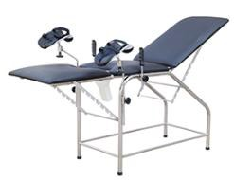 | Specification:  The bed is made of stainless steel. Size:1800*500*750mm  Back Section Raised from the Horizontal:0°~60°＋5°  Leg Section Lowered from the Horizontal:0°~70°＋5°  Accessories:  Leg supporter 2pcs pull handle 2pcs Mattress 1set | 960
Gynaecological Examination Bed | BT-OE026 | 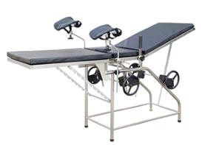 | The bed is made of stainless steel. Size:1800*500*750mm  Back Section Raised from the Horizontal:0°~60°＋5°  Leg Section Lowered from the Horizontal:0°~70°＋5° | 960

Gynaecological Examination Bed | BT-OE027 | 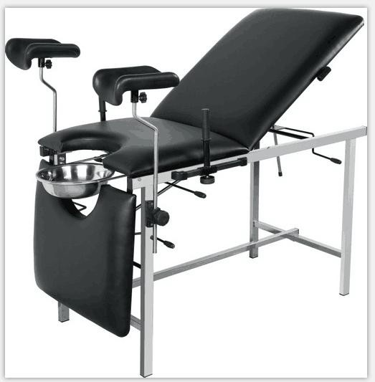 | Product Size : 180*60*80cm  Table frame made of tubular 201 stainless steel; Fixed bases with protective plastic feet;  Adjustable three sections with independent controls  Bed top is high-density polyurethane foam, and covered with washable faux leather: waterproof, flame retardant  Mattress thickness: 40mm;  One pair of adjustable knee support; one pair of handgrip; With slide-out S.S bowl φ28cm ;  Load bearing: 150kg; Knock down construction; | 869 | 133*70*20CM,34KG
Payment Terms: | 100% TT payment before production
Delivery Time: | 30 days after deposit arrival
Warranty: | The product that is damaged or fails to normal work really due to the manufacturing problem within one year after the purchasing date will gain free spare parts and assembling drawing from company.  Beyond the maintenance period, we will charge the accessories, but the technical service is still for free.

