COMMERCIAL OFFER
2020/02/18

Technological Equipment KHS Innofill DVF-PET 56/112/8 SV with instant Capacity of the line 12 500 Bph, for PET 2,0 format bottle liters filling labelling and packing which contains of following positions mentioned above:

Description of machine | Type | Serial number | Year | Make
Blowing mold machine | SBO 10 FOUR | 5452 | 2003 | SIDEL
Air transport for PET | LTR | 89400023/100-01 | 2004 | KHS
PARAMIX system | CMX 2-33/T20-3 | 962 | 2004 | KHS
Flow Pasteurization | KZE 330/T3-95-2/SA | 610-270 | 2004 | KHS
Bottle rinse system | FR ZM 56/45/B/RL | 61238 | 2004 | KHS
KHS innofill Filler PET | DVF-PET 56/112/8 SV | 40358 | 2004 | KHS
Labeling Machine | RF 33/180-12 | 173 | 2004 | KHS
KISTERS system | TSP 040 B TPFO | 2509 | 2004 | KHS
Pallet magazine | PMZ | 89400023/1700 | 2004 | KHS
Pallet transporter | PTR | 89400023/1800-01 | 2004 | KHS
Palletizing | PB 1 N(H) | 89-400023-1600 | 2003 | KHS
ROBOPAK system | 1803090275 | 2003 | ITALIANO
Transport system for PET bottles | BTR | 89400023/1000-01 | 2004 | KHS
Case transport | GTR | 89400023/1400-01 | 2004 | KHS
CIP station | 2006 | "Jonson Diversey "
Transporters lubrication system | 2004 | KHS
Data printer | 2004 | "Hitachi "

Blowing mold machine SIDEL SBO/10
• Press-form feeding system
• Press-form Lift system to machine
• Air transport system to Filling machine
Capacity 12 500 Bph

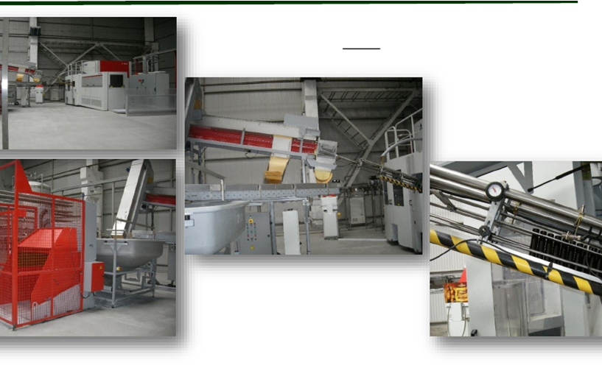
Mixing and Flow pasteurization
- Mixing flow capacity 30 000 liters/hour
- Possibility to Mix 4 components in one time (product, syrup, Co2, acid ore aroma)
Pasteurization
- Pasteurizer equipped with plate heat exchanger
- Product pasteurization with set temperature
- Product cooling to 4-10 °C

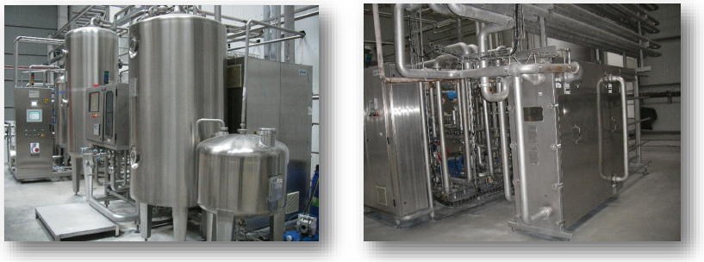
Filling Block KHS DVF-PET 56/112/8 SV 2004 + Labeling machine KHS polypropylene
- Formats 0,5/1,0/1,5/2,0 PET
- Filling valves 112
- Capping heads 8
- Labeling polypropylene all around label
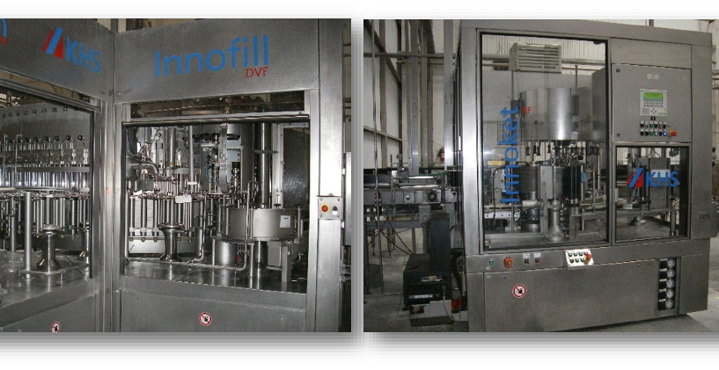

KHS Kisters Packing system
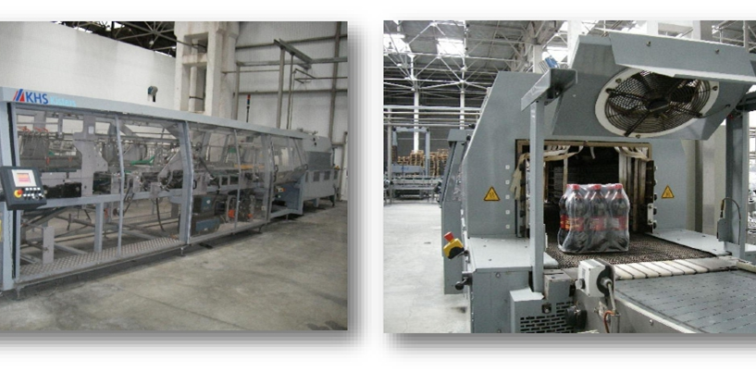
Handle ApplicationPROGRIP S50
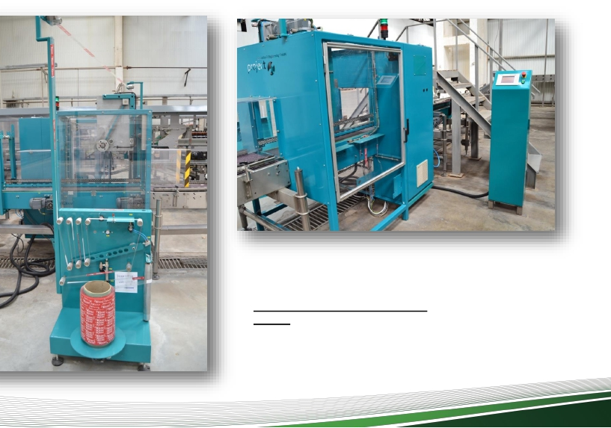

Palletizing station with pallet wrapping system
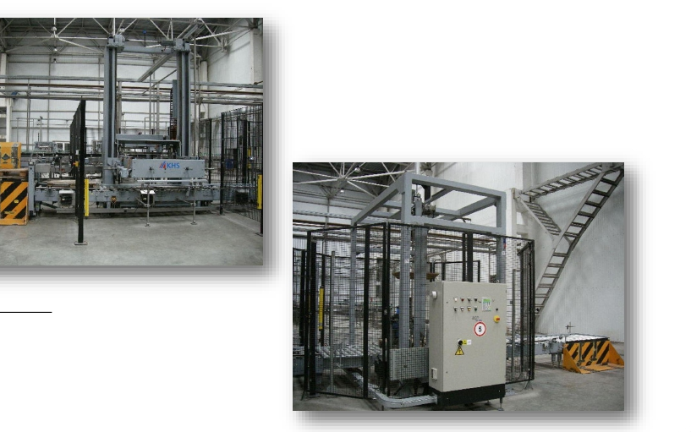

Offerprice: 595.000, 00EUR
Delivery term: As-Is, Where-Is
Payment term: 50 % down, 50 % before moving the equipment from this brewery
Other terms: Will be sold As-Is condition - can be dry tested machine by machine
Validity: This offer is valid 30 days, subject to prior sale without notice

