INSULATED MEDICAL TENT 20’W x 40’L x 10’H

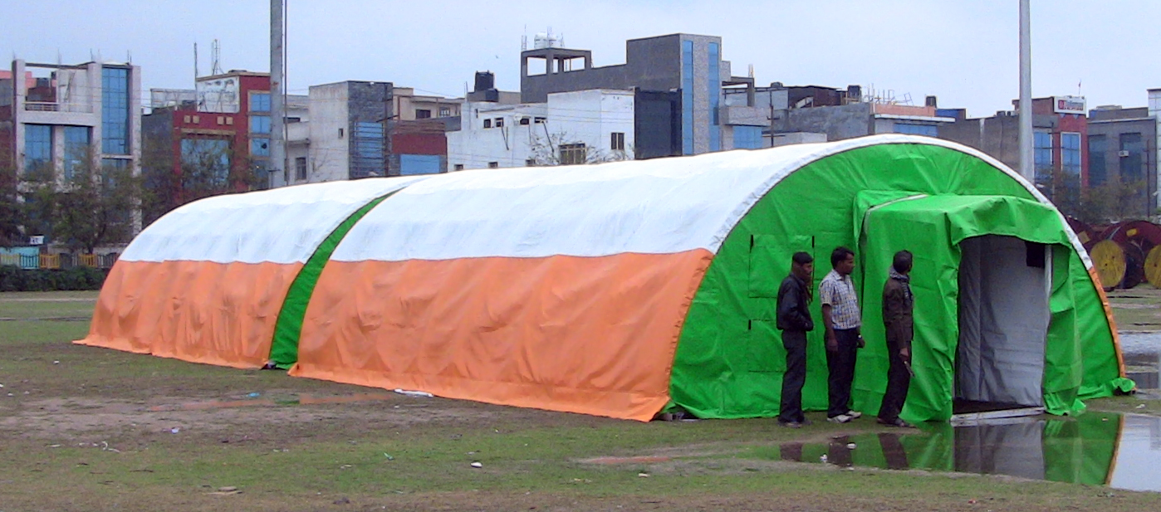

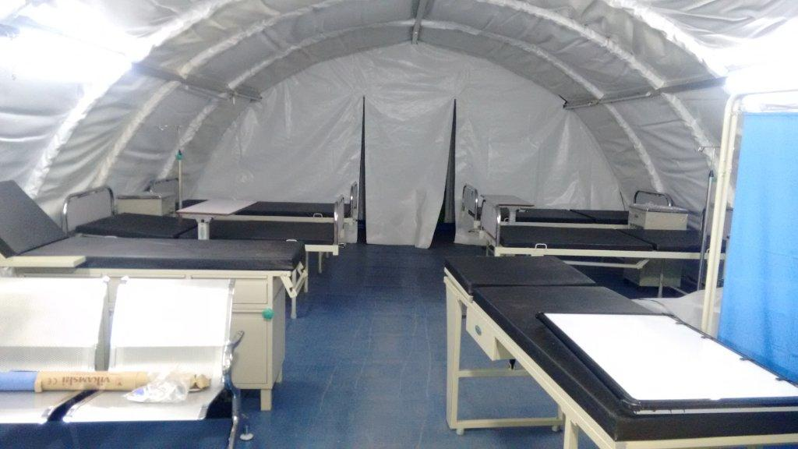

MEDIC- 40 AWT TENT SPECIFICATIONS:

Size: 20’ wide x 40’ long Insulated all Weather tent
Center Height: 10’high
Number Of beds 10 ICU Beds
Frame: Squair Extruded Aluminum alloy 6061/6082 T6
Outer Fabric: Desert Tan, Camouflage, Military Green, 18 oz PVC Fire rated & High UV-rated material
Middle Insulating Layer: 20mm thick flexible PU insulating sheet with Aluminized heat reflective coating on the outside. For reflecting heat outwards.
Inner Insulating layer White washable and fumigatable 9oz PVC Fire retardant sheeting with inner Utility net for hanging any kind of medical or electrical fixtures.
Doors: Insulated Front Steel Shelter Door 3.5’ x 7’ and a zipper door in the rear
Windows: 4 Numbers 20” x 20” screened & netted windows: 2 on front end wall, 2 on rear end wall and (10 on the main cover optional)
Snow Load 10Kg Sq Ft with canvus, Structure 40 Kg Sq ft.( Higher Snow Load Design On Order)
Wind Speed, Anchored 100 Km/ hr

Included Options:
- Three layered tenting system design on Squaire Aluminum Frame, for stable anchoring to the ground with temperature Insulation, Noise Insulation and Dust Prevention for use in forward surgical units as OT Tents, ICU tents, Or Recovery Tents.
- Tent Electrical – (10) 18-watt LED light fixtures. (1) – 20 amp load center panel with 6 duplex outlets (12 total plugs) per side. Plug and play electrical power can be configured for either 60Hz or 50 Hz.
- Vinyl Floor – 25 oz non-slip vinyl floor or 6” lip all around the perimeter that attaches to the side and end walls to prevent the intrusion of dust, insects and water from entering the shelter.
- Hard Honey Comb Flooring System (optional) – non-slip floor covering the complete interior of the tent. Slip fit-snap fit design individual 4’ x 4’ panels with interlocking design.
- Tent Vestibules (optional) – 4’wide x 8’long x 8’6” high vestibule that attaches completely weather tight to the front or Back of the tent
- ECU (Environmental Control Units) (optional) – (1) 5 ton ECU unit per tent. 50/60Hz ECU includes heat and A/C along with fresh air intake and exhaust – 18” interior ducts – 22” outside dimension. Interior fabric ducting to distribute air throughout the tent. Thermostat included, ECU unit provides minimum 60,000 BTU cooling and minimum 37,000 BTU heating. Pre-wired no certified electrician required to assemble. ECU ports on both front and rear fabric panels.
- Interior Liner – Insulates interior of tent. The tent will maintain between 74 degrees and 77 degrees Fahrenheit at an ambient temp of -10 degrees Fahrenheit through 100+ degrees Fahrenheit.
- Three/ single Phase Tent Electrical Distribution System for connecting to power source like generator (optional).

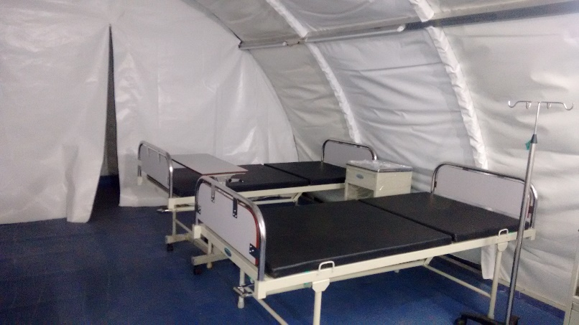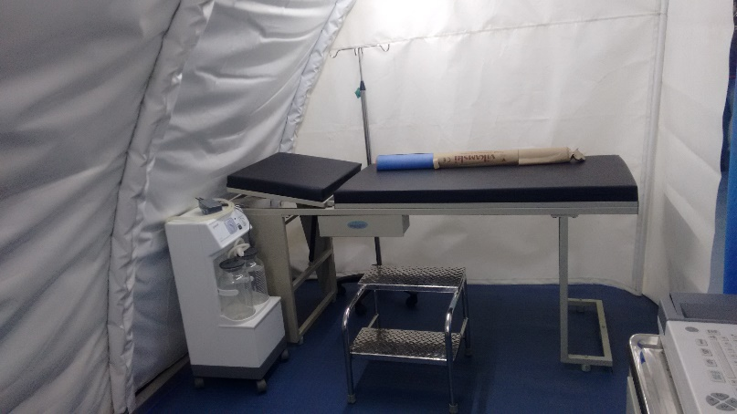

MEDIC- 20 AWT TENT SPECIFICATIONS:

Size: 20’ wide x 20’ long Insulated all Weather tent (Modular)
Center Height: 10’high
Number Of beds 4 ICU Beds
Frame: Squair Extruded Aluminum alloy 6061/6082 T6
Outer Fabric: Desert Tan, Camouflage, Military Green, 18 oz PVC Fire rated & High UV-rated material
Middle Insulating Layer: 20mm thick flexible PU insulating sheet with Aluminized heat reflective coating on the outside. For reflecting heat outwards.
Inner Insulating layer White washable and fumigatable 9oz PVC Fire retardant sheeting with inner Utility net for hanging any kind of medical or electrical fixtures.
Doors: Insulated Front Steel Shelter Door 3.5’ x 7’ and a zipper door in the rear
Windows: 4 Numbers 20” x 20” screened & netted windows: 2 on front end wall, 2 on rear end wall and (10 on the main cover optional)
Snow Load 10Kg Sq Ft with Cover, Structure 40 Kg Sq ft. (Higher Snow Load Design On Order)
Wind Speed, Anchored 100 Km/ hr

Included Options:
- Three layered tenting system design on Squair Aluminum Frame, for stable anchoring to the ground with temperature Insulation, Noise Insulation and Dust Prevention for use in forward surgical units as OT Tents, ICU tents, Or Recovery Tents.
- Tent Electrical – (6) 18-watt LED light fixtures. (1) – 20 amp load center panel with 4 duplex outlets (6 total plugs) per side. Plug and play electrical power can be configured for either 60Hz or 50 Hz.
- Vinyl Floor – 25 oz non-slip vinyl floor or 6” lip all around the perimeter that attaches to the side and end walls to prevent the intrusion of dust, insects and water from entering the shelter.
- Hard Honey Comb Flooring System (optional) – non-slip floor covering the complete interior of the tent. Slip fit-snap fit design individual 4’ x 4’ panels with interlocking design.
- Tent Vestibules (optional) – 4’wide x 8’long x 8’6” high vestibule that attaches completely weather tight to the front or Back of the tent
- ECU (Environmental Control Units) (optional) – (1) 3 ton ECU unit per tent. 50/60Hz ECU includes heat and A/C along with fresh air intake and exhaust – 18” interior ducts – 22” outside dimension. Interior fabric ducting to distribute air throughout the tent. Thermostat included, ECU unit provides minimum 40,000 BTU cooling and minimum 25,000 BTU heating. Pre-wired no certified electrician required to assemble. ECU ports on both front and rear fabric panels.
- Interior Liner – Insulates interior of tent. The tent will maintain between 74 degrees and 77 degrees Fahrenheit at an ambient temp of -10 degrees Fahrenheit through 100+ degrees Fahrenheit.
- Three/ single Phase Tent Electrical Distribution System for connecting to power source like generator (optional).

