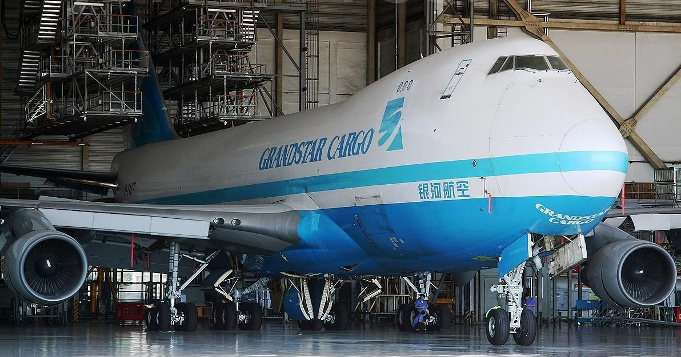
1996 Boeing 747-400 Freighter

Airframe
Aircraft type | B747-400F | Effective Date
Serial number |  | Previous Registration
Line number | N/A | New Registration
Total airframe hours since new | 70,818 | Date of manufacture | 1996/9/08
Total airframe cycles since new | 11,242

ENGINES | Engine 1 | Engine 2 | Engine 3 | Engine 4 |  | APU
Type/ model | PW4056 | PW4056 | PW4056 | PW4056 |  | PW901A
S/N of delivered engines/ APU | P727567 | P717645C  N | P727627 | P727693 |  | PCE900523
Current Type/ model | PW4056 | PW4056 | PW4056 | PW4056 |  | PW901A
Current Installed | Engine 1 | Engine 2 | Engine 3 | Engine 4 |  | APU
Thrust rating
Time Since New | 52743 | 71480 | 57118 | 55420 |  | 19368
Cycles Since New | 9455 | 10690 | 8191 | 7991 |  | 19969
Time Since Last Shopvisit | 4602 | 16794 | 19619 | 19024 |  | 2736
Cycles Since Last Shopvisit | 710 | 2761 | 3145 | 2812 |  | 2948
Cycles remaining first limiter | 4072 | 913 | 212 | 2077 |  | 10031
 | SEAL-AIR HPC INLET | SEAL-AIR LPT STG5 | SEAL-AIR LPT STG5 | RET PLATE- H PT  STG2 |  | IMPELLER HIGH COMPRESSOR
First limiter Description |  |  |  |  |  | DISC HIGH  TURBINE
 |  |  |  |  |  | ROTOR DISC
 |  |  |  |  |  | POWER
 |  |  |  |  |  | TURBINE
 |  |  |  |  |  | ROTOR

LANDING GEARS | NLG | LH Wing LG | RH Wing LG | LH Body LG | RH Body LG
Part number | 162U1000  93 | 161U100093 | 163U100067 | 163U100067 | 163U100068
Serial number installed | BFG2121 | BFG3055 | BFG3051 | BFG6076 | BFG6071
Total time since new | 80977
Total cycles since new | 9789 | 9789 | 9789 | 9789 | 9789
Time since overhaul
Cycles since overhaul | 5685 | 5685 | 5685 | 5685 | 5685
Time between overhaul
Last overhaul date | 2003/07/2  3 | 2003/07/23 | 2003/07/23 | 2003/07/23 | 2003/07/23

OPERATIONAL WEIGHTS
Date last weighting | 2017-08-08
Maximum Take-Off Weight | 396893 | Kg | 870,000 | Lbs
Maximum Taxi Weight | 398254 | Kg | 878,000 | Lbs
Maximum Landing Weight | 295742 | Kg | 652,000 | Lbs
Maximum Zero Fuel Weight | 276691 | Kg | 610,000 | Lbs
Basic Empty Weight |  | Kg | 355,880 | Lbs
Operating Empty Weight |  | Kg | 357,614 | Lbs

FUEL
Fuel Quantity Indication units | KG
Fuel Flow Indication units | KG
Total Fuel Capacity | 172741
Capacity Main Tank 1 or 4 | 14079
Capacity Main Tank 2 or 3 | 40400
Capacity Reserve Tank 2 or 3 | 4256
Capacity Center Tank | 55271

MAINTENANCE
A-check performed C-check performed
D-checks are performed
A-checks and line Maintenance C/checks are performed
Maintenance history | Date | Hours | Cycles | Location
7C | 2012-12-01 | 70818 | 11242 | AMECO
2D | 2009-06-16 | 61167 | 9789 | AMECO

SPECIAL OPERATION
RNAV-1, RNAV-2, RNAV-5, RNAV-10(RNP-10), Basic RNP-1, RNP-4, RNP APCH, RVSM,
CPDLC,CAT II
INTERIOR CONFIGURATION
Cargo-Configuration
747-400 PTF, The crew rest area is located in upper deck, Two double-seat, total 4 seats in upper

Deck
Additional Equipment
ATA | Description | Qty | Manufacturer | Remark
22 | Flight Control Computer | 3 | ROCKWELL  COLILINS | 622-8757-105
22 | Mode Control Panel | 1 | ROCKWELL  COLILINS | 622-8780-101
23 | PA Amplifier | 1 | BAE(V89954) | 284U1100-607
23 | HF Transceiver | 2 | ROCKWELL  COLILINS | 622-5272--120
23 | VHF Transceiver | 3 | ROCKWELL  COLILINS | 822-0323-002
23 | SELCAL Decoder | 1 | TEAM TELECOMMU NICATIONS ELECTRONIQ  UE(VF6168) | SC2253AD01
23 | ACARS Management Unit | 1 | HONEYWELL | 965-0758-001
23 | SATCOM High Power Amp | 1 | TIMCO | 284U1386-50
31 | Flight Data Recorder | 1 | HONEYWELL | 980-4700-033
31 | Flight Data Acquisition Unit | N/A |  | ONLY DFDAC
31 | Accelerometer | 1 | ALLIED-SIGN AL AEROSPACE(  V96774) | 18-3001-3
31 | EFIS System | 1 | ROCKWELL  COLILINS | /
31 | EICAS System | 1 | ROCKWELL  COLILINS | /
31 | Data Management Unit | 1 | HONEYWELL | 965-0680-003
31 | Airborne Data Loader | N/A |  | MAWEA
34 | Air Data Computer | 2 | HONEYWELL | 4040800-908
34 | GPWS Computer | 1 | HONEYWELL | 965-0976-003-222-222
34 | Inertial Reference Unit | 3 | HONEYWELL | HG1050AD11
34 | VHF Navigation | 3 | ROCKWELL  COLILINS | /
34 | DME | 2 | ROCKWELL | 622-4540-122

 |  |  | COLILINS
34 | Radio Altimeter | 3 | ROCKWELL  COLILINS | 622-4542-120
34 | Weather Radar | 2 | ROCKWELL  COLILINS | 622-5132-633
34 | TCAS Computer | 1 | HONEYWELL | 4066010-910
34 | ATC Transponder | 2 | HONEYWELL | 7517800-1109
34 | Marker Beacon Receiver | 2 | ROCKWELL  COLILINS | 822-0726-120
34 | ADF Receiver | 2 | HONEYWELL | 622-5222-120
34 | Flight Management Comp | 2 | HONEYWELL | 4052508-952
34 | Multi-Mode ILS Receiver | 3 | ROCKWELL  COLILINS | 822-1152-002

