Quotation for container house

No | item | specification | picture | quantity loaded in container | unit price
1 | container frame ADITR18-F | Size:W3010*L5940*H2810mm  2.2mm galvanized frame+powder coating for top and bottom main frame 2.3mm galvanized  frame+powder coating for post 14pcs 80*40 galvanized tube steel for bottom secondary beam  galvanized tube steel for top secondary beam  Without top and bottom panel Without wall,roof,window,door | 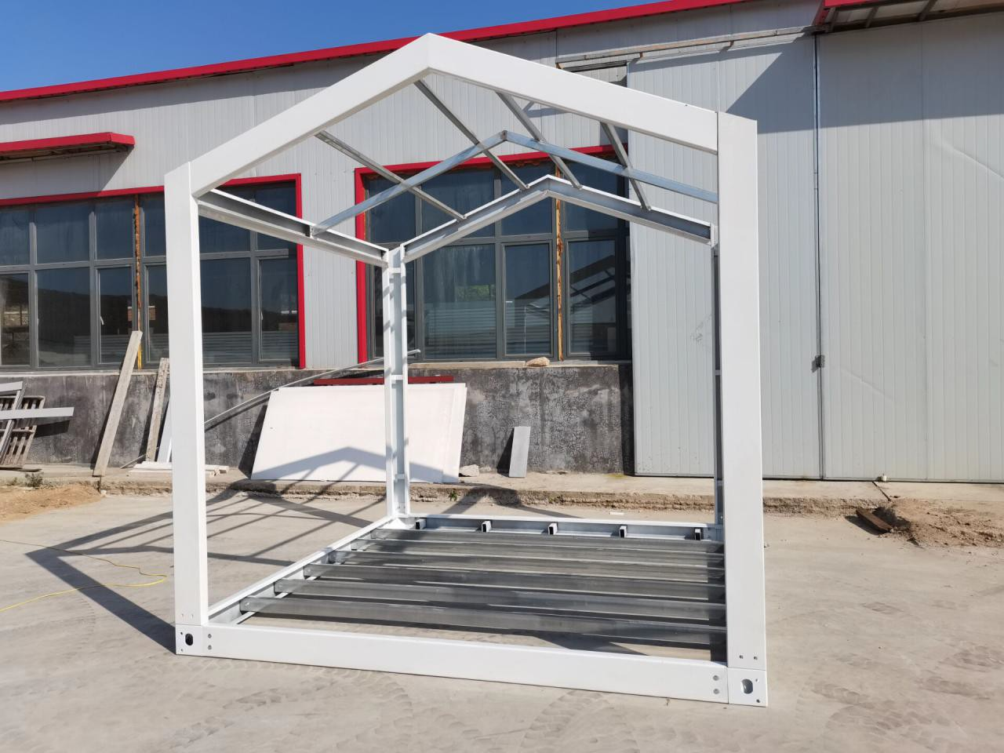 | 1*20ft container can load 25 units,1*40HC container can load 50 units | USD 1,200/UNIT EXW
2 | ADITR18-1 | Size:W3010*L5940*H2810mm  50mm sandwich panel for wall colorbond steel sheet for roof 50mm eps sandwich panel for ceiling  two single glazed pvc sliding window  one steel security door 16mm reinforced mgo board for floor  without electricity | 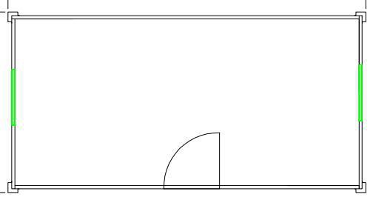 | 1*20ft container can load 5 units,1*40HC container can load 12 units | USD 2,631/UNIT EXW  1.6mm pvc floor tile plus USD 100/set

3 | ADITR18-2 | Size:W3010*L5940*H2810mm  50mm sandwich panel for wall colorbond steel sheet for roof 50mm eps sandwich panel for ceiling  Steel security door  Sliding window single glazed Wash basin,toilet,shower without electricity with plumbing  16mm reinforced MGO  board+1.6mm pvc floor | 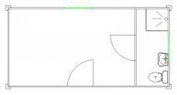 | 1*20ft container can load 4 units,1*40HC container can load 10 units | USD 3,754/UNIT EXW
4 | ADITR18-3 | Size:W3010*L5940*H2810mm  50mm sandwich panel for wall colorbond steel sheet for roof 50mm eps sandwich panel for ceiling  Steel security door  Sliding window single glazed Wash basin,toilet,shower with kitchen bottom cabinet,stainless steel countertop,basin,faucet without electricity with plumbing  16mm reinforced MGO board+1.6mm pvc floor | 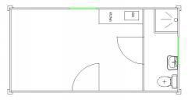 | 1*20ft container can load 4 units,1*40HC container can load 9 units | USD 4,062/UNIT EXW
remark
payment terms:50% deposit by T/T,50% balance before shipment
valid time:in 7 days
lead time:30-40 days
the quotation is EXW price,fob charges for 1*20ft container is USD 800,
fob charges for 1*40HC container is USD 1,000

material list for triangle roof container house
Project name: |  |  | Project No.:
Specification: |  | W3010*L5940*H2810mm | Area: | 18.0 | m2

NO | ITEM |  | SPECIFICATION |  | UNIT | QUANTI TY |  |  | PICTURE
1 | frame | top main beam |  | 2.2mm thickness galvanized steel frame+powder coating | SET | 1.0 |  |  | 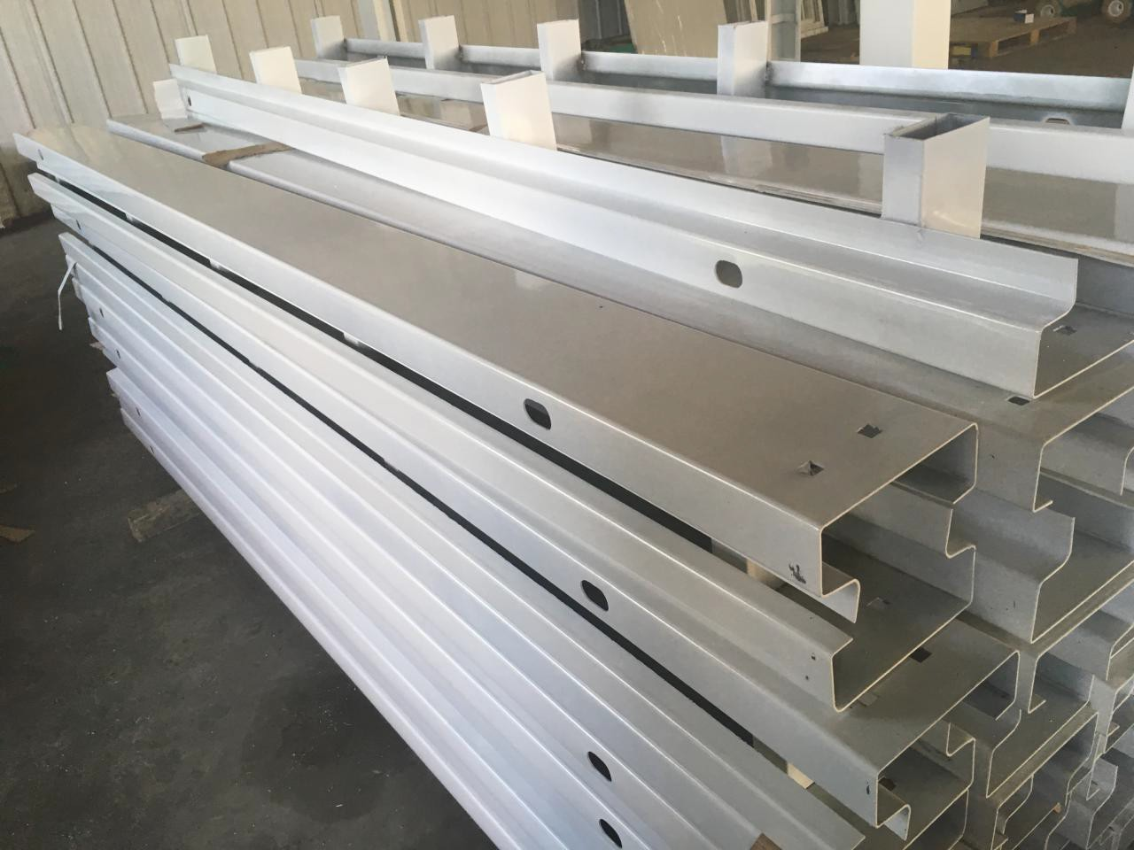
2 |  | bottom main beam |  | 2.2mm thickness galvanized steel frame+powder coating
3 |  | post |  | 2.3mm thickness galvanized steel frame+powder coating |  |  |  |  | 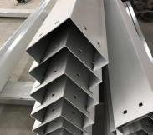
4 |  | top and bottom secondary beam |  | galvanized tube steel |  |  |  |  | 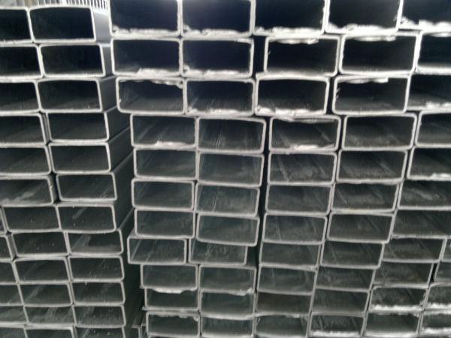
4 |  | lifting point |  | 3.75mm steel+powder coating |  |  |  |  | 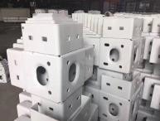
5 |  | bolt |  |  |  |  |  |  | 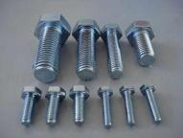
6 | floor board | mgo board |  | 16mm thickness reinforced | SET | 1.0 |  |  | 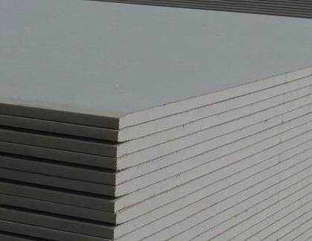
7 | inside decoration | with floor skirting,corner decoration |  |  |  |  |  |  | 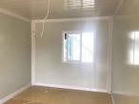
8 | top panel | 0.4mm colorbond steel sheet for roof+50mm eps sandwich panel for ceiling
9 | wall panel | sandwich panel |  | 50mm thickness eps sandwich panel double skin 0.4mm 10kg/m3 |  |  |  |  | 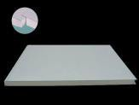

10 | door | steel door | each unit with one set size 930*2030mm |  |  |  |  | 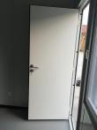
11 | window | pvc sliding window single glazed | each unit with two set size 930*1200mm |  |  |  |  | 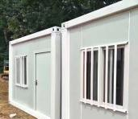
12 | surface floor tile |  | 1.6mm pvc floor | set | 1.0 |  |  | 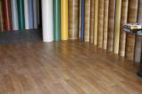
13 | bathroom partition |  | sandwich panel+one door+extra corner decoration | set | 1.0
14 | shower head |  | simple type | set | 1.0 |  |  | 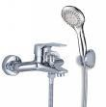
15 | shower pan |  | 900*900 mm | set | 1.0 |  |  | 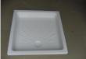
16 | toilet | ceremic seat toilet | universal standard | set | 1.0 |  |  | 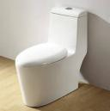
17 | wash basin | with faucet etc accessories | universal standard | set | 1.0 |  |  | 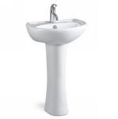
18 | kitchen | with bottom cupboard,st ainless  steel countertop | universal standard | set | 1.0 |  |  | 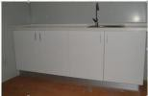
19 | plumbing | pvc,ppr pipe,elbw etc | inside the house | set | 1.0 | 0
20 | TOTAL |  | EXW |  |  |  | US$3,962

advantage

the advantage of our company and collapsible container frame/house is as follows

- modular house manufacture with CE and ISO certificate, with professional QC and after sale team to ensure the quality
- all bolt connection,take less space in container
- professional pacakge:steel pallet +plastic film(most of the supplier will load the materials of modular house pieces by pieces in container,it is hard to get damaged during shipping)
- competitive price with good quality:we lower the price without lower the quality to give distributor more profit to do bigger business together
- galvanized frame+powder coating,hard to get rusted.wall and roof with 50mm insulation
- triangle roof design,better for big rain and snow area
- all bolt connection to smaller parts,don’t need crane for installation

