PRICE LIST OF TRIANGLE ROOF CONTAINER HOUSE

1.Summary

- With triangle roof, good for heavy snow and rain area

- 50mm eps sandwich panel for wall and ceiling

- 0.4mm corrugated colorbond steel sheet for roof

- all bolt connection to small items,take less space and don't need crane for installation, can have fun to diy at home

- in mass production,the price is competitive

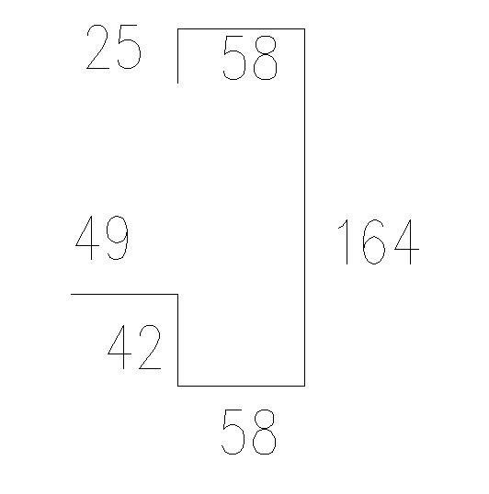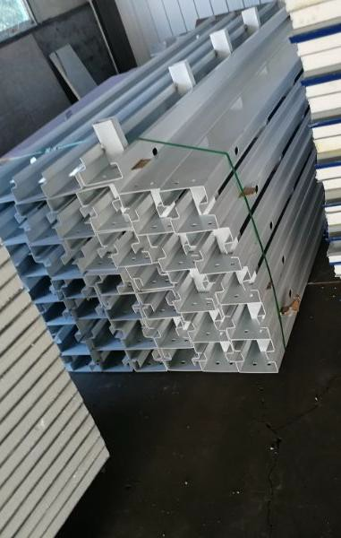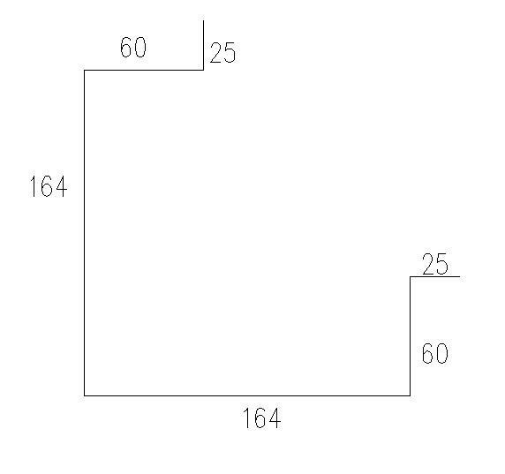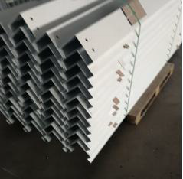technical features

NO | ITEM |  | SPECIFICATION | PICTURE
1 | FRAME  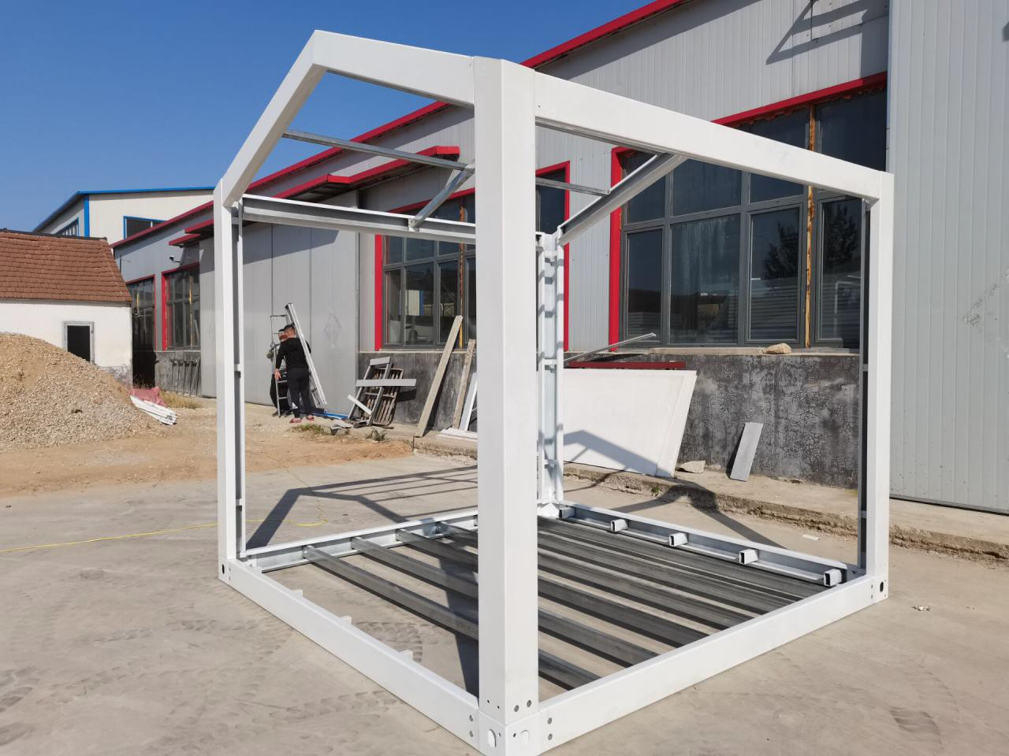 | TOP&BOTTOM  main beam | 2.2mm thickness galvanized steel+powder coating | 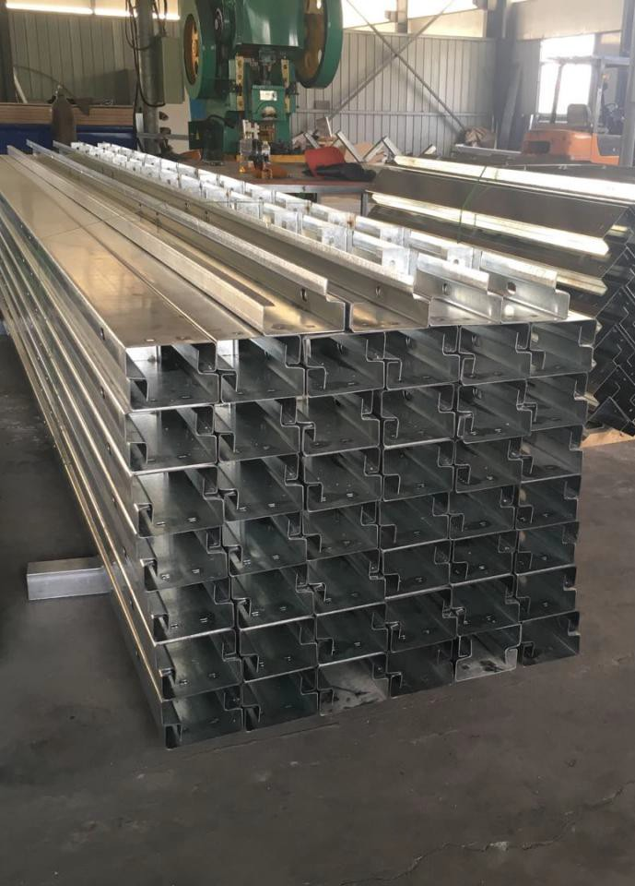
2 |  | COLUMN | 2.3mm thickness galvanized steel+powder coating | 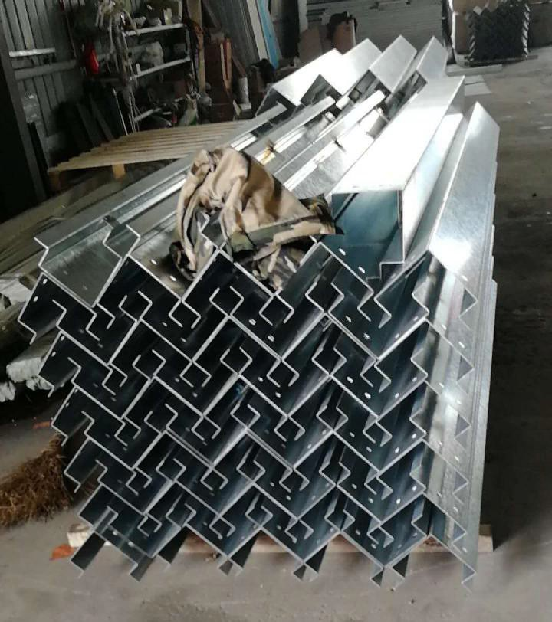

3 |  | Lifting points | 4mm thickness steel+powder coating | 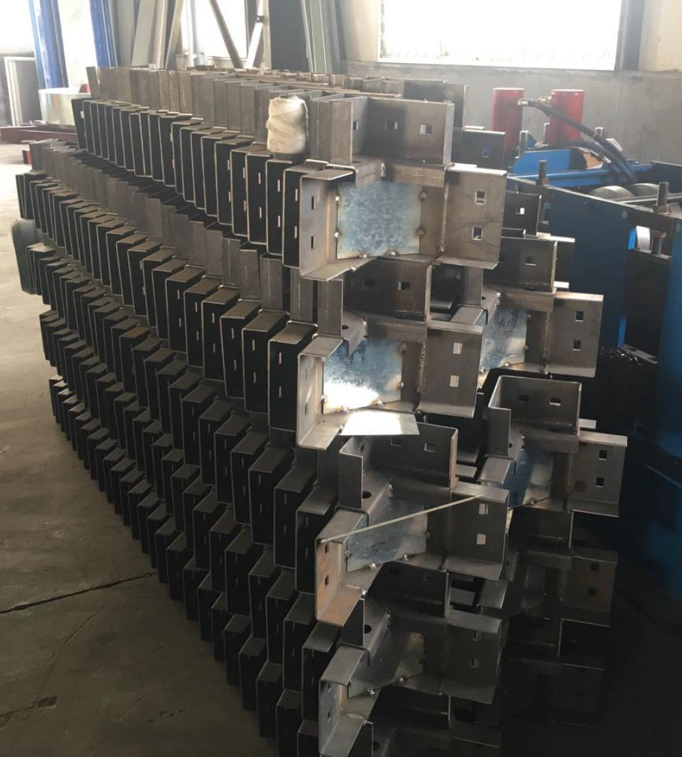
4 |  | Floor secondary beam | With 14pcs 80*40*2980mm*1.2mm galvanized tube steel | 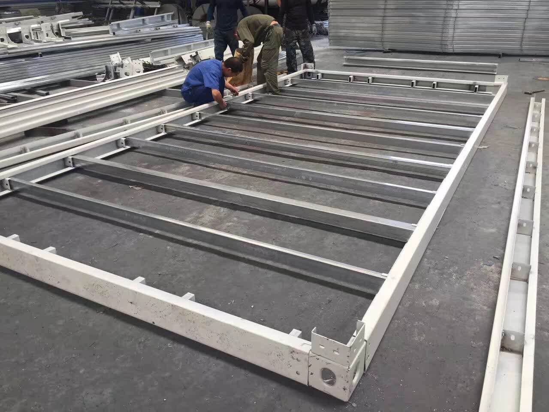
5 | Wall panel | EPS sandwich panel | 50mm/75mm thickness double skin 0.4mm,density 10KG/m3 | 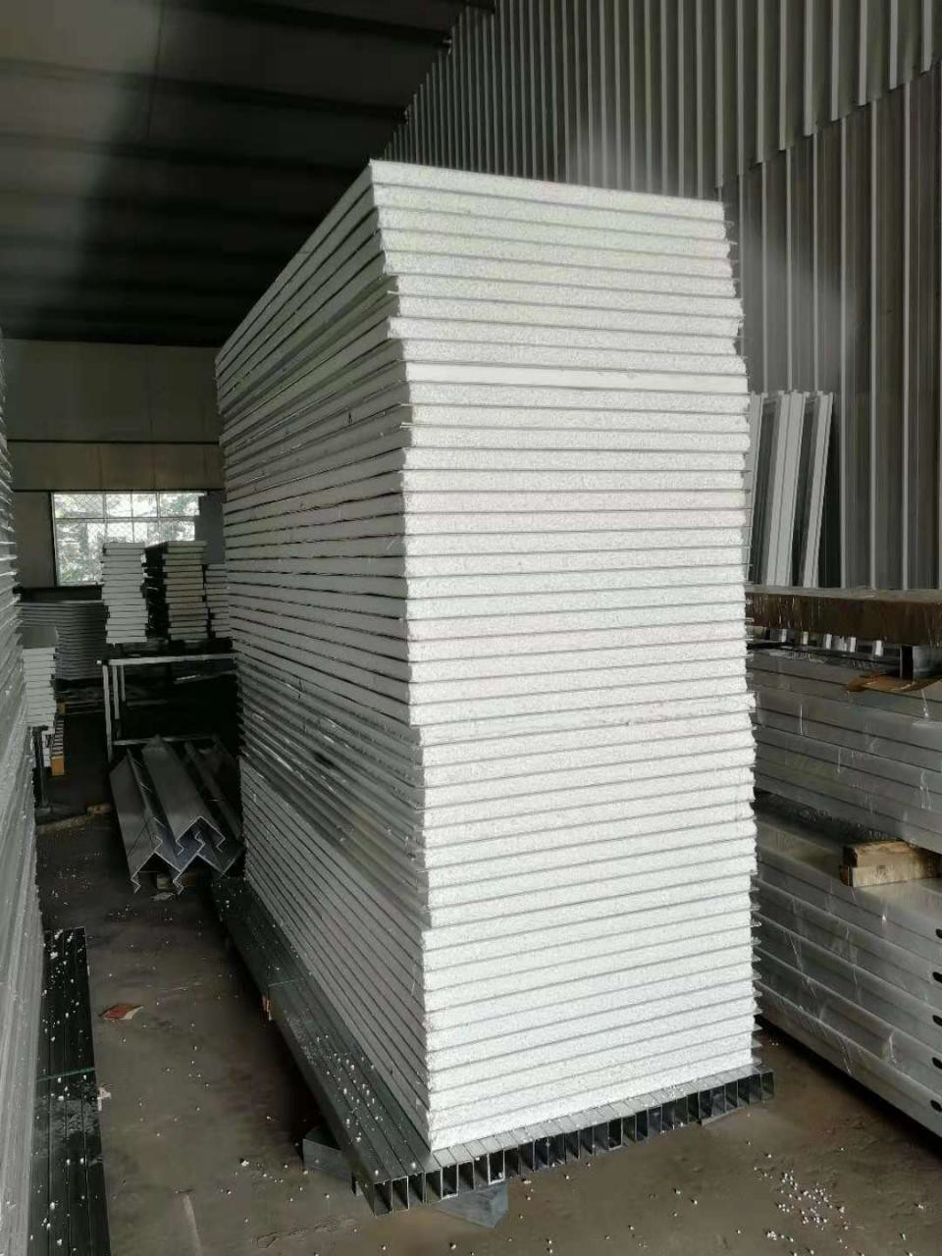
6 | ceiling | EPS sandwich panel | 50mm/75mm thickness double skin 0.4mm,density 12KG/m3 | 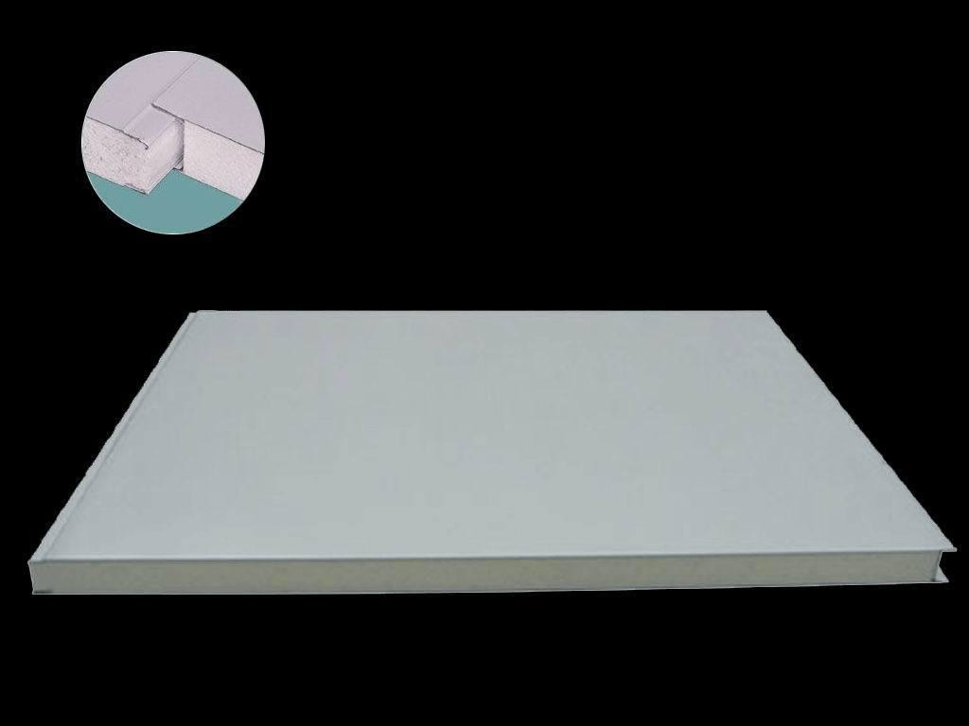
7 | Roof panel | 840 style corrugated Colorbond steel sheet | 0.4mm thickness | 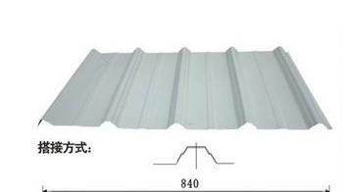
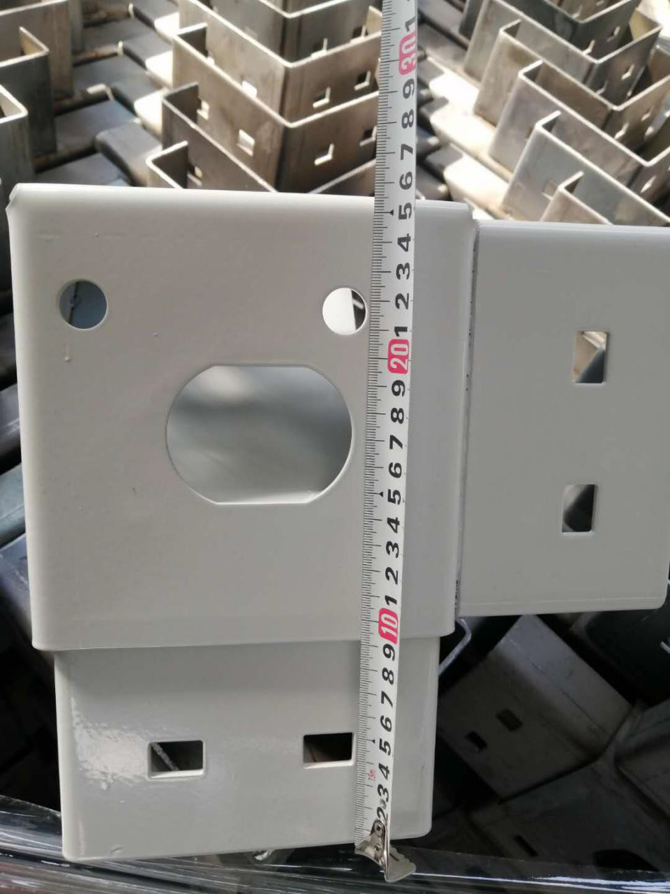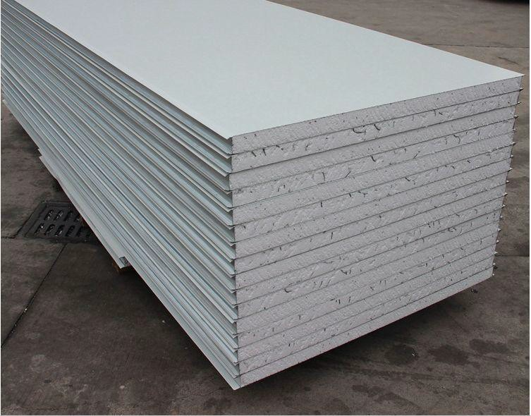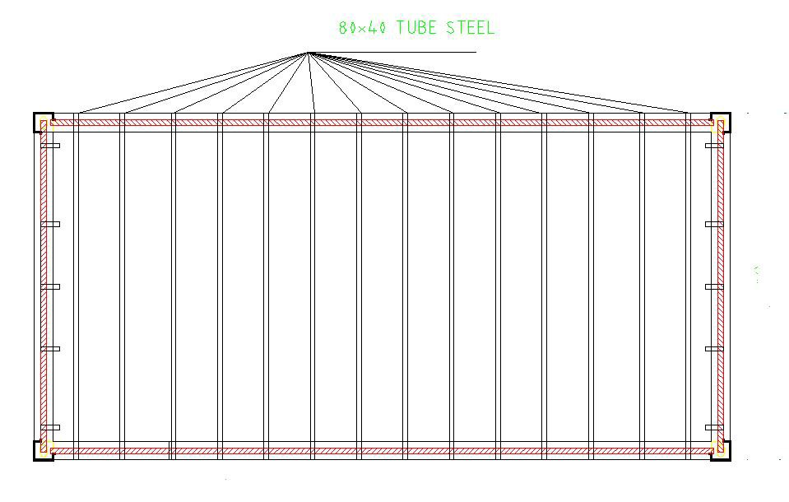

8 | Window&door | Steel door | Size 930*2030mm | 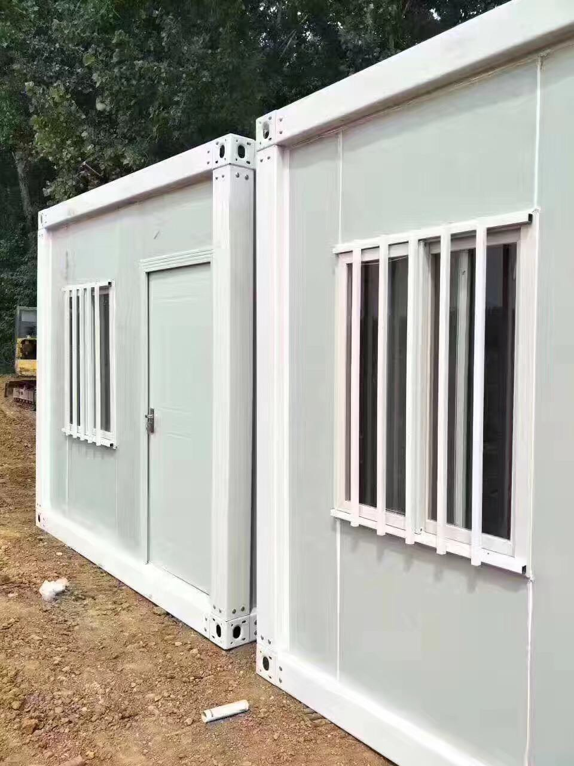
9 |  | Pvc sliding window | Size 930*1200mm single/double glazed with security grill
10 | floor | Sub floor | 16mm thickness MGO board (magnesium oxide board)/18mm fiber cement board | 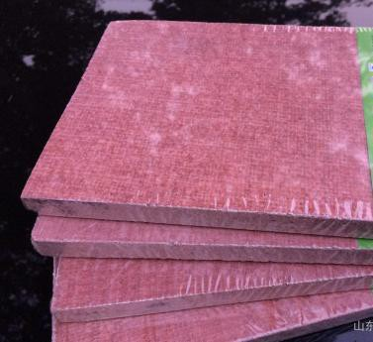
11 |  | Surface floor | 1.6mm thickness pvc tile
12 | Economic Bathroom&kitch en | bathroom | shower head,shower pan,seat toilet,wash basin | 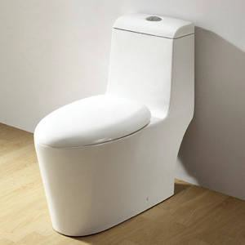
13 |  | kitchen | Bottom cabinet with stainless steel countertop,with stainless steel basin,with faucet | 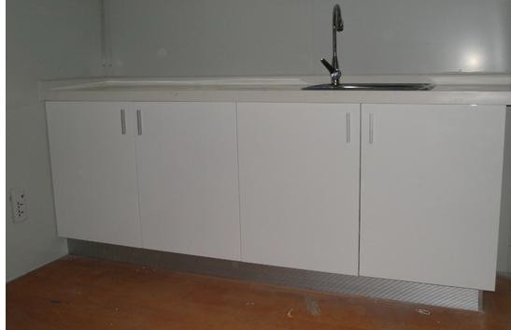
14 | Higher quality bathroom&kitche n | bathroom | Glass shower cabin,seat toilet,wash basin with mirror and cabinet | 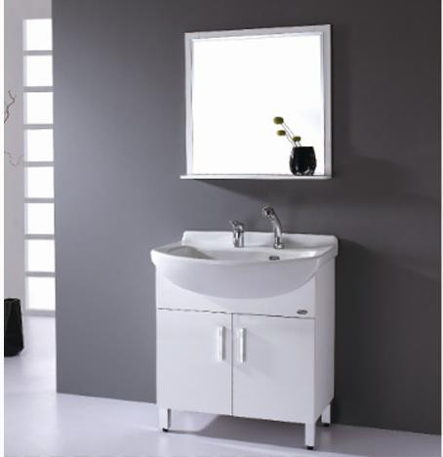
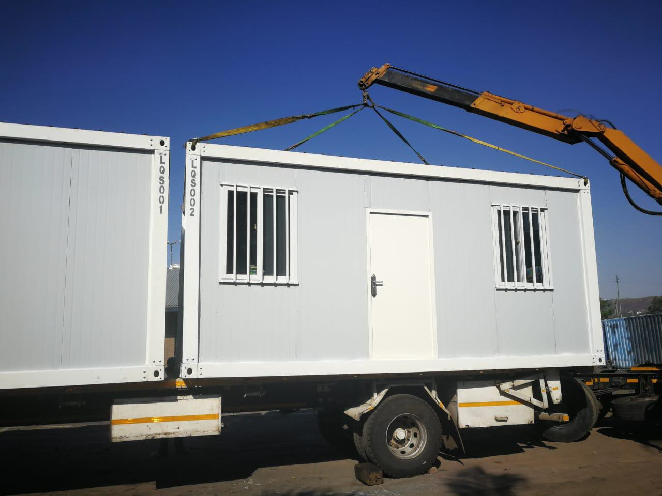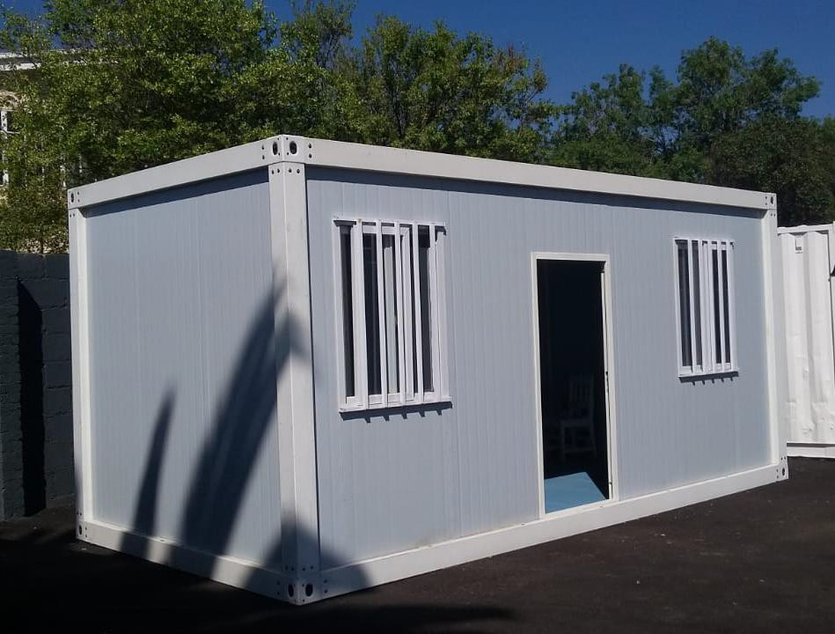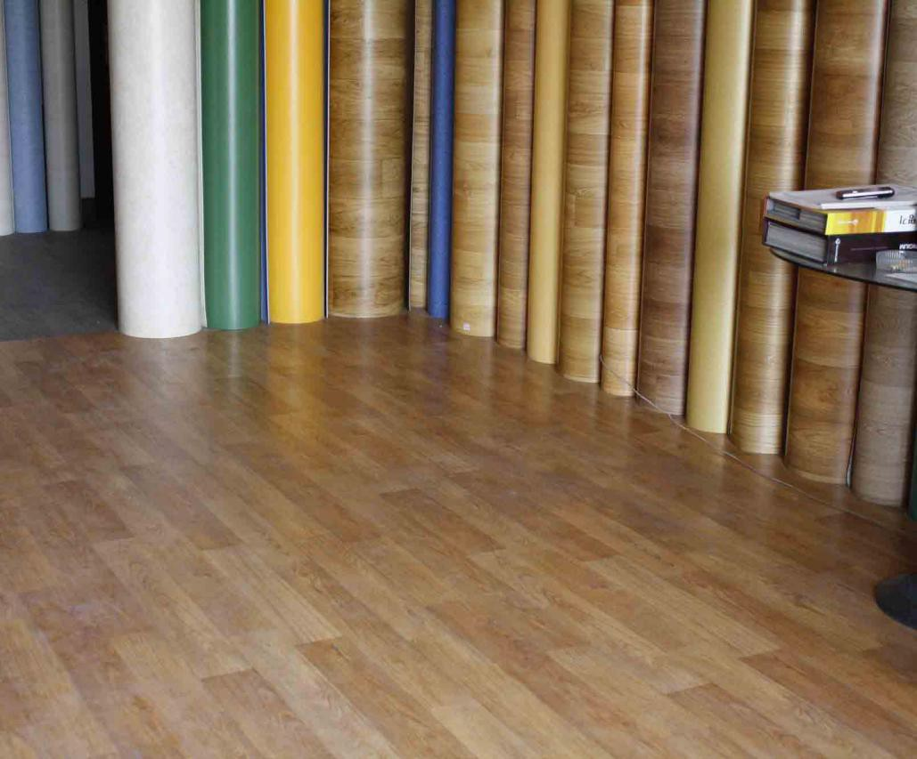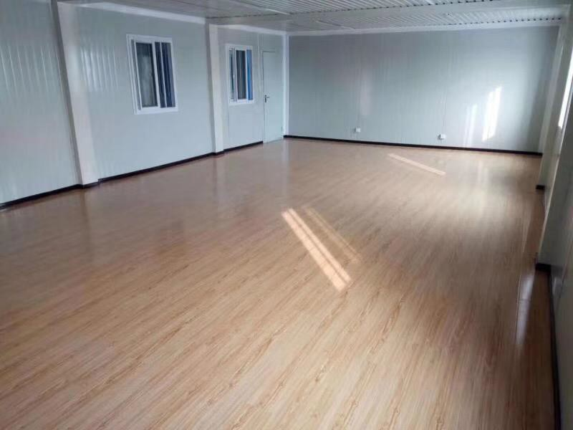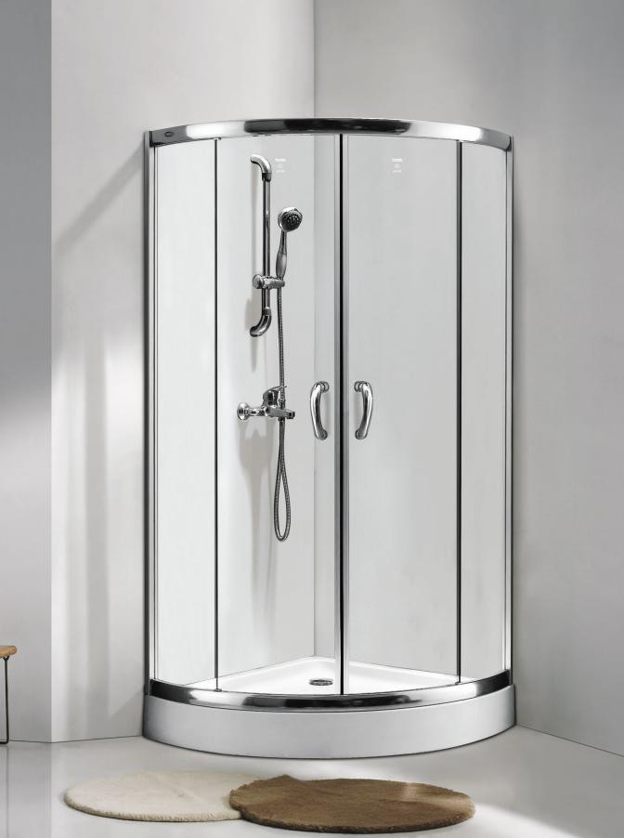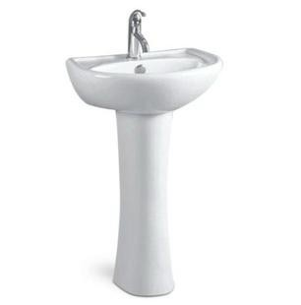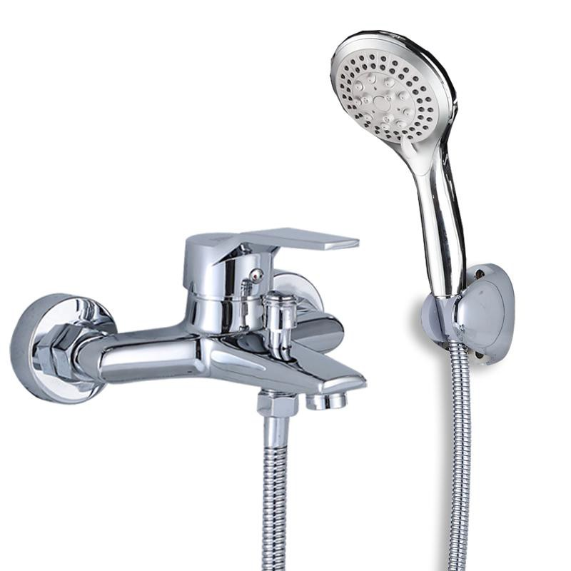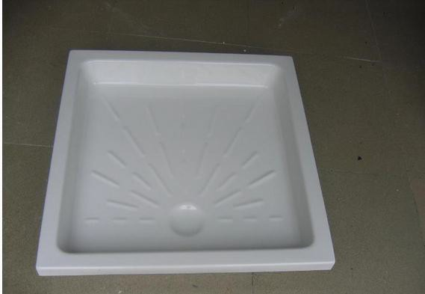

15 |  | kitchen | Bottom & top cabinet with stainless steel counter top,with stainless steel basin,with faucet | 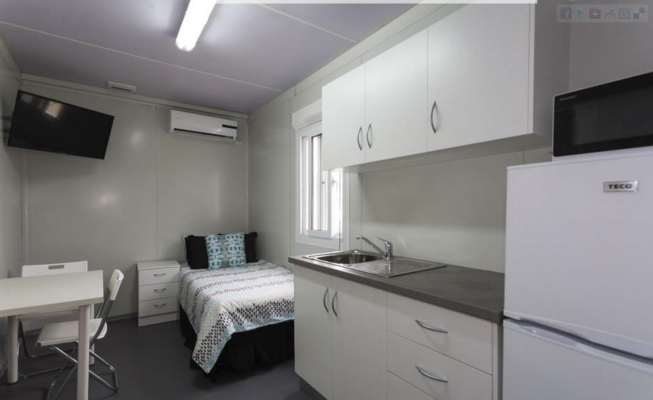
16 | Electricity | Suggest client buy locally due to regulations

- 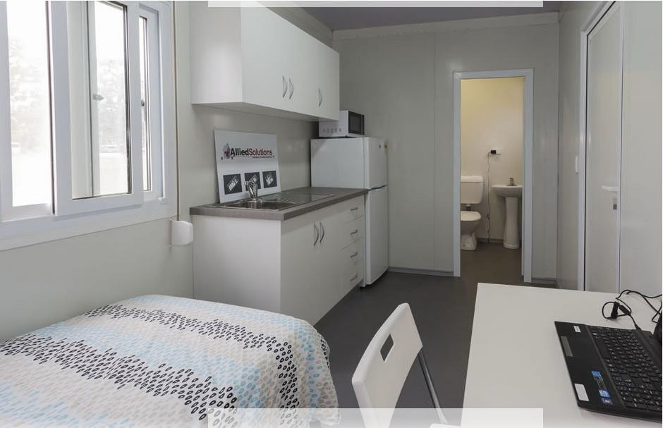catalogue of triangle roof container frame

model |  |  |  | Layout | Description | Loading | Unit price  EXW
 | ADITR18-F |  |  | 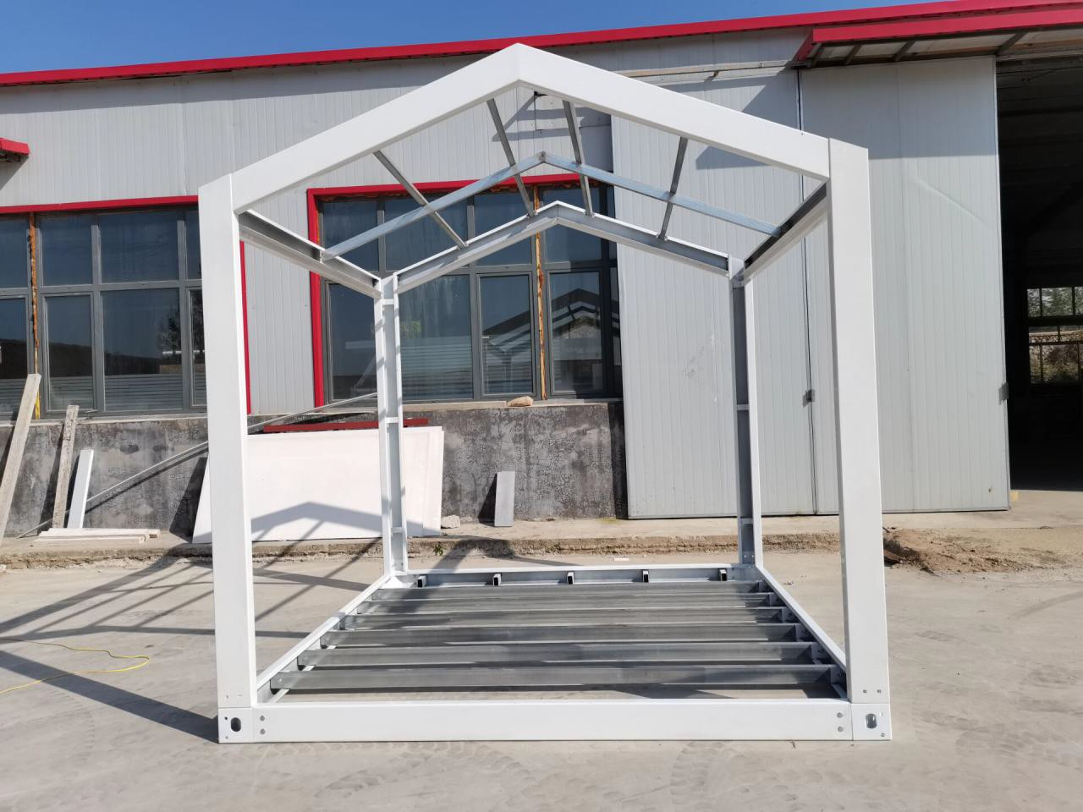 | Size:W3010*L5940*H2810mm  - mm galvanized frame+powder coating for top and bottom main frame  - mm galvanized frame+powder coating for post  14pcs 80*40 galvanized tube steel for bottom secondary beam  galvanized tube steel for top secondary beam  Without top and bottom panel  Without wall,roof,window,door | 1*20FT  container can load 25sets 1*40HC  container can load 50 units  etc | USD 1,450/UNIT EXW
 | HOT
SALE!!!

ADITR9-F |  | Size:W3010*L3010*H2810mm  - mm galvanized frame+powder coating for top and bottom main frame  - mm galvanized frame+powder coating for post  14pcs 80*40 galvanized tube steel for bottom secondary beam  galvanized tube steel for top secondary beam  Without top and bottom panel  Without wall,roof,window,door | 1*20FT  container can load 32sets 1*40HC  container can load 65 units | USD $1.327/UNIT EXW
ADITR12-F |  | Size:W3010*L3950*H2810mm  - mm galvanized frame+powder coating for top and bottom main frame  - mm galvanized frame+powder coating for post  14pcs 80*40 galvanized tube steel for bottom secondary beam  galvanized tube steel for top secondary beam  Without top and bottom panel  Without wall,roof,window,door | 1*20FT  container can load 29 sets 1*40HC  container can load 58 units | USDUSD1,416/UNIT EXW
ADITR15-F |  | Size:W3010*L4990*H2810mm  - mm galvanized frame+powder coating for top and bottom main frame  - mm galvanized frame+powder coating for post  14pcs 80*40 galvanized tube steel for bottom secondary beam  galvanized tube steel for top secondary  beam | 1*20FT  container can load 26 sets 1*40HC  container can load 53 units | USD$1,493/UNIT EXW

Without top and bottom panel
Without wall,roof,window,door
ADITR21-F |  | Size:W3010*L6890*H2810mm  - mm galvanized frame+powder coating for top and bottom main frame  - mm galvanized frame+powder coating for post  80*40 galvanized tube steel for bottom secondary beam  galvanized tube steel for top secondary beam  Without top and bottom panel | 1*40HC  container can load 42 units,1*20ft container can load 21 units | USD1.657/UNIT EXW
ADITR24-F |  | Size:W3010*L7840*H2810mm  - mm galvanized frame+powder coating for top and bottom main frame  - mm galvanized frame+powder coating for post  80*40 galvanized tube steel for bottom secondary beam  galvanized tube steel for top secondary beam  Without top and bottom panel | 1*40HC  container can load 37 units,1*20ft container can load 18 units | USD1,814/UNIT EXW
ADITR27-F |  | Size:W3010*L8790*H2810mm  - mm galvanized frame+powder coating for top and bottom main frame  - mm galvanized frame+powder coating for post  80*40 galvanized tube steel for bottom secondary beam  galvanized tube steel for top secondary  beam | 1*40HC  container can load 35 units,1*20ft container can load 17 units | USD1,908/UNIT EXW

 |  | Without top and bottom panel
ADITR36-F |  | Size:W3010*L12115*H2810mm  - mm galvanized frame+powder coating for top and bottom main frame  - mm galvanized frame+powder coating for post  80*40 galvanized tube steel for bottom secondary beam  galvanized tube steel for top secondary beam  Without top and bottom panel | 1*40HC  container can load 27 units,1*20ft container can load 13 units | USD2,282/UNIT EXW
ADITR24-FA |  | Size:W3960*L5940*H2810mm  - mm galvanized frame+powder coating for top and bottom main frame  - mm galvanized frame+powder coating for post  14pcs 80*40 galvanized tube steel for bottom secondary beam  galvanized tube steel for top secondary beam  Without top and bottom panel | 1*40HC  container can load 37 units,1*20ft container can load 18 units | USD1,660/UNIT EXW
ADITR30-F |  | Size:W4910*L5940*H2810mm  - mm galvanized frame+powder coating for top and bottom main frame  - mm galvanized frame+powder coating for post  14pcs 80*40 galvanized tube steel for bottom secondary beam  galvanized tube steel for top secondary beam  Without top and bottom panel | 1*40HC  container can load 33 units,1*20ft container can load 16 units | USD1,788/UNIT EXW

ADITR36-FA |  | Size:W5860*L5940*H2810mm  - mm galvanized frame+powder coating for top and bottom main frame  - mm galvanized frame+powder coating for post  14pcs 80*40 galvanized tube steel for bottom secondary beam  galvanized tube steel for top secondary beam  Without top and bottom panel | 1*40HC  container can load 30 units,1*20ft container can load 15 units | USD1,912/UNIT EXW

Catalogue of triangle roof open room container house

model |  |  |  | Layout | Description | Loading | Unit price  EXW
 | ADITR18-1 |  |  | 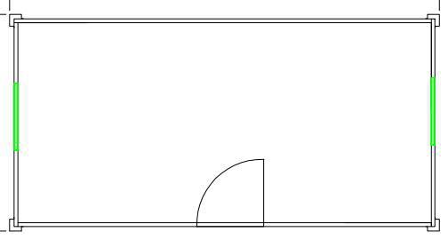 | Size:W3010*L5940*H2810mm  50mm sandwich panel for wall colorbond steel sheet for roof  50mm eps sandwich panel for ceiling two single glazed pvc sliding window  one steel security door | 1x40ft HQ container can load 12 sets, 1*20FT  container can  load 5 sets | USD 3,131/UNIT EXW  75mm thickness insulation plus USD 160/set  1.6mm pvc floor tile plus USD 100/set Double glazed window plus USD  80/set
 | HOT
SALE!!!

 |  | 16mm reinforced mgo board for floor  without electricity |  | 18mm Fiber cement board floor plus  USD 100/SET
ADIDRL18-1  higher quality |  | Size:W3010*L5940*H2810mm  75mm sandwich panel for wall colorbond steel sheet for roof  75mm eps sandwich panel for ceiling two double glazed pvc sliding window one steel security door  18mm fiber cement board+1.6mm pvc tile for floor  without electricity | 1x40ft HQ container can load 9 sets, 1*20FT  container can load 4 sets | USD3,571/UNIT EXW
ADITR9-1 | 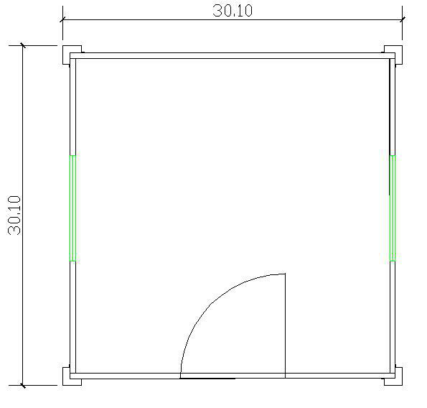 | Size:W3010*L3010*H2810mm  50mm sandwich panel for wall colorbond steel sheet for roof  50mm eps sandwich panel for ceiling two single glazed pvc sliding window one steel security door  16mm reinforced mgo board for floor without electricity | 1*20FT  container can load 8sets 1*40HC  container can load 18 units | USD 2,569/UNIT EXW  1.6mm thickness Pvc floor tile plus USD 70/set  75mm thickness insulation plus USD 100/set  Double glazed window plus USD 80/set  18mm Fiber cement board floor plus USD 60/SET
ADITR12-1 | 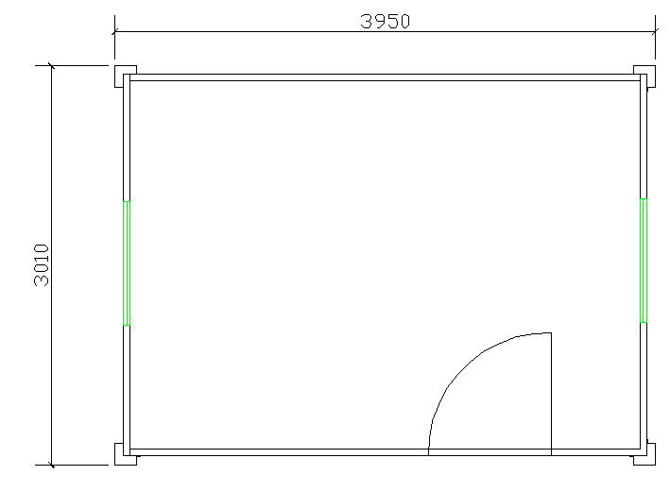 | Size:W3010*L3950*H2810mm  50mm sandwich panel for wall colorbond steel sheet for roof  50mm eps sandwich panel for ceiling two single glazed pvc sliding window one steel security door  16mm reinforced mgo board for floor without electricity | 1*20FT  container can load 6sets 1*40HC  container can load 14 units | USD 2,792/UNIT EXW  1.6mm thickness Pvc floor tile plus USD 90/set  75mm thickness insulation plus USD 120/set  Double glazed window plus USD 80/set  18mm Fiber cement board floor plus  USD 80/SET

ADITR15-1 | 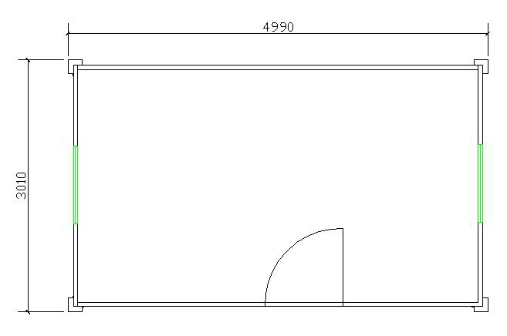 | Size:W3010*L4990*H2810mm  50mm sandwich panel for wall colorbond steel sheet for roof  50mm eps sandwich panel for ceiling two single glazed pvc sliding window one steel security door  16mm reinforced mgo board for floor without electricity | 1*20FT  container can load 5sets 1*40HC  container can load 13 units | USD 3036/UNIT EXW  1.6mm thickness Pvc floor tile plus USD 100/set  75mm thickness insulation plus USD 140/set  Double glazed window plus USD 80/set  18mm Fiber cement board floor plus  USD 100/SET
ADITR21-1 | 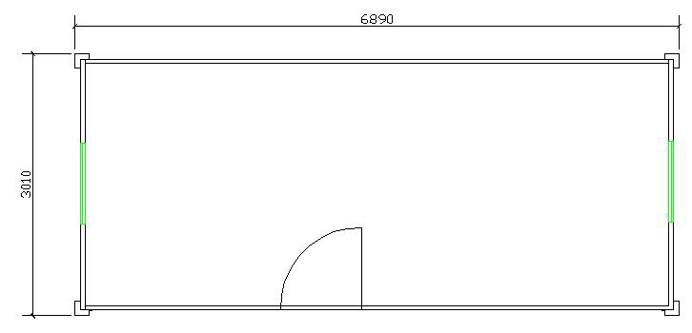 | Size:W3010*L6890*H2810mm  50mm sandwich panel for wall colorbond steel sheet for roof  50mm eps sandwich panel for ceiling two single glazed pvc sliding window one steel security door  16mm reinforced mgo board for floor without electricity | 1x40ft HQ container can load 10 sets,1  *20ft container can load 4 units | USD 3595/UNIT EXW  1.6mm thickness Pvc floor tile plus USD 120/set  75mm thickness insulation plus USD 180/set  Double glazed window plus USD 80/set  18mm Fiber cement board floor plus  USD 120/SET
ADITR24-1 | 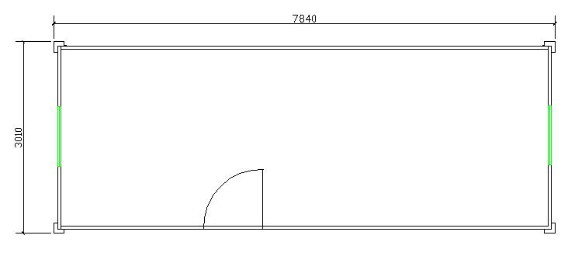 | Size:W3010*L7840*H2810mm  50mm sandwich panel for wall colorbond steel sheet for roof  50mm eps sandwich panel for ceiling two single glazed pvc sliding window one steel security door  16mm reinforced mgo board for floor without electricity | 1x40ft HQ container can load 9 sets,1* 20ft container can load 3 units | USD 3778/UNIT EXW  1.6mm thickness Pvc floor tile plus USD 140/set  75mm thickness insulation plus USD 200/set  Double glazed window plus USD 80/set  18mm Fiber cement board floor plus  USD 140/SET

ADITR27-1 |  | Size:W3010*L8790*H2810mm  50mm sandwich panel for wall colorbond steel sheet for roof  50mm eps sandwich panel for ceiling two single glazed pvc sliding window one steel security door  16mm reinforced mgo board for floor without electricity | 1x40ft HQ container can load 8 sets,1* 20ft container can load 3 units | USD 4,114/UNIT EXW  1.6mm thickness Pvc floor tile plus USD 160/set  75mm thickness insulation plus USD 220/set  Double glazed window plus USD 80/set  18mm Fiber cement board floor plus  USD 160/SET
ADITR36-1 |  | Size:W3010*L12115*H2810mm  50mm sandwich panel for wall colorbond steel sheet for roof  50mm eps sandwich panel for ceiling two single glazed pvc sliding window one steel security door  16mm reinforced mgo board for floor without electricity | 1*40HC  container can load 6 units,1*20ft container can load 2 units | USD5,142/UNIT EXW  1.6mm thickness Pvc floor tile plus USD 210/set  75mm thickness insulation plus USD 300/set  Double glazed window plus USD 80/set  18mm Fiber cement board floor plus USD 210/SET
ADITR24-1A | 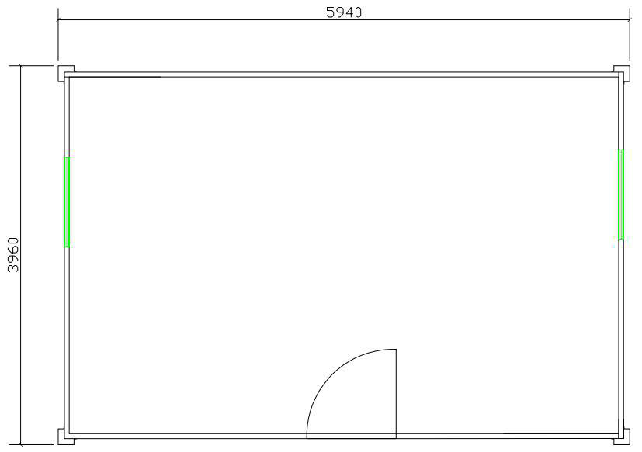 | Size:W3960*L5940*H2810mm  50mm sandwich panel for wall and roof steel ceiling  two single glazed pvc sliding window one steel security door  16mm reinforced mgo board for floor without electricity | 1x40ft HQ container can load 9 sets,1* 20ft container can load 3 units | USD3917/UNIT EXW  1.6mm thickness Pvc floor tile plus USD 140/set  75mm thickness insulation plus USD 220/set  Double glazed window plus USD 80/set  18mm Fiber cement board floor plus  USD 140/SET

ADITR30-1 | 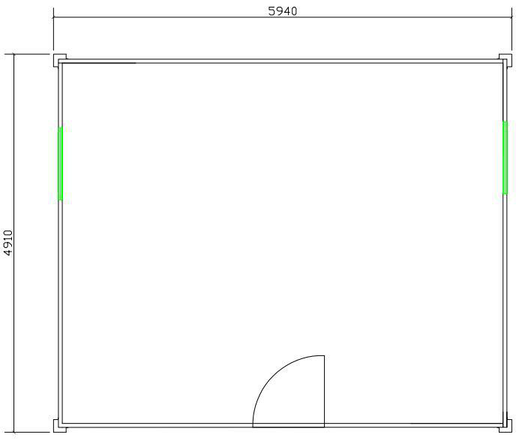 | Size:W4910*L5940*H2810mm  50mm sandwich panel for wall and roof steel ceiling  two single glazed pvc sliding window one steel security door  16mm reinforced mgo board for floor without electricity | 1x40ft HQ container can load 8 sets,1* 20ft container can load 3 units | USD4389/UNIT EXW  1.6mm thickness Pvc floor tile plus USD 170/set  75mm thickness insulation plus USD 240/set  Double glazed window plus USD 80/set  18mm Fiber cement board floor plus USD 200/SET
ADITR36-1A | 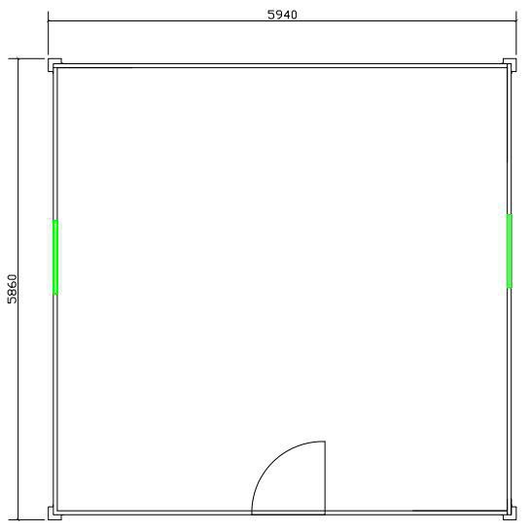 | Size:W5860*L5940*H2810mm  50mm sandwich panel for wall and roof steel ceiling  two single glazed pvc sliding window one steel security door  16mm reinforced mgo board for floor without electricity | 1x40ft HQ container can load 7 sets,1* 20ft container can load 3 units | USD4869/UNIT EXW  1.6mm thickness Pvc floor tile plus USD 200/set  75mm thickness insulation plus USD 280/set  Double glazed window plus USD 80/set  18mm Fiber cement board floor plus USD 200/SET

- catalogue of triangle roof container house with interior wall partition,bathroom and kitchen

model | Layout | Description | Loading | Unit price  EXW

ADITR18-2 | 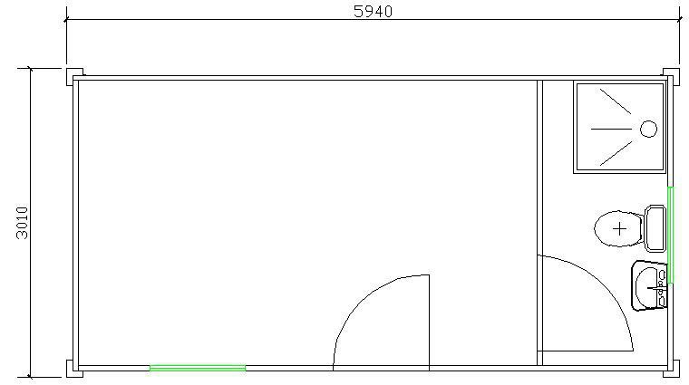 | Size:W3010*L5940*H2810mm  50mm sandwich panel for wall colorbond steel sheet for roof  50mm eps sandwich panel for ceiling Steel security door  Sliding window single glazed Wash basin,toilet,shower without electricity with plumbing  16mm reinforced MGO board+1.6mm pvc  floor | 1x40ft HQ container can load 10 sets, 1*20FT  container can load 4 sets  . | USD 3754/UNIT EXW  75mm thickness insulation plus USD 180/set  Double glazed window plus USD 80/set  18mm Fiber cement board floor plus USD 100/SET
ADITR18-3 | 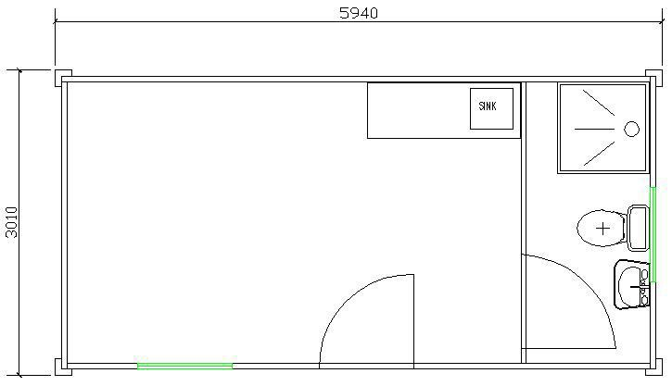 | Size:W3010*L5940*H2810mm  50mm sandwich panel for wall colorbond steel sheet for roof  50mm eps sandwich panel for ceiling Steel security door  Sliding window single glazed Wash basin,toilet,shower  with kitchen bottom cabinet,stainless steel countertop,basin,faucet  without electricity with plumbing  16mm reinforced MGO board+1.6mm pvc floor | 1x40ft HQ container can load 9 sets, 1*20FT  container can load 4 sets | USD 4062/UNIT EXW  75mm thickness insulation plus USD 180/set  Double glazed window plus USD 80/set  18mm Fiber cement board floor plus USD 100/SET
ADITR18-5 | 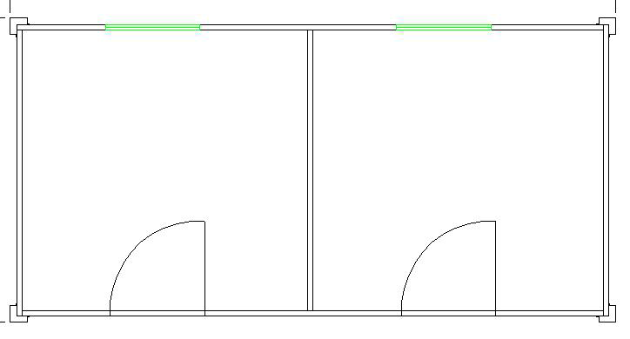 | Size:W3010*L5940*H2810mm  50mm sandwich panel for wall colorbond steel sheet for roof  50mm eps sandwich panel for ceiling two single glazed pvc sliding window one steel security door  16mm reinforced mgo board+1.6mm pvc tile for floor  without electricity | 1x40ft HQ container can load 11 sets, 1*20FT  container can load 4 sets  . | USD 4442/UNIT EXW  75mm thickness insulation plus USD 180/set  Double glazed window plus USD 80/set  18mm Fiber cement board floor plus USD 100/SET

ADITR18-6 | 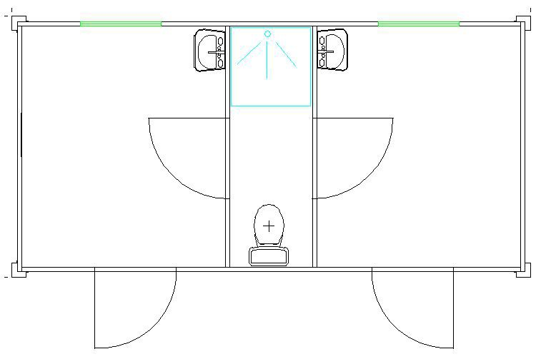 | Size:W3010*L5940*H2810mm  50mm sandwich panel for wall colorbond steel sheet for roof  50mm eps sandwich panel for ceiling Steel security door  Sliding window single glazed Wash basin,toilet,shower without electricity with plumbing  16mm reinforced MGO board+1.6mm pvc  floor roof | 1x40ft HQ container can load 9 sets, 1*20FT  container can load 3 sets | USD 4188/UNIT EXW  75mm thickness insulation plus USD 200/set  Double glazed window plus USD 80/set  18mm Fiber cement board floor plus USD 100/SET
ADITR18-7 | 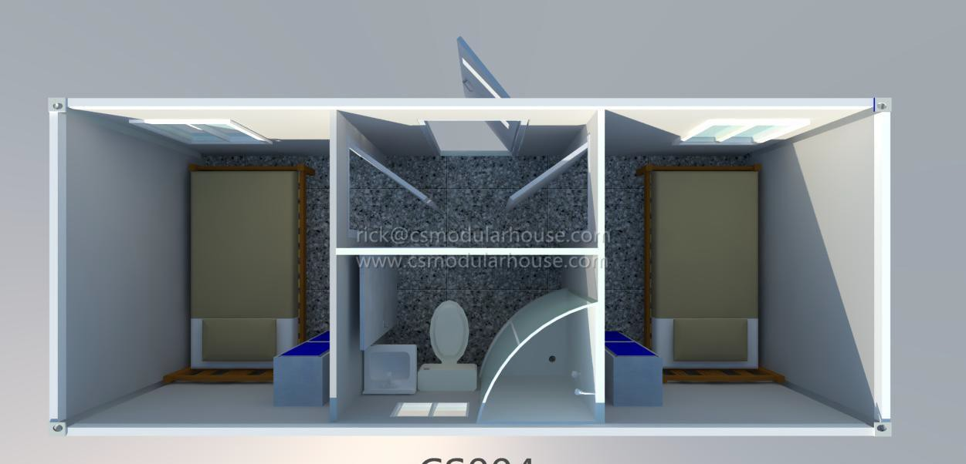 | Size:W3010*L5940*H2810mm  50mm sandwich panel for wall colorbond steel sheet for roof  50mm eps sandwich panel for ceiling Steel security door  Sliding window single glazed Wash basin,toilet,shower without electricity with plumbing  16mm reinforced MGO board+1.6mm pvc  floor | 1x40ft HQ container can load 9 sets, 1*20FT  container can load 3 sets | USD 4321/UNIT EXW  75mm thickness insulation plus USD 213/set  Double glazed window plus USD 80/set  18mm Fiber cement board floor plus USD 100/SET

- Catalogue of container bathroom/toilet/shower
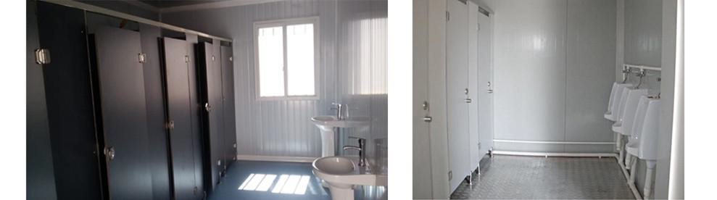

Item | Layout | Description | Loading | Unit price EXW
ADIDRT-1 | 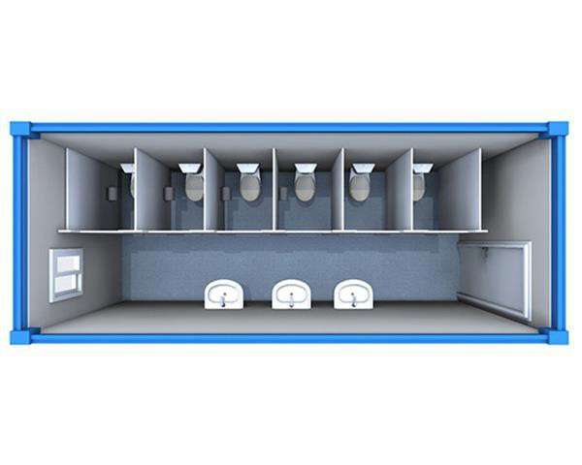 | Size:W3010*L5940*H2810mm  50mm eps sandwich panel for wall&ceiling  0.4mm corrugated steel sheet for roof Steel security door  Sliding window single glazed Wash basin,toilet,toilet partition With plumbing  Without electricity  18mm fiber cement board+1.6mm pvc floor | 1x40ft HQ container can load 10 sets, 1*20FT container can load 4 sets | USD 4,878/UNIT EXW  75mm thickness insulation plus USD 160/set  Double glazed window plus USD 40/set  1.5mm thickness Non skid aluminum surface panel plus USD 229/set  2mm thickness Non skid aluminum surface panel plus USD 368/set

ADIDRT-2 | 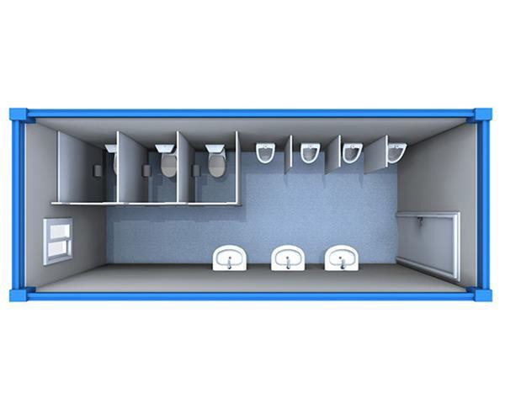 | Size:W3010*L5940*H2810mm  50mm eps sandwich panel for wall&roof Steel security door  Sliding window single glazed  Wash basin,toilet,urinal,toilet partition With plumbing  Without electricity  18mm fiber cement board+1.6mm pvc floor  With 0.4mm thickness extra single sheet | 1x40ft HQ container can load 10 sets, 1*20FT container can load 4 sets | USD 4,451/UNIT EXW  75mm thickness insulation plus USD 160/set  Double glazed window plus USD 40/set  1.5mm thickness Non skid aluminum surface panel plus USD 229/set  2mm thickness Non skid aluminum surface panel plus USD 368/set
ADIDRT-3 | 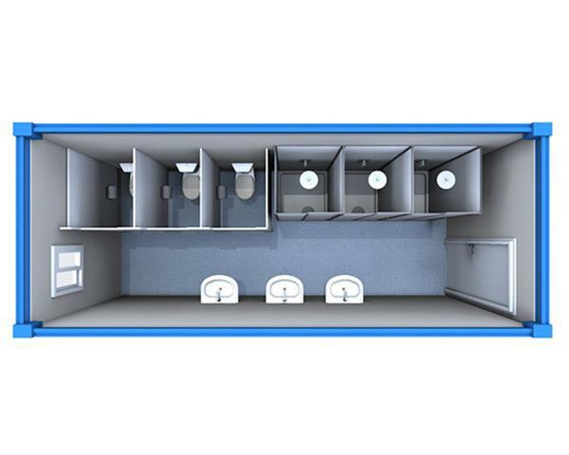 | Size:W3010*L5940*H2810mm  50mm eps sandwich panel for wall&roof Steel security door  Sliding window single glazed  Wash basin,toilet,shower,toilet partition With plumbing  Without electricity  18mm fiber cement board+1.6mm pvc floor  With 0.4mm thickness extra single sheet | 1x40ft HQ container can load 10 sets, 1*20FT container can load 4 sets | USD 4,836/UNIT EXW  75mm thickness insulation plus USD 160/set  Double glazed window plus USD 40/set  1.5mm thickness Non skid aluminum surface panel plus USD 229/set  2mm thickness Non skid aluminum surface panel plus USD 368/set
ADIDRT-4 | 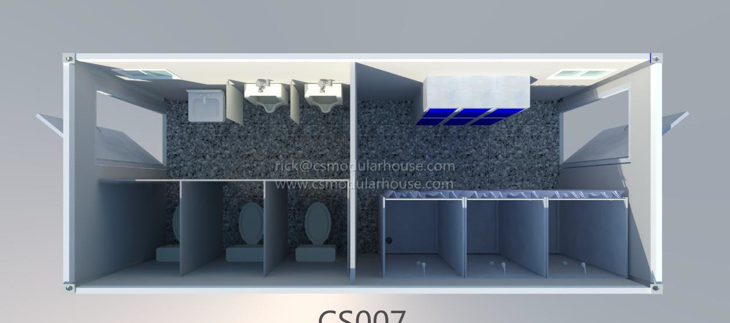 | Size:W3010*L5940*H2810mm  50mm eps sandwich panel for wall&roof Steel security door  Sliding window single glazed  Wash basin,toilet,shower,toilet partition With plumbing  Without electricity  18mm fiber cement board+1.6mm pvc floor  With 0.4mm thickness extra single sheet | 1x40ft HQ container can load 10 sets, 1*20FT container can load 4 sets | USD 5,576/UNIT EXW  75mm thickness insulation plus USD 180/set  Double glazed window plus USD 80/set  1.5mm thickness Non skid aluminum surface panel plus USD 229/set  2mm thickness Non skid aluminum surface panel plus USD 368/set

ADIDRT-5 | 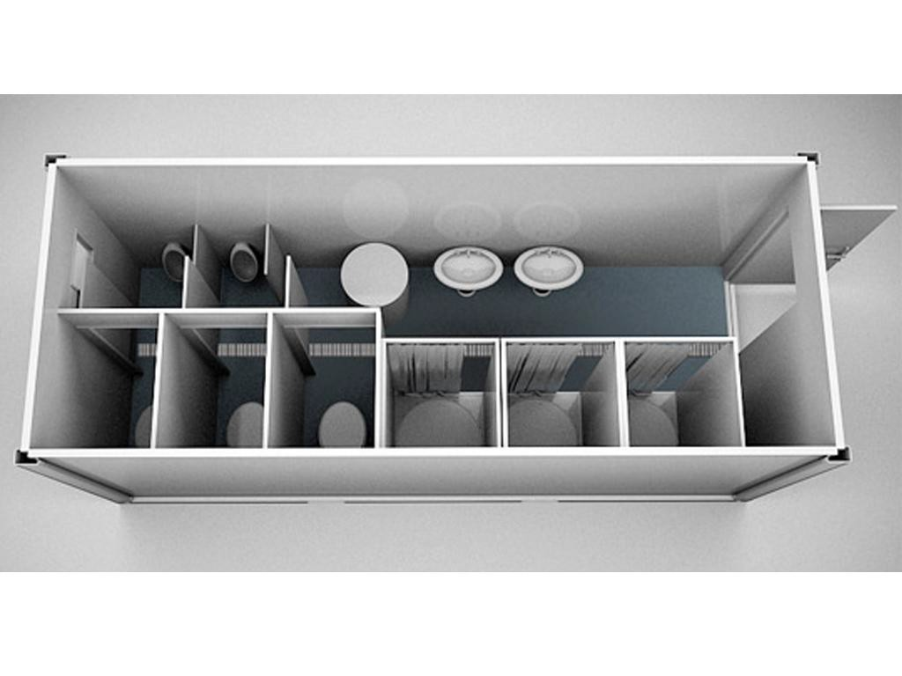 | Size:W3010*L5940*H2810mm  50mm eps sandwich panel for wall&roof Steel security door  Sliding window single glazed  Wash basin,toilet,shower,toilet partition With plumbing  Without electricity  18mm fiber cement board+1.6mm pvc floor  With 0.4mm thickness extra single sheet | 1x40ft HQ container can load 10 sets, 1*20FT container can load 4 sets | USD 5,436/UNIT EXW  75mm thickness insulation plus USD 160/set  Double glazed window plus USD 40/set  1.5mm thickness Non skid aluminum surface panel plus USD 229/set  2mm thickness Non skid aluminum surface panel plus USD 368/set
ADIDRT-6 | 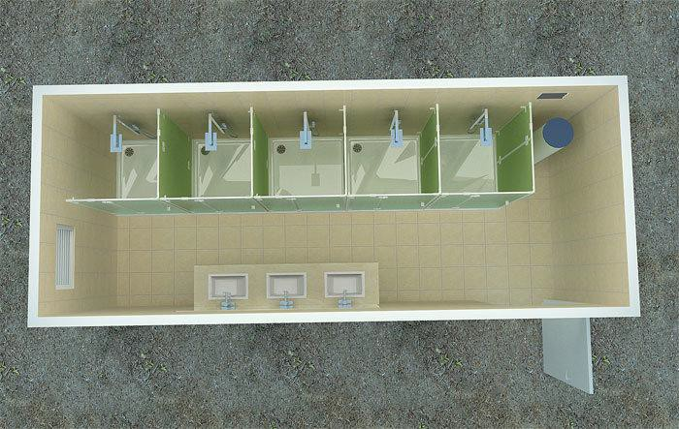 | Size:W3010*L5940*H2810mm  50mm eps sandwich panel for wall&roof Steel security door  Sliding window single glazed Wash basin,shower,toilet partition With plumbing  Without electricity  18mm fiber cement board+1.6mm pvc floor  With 0.4mm thickness extra single sheet | 1x40ft HQ container can load 10 sets, 1*20FT container can load 4 sets | USD 5,007/UNIT EXW  75mm thickness insulation plus USD 160/set  Double glazed window plus USD 40/set  1.5mm thickness Non skid aluminum surface panel plus USD 229/set  2mm thickness Non skid aluminum surface panel plus USD 368/set
ADIDRT-7 | 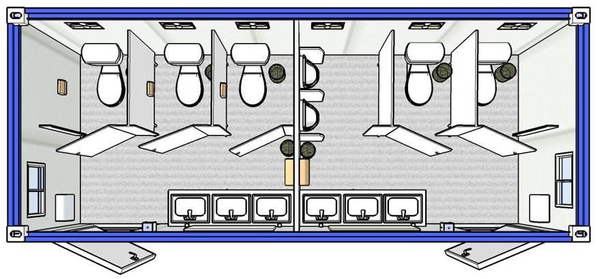 | Size:W3010*L5940*H2810mm  50mm eps sandwich panel for wall&roof Steel security door  Sliding window single glazed Wash basin,toilet,toilet partition With plumbing  Without electricity  18mm fiber cement board+1.6mm pvc floor  With 0.4mm thickness extra single sheet | 1x40ft HQ container can load 10 sets, 1*20FT container can load 4 sets | USD 5,246/UNIT EXW  75mm thickness insulation plus USD 180/set  Double glazed window plus USD 80/set  1.5mm thickness Non skid aluminum surface panel plus USD 229/set  2mm thickness Non skid aluminum surface panel plus USD 368/set

ADIDRT-8 | 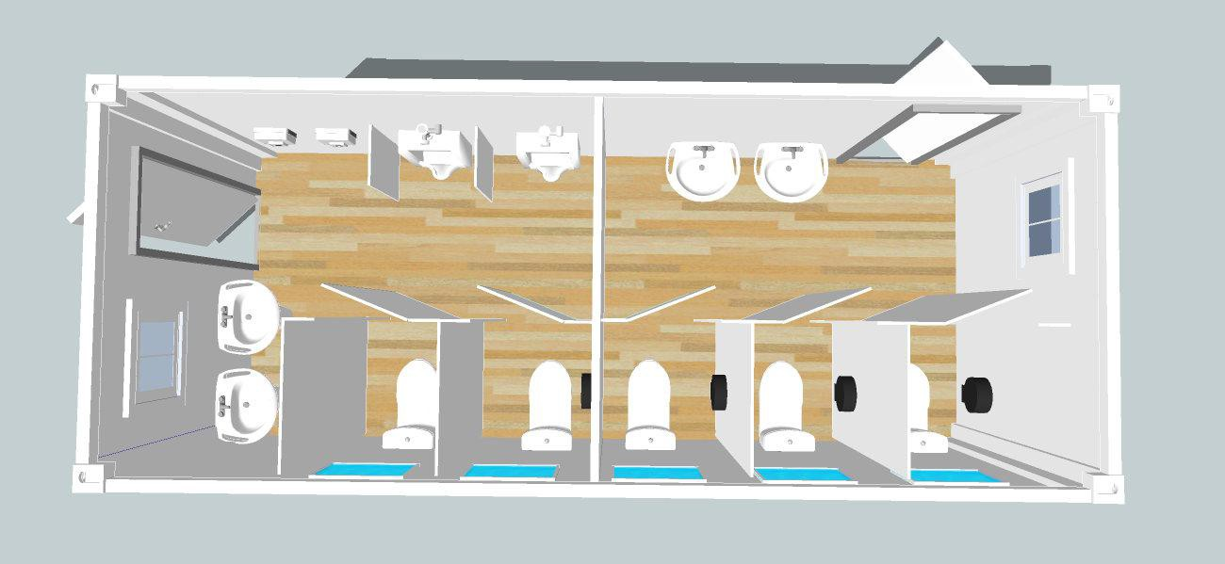 | Size:W3010*L5940*H2810mm  50mm eps sandwich panel for wall&roof Steel security door  Sliding window single glazed Wash basin,toilet,toilet partition With plumbing  Without electricity  18mm fiber cement board+1.6mm pvc floor  With 0.4mm thickness extra single sheet | 1x40ft HQ container can load 10 sets, 1*20FT container can load 4 sets | USD 5,086/UNIT EXW  75mm thickness insulation plus USD 180/set  Double glazed window plus USD 80/set  1.5mm thickness Non skid aluminum surface panel plus USD 229/set  2mm thickness Non skid aluminum surface panel plus USD 368/set

