**WOMEN BOOTS**

**ALDO NEW BOOTS**

**~~Price: $17.00 each~~     New price: $12.50 each                 ~~4,755~~ 2,360 pairs available**

**ALDO NEW BOOTS. READY TO SELL. DIFFERENT STYLES. BLEND OF SIZES.**

**Packed loosely in each case/Pares empaquetados sueltos en cada caja.**

**\*20-40 in each case/ pares en cada caja**

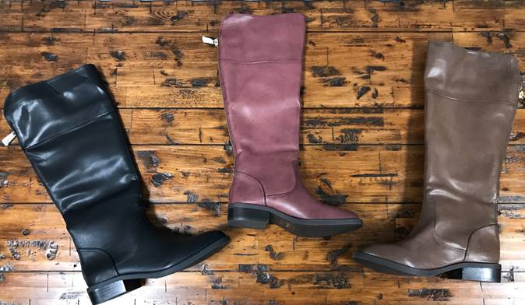  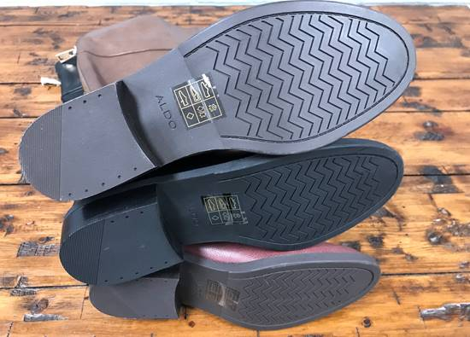

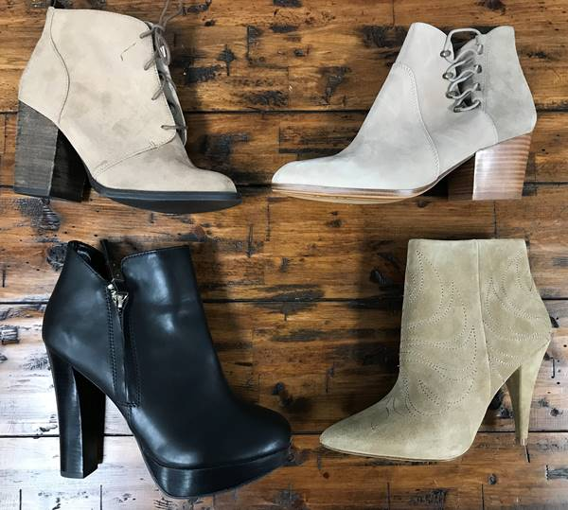   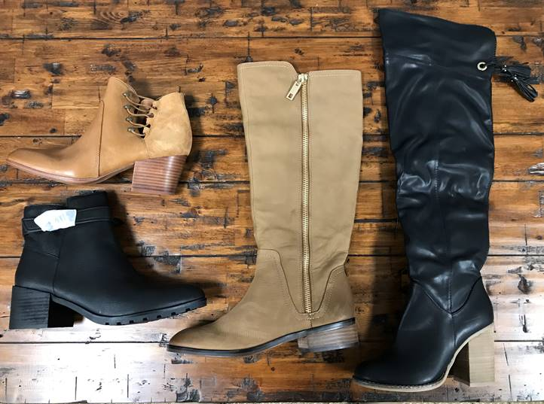

**DEP STORE NEW MATED WOMEN BOOTS**

**~~Price: Only $14.50 each~~        New price: $11.00 each                8,697 Pairs available**

**Boots are all new! These are singles that we mated up from a famous department store in the U.S. You will find brands like: RAMPAGE, Unlisted, Steve Madden, Bare Traps, New Direction, BOC, and more. Casual & Fashion /Man-Made Material, Suede, & Some Leather.**

**Packed loosely in each case / Pares empaquetados sueltos en cada caja    Prepárese para el invierno/prepare for fall and Winter!**

**\*15-35 in each case        * 15-35 pares en cada caja**

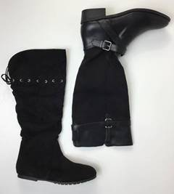   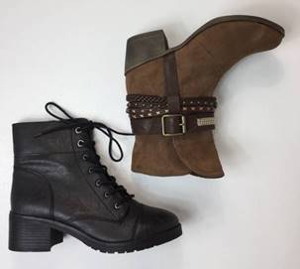   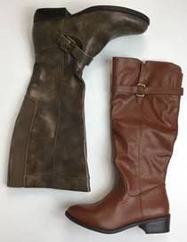   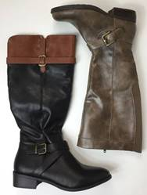  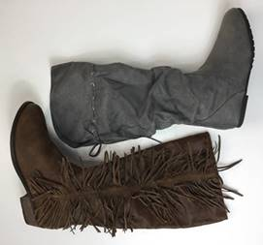    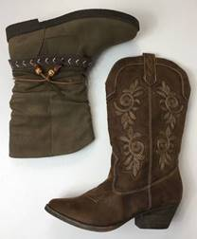   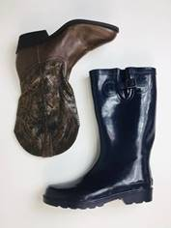

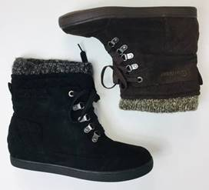   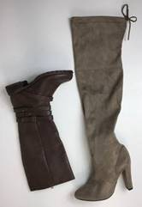    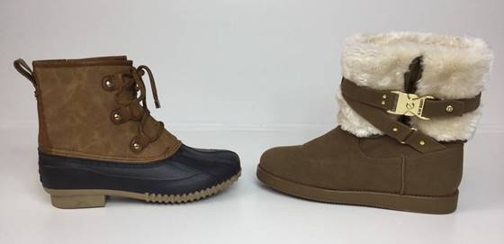

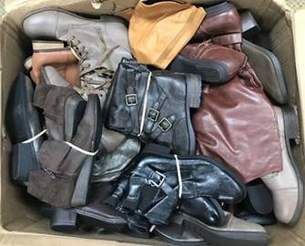 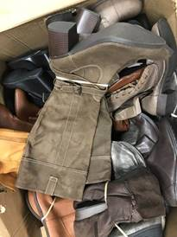 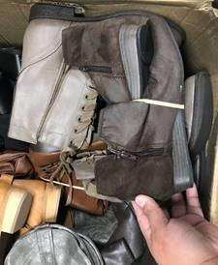 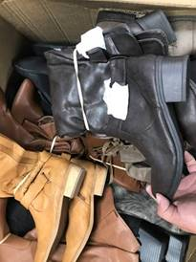

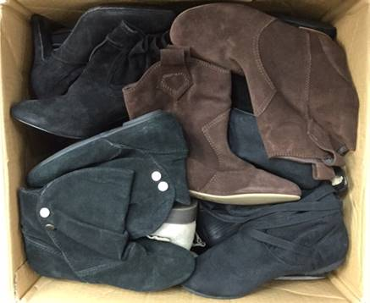  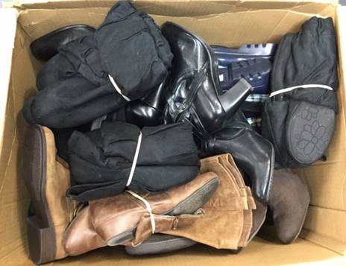

**AMAZON HASH BOOTS**

**Price: 10.00 each pair 1,452 PAIRS**

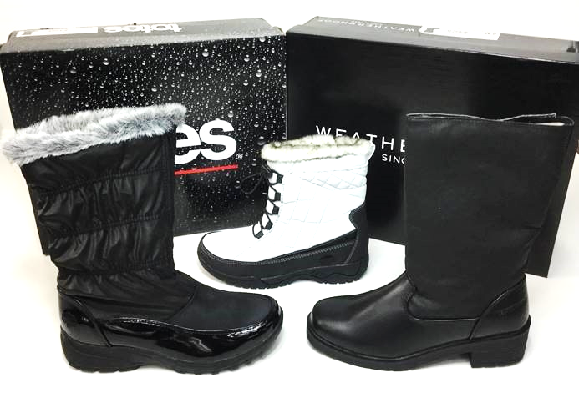 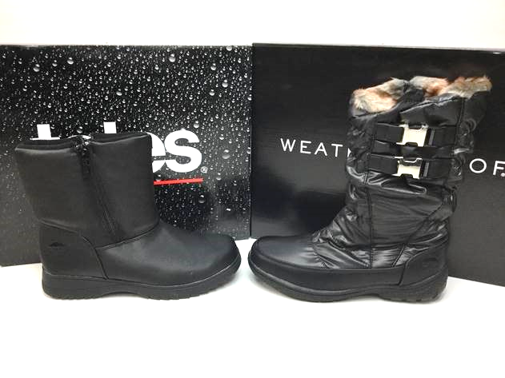

**DAVID TATE SAMPLE BOOTS**

**Price: $10.00 each pair 100 PAIRS**

David Tates lady boots. Heavy in size 8. A blend of styles.

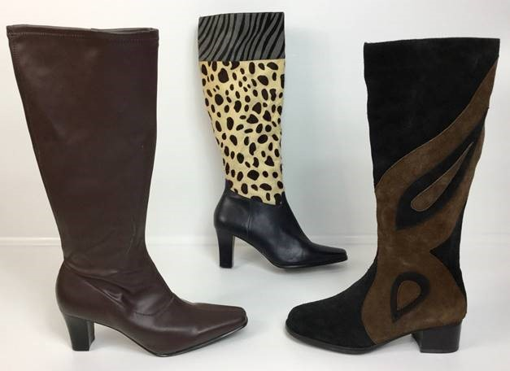   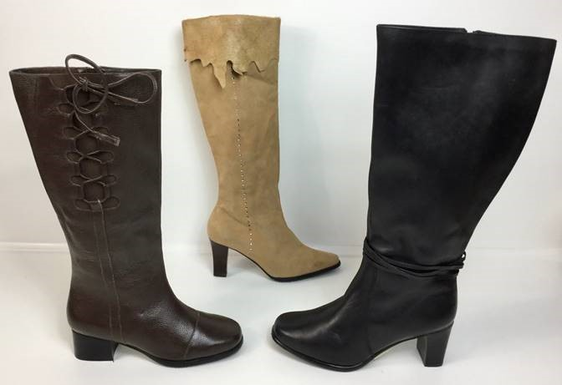

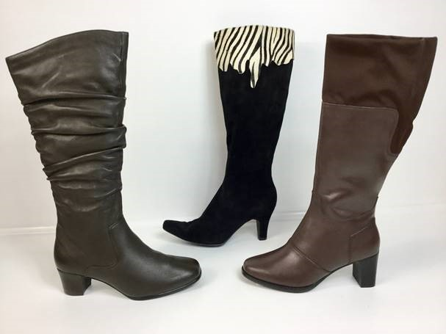

**DUCKHEAD CO CHANA BOOT**

**Price: $10.00 each 144 PAIR (MIDNIGHT VELVET)**

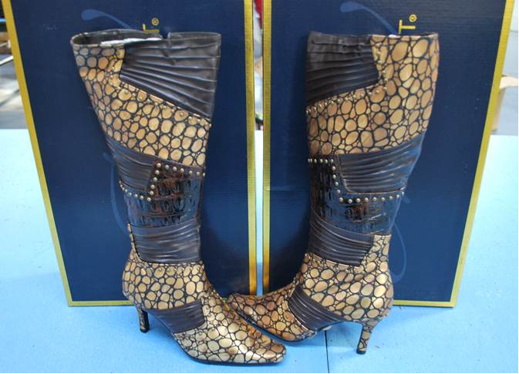

**EAST STAR LADY BOOT FD**

**Price: $10.00 each 97 PAIRS**

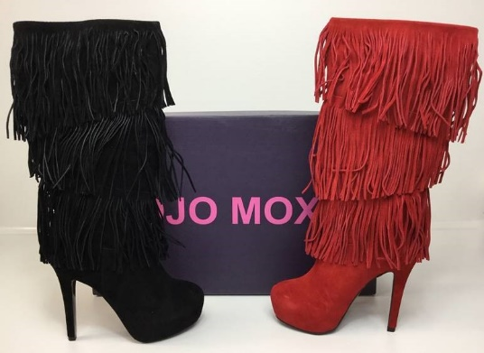

**EAST STAR LADY BOOT NEW**

**Price: $11.90 each 224 PAIRS**

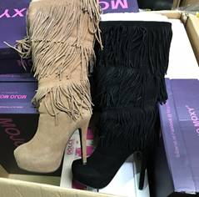 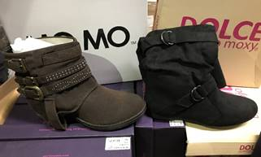

**MOJO MOXY BOOTS**

**Price: $10.00 each 673 PAIRS**



**RUGGED #1 BOOTS**

$12.50 per pair                Sizing: 5 – 11                           **Quantity: 354 pairs**

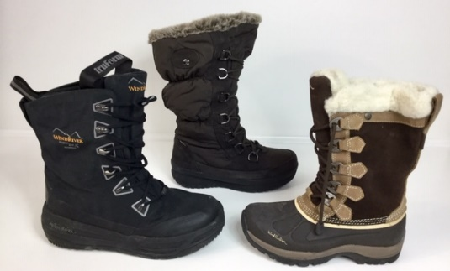 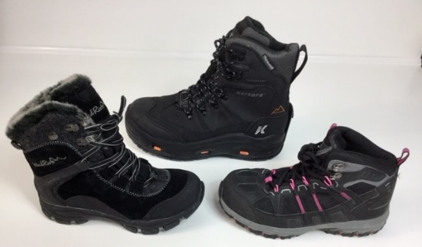 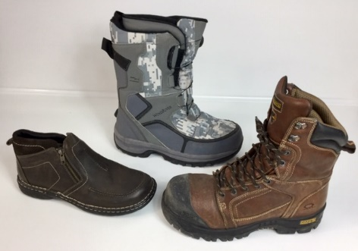

**STEVEN MADDEN WOMEN SHORT BOOTS**

$25.50 per pair                Sizing: 5 – 11                           First quality and boxed

**Quantity: 2,209 pairs**

**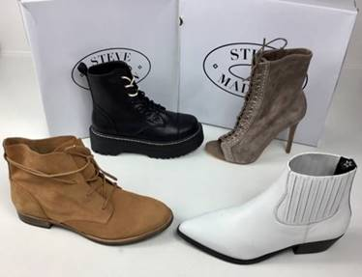  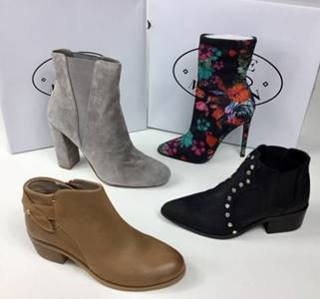  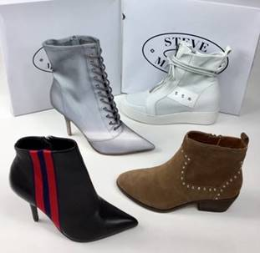 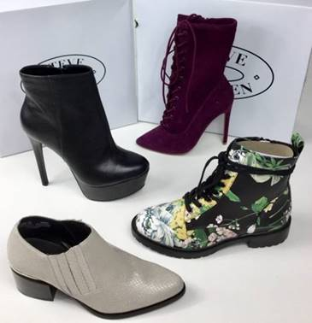 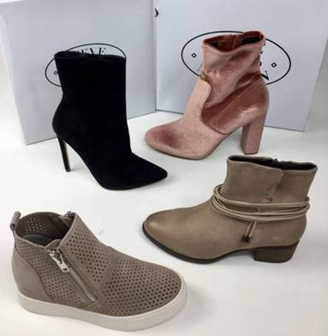**

**STEVEN MADDEN WOMEN BOOTS**

$23.00 per pair                Sizing: 5 – 10                           First quality and boxed

**Quantity: 318 pairs**

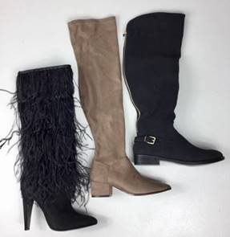 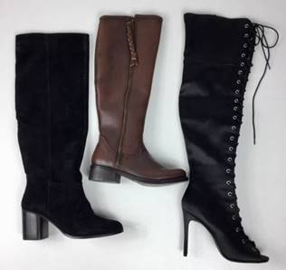

**SPRING STEP BOOTS FD**

**Price: $36.50 each 82 PAIRS**

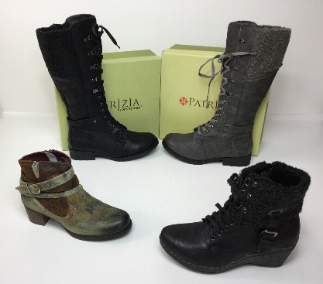 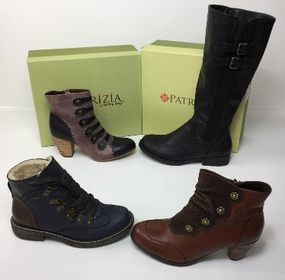 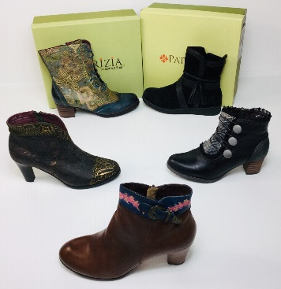 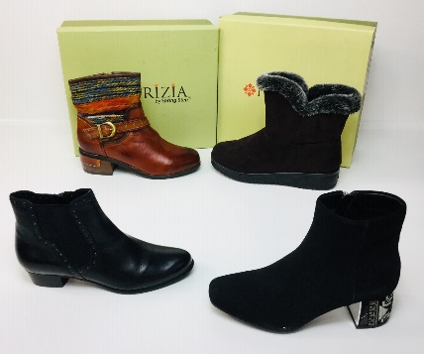

**SPERRY LADY LEATHER BOOTS**

**Price: $40.00 each 58 PAIRS**

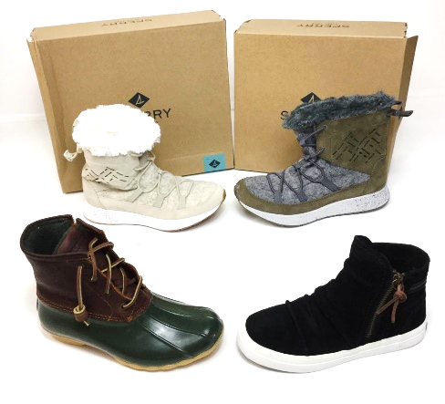

**TROTTERS BOOTS FD’S**

**Price: $19.50 each 44 PAIRS**

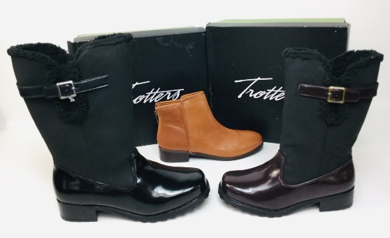 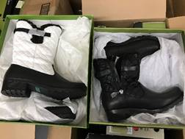 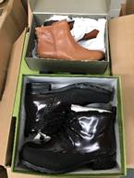 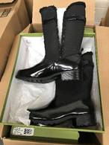

**WHITE MOUNTAIN BOOTS FD’S**

**Price: $23.50 each 164 PAIRS**

