L 410 UVP for Sale
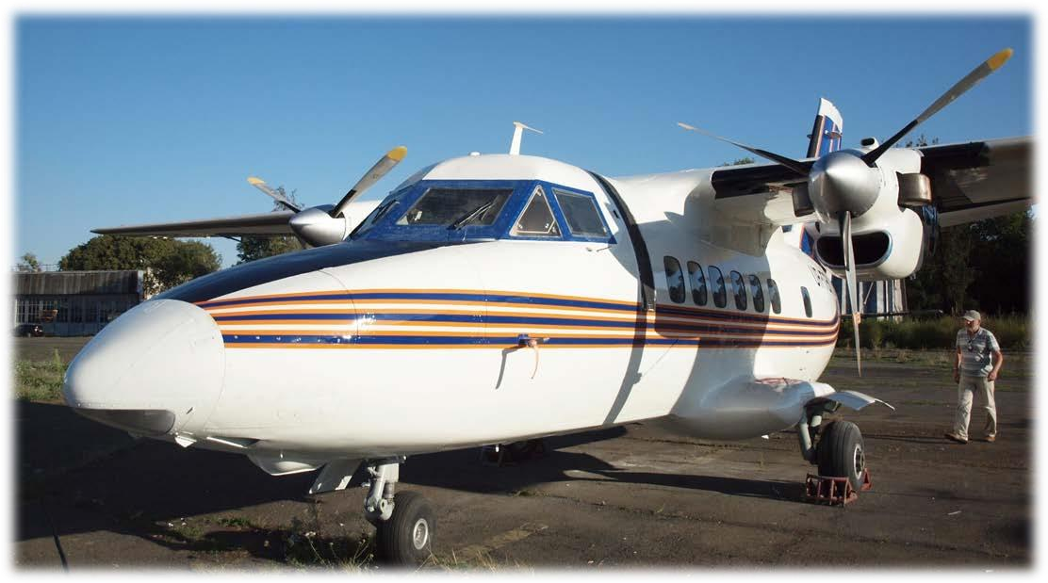

Aircraft Specifications

Total Airframe Hours Since New | 7,980 hrs
Total Airframe Cycles Since New | 13,386 cycles
Date of Revision (PTO) | August 28, 2015 year
Approved life time until the next Revision | 4,800+150 hr, 10 year
Engines
Engine Type and Model | Walter M601B
Approved Engine TBO | 1 000 hrs, 7 years + 1 year extension (optional)
 | Left Engine | Right Engine
Serial Number | 822001 | 814090
Date of Manufacture | April 10, 1982 | January 30, 1981
Hours Since New | 1,028 hrs | 1,931 hrs
Cycles Since New | 621 | 1,036
Date of Overhaul | July 3, 2015 | June 11, 2015
Hours Since Overhaul | ca. 300 | ca. 300
Cycles Since Overhaul | 250 | 250

Aircraft

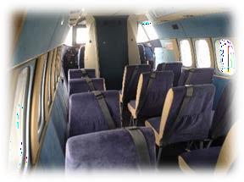
Type and model L 410 UVP
Serial number 841302
Registration UR-TEN
Date of Manufacture July 10, 1984
Base Rivne, Ukraine
Specification date December 5, 2016

Airframe Propellers

Propeller Type and Model Avia V 508 B, 3 bladed propeller
Approved Propeller TBO | 2,000 hrs
 | Left Propeller | Right Propeller
Serial Number | 01065723 | 120651036
Date of Manufacture | October 31, 1981 | September 29, 1982
Hours Since New | 1,606 hrs | 2,000 hrs
Date of Overhaul | October 15, 2013 | October 15, 2013
Hours Since Overhaul  Avionics | 350 | 350

Component | Manufacturer/Model
VHF comm. 2 | LUN 3524
VHF Navi-Course/Glide Slope/Marker | SP-50
Weather Radar | ------
ATC Transponder A/C | CO-69
ATC Transponder A/C | GTX320
ATC Transponder S | ------
Radio Altimeter | RV-5

Emergency Equipment, ELT | KANNAD 406 AS
ACAS (TCAS) | ------
Weights
Maximum Take-off Weight | 12,787 Lbs | 5,700 kg
Maximum Landing Weight | 12,125 Lbs | 5,500 kg
Maximum Payload | 2,888 Lbs | 1,310 kg
Passengers Capacity | 15

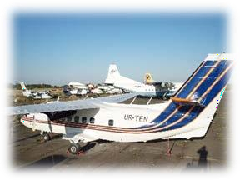

Other information
- Revision (PPTO) in 2015
- Maintenance Schedule L410.0000.000.000RO (Ukrainian STC from TORA Kharkiv Aviation Plant)
- Optional Skydiving Configuration
