SERVICIO GESTION SALAR SpA

SOFT CORPORATE OFFER

January 15th.2021 To: END BUYER
Ref : SGSS/SCO/2020/FE0116

Dear Sirs:

We are pleased to send you our Soft Corporate Offer for Iron Ore Magnetite, under the following terms and conditions:

COMMODITY:

1. | PRODUCT: | Iron Ore (Magnetite) fines
2. | SPECIFICATION: | FE 62% up rejeit 60%
3. | ORIGIN: | Copiapó, Chile, South America
4. | PRICE : | FOB - USD 75,00 per Ton  CFT PLATT less 15%  1.5 dollar per law point over 62%

5. | PACKING: | In bulk
6. | QUANTITY: | 50,000 MT (+/- 10%) for start and 100.000 mt x Five months, al sixth month 150.000 mt
7. | SHIPMENT: | 45-60 days after LC.
8. | LOADING PORT: | Las Losas / Coquimbo (Alternatives) Caldera or Totoralillo
9. | MINERAL SIZE: | 8 – 10 mm.

PAYMENT TERMS:

10 | PAYMENT TER MS: | Irrevocable, Confirmed, Transferable at sight, DLC for 100%, accepted by our Bank.
11. | PERFORMANCE BOND: | Only for the first shipment, PB 2% after receipt of satisfactory Letter of Credit from the Buyer.
12. | CONTRACT CONDITION: | Price Will be Revised every six months
13. | CONTRACT PERIOD: | 12 months with rolls and extensions.
14. | INSPECTION: | By S.G.S, or similar, at loading port only, on Seller’s account.
15. | VALIDITY OF THE SCO: | January 31th 2021
16. | After signature of contract, and after receipt of LC DRAFT, Buyer can send his representative so that he can visit the mine and also inspect the loading port. En case of non-transferable L.C. The Beneficiary must be JOMP (PTY) TD, if the issuing bank is in Europe. If the end buyer is in China , then the beneficiary will be HIMALYAN CORP LTD of Singapore

THESE FINANCIAL COMPANIES HELP THE MINE OWNER TO FINANCE THE MINING OPERATIONS AND LOGISTICS PORT AND MARITIME.

These financial companies that monetize payment instruments, transferable or non-transferable to the miner himself or Mining Company help to carry out the mining tasks and transport logistics to the port and international freight forwarder.

Price adjustment
For Fe content: the base price referred in 4 shall be adjusted as follows:
1. Bonus: if the Fe content is more than 62%, this basic price will be free for
Every 1% Fe above 62%, fractions prorate.
2. Penalty: The base price shall be decreased by US$1.00 per DMT for each
1% Fe below 62.00% down to and including 60%, fractions prorata.

For Other Elements:
If the shipment does not meet any of the chemical composition provided above in clause 3, the base price referred in 4 shall be decreased as follows, fractions pro-rata:
a) For excess of Silica (SiO2)
At the rate of US$0.05 per dry metric ton for each 0.1% in excess of 4.00%. The buyer
has the right to reject the cargo if SiO2 content above 4.5%. b) For excess of Alumina (Al2O3)
At the rate of US$0.05 per dry metric ton for each 0.1% in excess of 3.00%. The buyer
has the right to reject the cargo if Al2O3 content above 4.00%. c) For excess of Phosphorus (P)
At the rate of US$0.05 per dry metric tons or fraction pro-rata for each 0.01% in excess of
0.15%. The buyer has the right to reject the cargo if P content above 0.2%
d) For excess of Sulphur (S)
At the rate of US$ 0.05 per dry metric tons or fraction pro-rata for each 0.01 % in excess
of 0.15%. The buyer has the right to reject the cargo if S content above 0.2%

IMPORTANT NOTE FOR FINAL BUYER

The technical and chemical specifications of the components will be upon request, through a technical format in Excel if possible, which will be included in the official FCO and must be included in the final sale / purchase contract that will be met through international and official standards

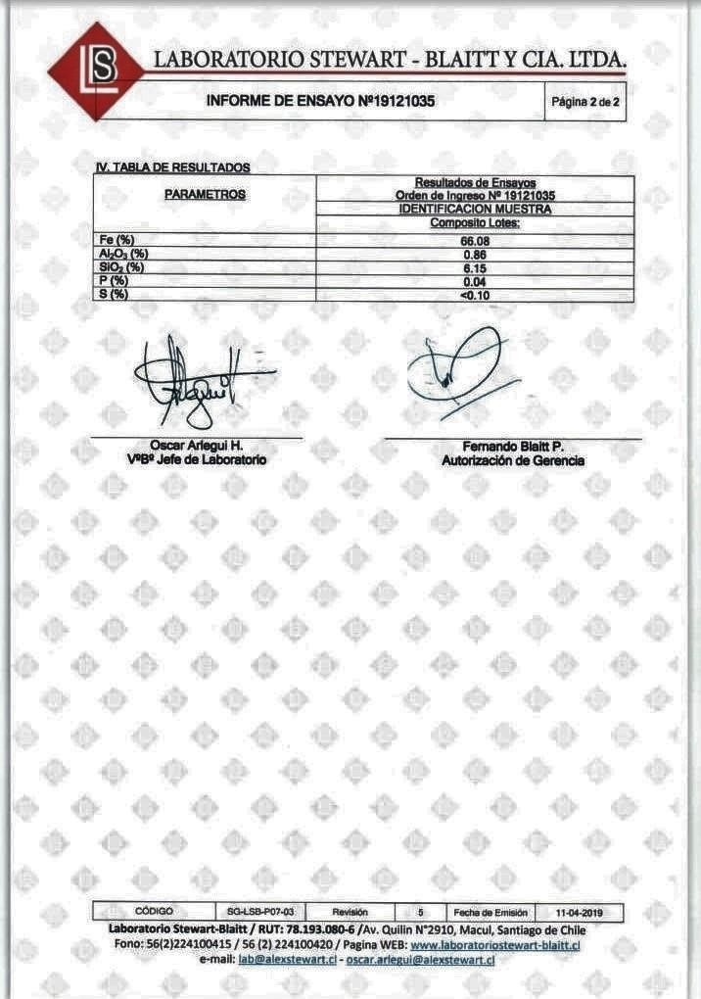

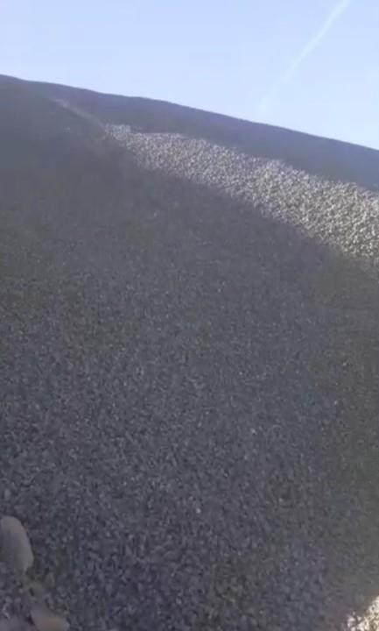

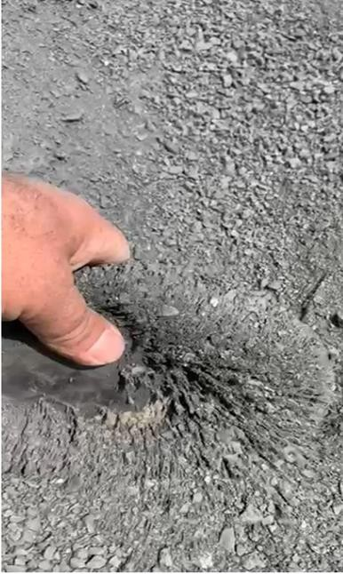
Regards

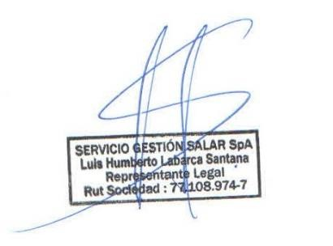
LUIS LABARCA SANTANA
Representante Legal Servicio Gestion Salar SpA

