MODEL | PICTURE | FOB USD PRICE | DETAILS | 1×40HQ
IT-019 | 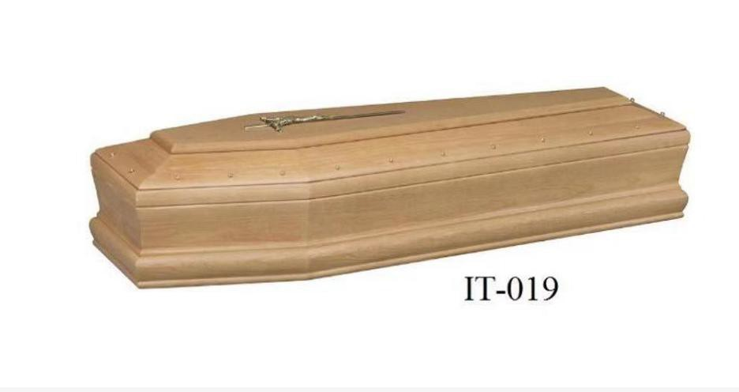 | $138/PCS | Material:Paulowina Tickness:25MM Glass:no  Interior:no | 140pcs
IT-020 | 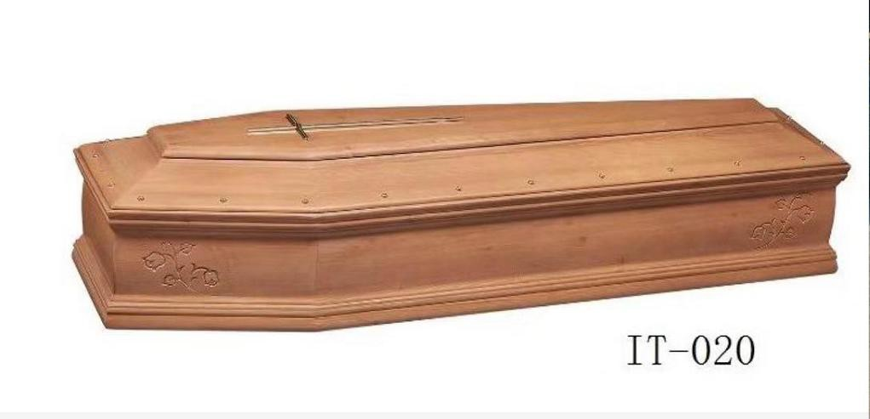 | $148/PCS | Material:Paulowina Tickness:25MM Glass:no  Interior:no | 140pcs

IT-011 | 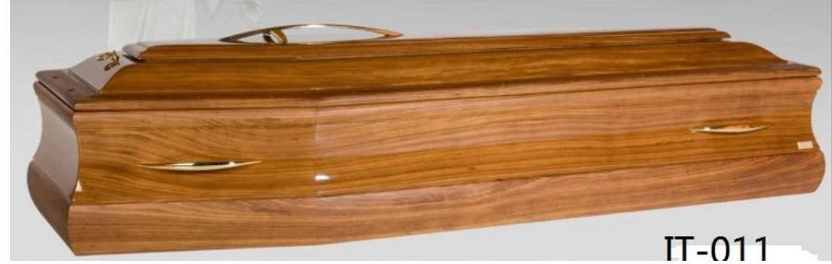 | $154/PCS | Material:Paulowina Tickness:25MM Glass:no  Interior:no | 140pcs
IT-021 | 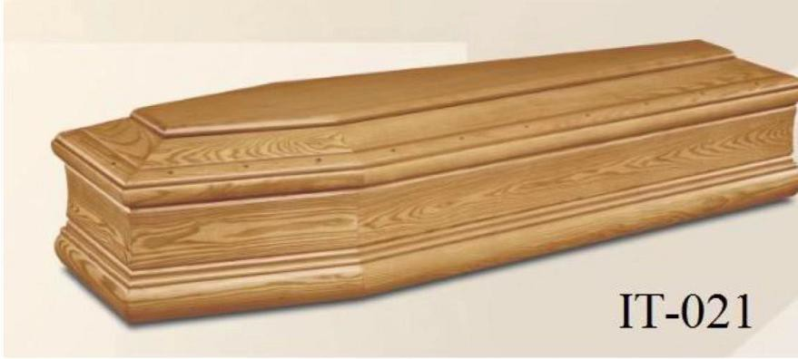 | $138/PCS | Material:Paulowina Tickness:25MM Glass:no Cross:no Interior:no | 140pcs
IT-22 | 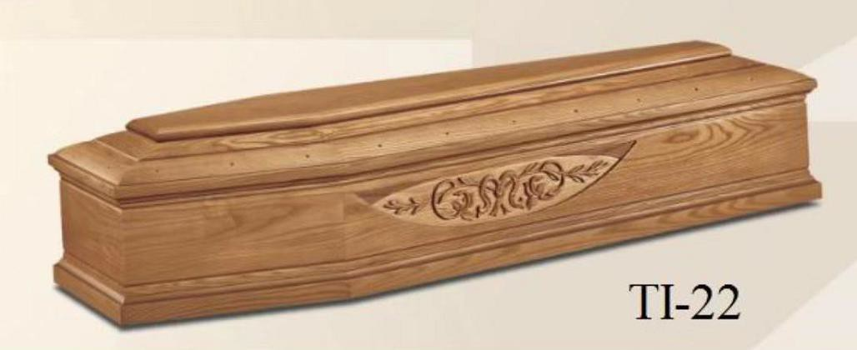 | $148/PCS | Material:Paulowina Tickness:25MM Glass:no  Cross:no Interior:no | 140pcs
IT-24 | 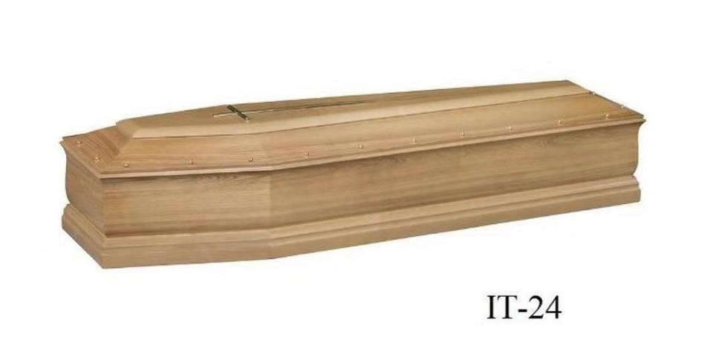 | $149/PCS | Material:Paulowina Tickness:25MM Glass:no  Cross:no Interior:no | 140pcs

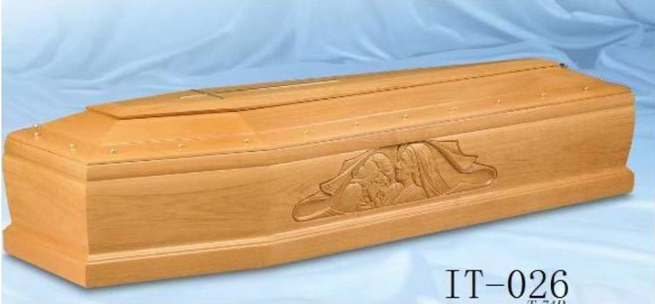
IT-025 | 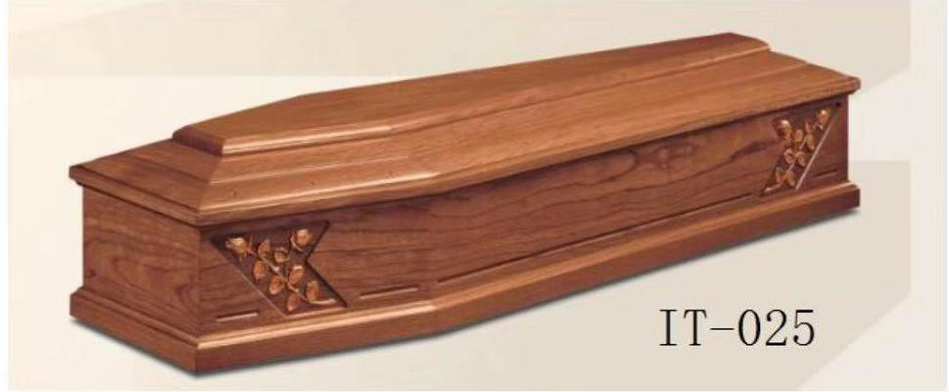 | $148/PCS | Material:Paulowina Tickness:25MM Glass:no  Cross:no Interior:no | 140pcs
IT-026 |  | $148/PCS | Material:Paulowina Tickness:25MM Glass:no  Cross:no Interior:no | 140pcs
IT-028 | 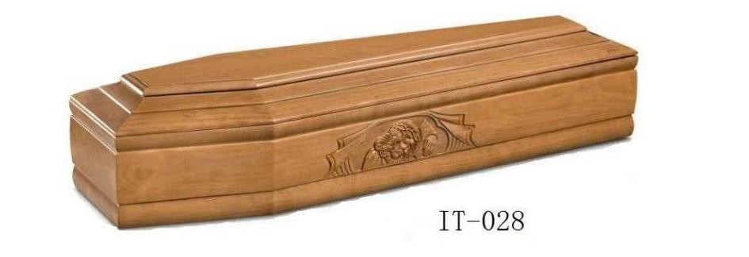 | $154/PCS | Material:Paulowina Tickness:25MM Glass:no  Cross:no Interior:no | 140pcs

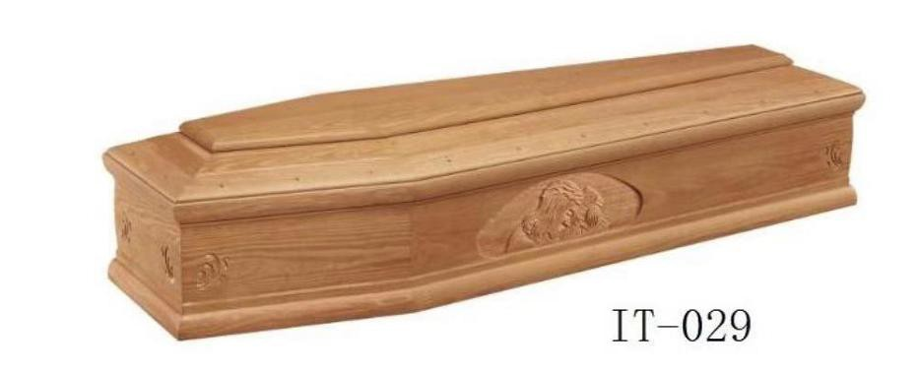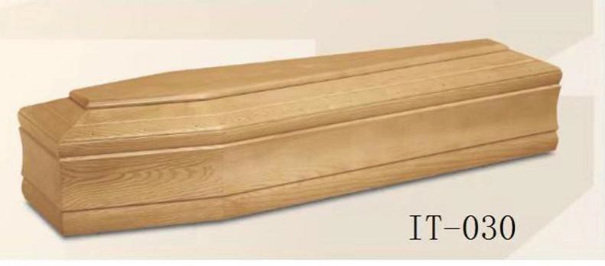
IT-029 |  | $155/PCS | Material:Paulowina Tickness:25MM Glass:no  Cross:no Interior:no | 140pcs
IT-030 |  | $149/PCS | Material:Paulowina Tickness:25MM Glass:no  Cross:no Interior:no | 140pcs

