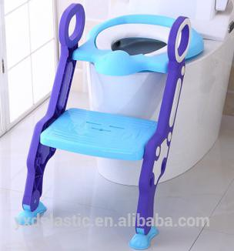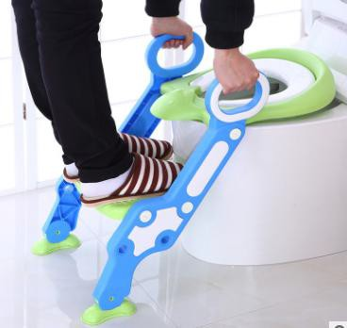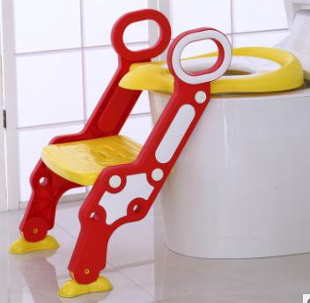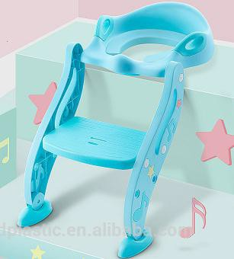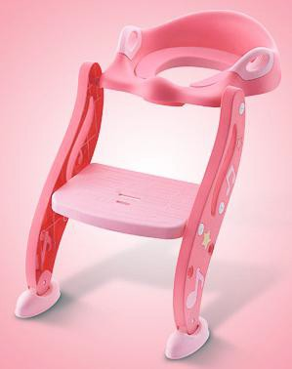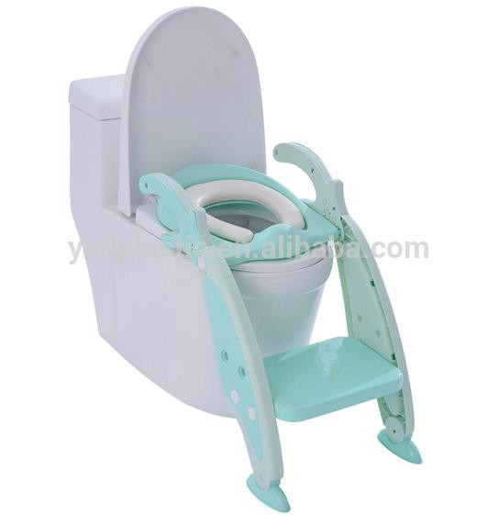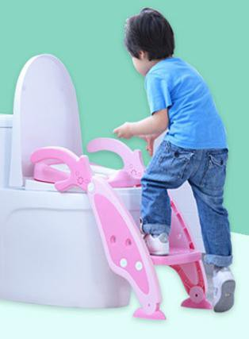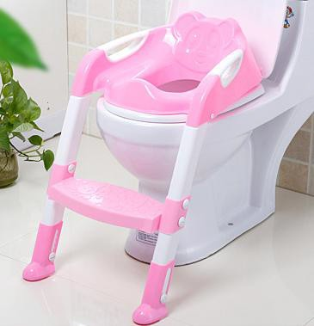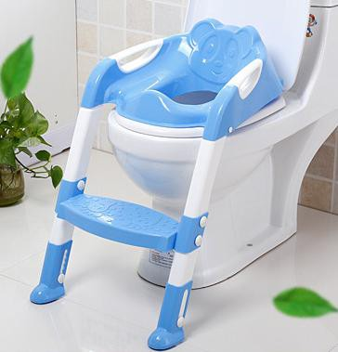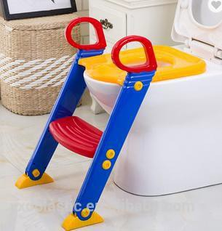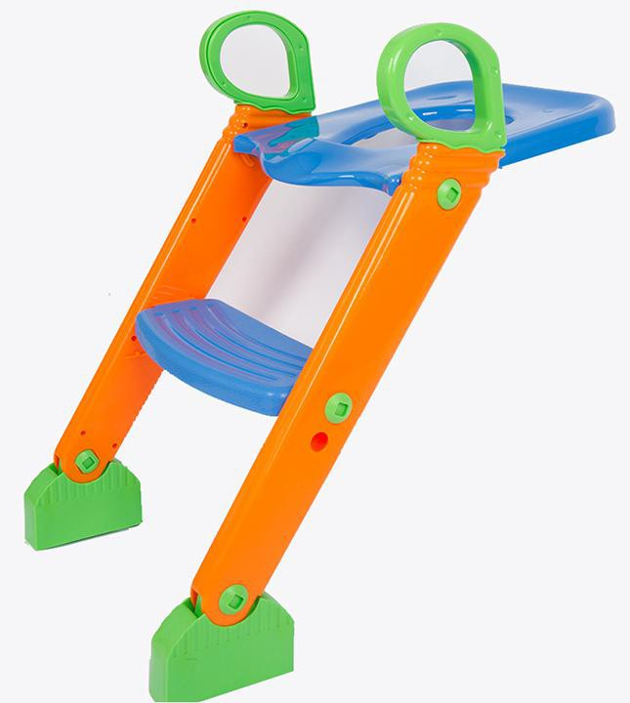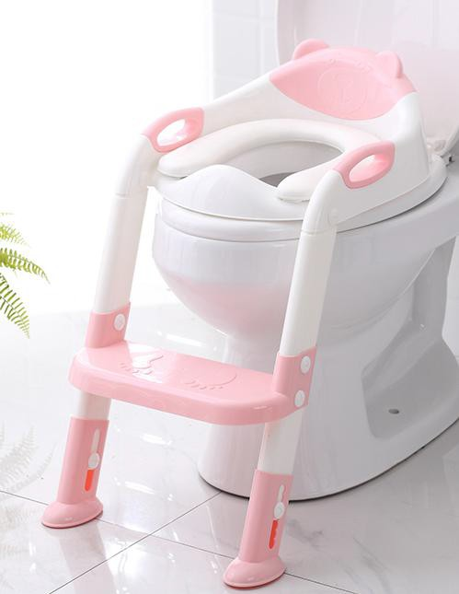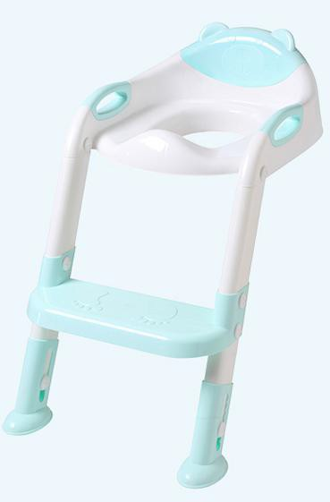
Baby Toilet Ladder Quotation
Item NO | Image | Specification | Package | Unit Price USD（Ex factory Xiamen)
 |  |  |  |  | 500 PCS | 1000-5000 PCS
ADIYDG-UB1010 |  | Material:PP adjustable potty ladder  Product Size: 58*38*37 CM  Color: red+yellow+blue | 1PC/BOX  1 BOXES/CARTON CARTON SIZE: 39.5*17*39.5CM  Gross weight: 1.30Kg  per carton |  | US$9.00 | US$8.00
ADIYDG-DZW202 |  | Material:PP  Ladder potty Product Size: 34*66*40 N.W:1.15kg  Color: Blue,Pink | 1/opp bag/carton Size:35*14*39CM G.W:1.47Kg/CARTO N |  | US$9.50 | US$9.00
ADIYDG-1016 |  | Material:PP Folded:Yes; Product Size:62*44.5*36.5  Feature: soft pad optional and Anti-sliping;  Red, blue, purple | 1PC/BOX  1 BOXES/CARTON CARTON SIZE:  65*37*10CM Gross Weight:2.06Kg per carton |  | US$9.50 | US$9.00
ADIYDG-1013 |  | Material:PP  3-IN-1 training potty Product Size: 40.3*64.8*13.8 CM  Color: Green,Pink | 1PC/BOX  1 BOXES/CARTON CARTON SIZE: 37*14.5*54CM  Gross weight: 1.55Kg  per carton |  | US$10.00 | US$9.50
ADIYDG-1015 |  | Material:PP  Baby Potty Training Toilet Product Size: 39.5*17*39.5CMCM  Color: Green,Pink | 1PC/BOX  1 BOXES/CARTON CARTON SIZE: 37.5*11*65CM  Gross Weight:2.50Kg per carton |  | US$9.50 | US$9.00
ADIYDG-1014 |  | Material:PP training potty Product Size: 58*38*37CM Color: Blue | 1PC/BOX  BOX SIZE:51*38*7.5cm 6 BOXES/CARTON CARTON SIZE: 53*40*48.5CM  Gross Weight: 11.8Kg  per Carton |  | US$10.50 | US$9.00
Remarks:
- Payment: 50% in advanced, 50% before shipment
- Delivery time: 30 working days since arrival full payment;
- Price Validity: Within 30 days, the unit price will be updated if the exchange rate is changed 2%, the current rate is 1:6.5;

