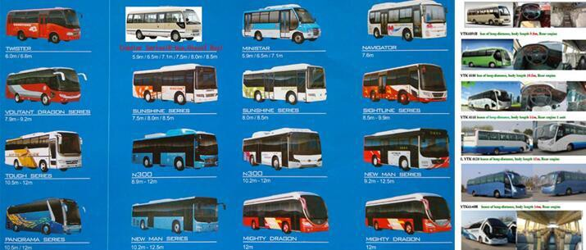
Bus Body and buses assembly plant project

Our bus model: Let us explain, what is Chain auto assemble plant project, and Relevant background information:

A, Relevant background information:

About our China's automobile industry status in the world:

Do you know China auto technology development very fast, 2016 Chinese auto production about 28.6 millions units > Japanese + U.S.+ Korea auto total production.
2017, the production of new energy vehicles in China was 860,000, the world's largest,surpassing the total output of new energy vehicles was over total output of all other countries.
2017, China have export over 400,000 units Buses, the output is No.1 on the world.

China government encourages China enterprises to open oversea markets and increase oversea investments. The goverment offer favorable policies. Our suppliers board of directors make a relative decision of building 10 more auto factories throughout the world in future. In Africa, three auto assembly plants are arranged, to be located in east Africa, west Africa and north Africa. Our investment scale of each factory is arranged to be up to 1-2 million USD, which will be invested into the project step by step. At the same time China Development Bank and China Import & Export bank may give us credit line. It is a good chance for our development of the overseas market,in order to be confident of our cooperation, we hope you can catch it and speed up the project schedule.

B, what is CBU with SKD, CKD

CBU = finished automobile

CKD = Completely Knocked down parts . All materials supplied loose for final welding and final assembly, or raw body shell and all other parts loose and not assembled.

SKD I = Semi knocked down parts.Car body and trucks cabin are unpainted.The engine,gearbox,axles,suspension,driveshaft, steering,seats,tyres,batteries,exhaust system,elec trical,etc.are supplied as individual units for assembly.
SKD II = Car body is fully painted and glazed.Truck cabin is fully painted.The engine, gearbox, axles,suspension, driveshaft, steering, seats, tyres, batteries, exhaust system,e lectrical etc. are supplied as individual units for assembly.

C, Auto assembly plant by Turn Key Project and Joint Venture model:

1. Definition of our Turn Key Project:

The turn key project is aiming at offering you an easy and quick approach to enter the automobile industry, we will help you to establish an asse mbly factory and provide you automobile parts for assembling first,we export parts to your side under SKD or CKD in order that great much cos t will be cutted, we help you design and build up the assembly plant as well as provide you necassery and detailed technology assistance till you master all required technologies and be capable to make vehicles on your own totally.

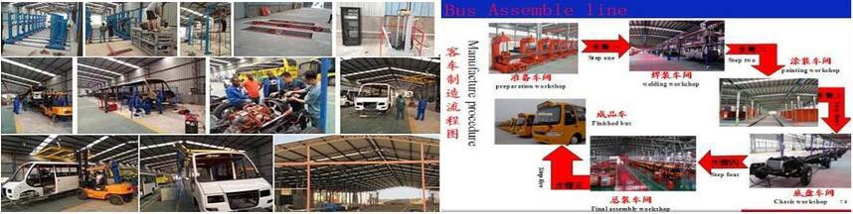

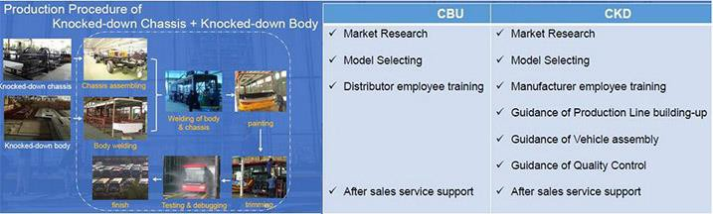

2, A rough idea on the budget and kinds of input for you reference: in the initial stage, the production line equipment needs around 1 million US Dollars; a 5000-8000 square meters workshop area (the inside), construction cost of the factory building is around 80-90 US dollars per square meters on average; working staff around 50 - 100 persons, i ncluding workers,engineers and technicians, managerial personnels, and sales persons, which will be increased gradually with the expanding of the factory scale.

3, the power supply requirements over: 300-500kw.

4, Project stages: the stage of SKD, CKD stage, stage of auto parts localization manufacturing.

5, Usually production is gradually increased from 50-100 units per month, according to the market demand and sales situation, output shall be gradually increased every month and every year, as well as the vehicle models.

6, As regards the working capital / liquidity requirements: Usually, a normal running factory needs to prepare 3-4 times as much as the value of monthly production, one batch of KD parts produced in China, one batch of KD parts in transit, and another batch of KD parts are in the factory for being assembled; of

course, our company often provides our foreign partners some credit for financing, for example, we can accept Usance L/C.

7, About sales, cooperating with the local bank and leasing company, sell the vehicles with the way of financing lease, and improving the local after-sales service system, and it is also important to strive for government orders and group sales.

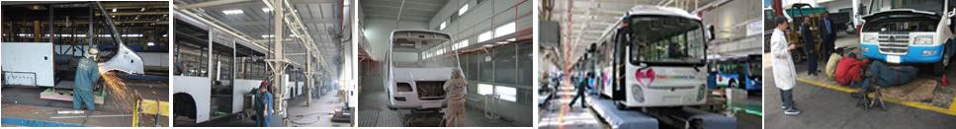

Chinese factory will provide spare parts supply, technical support, and train, assembled auto mobile products have Quality assurance

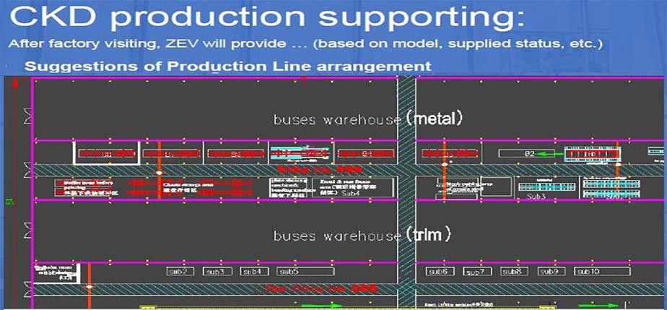

H, Shortcut of starting automobile industry from Order sample to order SKD ----CKD----Parts localization production.

F-1, From trade of CBU starting---- assembly CKD or starting assembly Pickup, SUV---- CKD and adding assembly buses. F-2, From Mini bus SKD starting--to-- assembly CKD of buses series.
Starting from the lowest investment, and gradually upgrade (investment to upgrade, technology upgrading, market upgrade, the scale upgrade)

I, what is Assembly auto is four line:

Welding joint line, Metal surface treatment and coating process, general assembly line, Detection line.If starting from SKD, the equipment list is just need this part: coating process, general assembly line, Detection line. in fact, best big investment is this part :Welding joint line, Metal surface treatment. From SKD starting, step by stey investment equipment is better suitable developing country investor or industrialist.
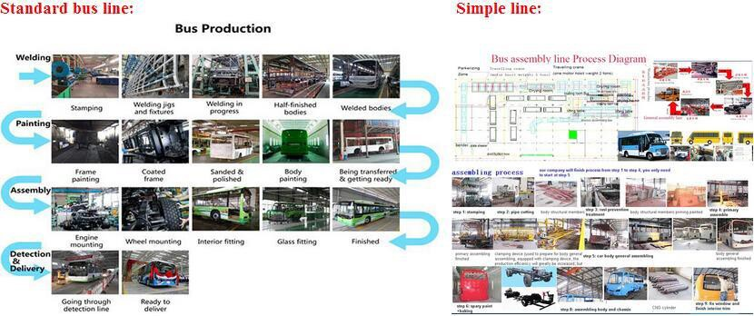

J, About bus factory equipment investment budget, due to production arrangement, the model selection, production line automation degree, different power supply, production workshop area is different, different standards for environmental protection... and so on more
reason, These will affect the investment budget. please you check two budget list in enclosure, in

fact, The truly accurate bus factory investment budget is to complete the design and consideration of all relevant elements in the factory.

K, We provide more service of intelligent public transport bus,taxi and safety management system too !
Background information: China has established a perfect urban public traffic safety, including urban public transport buses, taxis, intelligent, network management, greatly improve the efficiency, safety and reliability, This is the development trend of urban public transport management. we may provide all service of intelligent public transport.

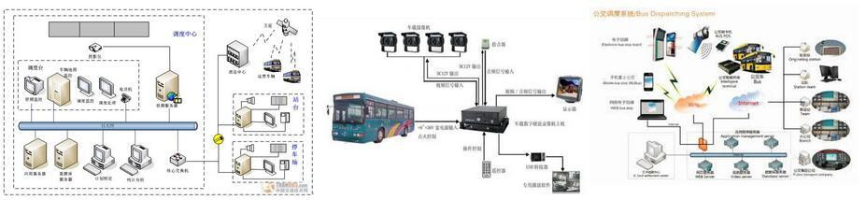

Intelligent bus system has effective data management and analytical capability, operational data management and analytical data management.The aim is to ensure the efficie nt management, planning and scheduling of daily operations, as well as to provide high-quality information consulting services to the public.To provide real-time system stat us query and historical data analysis services
to the manager, support the decision maker to formulate the policy of traffic development and the macro information analysis of the planning.

This task is mainly completed by the bus information center.

L, How much investment is need to do the bus assembly factory project ?

1, equipment investment

budget, One is the easiest, the annual production of 500-800 vehicles, the simple version of the bus line equipment budget, about half

million dollars;In addition, the equipment budget for the upgraded version of the bus production line will be completed in the next production lin e of 2000-3000 buses
equipment investment budget is about 2 millions USD. 2, Workshop over 8000M2, land over 20000M2.
3, worker is obout 50-150.

4, Work capital 3-5 millions USD.

if you have market resources, government network resources, capital investment capacity, and idle factories..........

M, Background information:
1, 2016 Chinese auto production about 30 million = Japanese cars + U.S. auto production

2, In 2016, the production of new energy vehicles in China was 700,000, the world's largest, surpassing the total output of new energy vehicles in all other countries.
3, China's electric car manufacturing technology has is a world leading level.China big city have Popularized the electric buses. 4, Per year, China export buses is about 400,000 units .
N，China bus manufacture and China buses market

Our China bus plant manufacture products 75% is new energy resources bus, just 25% is petro fuel bus. China city almost all use new energy resources bus, petrol fuel bus can't use in city. new energy resources bus

include Pure electric bus, quick charge bus, slow charge bus, hybrid electric bus (CNG + power mode) and CNG bus. the petro fuel bus is use export to other developing countries. we may provide bus manufacture technology and some investment
for new energy resources bus and petrol fuel buses.

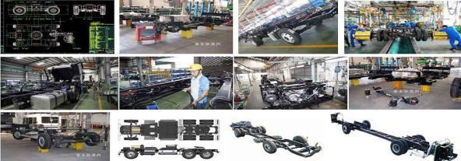

O, For the new energy bus assembly plant, it is necessary to add some necessary charging equipment, special equipment for batteries an d motors.
P, Please analyze and compare the final cost of CBU and CKD.
1, CKZ6115D this bus used for long-distance passenger transport.
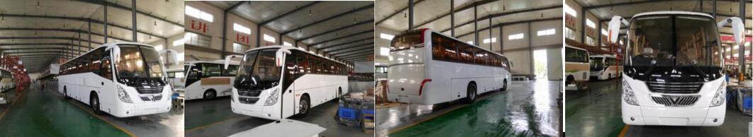

QUOTATION
 | CBU term |  |  |  | CKD term
 | with air conditioner | without air conditioner |  | with air conditioner | without air conditioner
USD Prcie/unit EX  W | US$69,500.00 | US$63,500.00 |  | US$66,500.00 | US$60,500.00
freight and insurance  （Chongqing to Lago s） | US$12,860.00 | US$12,515.00 |  | US$3,000.00 | US$3,000.00
Package Cost | / |  | / | US$2,000.00 | US$2,000.00
unit price CFR Lagos | US$72,360.00 | US$66,015.00 |  | US$61,500.00 | US$55,500.00

Nigeria auto import tariff: CBU(FBU) 35% ;SKD 10%; CKD free.

2, ADICKZ6116D this bus used city passenger transport. Ex factory USD 50000.00--57000

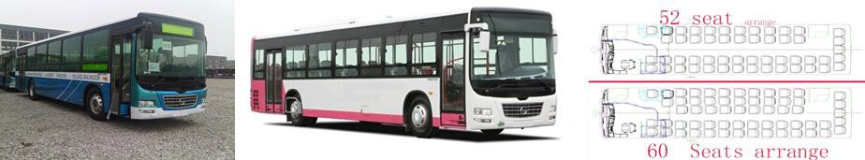

ADICKZ6116D QUOTATION
 | CBU term |  | CKD term
 | with air conditioner | without air conditioner | with air conditioner | without air conditioner
USD Prcie/unit EXW | US$54,000.00 | US$48,000.00 | US$57,000.00 | US$46,000.00

freight and insurance  （Chongqing to Lagos） | US$12,860.00 | US$12,515.00 | US$3,000.00 | US$3,000.00
Nigeria auto import tariff: CBU(FBU) 35% ;SKD 10%; CKD free.

3, For the mini-middle bus series:

ADICKZ6650D model bulk length 6.5 m, take passenger 28/ seats 15-19 + stance 9-13 ADICKZ6710D model bulk length 7.05m, take passenger 33/ seats 19-27 + stance 0-13
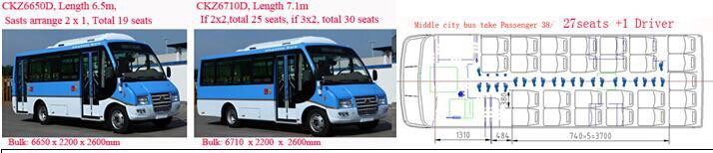

ADICKZ6650D QUOTATION
 |  | CBU term |  |  | CKD term
 | with air conditioner | without air conditioner |  | with air conditioner | without air conditioner
USD Prcie/unit EXW | US$25,000.00 |  | US$22,500.00 | US$24000 | US$21,500
freight and insurance  （Chongqing to Lagos） | US$5000.00 |  | US$4800 | US$ 1500.00 | US$1500.00
Package Cost | / |  | / | US$ 1200.00 | US$ 1000.00
unit price CFR Lagos | US$29,500 |  | US$27,300.00 | US$ 26700 | US$ 2400

ADICKZ6710 model(30 seats), it is better high cost performance. it is cost high USD2000 than ADICKZ 6650D.

For the mini-middle bus series:

ADICKZ6650D model bulk length 6.5 m, take passenger 24/ seats 15-19 + stance 9-13 ADICKZ6710D model bulk length 7.05m, take passenger 30/ seats 19-27 + stance 0-13

4, Caster series bus If CBU(FBU) Term :
Coaster ADICKZ6730 model(38 passenger/23-29 seats + 15 stance + 1 driver), it is better high cost performance. freight is by Roll-roll ship by CBU, by CBU, it is Ex factory USD 30999.00 --36999.00
Pure Electric power Caster series bus:Ex factory : USD98,000.00(due to high cost, we do not focus on recommending this model)

If CKD Term :

EX factory USD 29999.00 + package $800.00, if you have bus manufacturing license in Nigeria, import tariff free only )

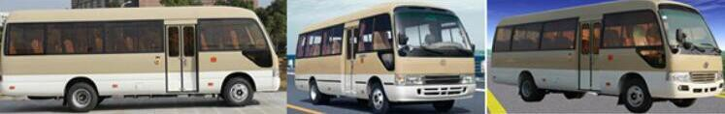

Coaster ADICKZ6730D QUOTATION
 |  | CBU term |  |  | CKD term
 | with air conditioner | without air conditioner |  | with air conditioner | without air conditioner
USD Prcie/unit EXW | US$33,499.00 |  | US$30,999.00 | US$32,499,00 | US$29,999.00
freight and insurance  （Chongqing to Lagos） | US$5000.00 |  | US$4800 | US$ 1600.00 | US$1600.00
Package Cost | / |  | / | US$ 1000.00 | US$ 1000.00
unit price CFR Lagos | US$38,499.00 |  | US$35,799.00 | US$ 35,099.00 | US$ 32,599
Nigeria auto import tariff: CBU(FBU) 35% ;SKD 10%; CKD free.

If you wish know more message, please you receive next few letter, or, inform us your care about questions.

Looking forward to your early reply !
