Asset Complete Specification

Manufacturer: Model Designation:Airbus A380
Airbus SAS

Confidentiality and Disclaimer:
All rights reserved. This document is the sole property of ……….. This document has been drafted and distributed for information purposes only. This document may not be reproduced or (re)distributed or otherwise utilized in part or whole without the express prior written permission of ………... While the information presented in this document is given in good faith based upon the most current information available, changes or modifications with respect to the subject equipment and the associated records and documentation may be made at any time. No express or implied warranty or representation is made and this document may not be regarded as establishing any obligation on the part of …… or any of its affiliates or associates. It is expected that interested parties will conduct an independent physical inspection of the equipment and associated records and documentation.

Asset Specific Data
Asset Model Designation | A380-841  Description | Comment
General Information
Line Number | None
Production (Variable) Number
OEM Detailed Specification | 00L000H0841/C0S Issue 3
Certification Bases
OEM Aircraft Certification Basis EASA
Type Certificate Data Sheet EASA TCDS A.110
JAR-OPS Part K Not Compliant
JAR-OPS Part L Not Compliant
FAA Type Certification Requirements Compliant
Certification of Dynamically Tested Passenger Compliant Seats
Configuration

Cockpit Seats | 4
Total Passenger Seats | 471
Passenger Seats First Class | 12
Passenger Seats Business Class | 60
Passenger Seats Economy Class | 399
Attendant Positions | 24
Galleys Installed | 22 | GM1, GM2/3, GM4, GM5, GM6, GM7, GM8, GM9, GM10, GM11, GU1, GU2/3, GU4, GU5, GU6, GU7, GU8, GU9, GU10, GU11, GU12 and GU13
Galley Type | ATLAS
Lavatories | 15 | LM35, LM36, LM41, LM42, LM46, LM53, LM54, LM88, LM94, LU11, LU32, LU47, LU48, LU75 and LU76
OPS Data
Autoland Capabilities | Certified for CAT IIIB
 | Current CAT IIIB
Area Navigation | PRNAV-RNP1
Tailwind Certification | Certified for 10 knots @ Take-off and Landing
Reduced Vertical Separation Minimum | RVSM Compliant
Extended-range Twin-engine Operations | No Requirements
Maximum Operating Altitude | 43,100 ft
APU Maximum Operating Altitude | 22,500 ft
Maximum Operating Limit Speed | 340 knots
Maximum Mach Operating Speed | 0.89 M
Additional Information
Usable Fuel Capacity | 258,837 kg

Asset Model Designation A380-841
Description Comment
Additional Information
Usable Fuel Capacity 323,546 ltr
Regulatory Compliance
Eurocontrol FM Immunity Compliant
Eurocontrol 8.33 Khz Programme Compliant
Mode S Enhanced Surveillance (EHS) Compliant
Mode S Elementary Surveillance (ELS) Compliant
Enhanced Ground Proximity Warning System Compliant
Traffic alert and Collision Avoidance System TCASII version 7.0
Cargo Compartment Fire Compliance Class C Compliant
Flight Data Recorder Parameters (number) 88 Parameters as per JAR-OPS
1.715 and FAR 121.344
Noise Category ICAO Annex 16, Chap 4
Engine Data
Engine Thrust Rating - Factory Delivery 75,152 lb
Engine Thrust Rating - Current Operating 75,152 lb

Asset Weights:  Description: | Current  (kg) (lb) | Max. Designed  (kg) (lb) | Purchased / Leased  (kg) (lb)
Maximum Take Off Weight | 569,000 1,254,42 | 569,000 1,254,42 | 569,000 1,254,42
 | 9 | 9 | 9
Maximum Taxi Weight | 571,000 1,258,83 | 571,000 1,258,83 | 571,000 1,258,83
 | 9 | 9 | 9
Maximum Zero Fuel Weight Maximum Landing Weight Operational Empty Weight Manufacturers Empty Weight Weight Variant:  Date:  Last Weighing: 20/May/2018  Last Weighing 20/May/2018 Report: | 366,000 806,891  391,000 862,007  288,398 635,809  258,092 568,986  WV002  Comment: | 366,000 806,891  391,000 | 366,000 806,891  391,000 862,007

Major Components

Description | Position | Type | Part No | Serial No | TSN | CSN | Date
Airframe  Airframe for Airbus A380 |  |  | AIRFRAME | 0006 | 44,995 | 5,565 | 31/Jul/2019

Manufacturer: Airbus SAS

Engine General
Engine | Left #1 | TRENT 900 | TRENT 970-84 | 91035 | 38,934 | 4,412 | 31/Jul/2019
Status: On Aircraft

Manufacturer: RR

Engine General
Engine | Left #2 | TRENT 900 | TRENT 970-84 | 91036 | 33,215 | 4,066 | 31/Jul/2019
Status: On Aircraft

Manufacturer: RR

Engine General
Engine | Right #3 | TRENT 900 | TRENT 970-84 | 91055 | 33,593 | 3,861 | 31/Jul/2019
Status: On Aircraft

Manufacturer: RR

Engine General

Engine Right #4 TRENT 900 TRENT 970-84 91038 37,752 4,204 31/Jul/2019

Status: On Aircraft

Manufacturer: RR

Main Landing Gear
Left Wing Landing Gear Left Wing 2143A4100-40 GLGW4100S0
1

8,320 1,142 31/Jul/2019

Status: On Aircraft

Manufacturer: Messier Dowty

Main Landing Gear
Left Body Landing Gear Left Body 2144A4100-50 GLGB4100S01 8,320 1,142 31/Jul/2019 Status: On Aircraft

Manufacturer: Messier Dowty

Main Landing Gear
Right Body Landing Gear Right
Body

2244A4100-50 GLGH4100S01 8,320 1,142 31/Jul/2019

Status: On Aircraft

Manufacturer: Messier Dowty

Main Landing Gear
Right Wing Landing Gear Right
Wing

2243A4100-40 GLGM4100S0
1

8,320 1,142 31/Jul/2019

Status: On Aircraft

Manufacturer: Messier Dowty

Nose Landing Gear

Nose Landing Gear 10-200201-052 15B38872 8,320 1,142 31/Jul/2019

Status: On Aircraft

Manufacturer: Goodrich Corporation

APU - Engine (APU hrs/cyc)
APU PW980A 3900941-01 PCE-GG0030 13,084 8,118 31/Jul/2019

Status: On Aircraft

Manufacturer: P&W Canada

Maintenance Status History

Overhaul/Check/Shop Visit Maintenance Provider Location FH FC Date

Airframe for Airbus A380 (S/N: 0006)

Bridging - Check |  |  | 44,613 | 5,502 | 01/Mar/2019
HMA & Delease & C05 - Check & 12YR - Check & A01 - Check |  |  | 44,091 | 5,417 | 27/Apr/2018
A11 - Check |  |  | 42,142 | 5,150 | 19/Jun/2017
A10 - Check |  |  | 40,788 | 4,958 | 09/Mar/2017
A09 - Check |  |  | 39,529 | 4,788 | 14/Dec/2016
A08 - Check |  |  | 38,084 | 4,592 | 01/Sep/2016
C04 - Check & A07 - Check |  |  | 36,675 | 4,423 | 23/May/2016
A06 - Check |  |  | 35,633 | 4,307 | 05/Dec/2015
A05 - Check |  |  | 34,357 | 4,119 | 02/Sep/2015
A04 - Check |  |  | 33,232 | 3,959 | 13/Jun/2015
A03 - Check |  |  | 31,967 | 3,789 | 17/Mar/2015
A02 - Check |  |  | 30,646 | 3,608 | 17/Dec/2014
A01 - Check |  |  | 29,365 | 3,425 | 16/Sep/2014
6YR - Check & C03 - Check & A12 - Check |  |  | 27,957 | 3,228 | 04/Jun/2014
A11 - Check |  |  | 27,513 | 3,169 | 14/Jan/2014
A10 - Check |  |  | 26,102 | 2,984 | 04/Oct/2013
A09 - Check |  |  | 24,894 | 2,850 | 09/Jul/2013
A08 - Check |  |  | 23,687 | 2,708 | 14/Apr/2013
A07 - Check |  |  | 22,563 | 2,576 | 27/Jan/2013
A06 - Check |  |  | 21,007 | 2,392 | 13/Oct/2012
A05 - Check |  |  | 20,214 | 2,300 | 08/Aug/2012
C02 - Check & A04 - Check |  |  | 18,481 | 2,112 | 06/Apr/2012

Overhaul/Check/Shop Visit | Maintenance Provider | Location | FH | FC | Date
A03 - Check |  |  | 18,057 | 2,064 | 09/Jan/2012
A02 - Check |  |  | 16,805 | 1,923 | 10/Oct/2011
A01 - Check |  |  | 15,348 | 1,765 | 04/Jul/2011
A12 - Check |  |  | 14,066 | 1,628 | 21/Mar/2011
A11 - Check |  |  | 12,865 | 1,487 | 28/Dec/2010
A10 - Check |  |  | 11,682 | 1,357 | 01/Oct/2010
A09 - Check |  |  | 10,384 | 1,212 | 23/Jun/2010
A08 - Check |  |  | 9,115 | 1,084 | 20/Mar/2010
C01 - Check & A07 - Check |  |  | 7,907 | 935 | 14/Dec/2009
A06 - Check |  |  | 7,409 | 877 | 17/Oct/2009
A05 - Check |  |  | 6,295 | 737 | 16/Jul/2009
A04 - Check |  |  | 5,166 | 617 | 19/Apr/2009
A03 - Check |  |  | 3,924 | 495 | 17/Jan/2009
A02 - Check |  |  | 2,856 | 372 | 28/Oct/2008
A01 - Check |  |  | 1,421 | 204 | 07/Jul/2008
Engine (S/N: 91035) Left #1
Repaired, Inspected, Modified & Tested (Refurbishment) |  |  | 38,024 | 4,263 | 23/Feb/2018
Repaired, Inspected, Modified & Tested |  |  | 30,291 | 3,501 | 16/Feb/2016
Repaired, Inspected, Modified & Tested |  |  | 29,190 | 3,360 | 11/Jun/2015
Repaired, Inspected, Modified & Tested (Refurbishment) |  |  | 21,971 | 2,497 | 11/Jul/2013
Repaired, Inspected, Modified & Tested |  |  | 13,733 | 1,559 | 18/Aug/2011
Repaired, Inspected, Modified & Tested |  |  | 4,753 | 577 | 25/Apr/2009
Installed | New Engine - First Run |  | 0 | 0 | 15/Jan/2008

Overhaul/Check/Shop Visit Maintenance Provider Location FH FC Date

Engine (S/N: 91036) Left #2

Repaired, Inspected, Modified & Tested |  |  | 32,305 | 3,917 | 13/Dec/2017
Repaired, Inspected, Modified & Tested (Refurbishment) |  |  | 27,222 | 3,236 | 05/Jul/2016
Repaired, Inspected, Modified & Tested |  |  | 26,679 | 3,178 | 25/Jul/2015
Repaired, Inspected, Modified & Tested (Refurbishment) |  |  | 12,610 | 1,436 | 25/Mar/2012
Repaired |  |  | 8,291 | 956 | 27/Jan/2011
Repaired, Inspected, Modified & Tested |  |  | 7,749 | 896 | 14/Oct/2010
Repaired, Inspected, Modified & Tested |  |  | 4,102 | 513 | 13/Aug/2009
Repaired, Inspected, Modified & Tested |  |  | 3,609 | 447 | 28/Feb/2009
Installed |  |  | 0 | 0 | 15/Jan/2008
Engine (S/N: 91055) Right #3

Repaired, Inspected, Modified & Tested (Refurbishment) |  |  | 32,683 | 3,712 | 12/Feb/2018
Repaired, Inspected, Modified & Tested |  |  | 22,009 | 2,650 | 20/Jun/2015
Repaired, Inspected, Modified & Tested (Refurbishment) |  |  | 13,470 | 1,551 | 04/Mar/2013
Repaired, Inspected, Modified & Tested |  |  | 6,776 | 791 | 17/Jun/2011
Repaired, Inspected, Modified & Tested |  |  | 5,975 | 708 | 24/Sep/2010
Repaired, Inspected, Modified & Tested |  |  | 5,337 | 640 | 25/Mar/2010
Repaired, Inspected, Modified & Tested |  |  | 819 | 122 | 11/Sep/2008
Installed | New Engine - First Run |  | 0 | 0 | 15/Jan/2008

Overhaul/Check/Shop Visit Maintenance Provider Location FH FC Date

Engine (S/N: 91038) Right #4

Repaired, Inspected, Modified & Tested (Refurbishment) |  |  | 36,842 | 4,055 | 03/Feb/2018
Repaired, Inspected, Modified & Tested (Refurbishment) |  |  | 22,108 | 2,398 | 13/Apr/2014
Repaired, Inspected, Modified & Tested |  |  | 13,280 | 1,518 | 11/Feb/2012
Repaired, Inspected, Modified & Tested |  |  | 9,236 | 1,095 | 31/Dec/2010
Repaired, Inspected, Modified & Tested |  |  | 8,061 | 964 | 24/Aug/2010
Repaired, Inspected, Modified & Tested |  |  | 3,609 | 447 | 26/Feb/2009
Installed |  |  | 0 | 0 | 15/Jan/2008
Left Wing Landing Gear (S/N: GLGW4100S01) Left Wing

New | Goodrich Landing | Oakville, | 0 | 0 | 23/May/2016
 | Systems Services | Canada
Left Body Landing Gear (S/N: GLGB4100S01) Left Body

New | Goodrich Landing | Oakville, | 0 | 0 | 23/May/2016
 | Systems Services | Canada
Right Body Landing Gear (S/N: GLGH4100S01) Right Body

New | Goodrich Landing | Oakville, | 0 | 0 | 23/May/2016
 | Systems Services | Canada
Right Wing Landing Gear (S/N: GLGM4100S01) Right Wing

New | Goodrich Landing Systems Services | Oakville, Canada | 0 | 0 | 23/May/2016
Nose Landing Gear (S/N: 15B38872)
New | Messier Dowty | Velizy- Villacoublay, France | 0 | 0 | 23/May/2016
APU (S/N: PCE-GG0030)
Overhaul | Revima APU | Caudebec-en- Caux, France | 12,311 | 7,645 | 04/Oct/2017
Repair | Revima APU | Caudebec-en- Caux, France | 7,354 | 4,722 | 20/Mar/2014
Repair | Revima APU | Caudebec-en- Caux, France | 2,921 | 2,008 | 13/Jul/2011

Configuration Components

 | Description | Manufacturer | Part Number | Remarks | QTY
Avionics
2270 | Flight Management Computer | Honeywell | 4090000-905 |  | 3
2280 | FCU | Thales Avionics | C16455AC03 |  | 1
2310 | HFDR - Transceiver | Rockwell Collins | 822-0990-020 |  | 2
2310 | Radio Management Panel | Team | RMP8000AA120101 |  | 3
2310 | VHF Com Transceiver (Incl.  8.33 & FM im) | Rockwell Collins | 822-1250-020 |  | 3
2320 | High Speed Data Unit - SATCOM | Honeywell | 7520061-34010 |  | 1
2320 | Satellite Data Unit - SATCOM | Honeywell | 7516118-27140 |  | 1
2350 | Audio Management Unit | Team | AMU4032AA130101 |  | 2
2370 | Camera Interface Unit | Latecoere STE | 1215L1020020 |  | 1
2370 | CDSS Controller | Securaplane | 100-2603-02 |  | 1
2370 | Solid State Cockpit Voice Recorder | L3-Communications | 2100-1025-02 |  | 1
2370 | Taxi Aid Camera - Belly | Latecoere STE | 1226L1000010 |  | 1
2370 | Taxi Aid Camera - Vertical Stabilizer | Latecoere STE | 1237L1000010 |  | 1
2705 | SFCC-Slat/Flap Control Computer | DIEHL Avionik Systems | 84320-00-0404 |  | 2
2790 | FCGU | Airbus SAS | LA8P00200HL0202 |  | 6
2790 | SEC - Secondary Computer | Airbus France | LA8S00200HL0302 |  | 3
3120 | Clock | Air Precision | APE5100-3 |  | 1
3130 | Accelerometer - Three Axis | AMETEK Aerospace | 3001-01-111 |  | 1
3130 | Solid State Flight Data Recorder (SSFDR) | L3-Communications | 2100-4045-00 |  | 1
3140 | KCCU L/H | Thales Avionics | C16449AD |  | 1
3140 | KCCU R/H | Thales Avionics | C16449BD |  | 1
3140 | Video Concentrator | Smith Industries | 181900-003 |  | 1
3160 | Display Unit | Thales Avionics | C19596AC04 |  | 8
3410 | Air Data Inertial Reference Unit - ADIRU | Honeywell | HG2030BE02 |  | 3
3420 | ISIS Indicator | Thales Avionics | C16221SB03 |  | 2
3420 | Standby Magnetic Compass | SIRS Navigation Ltd. | KCA0105W |  | 1

 | Description | Manufacturer | Part Number | Remarks | QTY
Avionics
3430 | Onboard Airport Navigation | Thales Avionics | C19668AA02 |  | 1
3440 | AESU | Honeywell | 965-1694-001 |  | 2
3440 | Radio Altimeter Transceiver | Thales Avionics | 9599-607-19994 |  | 3
3440 | Weather Radar Transceiver | Honeywell | 930-2000-001 |  | 2
3450 | DME Interrogator | Rockwell Collins | 822-0329-021 |  | 2
3450 | MMR - ILS/GPS | Rockwell Collins | 822-1821-131 |  | 2
3450 | VOR Receiver (incl. FM immunity) | Rockwell Collins | 822-0297-020 |  | 2
4410 | Data Acquisition Unit | Parker Hannifin Corp. | 367-352-001 |  | 1
4420 | Cabin Router Unit | Airbus Deutschland | Z485H000080A |  | 1
4420 | Controller - IFE - System | Panasonic Avion (Matsushita) | RD-FA1011-01 |  | 2
4420 | Disc Drive | Panasonic Avion (Matsushita) | RD-FA1141-01 |  | 1
4420 | Encoder - Media D/A | Panasonic Avion (Matsushita) | RD-FA1009-01 |  | 1
4420 | Ethernet Switch Unit | Panasonic Avion (Matsushita) | RD-FA1041-01 |  | 2
4420 | FAP | Airbus Deutschland | Z145H060780B |  | 4
4420 | FAP - Mini | Airbus Deutschland | Z195H000680A |  | 1
4420 | Hard Disk Drive Array | Panasonic Avion (Matsushita) | RD-FA1031-01 |  | 3
4420 | Keyboard | Panasonic Avion (Matsushita) | RDAA8011-22 |  | 2
4420 | Keyboard - FAP | Airbus Deutschland | Z144H0000110 |  | 3
4420 | Printer | Panasonic Avion (Matsushita) | RD-FA1161-01 |  | 2
4420 | RCC (CM02) | Panasonic Avion (Matsushita) | RDAA902584-01 |  | 1
4420 | RCC (GU01) | Panasonic Avion (Matsushita) | RDAA902585-01 |  | 1
4420 | Server - File | Panasonic Avion (Matsushita) | RD-KA1003-02 |  | 2
4420 | Server - Media | Panasonic Avion (Matsushita) | RD-FA1061-01 |  | 3
4420 | Smart Card Reader | Panasonic Avion (Matsushita) | RD-FA1131-01 |  | 2
4420 | Video - Reproducer | Panasonic Avion (Matsushita) | RD-AV1306-01 |  | 1
4600 | Aircraft GSM Server (AGS)/ Cabin Network | Kid-Systeme GmbH | Z465H0000111 |  | 1
4600 | Aircraft Router Unit | SAGEM Defence Securite SA | 251375122-1001 |  | 2

 | Description | Manufacturer | Part Number | Remarks | QTY
Avionics
4600 | Aircraft Router Unit | SAGEM Defence Securite SA | 252666064-1001 |  | 1
4600 | ANSU - AFMR | SAGEM Defence Securite SA | 252666043-1001 |  | 1
4600 | ANSU - OPS | SAGEM Defence Securite SA | 251375101-1001 |  | 2
4600 | Avionics Full Duplex Switch Ethernet | Rockwell Collins | 822-1745-100 |  | 16
4600 | Centralized Data Acquisition Module | SAGEM Defence Securite SA | ED50A101-01 |  | 1
4600 | Core Processing Input Output Module - A | Thales Avionics | C31000EB02 |  | 4
4600 | Core Processing Input Output Module - B | Thales Avionics | C31001EB03 |  | 4
4600 | Core Processing Input Output Module - C | Airbus France | LA8C00000HL0501 |  | 2
4600 | Core Processing Input Output Module - D | Airbus France | LA8D00000HL0501 |  | 2
4600 | Core Processing Input Output Module - E | Thales Avionics | C13145EB02 |  | 2
4600 | Core Processing Input Output Module - F | Thales Avionics | C13096HA02 |  | 4
4600 | Core Processing Input Output Module - G | Thales Avionics | C13097JA02 |  | 4
4600 | Input Output Module A | Airbus France | LA8M00000HL0101 |  | 8
4600 | Network Server System Laptop | Airbus France | LA8L00000HL0304 |  | 3
4600 | Power Distribution Maintenance Computer Hardware | Honeywell | 1153398-4 |  | 2
4620 | SCIA110 | SAGEM Defence Securite SA | SCIA110-01 |  | 2
Configuration
2510 | Reinforced Cockpit Door - Phase II | Airbus SAS |  |  | 1
2510 | Seat - 3rd Occupant | EADS Sogerma | TAAI4-00IM30-01 |  | 1
2510 | Seat - 4th Occupant | AMI Industries Goodrich Corp | 2386-034SAA1 |  | 1
2510 | Seat - Copilot | EADS Sogerma | TAAI4-04CE40-01 |  | 1
2510 | Seat - Pilot | EADS Sogerma | TAAI4-04PE40-01 |  | 1
2520 | Cabin Attendant Seat Aft U1RH/FWD(Single) | AMI Industries Goodrich Corp | 2380TS3TAA21CA1 | Upper Deck | 1
2520 | Cabin Attendant Seat Door M1CTR (Single) | AMI Industries Goodrich Corp | 2380HS3TAA21CA | Main Deck | 1
2520 | Cabin Attendant Seat Door M1LH (Single) | AMI Industries Goodrich Corp | 2383HL3DAC51CA | Main Deck | 1
2520 | Cabin Attendant Seat Door M1RH (Single) | AMI Industries Goodrich Corp | 2380HS3CAA31CA | Main Deck | 1

Description Manufacturer Part Number Remarks QTY

Configuration

2520 | Cabin Attendant Seat Door M2LH (Single) | AMI Industries Goodrich Corp | 2380TS3RBA21CA1 | Main Deck | 1
2520 | Cabin Attendant Seat Door M2RH (Single) | AMI Industries Goodrich Corp | 2383TR3DAC51CA1 | Main Deck | 1
2520 | Cabin Attendant Seat Door M3LH (Double) | AMI Industries Goodrich Corp | 2382TD3BAA21CA | Main Deck | 1
2520 | Cabin Attendant Seat Door M3RH (Double) | AMI Industries Goodrich Corp | 2382TD3AAA21CA | Main Deck | 1
2520 | Cabin Attendant Seat Door M4LH (Single) | AMI Industries Goodrich Corp | 2380TS3RAA21CA1 | Main Deck | 1
2520 | Cabin Attendant Seat Door M4RH (Single) | AMI Industries Goodrich Corp | 2380TS3TAA21CA1 | Main Deck | 1
2520 | Cabin Attendant Seat Door M5CTR/LH (Single) | AMI Industries Goodrich Corp | 2380TS3BAA31CA1 | Main Deck | 1
2520 | Cabin Attendant Seat Door M5CTR/RH (Single) | AMI Industries Goodrich Corp | 2380TS3CAA31CA1 | Main Deck | 1
2520 | Cabin Attendant Seat Door M5LH (Single) | AMI Industries Goodrich Corp | 2380TS3RBA21CA1 | Main Deck | 1
2520 | Cabin Attendant Seat Door M5RH (Single) | AMI Industries Goodrich Corp | 2380TS3RAA21CA1 | Main Deck | 1
2520 | Cabin Attendant Seat Door U1 LH (Single) | AMI Industries Goodrich Corp | 2380TS3RAA21CA1 | Upper Deck | 1
2520 | Cabin Attendant Seat Door U2 LH (Single) | AMI Industries Goodrich Corp | 2380TS3RAA21CA1 | Upper Deck | 1
2520 | Cabin Attendant Seat Door U2RH (Single) | AMI Industries Goodrich Corp | 2380TS3TAA21CA1 | Upper Deck | 1
2520 | Cabin Attendant Seat Door U3 RH (Single) | AMI Industries Goodrich Corp | 2380TS3RBA21CA1 | Upper Deck | 1
2520 | Cabin Attendant Seat Door U3LH (Single) | AMI Industries Goodrich Corp | 2380TS3TBA21CA1 | Upper Deck | 1
2520 | Cabin Attendant Seat Fwd U1RH/AFT (Single) | AMI Industries Goodrich Corp | 2383TR3BAC61CA1 | Upper Deck | 1
2520 | Cabin Attendant Seat Side CU1 RH (Single) | AMI Industries Goodrich Corp | 2380HS3TAA23CA | Upper Deck | 1
2520 | Cabin Attendant Seat Side CU2 LH (Single) | AMI Industries Goodrich Corp | 2381WS3RAA21CA | Upper Deck | 1
2520 | Cabin Lay-Out Total Passenger Seats |  |  |  | 471
2520 | Passenger Seat - Double - Business Class | Koito Industries | 83292B18092-4XX |  | 15
2520 | Passenger Seat - Double - Economy Class | Weber Aircraft | 85681X-4XX |  | 24
2520 | Passenger Seat - Quadruple - Economy Class | Weber Aircraft | 85681X-4XX |  | 39
2520 | Passenger Seat - Single - Business Class | Koito Industries | 83292B18092-4XX |  | 30
2520 | Passenger Seat - Single - First Class | Sicma Aero Seat | 18011XX-XXX |  | 12
2520 | Passenger Seat - Triple - Economy Class | Weber Aircraft | 85681X-4XX |  | 65

Description Manufacturer Part Number Remarks QTY

Configuration

2530 | Galley GM1 | Jamco | SQA7821-1 |  | 1
2530 | Galley GM10 | Jamco | SQA7846-1 |  | 1
2530 | Galley GM11 | Jamco | SQA7851-1 |  | 1
2530 | Galley GM2/3 | Jamco | SQA7822-1 |  | 1
2530 | Galley GM4 | Jamco | SQA7824-1 |  | 1
2530 | Galley GM5 | Jamco | SQA7825-1 |  | 1
2530 | Galley GM6 | Jamco | SQA7826-1 |  | 1
2530 | Galley GM7 | Jamco | SQA7841-1 |  | 1
2530 | Galley GM8 | Jamco | SQA7842-1 |  | 1
2530 | Galley GM9 | Jamco | SQA7845-1 |  | 1
2530 | Galley GU1 | Jamco | SQA7871-1 |  | 1
2530 | Galley GU10 | Jamco | SQA7893-1 |  | 1
2530 | Galley GU11 | Jamco | SQA7894-1 |  | 1
2530 | Galley GU12 | Jamco | SJ338-1 |  | 1
2530 | Galley GU13 | Jamco | SJ338-12 |  | 1
2530 | Galley GU2/3 | Jamco | SQA7872-1 |  | 1
2530 | Galley GU4 | Jamco | SQA7874-1 |  | 1
2530 | Galley GU5 | Jamco | SQA7875-1 |  | 1
2530 | Galley GU6 | Jamco | SQA7876-1 |  | 1
2530 | Galley GU7 | Jamco | SQA7877-1 |  | 1
2530 | Galley GU8 | Jamco | SQA7891-1 |  | 1
2530 | Galley GU9 | Jamco | SQA7892-1 |  | 1
2540 | Lavatory LM35 | Dasell Cabin Int. | A825417001-000 | Vacuum Type | 1
2540 | Lavatory LM36 | Dasell Cabin Int. | A825410001-002 | Vacuum Type | 1
2540 | Lavatory LM41 | Dasell Cabin Int. | A825418001-002 | Vacuum Type | 1
2540 | Lavatory LM42 | Dasell Cabin Int. | A825419001-002 | Vacuum Type | 1
2540 | Lavatory LM46 | Dasell Cabin Int. | A825449001-000 | Vacuum Type | 1
2540 | Lavatory LM53 | Dasell Cabin Int. | A825411001-000 | Vacuum Type | 1
2540 | Lavatory LM54 | Dasell Cabin Int. | A825415001-000 | Vacuum Type | 1
2540 | Lavatory LM83 | Dasell Cabin Int. | A825420001-004 | Vacuum Type | 1

Description Manufacturer Part Number Remarks QTY

Configuration

2540 | Lavatory LM94 | Dasell Cabin Int. | A825421001-004 | Vacuum Type | 1
2540 | Lavatory LU11 | Dasell Cabin Int. | A825451001-000 | Vacuum Type | 1
2540 | Lavatory LU32 | Dasell Cabin Int. | A825466001-002 | Vacuum Type | 1
2540 | Lavatory LU47 | Dasell Cabin Int. | A825469001-002 | Vacuum Type | 1
2540 | Lavatory LU48 | Dasell Cabin Int. | A825468001-002 | Vacuum Type | 1
2540 | Lavatory LU75 | Dasell Cabin Int. | A825481001-000 | Vacuum Type | 1
2540 | Lavatory LU76 | Dasell Cabin Int. | A825482001-000 | Vacuum Type | 1
2560 | ELT - Fixed - 121.5/243/406 MHz | ELTA | 01N65900 |  | 1
2560 | ELT - Portable - 121.5/243/406 MHz | Honeywell | 1151324-1M563 |  | 4
2560 | Escape Slide Raft (Main Deck) | BF Goodrich | 103002-1 | A380 Fit | 1
2560 | Escape Slide Raft (Main Deck) | BF Goodrich | 103002-2 | A380 Fit | 1
2560 | Escape Slide Raft (Main Deck) | BF Goodrich | 103003-1 | A380 Fit | 1
2560 | Escape Slide Raft (Main Deck) | BF Goodrich | 103003-2 | A380 Fit | 1
2560 | Escape Slide Raft (Main Deck) | BF Goodrich | 103005-1 | A380 Fit | 1
2560 | Escape Slide Raft (Main Deck) | BF Goodrich | 103005-2 | A380 Fit | 1
2560 | Escape Slide Raft (Main Deck) | BF Goodrich | 103006-1 | A380 Fit | 1
2560 | Escape Slide Raft (Main Deck) | BF Goodrich | 103006-2 | A380 Fit | 1
2560 | Escape Slide Raft (Upper Deck) | BF Goodrich | 103007-1 | A380 Fit | 1
2560 | Escape Slide Raft (Upper Deck) | BF Goodrich | 103007-2 | A380 Fit | 1
2560 | Escape Slide Raft (Upper Deck) | BF Goodrich | 103008-1 | A380 Fit | 2
2560 | Escape Slide Raft (Upper Deck) | BF Goodrich | 103008-2 | A380 Fit | 2
2560 | Escape Slide Ramp (Main Deck) | BF Goodrich | 103004-1 | A380 Fit | 1
2560 | Escape Slide Ramp (Main Deck) | BF Goodrich | 103004-2 | A380 Fit | 1
Miscellaneous
1120 | Exterior Placards and Markings | English |  |  | 1
1130 | Cabin Placards and Markings | English |  |  | 1

Description Manufacturer Part Number Remarks QTY

Miscellaneous

1130 | Cockpit Placards and Markings |  | English | 1
2850 | FQDC - Fuel Quantity Data Concentrator | Parker Hannifin Corp. 367-334-002 |  | 2
3240 | Brake - Wheel | Honeywell DAP00021-04 | Carbon | 16
5210 | Passenger/Crew Door - Type 1- Main Deck | Airbus SAS | Outward Opening (Plug Type) | 10
5210 | Passenger/Crew Door - Type 1- Upper Deck | Airbus SAS | Outward Opening (Plug Type) | 6
5230 | Aft Lower Cargo Hold | Airbus SAS |  | 1
5230 | Bulk Cargo Door | Airbus SAS |  | 1
5230 | Fwd Lower Cargo Hold | Airbus SAS |  | 1

Engine LLP Snapshot

Engine PN:TRENT 970-84 [SN:91035] Lowest Limiter: |  |  |  | Lowest Limiter:
Current Engine Default at 23/Feb/2018 Rating: |  |  | 3,868 | at 31/Jul/2019 |  | 3,719
Current Thrust Level: 75,152 lb TSN: |  |  | 38,024 | TSN: |  | 38,934
CSN: |  |  | 4,263 | CSN: |  | 4,412
Comment:
LLP Descriptor | LLP Part Number | LLP Serial Number | FC Remaining at 23/Feb/2018 | Life Limit | FC Remaining at 31/Jul/2019
LPC - ROTOR SHAFT | FW21472 | 200581BBAN5121 | 12,500 | 12,500 | 12,351
LPC - ROTOR DISK | FW25895 | LDTDK13858 | 10,737 | 15,000 | 10,588
LPC - BLADE 1 | FW32021 | RGN11795 | 10,737 | 15,000 | 10,588
LPC - BLADE 2 | FW32021 | RGN11809 | 10,737 | 15,000 | 10,588
LPC - BLADE 3 | FW32021 | RGN11772 | 10,737 | 15,000 | 10,588
LPC - BLADE 4 | FW32021 | RGN11796 | 10,737 | 15,000 | 10,588
LPC - BLADE 5 | FW32021 | RGN11784 | 10,737 | 15,000 | 10,588
LPC - BLADE 6 | FW32021 | RGN11778 | 10,737 | 15,000 | 10,588
LPC - BLADE 7 | FW32021 | RGN11761 | 10,737 | 15,000 | 10,588
LPC - BLADE 8 | FW32021 | RGN11607 | 10,737 | 15,000 | 10,588
LPC - BLADE 9 | FW32021 | RGN11794 | 10,737 | 15,000 | 10,588
LPC - BLADE 10 | FW32021 | RGN11748 | 10,737 | 15,000 | 10,588
LPC - BLADE 11 | FW32021 | RRWCFBRGN19883 | 14,276 | 15,000 | 14,127
LPC - BLADE 12 | FW32021 | RGN11741 | 10,737 | 15,000 | 10,588
LPC - BLADE 13 | FW32021 | RGN11800 | 10,737 | 15,000 | 10,588
LPC - BLADE 14 | FW32021 | RGN11743 | 10,737 | 15,000 | 10,588
LPC - BLADE 15 | FW32021 | RGN11616 | 10,737 | 15,000 | 10,588
LPC - BLADE 16 | FW32021 | RGN11744 | 10,737 | 15,000 | 10,588
LPC - BLADE 17 | FW32021 | RGN11768 | 10,737 | 15,000 | 10,588
LPC - BLADE 18 | FW32021 | RGN11716 | 10,737 | 15,000 | 10,588
LPC - BLADE 19 | FW32021 | RGN11740 | 10,737 | 15,000 | 10,588
LPC - BLADE 20 | FW32021 | RGN11628 | 10,737 | 15,000 | 10,588
LPC - BLADE 21 | FW32021 | RGN11727 | 10,737 | 15,000 | 10,588
LPC - BLADE 22 | FW32021 | RGN11803 | 10,737 | 15,000 | 10,588
LPC - BLADE 23 | FW32021 | RRWCFBRGN19645 | 14,276 | 15,000 | 14,127
LPC - BLADE 24 | FW32021 | RGN11765 | 10,737 | 15,000 | 10,588
LPC - ANNULUS FILLER 1 | FW42013 | 202542P491900-1 | 10,500 | 10,500 | 10,351
LPC - ANNULUS FILLER 2 | FW42013 | 202542P418648-2 | 9,738 | 10,500 | 9,589
LPC - ANNULUS FILLER 3 | FW42013 | 202542P491900-3 | 10,500 | 10,500 | 10,351
LPC - ANNULUS FILLER 4 | FW42013 | 202542P490990-1 | 10,500 | 10,500 | 10,351
LPC - ANNULUS FILLER 5 | FW42013 | 202542P490660-1 | 10,500 | 10,500 | 10,351
LPC - ANNULUS FILLER 6 | FW42013 | 202542P411687-3 | 9,738 | 10,500 | 9,589
LPC - ANNULUS FILLER 7 | FW42013 | 202542P490990-4 | 10,500 | 10,500 | 10,351
LPC - ANNULUS FILLER 8 | FW42013 | 202542P411687-2 | 9,738 | 10,500 | 9,589
LPC - ANNULUS FILLER 9 | FW42013 | 202542P411687-6 | 9,738 | 10,500 | 9,589
LPC - ANNULUS FILLER 10 | FW42013 | 202542P490986-1 | 10,500 | 10,500 | 10,351

LLP Descriptor | LLP Part Number | LLP Serial Number | FC Remaining at 23/Feb/2018 | Life Limit | FC Remaining at 31/Jul/2019
LPC - ANNULUS FILLER 11 | FW42013 | 202542P411689-2 | 9,738 | 10,500 | 9,589
LPC - ANNULUS FILLER 12 | FW42013 | 202542P411690-6 | 9,738 | 10,500 | 9,589
LPC - ANNULUS FILLER 13 | FW42013 | 202542P411690-5 | 9,738 | 10,500 | 9,589
LPC - ANNULUS FILLER 14 | FW42013 | 202542P411648-3 | 9,738 | 10,500 | 9,589
LPC - ANNULUS FILLER 15 | FW42013 | 202542P411690-4 | 9,738 | 10,500 | 9,589
LPC - ANNULUS FILLER 16 | FW42013 | 202542P482836-2 | 10,500 | 10,500 | 10,351
LPC - ANNULUS FILLER 17 | FW42013 | 202542P411690-2 | 9,738 | 10,500 | 9,589
LPC - ANNULUS FILLER 18 | FW42013 | 202542P414753-6 | 9,738 | 10,500 | 9,589
LPC - ANNULUS FILLER 19 | FW42013 | 202542P411689-3 | 9,738 | 10,500 | 9,589
LPC - ANNULUS FILLER 20 | FW42013 | 202542P411687-4 | 9,738 | 10,500 | 9,589
LPC - ANNULUS FILLER 21 | FW42013 | 202542P411687-5 | 9,738 | 10,500 | 9,589
LPC - ANNULUS FILLER 22 | FW42013 | 202542P414753-5 | 9,738 | 10,500 | 9,589
LPC - ANNULUS FILLER 23 | FW42013 | 202542P490986-3 | 10,500 | 10,500 | 10,351
LPC - ANNULUS FILLER 24 | FW42013 | 202542P411690-3 | 9,738 | 10,500 | 9,589
IPC - DRUM STG 1 to 8 | FW20677 | MW0286327 | 3,868 | 8,000 | 3,719
IPC - REAR SHAFT | FW86613 | RRDSFTEBAN263 | 13,234 | 15,000 | 13,085
HPC - STAGE 1-4 DISK AND SHAFT | FW79584 | RRDCDD024213 | 7,100 | 7,100 | 6,951
HPC - STAGE 6 DISK AND SHAFT | FW79586 | RRDCDD023779 | 7,100 | 7,100 | 6,951
HPC - STAGE 5 DISK | FW79585 | RRDCDDB33108 | 5,334 | 7,100 | 5,185
HPT - ROTOR DISK | FW77435 | RRSUNDC93B | 4,100 | 4,100 | 3,951
HPT - PLATE FRONT COVER | FW77437 | RRXP017966 | 4,100 | 4,100 | 3,951
IPT - ROTOR DISK | FW43058 | RRSUNDC382 | 10,734 | 12,500 | 10,585
IPT - ROTOR SHAFT | FW85927 | RRDSFTBBAP3230 | 11,738 | 12,500 | 11,589
IPT - REAR AIR SEAL | FW56921 | 213072LAA270 | 12,500 | 12,500 | 12,351
LPT - ROTOR SHAFT | FW41894 | CBAP290 | 8,237 | 12,500 | 8,088
LPT - STAGE 1 ROTOR DISK | FW21661 | FTREW00276 | 8,237 | 12,500 | 8,088
LPT - STAGE 2 ROTOR DISK | FW21662 | FTREW00391 | 8,237 | 12,500 | 8,088
LPT - STAGE 3 ROTOR DISK | FW21663 | FTREW00389 | 8,237 | 12,500 | 8,088
LPT - STAGE 4 ROTOR DISK | FW45269 | FTREW03518 | 10,734 | 12,500 | 10,585
LPT - STAGE 5 ROTOR DISK | FW21665 | FTREW00396 | 8,237 | 12,500 | 8,088
HP/IP BEARING SUPPORT | KH58088 | RRSCAMGB19985 | 5,700 | 5,700 | 5,551
The LLP life remaining as listed in this report is valid and based on the latest loaded LLP Snapshot creation date and the LLP Life Limits as listed in the latest LLP Disk Sheet loaded in the database. It does not take into account any LLP Life Limit change after the creation date following an Engine Event such as a Shop Visit, change in Thrust Rating or revision of a LLP Life Limit in the Time Limits Manual introduced after the creation of the last LLP Disk Sheet provided. The estimated Flight Cycles remaining assumes that correct utilization is reported and populated and no Engine Event such as a Shop Visit, a change in Thrust Rating or a LLP Life Limit change has occurred between the date of the latest LLP Disk Sheet and the date of the last valid utilization loaded in the database.

Engine PN:TRENT 970-84 [SN:91036] Lowest Limiter: |  |  |  | Lowest Limiter:
Current Engine Default at 13/Dec/2017 Rating: |  |  | 3,222 | at 31/Jul/2019 |  | 3,073
Current Thrust Level: 75,152 lb TSN: |  |  | 32,305 | TSN: |  | 33,215
CSN: |  |  | 3,917 | CSN: |  | 4,066
Comment:
LLP Descriptor | LLP Part Number | LLP Serial Number | FC Remaining at 13/Dec/2017 | Life Limit | FC Remaining at 31/Jul/2019
LPC - ROTOR SHAFT | FW21472 | CBAN107 | 8,583 | 12,500 | 8,434
LPC - ROTOR DISK | FW25895 | LDTDK13768 | 11,083 | 15,000 | 10,934
LPC - BLADE 1 | FW32021 | RGN11465 | 11,083 | 15,000 | 10,934
LPC - BLADE 2 | FW32021 | RGN11392 | 11,083 | 15,000 | 10,934
LPC - BLADE 3 | FW32021 | RGN11437 | 11,083 | 15,000 | 10,934
LPC - BLADE 4 | FW32021 | RGN11485 | 11,083 | 15,000 | 10,934
LPC - BLADE 5 | FW32021 | RGN11482 | 11,083 | 15,000 | 10,934
LPC - BLADE 6 | FW32021 | RGN11521 | 11,083 | 15,000 | 10,934
LPC - BLADE 7 | KH63936 | RRFBSGSNN21063 | 15,000 | 15,000 | 14,851
LPC - BLADE 8 | FW32021 | RGN11481 | 11,083 | 15,000 | 10,934
LPC - BLADE 9 | FW32021 | RGN11405 | 11,083 | 15,000 | 10,934
LPC - BLADE 10 | FW32021 | RGN11456 | 11,083 | 15,000 | 10,934
LPC - BLADE 11 | FW32021 | RGN11412 | 11,083 | 15,000 | 10,934
LPC - BLADE 12 | FW32021 | RGN11499 | 11,083 | 15,000 | 10,934
LPC - BLADE 13 | FW32021 | RGN11535 | 11,083 | 15,000 | 10,934
LPC - BLADE 14 | FW32021 | RGN11384 | 11,083 | 15,000 | 10,934
LPC - BLADE 15 | FW32021 | RGN11541 | 11,083 | 15,000 | 10,934
LPC - BLADE 16 | FW32021 | RGN11474 | 11,083 | 15,000 | 10,934
LPC - BLADE 17 | FW32021 | RGN11346 | 11,083 | 15,000 | 10,934
LPC - BLADE 18 | FW32021 | RGN11473 | 11,083 | 15,000 | 10,934
LPC - BLADE 19 | FW32021 | RGN11414 | 11,083 | 15,000 | 10,934
LPC - BLADE 20 | FW32021 | RGN11516 | 11,083 | 15,000 | 10,934
LPC - BLADE 21 | FW32021 | RGN11479 | 11,083 | 15,000 | 10,934
LPC - BLADE 22 | FW32021 | RGN11517 | 11,083 | 15,000 | 10,934
LPC - BLADE 23 | FW32021 | RGN11764 | 11,083 | 15,000 | 10,934
LPC - BLADE 24 | FW32021 | RGN11552 | 11,083 | 15,000 | 10,934
LPC - ANNULUS FILLER 1 | FW42013 | P128161-02 | 6,586 | 10,500 | 6,437
LPC - ANNULUS FILLER 2 | FW42013 | P127628-05 | 6,586 | 10,500 | 6,437
LPC - ANNULUS FILLER 3 | FW42013 | P128161-06 | 6,586 | 10,500 | 6,437
LPC - ANNULUS FILLER 4 | FW42013 | 202542P480173-2 | 10,500 | 10,500 | 10,351
LPC - ANNULUS FILLER 5 | FW42013 | P128161-04 | 6,586 | 10,500 | 6,437
LPC - ANNULUS FILLER 6 | FW42013 | P127628-04 | 6,586 | 10,500 | 6,437
LPC - ANNULUS FILLER 7 | FW42013 | P128166-02 | 6,586 | 10,500 | 6,437
LPC - ANNULUS FILLER 8 | FW42013 | 202542P477810-1 | 10,500 | 10,500 | 10,351
LPC - ANNULUS FILLER 9 | FW42013 | 202542P482382-4 | 10,500 | 10,500 | 10,351
LPC - ANNULUS FILLER 10 | FW42013 | P127281-06 | 6,586 | 10,500 | 6,437
LPC - ANNULUS FILLER 11 | FW42013 | 202542P482382-1 | 10,500 | 10,500 | 10,351
LPC - ANNULUS FILLER 12 | FW42013 | 202542P482382-2 | 10,500 | 10,500 | 10,351

LLP Descriptor | LLP Part Number | LLP Serial Number | FC Remaining at 13/Dec/2017 | Life Limit | FC Remaining at 31/Jul/2019
LPC - ANNULUS FILLER 13 | FW42013 | P127628-01 | 6,586 | 10,500 | 6,437
LPC - ANNULUS FILLER 14 | FW42013 | P128166-06 | 6,586 | 10,500 | 6,437
LPC - ANNULUS FILLER 15 | FW42013 | P127628-03 | 6,586 | 10,500 | 6,437
LPC - ANNULUS FILLER 16 | FW42013 | P128161-05 | 6,586 | 10,500 | 6,437
LPC - ANNULUS FILLER 17 | FW42013 | P128164-01 | 6,586 | 10,500 | 6,437
LPC - ANNULUS FILLER 18 | FW42013 | 202542P477486-1 | 10,500 | 10,500 | 10,351
LPC - ANNULUS FILLER 19 | FW42013 | P128166-03 | 6,586 | 10,500 | 6,437
LPC - ANNULUS FILLER 20 | FW42013 | P128166-05 | 6,586 | 10,500 | 6,437
LPC - ANNULUS FILLER 21 | FW42013 | P128164-05 | 6,586 | 10,500 | 6,437
LPC - ANNULUS FILLER 22 | FW42013 | P128161-01 | 6,586 | 10,500 | 6,437
LPC - ANNULUS FILLER 23 | FW42013 | P127628-06 | 6,586 | 10,500 | 6,437
LPC - ANNULUS FILLER 24 | FW42013 | 202542P323691-3 | 10,500 | 10,500 | 10,351
IPC - DRUM STG 1 to 8 | FW20677 | MW0295035 | 4,084 | 8,000 | 3,935
IPC - REAR SHAFT | FW86613 | RRDSFTEBAN645 | 14,319 | 15,000 | 14,170
HPC - STAGE 1-4 DISK AND SHAFT | FW79584 | RRDCDDB16960 | 4,619 | 7,100 | 4,470
HPC - STAGE 6 DISK AND SHAFT | FW79585 | RRDCDDB10304 | 4,619 | 7,100 | 4,470
HPC - STAGE 5 DISK | FW79586 | RRDCDDB15888 | 4,619 | 7,100 | 4,470
HPT - ROTOR DISK | FW77435 | RRSUNDC72L | 4,100 | 4,100 | 3,951
HPT - PLATE FRONT COVER | FW77437 | RRXP016879 | 4,100 | 4,100 | 3,951
IPT - ROTOR DISK | FW43058 | RRXP014600 | 11,819 | 12,500 | 11,670
IPT - ROTOR SHAFT | FW85927 | RRDSFTBBAP3719 | 11,819 | 12,500 | 11,670
IPT - REAR AIR SEAL | FW56921 | 213072LAA289 | 12,500 | 12,500 | 12,351
LPT - ROTOR SHAFT | FW41894 | RRDSFTBBAP3763 | 11,819 | 12,500 | 11,670
LPT - STAGE 1 ROTOR DISK | FW21661 | FTREW06053 | 11,819 | 12,500 | 11,670
LPT - STAGE 2 ROTOR DISK | FW21662 | FTREW05953 | 11,819 | 12,500 | 11,670
LPT - STAGE 3 ROTOR DISK | FW21663 | FTREW06016 | 11,819 | 12,500 | 11,670
LPT - STAGE 4 ROTOR DISK | FW45269 | FTREW04781 | 11,819 | 12,500 | 11,670
LPT - STAGE 5 ROTOR DISK | FW21665 | FTREW05785 | 11,819 | 12,500 | 11,670
HP/IP BEARING SUPPORT | KH13811 | GB19532 | 3,222 | 5,700 | 3,073
The LLP life remaining as listed in this report is valid and based on the latest loaded LLP Snapshot creation date and the LLP Life Limits as listed in the latest LLP Disk Sheet loaded in the database. It does not take into account any LLP Life Limit change after the creation date following an Engine Event such as a Shop Visit, change in Thrust Rating or revision of a LLP Life Limit in the Time Limits Manual introduced after the creation of the last LLP Disk Sheet provided. The estimated Flight Cycles remaining assumes that correct utilization is reported and populated and no Engine Event such as a Shop Visit, a change in Thrust Rating or a LLP Life Limit change has occurred between the date of the latest LLP Disk Sheet and the date of the last valid utilization loaded in the database.

Engine PN:TRENT 970-84 [SN:91055] Lowest Limiter: |  |  |  | Lowest Limiter:
Current Engine Default at 12/Feb/2018 Rating: |  |  | 4,100 | at 31/Jul/2019 |  | 3,951
Current Thrust Level: 75,152 lb TSN: |  |  | 32,683 | TSN: |  | 33,593
CSN: |  |  | 3,712 | CSN: |  | 3,861
Comment:
LLP Descriptor | LLP Part Number | LLP Serial Number | FC Remaining at 12/Feb/2018 | Life Limit | FC Remaining at 31/Jul/2019
LPC - ROTOR SHAFT | FW21472 | CBAN179 | 8,788 | 12,500 | 8,639
LPC - ROTOR DISK | FW25895 | LDTDK15276 | 11,288 | 15,000 | 11,139
LPC - BLADE 1 | FW32021 | RGN12276 | 11,288 | 15,000 | 11,139
LPC - BLADE 2 | FW32021 | RGN12210 | 11,288 | 15,000 | 11,139
LPC - BLADE 3 | FW32021 | RGN12220 | 11,288 | 15,000 | 11,139
LPC - BLADE 4 | FW32021 | RGN12362 | 11,288 | 15,000 | 11,139
LPC - BLADE 5 | FW32021 | RGN12366 | 11,288 | 15,000 | 11,139
LPC - BLADE 6 | FW32021 | RGN12406 | 11,288 | 15,000 | 11,139
LPC - BLADE 7 | KH63936 | RGN12150 | 11,288 | 15,000 | 11,139
LPC - BLADE 8 | FW32021 | RGN12025 | 11,288 | 15,000 | 11,139
LPC - BLADE 9 | FW32021 | RGN12355 | 11,288 | 15,000 | 11,139
LPC - BLADE 10 | FW32021 | RGN12232 | 11,288 | 15,000 | 11,139
LPC - BLADE 11 | FW32021 | RGN12307 | 11,288 | 15,000 | 11,139
LPC - BLADE 12 | FW32021 | RGN12343 | 11,288 | 15,000 | 11,139
LPC - BLADE 13 | FW32021 | RGN12225 | 11,288 | 15,000 | 11,139
LPC - BLADE 14 | FW32021 | RGN12152 | 11,288 | 15,000 | 11,139
LPC - BLADE 15 | FW32021 | RGN12327 | 11,288 | 15,000 | 11,139
LPC - BLADE 16 | FW32021 | RGN11935 | 11,288 | 15,000 | 11,139
LPC - BLADE 17 | FW32021 | RGN12009 | 11,288 | 15,000 | 11,139
LPC - BLADE 18 | FW32021 | RGN12328 | 11,288 | 15,000 | 11,139
LPC - BLADE 19 | FW32021 | RGN12187 | 11,288 | 15,000 | 11,139
LPC - BLADE 20 | FW32021 | RGN11813 | 11,288 | 15,000 | 11,139
LPC - BLADE 21 | FW32021 | RGN12351 | 11,288 | 15,000 | 11,139
LPC - BLADE 22 | FW32021 | RGN12185 | 11,288 | 15,000 | 11,139
LPC - BLADE 23 | FW32021 | RGN12284 | 11,288 | 15,000 | 11,139
LPC - BLADE 24 | FW32021 | RGN12358 | 11,288 | 15,000 | 11,139
LPC - ANNULUS FILLER 1 | FW42013 | P123344-01 | 6,788 | 10,500 | 6,639
LPC - ANNULUS FILLER 2 | FW42013 | P121044-02 | 6,788 | 10,500 | 6,639
LPC - ANNULUS FILLER 3 | FW42013 | P123344-03 | 6,788 | 10,500 | 6,639
LPC - ANNULUS FILLER 4 | FW42013 | P121045-01 | 6,788 | 10,500 | 6,639
LPC - ANNULUS FILLER 5 | FW42013 | P123346-06 | 6,788 | 10,500 | 6,639
LPC - ANNULUS FILLER 6 | FW42013 | P121042-03 | 6,788 | 10,500 | 6,639
LPC - ANNULUS FILLER 7 | FW42013 | P123343-02 | 6,788 | 10,500 | 6,639
LPC - ANNULUS FILLER 8 | FW42013 | P120066-01 | 6,788 | 10,500 | 6,639
LPC - ANNULUS FILLER 9 | FW42013 | P124056-02 | 6,788 | 10,500 | 6,639
LPC - ANNULUS FILLER 10 | FW42013 | P123345-06 | 6,788 | 10,500 | 6,639
LPC - ANNULUS FILLER 11 | FW42013 | P123344-02 | 6,788 | 10,500 | 6,639
LPC - ANNULUS FILLER 12 | FW42013 | P124056-06 | 6,788 | 10,500 | 6,639

LLP Descriptor | LLP Part Number | LLP Serial Number | FC Remaining at 12/Feb/2018 | Life Limit | FC Remaining at 31/Jul/2019
LPC - ANNULUS FILLER 13 | FW42013 | P123346-03 | 6,788 | 10,500 | 6,639
LPC - ANNULUS FILLER 14 | FW42013 | P121044-05 | 6,788 | 10,500 | 6,639
LPC - ANNULUS FILLER 15 | FW42013 | P123344-06 | 6,788 | 10,500 | 6,639
LPC - ANNULUS FILLER 16 | FW42013 | P121042-06 | 6,788 | 10,500 | 6,639
LPC - ANNULUS FILLER 17 | FW42013 | P123344-04 | 6,788 | 10,500 | 6,639
LPC - ANNULUS FILLER 18 | FW42013 | P121043-05 | 6,788 | 10,500 | 6,639
LPC - ANNULUS FILLER 19 | FW42013 | P121990-06 | 6,788 | 10,500 | 6,639
LPC - ANNULUS FILLER 20 | FW42013 | P123343-01 | 6,788 | 10,500 | 6,639
LPC - ANNULUS FILLER 21 | FW42013 | P124054-06 | 6,788 | 10,500 | 6,639
LPC - ANNULUS FILLER 22 | FW42013 | P124054-05 | 6,788 | 10,500 | 6,639
LPC - ANNULUS FILLER 23 | FW42013 | P124054-03 | 6,788 | 10,500 | 6,639
LPC - ANNULUS FILLER 24 | FW42013 | P123346-01 | 6,788 | 10,500 | 6,639
IPC - DRUM STG 1 to 8 | FW20677 | MW0342101 | 4,288 | 8,000 | 4,139
IPC - REAR SHAFT | FW86613 | RRDSFTEBAN402 | 12,839 | 15,000 | 12,690
HPC - STAGE 1-4 DISK AND SHAFT | FW79584 | RRDCDDB16960 | 7,100 | 7,100 | 6,951
HPC - STAGE 6 DISK AND SHAFT | FW79586 | RRDCDD025142 | 7,100 | 7,100 | 6,951
HPC - STAGE 5 DISK | FW79585 | RRDCDD018976 | 7,100 | 7,100 | 6,951
HPT - ROTOR DISK | FW77435 | RRSUNDC21H | 4,100 | 4,100 | 3,951
HPT - PLATE FRONT COVER | FW77437 | RRXP017028 | 4,100 | 4,100 | 3,951
IPT - ROTOR DISK | FW43058 | LDRQA00531 | 8,786 | 12,500 | 8,637
IPT - ROTOR SHAFT | FW85927 | RRDSFTBBAP2529 | 10,339 | 12,500 | 10,190
IPT - REAR AIR SEAL | FW56921 | 213072LAA237 | 12,500 | 12,500 | 12,351
LPT - ROTOR SHAFT | FW41894 | CBAP434 | 8,788 | 12,500 | 8,639
LPT - STAGE 1 ROTOR DISK | FW21661 | FTREW00467 | 8,788 | 12,500 | 8,639
LPT - STAGE 2 ROTOR DISK | FW21662 | FTREW00630 | 8,788 | 12,500 | 8,639
LPT - STAGE 3 ROTOR DISK | FW21663 | FTREW00526 | 8,788 | 12,500 | 8,639
LPT - STAGE 4 ROTOR DISK | FW45269 | FTREW00589 | 8,788 | 12,500 | 8,639
LPT - STAGE 5 ROTOR DISK | FW21665 | FTREW00626 | 8,788 | 12,500 | 8,639
HP/IP BEARING SUPPORT | KH58088 | RRSCAMGB19968 | 5,700 | 5,700 | 5,551
The LLP life remaining as listed in this report is valid and based on the latest loaded LLP Snapshot creation date and the LLP Life Limits as listed in the latest LLP Disk Sheet loaded in the database. It does not take into account any LLP Life Limit change after the creation date following an Engine Event such as a Shop Visit, change in Thrust Rating or revision of a LLP Life Limit in the Time Limits Manual introduced after the creation of the last LLP Disk Sheet provided. The estimated Flight Cycles remaining assumes that correct utilization is reported and populated and no Engine Event such as a Shop Visit, a change in Thrust Rating or a LLP Life Limit change has occurred between the date of the latest LLP Disk Sheet and the date of the last valid utilization loaded in the database.

Engine PN:TRENT 970-84 [SN:91038] Lowest Limiter: |  |  |  | Lowest Limiter:
Current Engine Default at 03/Feb/2018 Rating: |  |  | 3,797 | at 31/Jul/2019 |  | 3,648
Current Thrust Level: 75,152 lb TSN: |  |  | 36,842 | TSN: |  | 37,752
CSN: |  |  | 4,055 | CSN: |  | 4,204
Comment:
LLP Descriptor | LLP Part Number | LLP Serial Number | FC Remaining at 03/Feb/2018 | Life Limit | FC Remaining at 31/Jul/2019
LPC - ROTOR SHAFT | FW21472 | CBAN111 | 8,445 | 12,500 | 8,296
LPC - ROTOR DISK | FW25895 | LDTDK14194 | 10,945 | 15,000 | 10,796
LPC - BLADE 1 | FW32021 | RGN11560 | 10,944 | 15,000 | 10,795
LPC - BLADE 2 | FW32021 | RGN11685 | 10,944 | 15,000 | 10,795
LPC - BLADE 3 | FW32021 | RGN11623 | 10,944 | 15,000 | 10,795
LPC - BLADE 4 | FW32021 | RGN11653 | 10,944 | 15,000 | 10,795
LPC - BLADE 5 | FW32021 | RGN11578 | 10,944 | 15,000 | 10,795
LPC - BLADE 6 | FW32021 | RGN11691 | 10,944 | 15,000 | 10,795
LPC - BLADE 7 | FW32021 | RGN11556 | 10,944 | 15,000 | 10,795
LPC - BLADE 8 | FW32021 | RGN11670 | 10,944 | 15,000 | 10,795
LPC - BLADE 9 | FW32021 | RGN11633 | 10,944 | 15,000 | 10,795
LPC - BLADE 10 | FW32021 | RGN11591 | 10,944 | 15,000 | 10,795
LPC - BLADE 11 | FW32021 | RGN11631 | 10,944 | 15,000 | 10,795
LPC - BLADE 12 | FW32021 | RGN11551 | 10,944 | 15,000 | 10,795
LPC - BLADE 13 | FW32021 | RGN11573 | 10,944 | 15,000 | 10,795
LPC - BLADE 14 | FW32021 | RGN11650 | 10,944 | 15,000 | 10,795
LPC - BLADE 15 | FW32021 | RGN11674 | 10,944 | 15,000 | 10,795
LPC - BLADE 16 | FW32021 | RGN11677 | 10,944 | 15,000 | 10,795
LPC - BLADE 17 | FW32021 | RGN11606 | 10,944 | 15,000 | 10,795
LPC - BLADE 18 | FW32021 | RGN11596 | 10,944 | 15,000 | 10,795
LPC - BLADE 19 | FW32021 | RGN11585 | 10,944 | 15,000 | 10,795
LPC - BLADE 20 | FW32021 | RGN11569 | 10,944 | 15,000 | 10,795
LPC - BLADE 21 | FW32021 | RGN11672 | 10,944 | 15,000 | 10,795
LPC - BLADE 22 | FW32021 | RGN11636 | 10,944 | 15,000 | 10,795
LPC - BLADE 23 | FW32021 | RGN11589 | 10,944 | 15,000 | 10,795
LPC - BLADE 24 | FW32021 | RGN11699 | 10,944 | 15,000 | 10,795
LPC - ANNULUS FILLER 1 | FW42013 | P130591-08 | 6,445 | 10,500 | 6,296
LPC - ANNULUS FILLER 2 | FW42013 | P130591-24 | 6,445 | 10,500 | 6,296
LPC - ANNULUS FILLER 3 | FW42013 | P130377-07 | 6,448 | 10,500 | 6,299
LPC - ANNULUS FILLER 4 | FW42013 | P130591-23 | 6,445 | 10,500 | 6,296
LPC - ANNULUS FILLER 5 | FW42013 | P130591-09 | 6,445 | 10,500 | 6,296
LPC - ANNULUS FILLER 6 | FW42013 | P126445-01 | 6,445 | 10,500 | 6,296
LPC - ANNULUS FILLER 7 | FW42013 | P126780-04 | 6,445 | 10,500 | 6,296
LPC - ANNULUS FILLER 8 | FW42013 | P130591-14 | 6,445 | 10,500 | 6,296
LPC - ANNULUS FILLER 9 | FW42013 | 202542P480946-1 | 10,500 | 10,500 | 10,351
LPC - ANNULUS FILLER 10 | FW42013 | P130591-15 | 6,445 | 10,500 | 6,296
LPC - ANNULUS FILLER 11 | FW42013 | P130591-05 | 6,445 | 10,500 | 6,296
LPC - ANNULUS FILLER 12 | FW42013 | 202542P481955-2 | 10,500 | 10,500 | 10,351

LLP Descriptor | LLP Part Number | LLP Serial Number | FC Remaining at 03/Feb/2018 | Life Limit | FC Remaining at 31/Jul/2019
LPC - ANNULUS FILLER 13 | FW42013 | P130591-12 | 6,445 | 10,500 | 6,296
LPC - ANNULUS FILLER 14 | FW42013 | P130591-22 | 6,445 | 10,500 | 6,296
LPC - ANNULUS FILLER 15 | FW42013 | P130591-07 | 6,445 | 10,500 | 6,296
LPC - ANNULUS FILLER 16 | FW42013 | P130591-01 | 6,445 | 10,500 | 6,296
LPC - ANNULUS FILLER 17 | FW42013 | P130591-04 | 6,445 | 10,500 | 6,296
LPC - ANNULUS FILLER 18 | FW42013 | P130591-13 | 6,445 | 10,500 | 6,296
LPC - ANNULUS FILLER 19 | FW42013 | P130591-02 | 6,445 | 10,500 | 6,296
LPC - ANNULUS FILLER 20 | FW42013 | P130591-21 | 6,445 | 10,500 | 6,296
LPC - ANNULUS FILLER 21 | FW42013 | P130591-19 | 6,445 | 10,500 | 6,296
LPC - ANNULUS FILLER 22 | FW42013 | P130591-20 | 6,445 | 10,500 | 6,296
LPC - ANNULUS FILLER 23 | FW42013 | P130591-03 | 6,445 | 10,500 | 6,296
LPC - ANNULUS FILLER 24 | FW42013 | P130591-06 | 6,445 | 10,500 | 6,296
IPC - DRUM STG 1 to 8 | FW20677 | MW0280061 | 3,797 | 8,000 | 3,648
IPC - REAR SHAFT | FW86613 | RRDSFTEBAN575 | 13,343 | 15,000 | 13,194
HPC - STAGE 1-4 DISK AND SHAFT | FW79584 | RRDCDDB14807 | 4,563 | 7,100 | 4,414
HPC - STAGE 6 DISK AND SHAFT | FW79586 | RRDCDDB14495 | 4,563 | 7,100 | 4,414
HPC - STAGE 5 DISK | FW79585 | LDRQA06788 | 7,100 | 7,100 | 6,951
HPT - ROTOR DISK | FW77435 | RRSUNDC97N | 4,100 | 4,100 | 3,951
HPT - PLATE FRONT COVER | FW77437 | RRXP06889 | 4,100 | 4,100 | 3,951
IPT - ROTOR DISK | FW43058 | RRXP011213 | 10,843 | 12,500 | 10,694
IPT - ROTOR SHAFT | FW85927 | RRDSFTBBAP2911 | 10,843 | 12,500 | 10,694
IPT - REAR AIR SEAL | FW56921 | 213072LAA018 | 10,843 | 12,500 | 10,694
LPT - ROTOR SHAFT | FW41894 | CBAP219 | 8,445 | 12,500 | 8,296
LPT - STAGE 1 ROTOR DISK | FW21661 | FTREW00236 | 8,445 | 12,500 | 8,296
LPT - STAGE 2 ROTOR DISK | FW21662 | FTREW00412 | 8,445 | 12,500 | 8,296
LPT - STAGE 3 ROTOR DISK | FW21663 | FTREW00374 | 8,445 | 12,500 | 8,296
LPT - STAGE 4 ROTOR DISK | FW45269 | 201293222055972 | 12,500 | 12,500 | 12,351
LPT - STAGE 5 ROTOR DISK | FW21665 | FTREW00398 | 8,445 | 12,500 | 8,296
HP/IP BEARING SUPPORT | KH58088 | RRSCAMGB19958 | 5,700 | 5,700 | 5,551
The LLP life remaining as listed in this report is valid and based on the latest loaded LLP Snapshot creation date and the LLP Life Limits as listed in the latest LLP Disk Sheet loaded in the database. It does not take into account any LLP Life Limit change after the creation date following an Engine Event such as a Shop Visit, change in Thrust Rating or revision of a LLP Life Limit in the Time Limits Manual introduced after the creation of the last LLP Disk Sheet provided. The estimated Flight Cycles remaining assumes that correct utilization is reported and populated and no Engine Event such as a Shop Visit, a change in Thrust Rating or a LLP Life Limit change has occurred between the date of the latest LLP Disk Sheet and the date of the last valid utilization loaded in the database.

Pictures

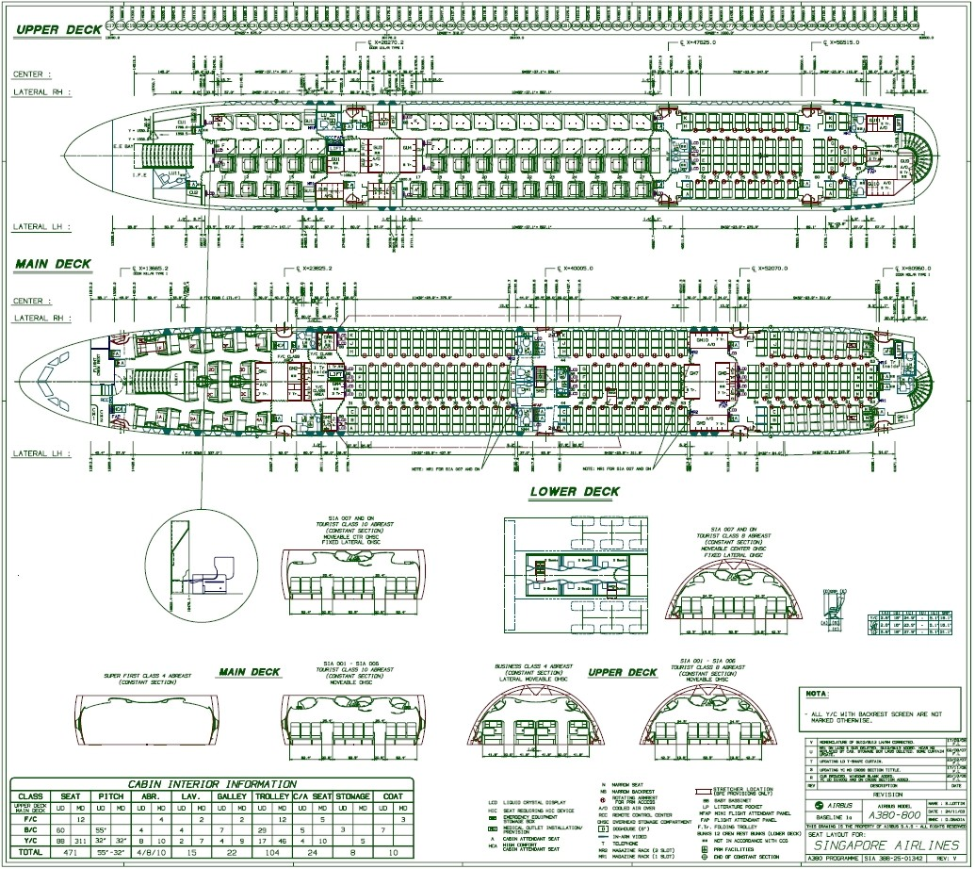
- Cabin Configuration

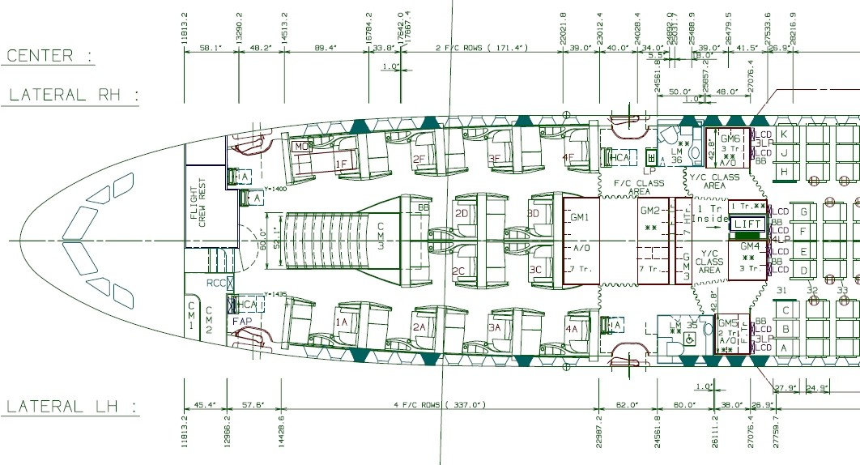
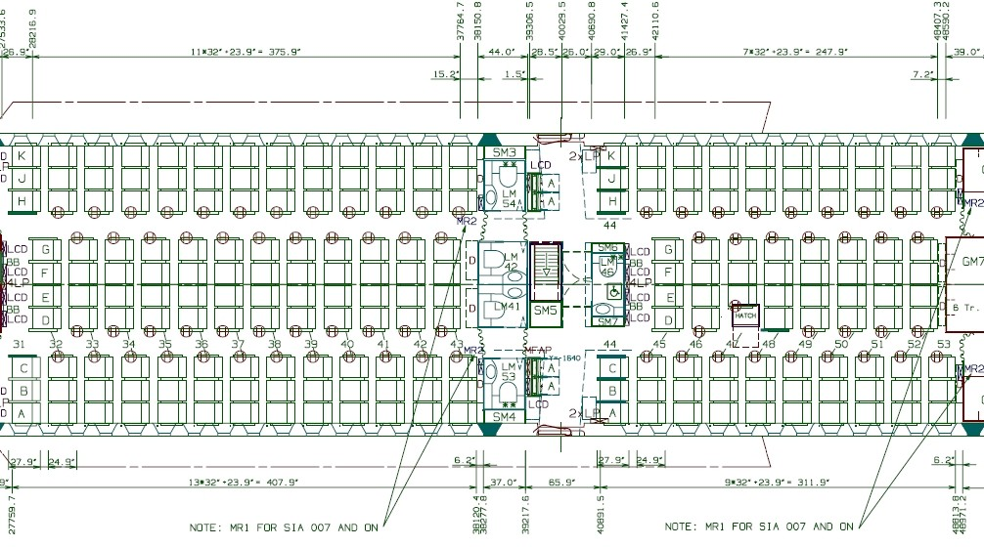
MSN 0006 - Main Deck - Front
- Main Deck - Mid

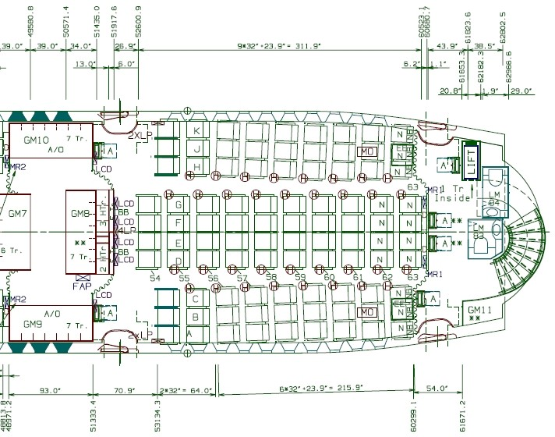

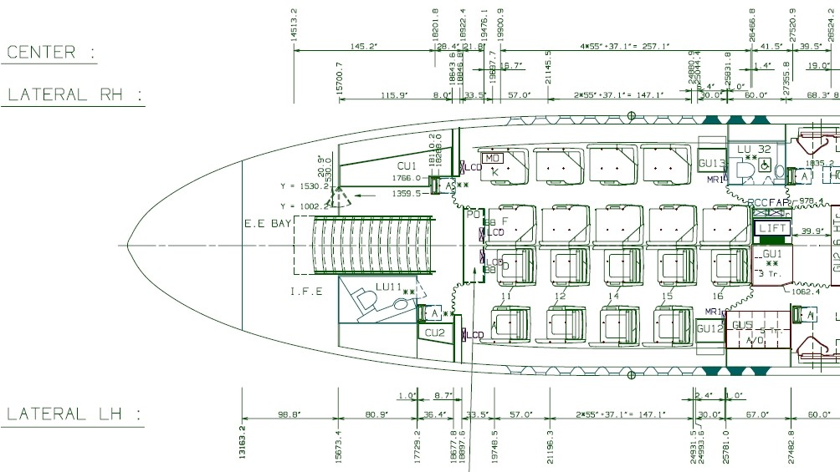
Main Deck - Rea Upper Deck - Front

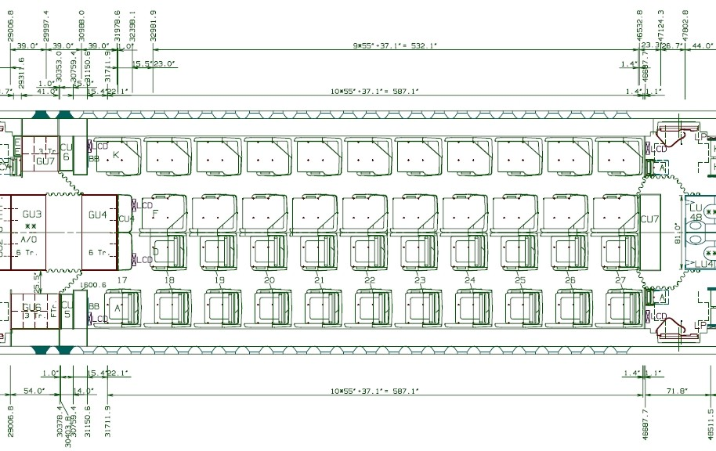
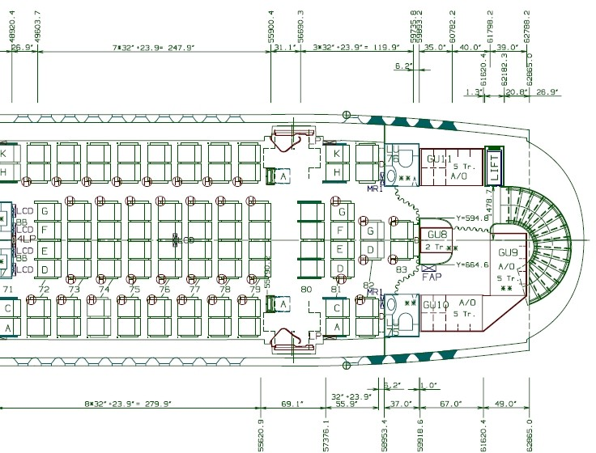
MSN 0006 - Upper Deck - Mid
Upper Deck - Rear

