Sine Wave Portable Energy Storage System (lithium Battery)

MODEL | PICTURE | CAPACITY | SPEC/PCACKING | QTY | EXW USD
SRY1L12220-02P | 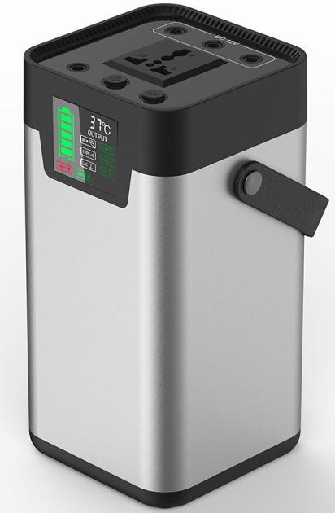 | 54.6AH (200WH)  Rated power 200w peak power 200w | AC 220V50HZ/110V60HZ*1，3*USB 5V2A；  DC12v*3；Type-c；COB LED ：3W  - can use 18V60w-100w solar panel charging；  - built-in LED 3.Digital display  accessories ：charge calbe;specification;color box product size :105*105*210mm  packing size：300*150*150mm  WG：2.5kg | 100 | $110.00
SRY1L12220-05P | 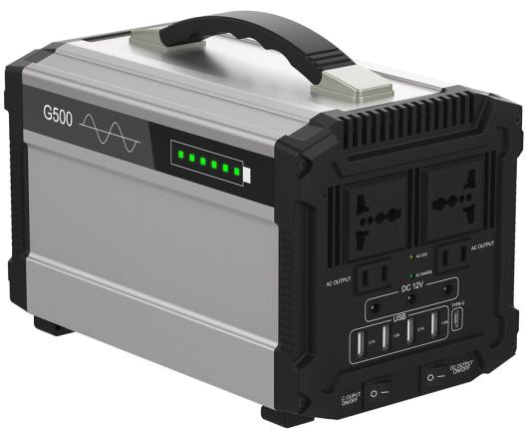 | 120AH (444WH)  Rated power 500w peak power 750w | AC220V50HZ/110V60HZ 4PCS；4*USB OUT 5V2A  Dc out 12v*3；Type-c : 5v3a 1.Cigarette lighter output 120w  2.can use 18V60w-100w solar panel charging； accessories ：charge calbe;specification;color box prodcut:251*159*158mm  packing size：320*230*210mm SRY1L12220-05 WG：6.0KG SRY1L12220-03 WG：4.8KG | 100 | $225.00
SRY1L12220-03P | 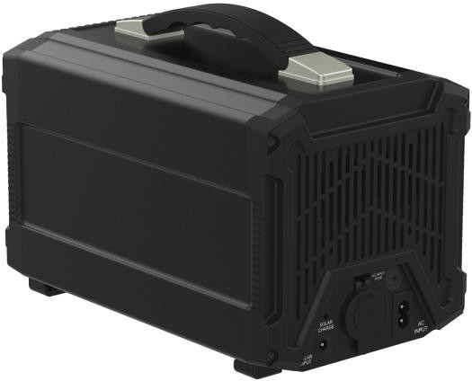 | 78AH (288WH)  Rated power 300w peak power 350w |  | 100 | $178.00
SRYG301（NEW） |  | 80AH (296WH)  Rated power 300w peak power 350w | AC100V 50Hz/ 60Hz *2 OR AC 220V  USB output: 5V *3; DC output:12V*2;Type-c:5V/3A 1.built-in LED，2.LCD display  3.can use 18V60w-100w solar panel charging；  accessories：charge calbe ; specification;color box prodcut size:255*255*230mm  color box size：280*170*280mm WG 3.2KG  packing size :440*350*260mm 3sets. | 100 | $145.00
SRYG518（NEW） |  | 117AH (435WH)  Rated power 500w peak power 750w | AC 100V 50Hz/ 60Hz *2 OR AC 220V  USB output 5V *3; DC output:12V*2;Type-c:5V/3A 1.built-in LED  - LCD display  - can use 18V60w-100w solar panel charging; accessories ：charge calbe ; specification;color box prodcut size: 320*120*170mm  color box size：340*215*220mm WG 5.3kg packing box 440*350*260mm 2sets in a box | 100 | $190.00
SRYG1000 | 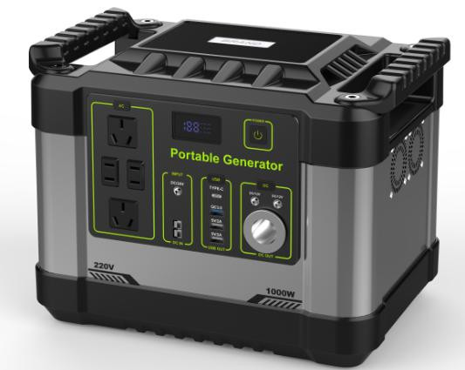 | 300AH (1100WH)  Rated power 1kw peak power 2kw | AC output 220-240V50hz or 100-120V60Hz  USB output：5V3.1A,QC3.0:5V/3A and 9V/2A,12V/1.5A  DC output 12V3pcs；Type-c：PD45W,5V/3A，9V/3A 12V/3A，15V/3A,20V/2.25A  300AH (1100WH),Rated power 1kw peak power 2kw accessories:charge calbe;specification;color box prodcut size:320*230*260mm  N.W: 12kg,G.W: 14kg | 100 | $490.00
SRYG1000L |  | 405AH (1500WH)  Rated power：1kw peak power：2kw | AC output 220-240V50hz/100-120V60Hz  USB output：5V3.1A,QC3.0:5V/3A and 9V/2A,12V/1.5A  DC output 12V3pcs；Type-c：PD45W,5V/3A，9V/3A 12V/3A，15V/3A,20V/2.25A  accessories:charge calbe;specification;color box prodcut size:320*230*260mm N.W 13kg,.G .W:15kg | 100 | $564.00
SRFZ100P18-100 | 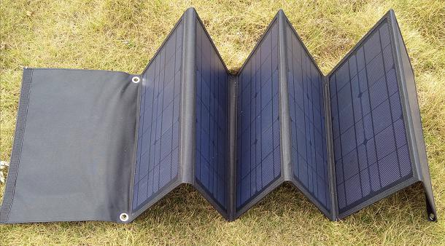 | 100W | 100Wp mono panel  Voltgae 18V/5.5A black color Open size：2110*420*5mm  Folded size：420*295*45mm，WG:3.3KG | 100 | $120.00
SRFZ100P18-150 | 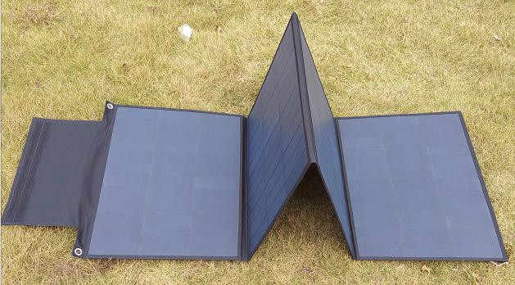 | 150W | 150Wp mono  Voltage 18V/8.3A black color Open size：1900*550*5mm  Folded size ：550*415*35mm，WG 3KG | 100 | $178.00

Note 1. this price is Exw price .tax-exclusive

- payment :50% and 50% T/T

- delivery time : more than 100sets 20 to 30 days .

