HOSPITAL BED PRICE LIST

Product Name | Model | Picture | Specification | Package | EXW Unit price USD
5-Function Electric Hospital Bed, Weighing-Type |  | 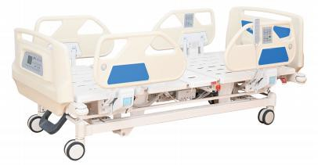 | Features:  1) Overallsize (L*W*H):2150*980*480-720mm(±20mm), platform  size:1940*900mm(±20mm)  - Frame: steel, treated by sand-balsting and electrostatic powder-coating  - Headboard/footboard:ABS,Detachable  - Side rail: Detachable, ABS  - Rail controller: embedded on side rail at head side  - Nurse controller: embedded on footboard,all functions can be operated from it,and there are locks to control wrong operation by patients themselves from the side rails.  - Motor: Chinese motor,with backup batteries  - Weighing function: accuracy 0.1KG(0.05KG, 0.02KG optional);  - Alarm system: once patients get out of bed, the alarm works  - Manual CPR handles at head side ,electric CPR  - Castors: Central-controlled braking system, four silent wheels, φ125mm, 12)Weight load: static safe load 400kg, dynamic safe load: 170kg  13)Standard accessories:I.V pole 1pc, IV pole holes 4pcs, Drainage hooks 2pcs, angle indicator on side rail 2pcs | 2160*1060*58  0mm, N.W.:130KG,  G.W.:150KG,1p  c/carton | 1,307<50pcs 1,291>50pcs

5-Function Electric Hospital Bed |  | 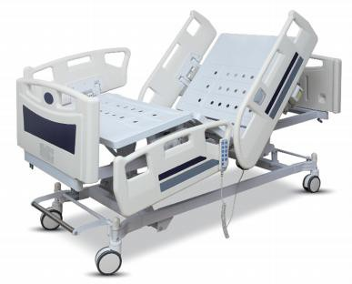 | Features:  1) Overallsize (L*W*H):2100*1000*480-720mm(±20mm), platform size:1940*900mm(±20mm)  - Frame: steel, treated by sand-balsting and electrostatic powder-coating  - Bedboard: steel, 4-part  - Headboard/footboard:ABS,Detachable  - Side rail: Detachable,Big ABS  - Motor: Chinese motor  - Handset controller: Intelligent remote control, movable  - Castors: four Central-controlled silent wheels, φ125mm 9)Weight load: 250kg  10)Standard accessories:I.V pole 1pc, IV pole holes 4pcs, Drainage hooks 2pcs  5-function:  - Backrest max upward angle: 0-80°±5°  - Footrest max upward angle: 0-45°±5°  - Height adjustment: 480-720mm(±20mm) | 2140*1040*50  0mm, N.W.:120KG,G. W.:140KG,1pc/  carton | 672<50pcs 656>50pcs
5-Function Electric Hospital Bed |  | 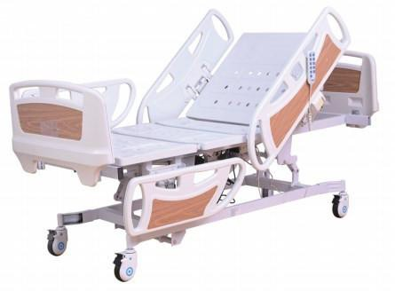 | Features:  1) Overallsize (L*W*H):2100*1000*480-720mm(±20mm); platform size:1940*900mm(±20mm)  - Frame: steel, treated by sand-balsting and electrostatic powder-coating  - Bedboard: steel, 4-part ,  - Headboard/footboard:ABS,Detachable, size:950*130*550mm  - Side rail: Detachable,ABS;Big rail size:1070*240*320mm, small rail size:850*240/320mm;  - Motor: Chinese motor  - Handset controller: Intelligent remote control, movable  - Castors: four silent wheels with brakes, φ125mm 9)Weight load: 250kg  10)Standard accessories:I.V pole 1pc, IV pole holes 4pcs, Drainage hooks 2pcs  5-function:  - Backrest max upward angle: 0-80°±5°  - Footrest max upward angle: 0-45°±5°  - Height adjustment: 480-720mm(±20mm)  - Trendelenburg: 0-13°±5°  - Anti-trendelenburg: 0-13±5° | 2120*930*330  mm, N.W.:115KG, G.W.:135KG | 593<50pcs 577>50pcs

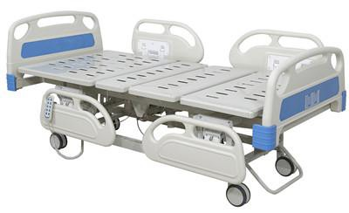
5-Function Electric Hospital Bed | BT-AE011 |  | Features:  1) Overallsize (L*W*H):2100*1000*480-720mm(±20mm), platform size:1940*900mm(±20mm)  - Frame: steel, treated by sand-balsting and electrostatic powder-coating  - Bedboard: steel, 4-part  - Headboard/footboard:ABS,Detachable  - Side rail: Detachable,small ABS  - Motor: Chinese motor  - Handset controller: Intelligent remote control, movable  - Castors: four Central-controlled silent wheels, φ125mm 9)Weight load: 250kg  10)Standard accessories:I.V pole 1pc, IV pole holes 4pcs, Drainage hooks 2pcs  5-function:  - Backrest max upward angle: 0-80°±5°  - Footrest max upward angle: 0-45°±5°  - Height adjustment: 480-720mm(±20mm)  - Trendelenburg: 0-13°±5° 5)Anti-trendelenburg: 0-13±5° | 2140*1040*50  0mm, N.W.:120KG,G. W.:140KG,1pc/  carton | 561<50pcs 545>50pcs
5-Function Electric Hospital Bed | BT-AE015 | 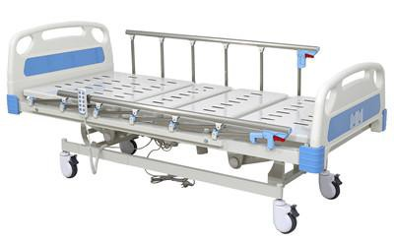 | Features:  1) Overallsize (L*W*H):2100*950*480-720mm(±20mm); platform size:1940*900mm(±20mm)  - Frame: steel, treated by sand-balsting and electrostatic powder-coating  - Bedboard: steel, 4-part ,  - Headboard/footboard:ABS,Detachable, size:950*130*550mm  - Side rail: Foldable,6-rank al-alloy  - Motor: Chinese motor  - Handset controller: Intelligent remote control, movable  - Castors: four silent wheels with brakes, φ125mm 9)Weight load: 250kg  10)Standard accessories:I.V pole 1pc, IV pole holes 4pcs, Drainage hooks 2pcs  5-function:  - Backrest max upward angle: 0-80°±5°  - Footrest max upward angle: 0-45°±5°  - Height adjustment: 480-720mm(±20mm)  - Trendelenburg: 0-13°±5° 5)Anti-trendelenburg: 0-13±5° | 2120*930*330  mm, N.W.:115KG, G.W.:135KG | 529<50pcs 513>50pcs
3-Function Electric Hospital Bed

3-Function Electric Hospital Bed | BT-AE102 | 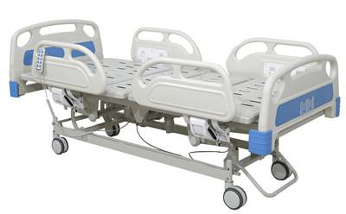 | Features:  1) Overallsize (L*W*H):2100*1000*480-720mm(±20mm), platform size:1940*900mm(±20mm)  - Frame: steel, treated by sand-balsting and electrostatic powder-coating  - Bedboard: steel, 4-part  - Headboard/footboard:ABS,Detachable  - Side rail: Detachable,small ABS  - Motor: Chinese motor  - Handset controller: Intelligent remote control, movable  - Castors: four Central-controlled silent wheels, φ125mm 9)Weight load: 250kg  10)Standard accessories:I.V pole 1pc, IV pole holes 4pcs, Drainage hooks 2pcs  3-function:  1) Backrest max upward angle: 0-80°±5° | 2140*1040*50  0mm, N.W.:120KG,G. W.:140KG,1pc/  carton | 442<50pcs 426>50pcs
3-Function Electric Hospital Bed | BT-AE105 | 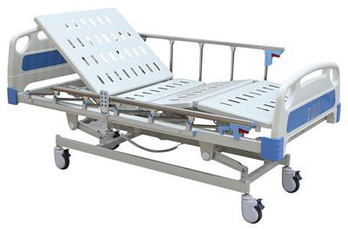 | Features:  1) Overallsize (L*W*H):2100*950*480-720mm(±20mm); platform size:1940*900mm(±20mm)  - Frame: steel, treated by sand-balsting and electrostatic powder-coating  - Bedboard: steel, 4-part ,  - Headboard/footboard:ABS,Detachable, size:950*130*550mm  - Side rail: Foldable,6-rank al-alloy  - Motor: Chinese motor  - Handset controller: Intelligent remote control, movable  - Castors: four silent wheels with brakes, φ125mm 9)Weight load: 250kg  10)Standard accessories:I.V pole 1pc, IV pole holes 4pcs, Drainage hooks 2pcs  3-function:  - Backrest max upward angle: 0-80°±5°  - Footrest max upward angle: 0-45°±5°  - Height adjustment: 480-720mm(±20mm) | 2120*930*330  mm, N.W.:115KG, G.W.:135KG | 386<50pcs 370>50pcs
2-Function Electric Hospital Bed

2-Function Electric Hospital Bed | BT-AE201 | 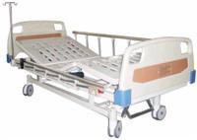 | Features:  - Overallsize (L*W*H):2100*950*500mm(±20mm), platform size:1940*900mm(±20mm)  - Frame: steel, treated by sand-balsting and electrostatic powder-coating  - Bedboard: steel, 4-part  - Headboard/footboard:ABS,Detachable  - Side rail: Foldable,6-rank al-alloy  - Motor: Chinese motor  - Handset controller: Intelligent remote control, movable  - Castors: four Central-controlled silent wheels, φ125mm 9)Weight load: 250kg  10)Standard accessories:I.V pole 1pc, IV pole holes 4pcs, Drainage hooks 2pcs  2-function: | 2140*1040*50  0mm, N.W.:120KG,G. W.:140KG,1pc/  carton | 386<50pcs 370>50pcs
2-Function Electric Hospital Bed | BT-AE202 | 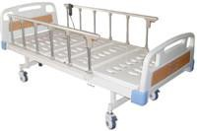 | Features:  - Overallsize (L*W*H):2100*950*500mm(±20mm); platform size:1940*900mm(±20mm)  - Frame: steel, treated by sand-balsting and electrostatic powder-coating  - Bedboard: steel, 4-part ,  - Headboard/footboard:ABS,Detachable, size:950*130*550mm  - Side rail: Foldable,6-rank al-alloy  - Motor: Chinese motor  - Handset controller: Intelligent remote control, movable  - Castors: four silent wheels with brakes, φ125mm 9)Weight load: 250kg  10)Standard accessories:I.V pole 1pc, IV pole holes 4pcs, Drainage hooks 2pcs  2-function: | 2020*930*140 mm,N.W.:55KG  ; G.W.:66KG | 323<50pcs 307>50pcs
4-Crank Manual Hospital Bed

5-Function Manual Hospital bed | BT-AM004 | 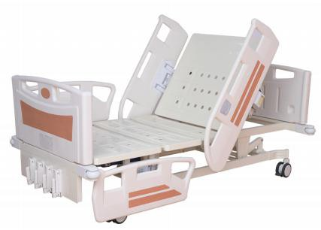 | Features:  1)Overallsize (L*W*H):2100*980*470-730mmm,platform size:2000*900mm 2)Frame: steel, treated by sand-balsting and electrostatic powder-coating 3)Bedboard: steel,4-part  4)Headboard/footboard:ABS,Detachable 5)Side rail: Detachable, ABS  6)Castors: four silent wheels with brakes, φ125mm 7)Weight load: 250kg  8)Standard accessories:I.V pole 1pc, IV pole holes 4pcs, Drainage hooks 2pcs  5-function:  - Backrest max upward angle: 0-80°±5°  - Footrest max upward angle: 0-45°±5°  - Height adjustment: 470-730mm(±20mm)  - Trendelenburg: 0-13°±5° 5)Anti-trendelenburg: 0-13±5° | 2020*930*330  mm | 466<50pcs 450>50pcs
3-Crank Manual Hospital Bed
3-Crank Manual Hospital Bed | BT-AM102 | 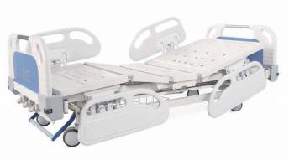 | Features:  1) Overallsize (L*W*H):2100*950*500-700mm(±20mm), platform size:1940*900mm(±20mm)  - Frame: steel, treated by sand-balsting and electrostatic powder-coating  - Bedboard: steel, 4-part  - Headboard/footboard:ABS,Detachable  - Side rail: Detachable,small ABS  8) Castors: four Central-controlled silent wheels, φ125mm 9)Weight load: 250kg  10)Standard accessories:I.V pole 1pc, IV pole holes 4pcs, Drainage hooks 2pcs  3-function:  - Backrest max upward angle: 0-75°±5°  - Footrest max upward angle: 0-35°±5°  - Height adjustment: 500-700mm(±20mm) | 2020*930*500  mm | 378<50pcs 370>50pcs

3-Crank Manual Hospital Bed | BT-AM106 | 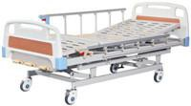 | Features:  1) Overallsize (L*W*H):2100*950*500-700mm(±20mm), platform size:1940*900mm(±20mm)  - Frame: steel, treated by sand-balsting and electrostatic powder-coating  - Bedboard: steel, 4-part  - Headboard/footboard:ABS,Detachable  - Side rail: Foldable,6-rank al-alloy  8) Castors: four silent wheels with brakes, φ125mm 9)Weight load: 250kg  10)Standard accessories:I.V pole 1pc, IV pole holes 4pcs, Drainage hooks 2pcs  3-function:  - Backrest max upward angle: 0-75°±5°  - Footrest max upward angle: 0-35°±5°  - Height adjustment: 500-700mm(±20mm) | 2020*930*330  mm | 315<50pcs 307>50pcs
2-crank Manual Hospital Bed
2-Crank Manual Hospital Bed | BT-AM202 | 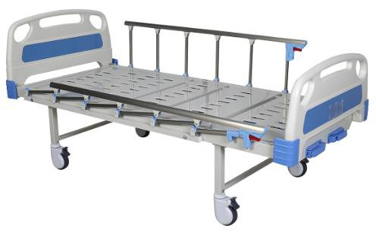 | Features:  - Overallsize (L*W*H):2100*970*500mm(±20mm), platform size:1940*900mm(±20mm)  - Frame: steel, treated by sand-balsting and electrostatic powder-coating  - Bedboard: steel, 4-part  - Headboard/footboard:ABS,Detachable  - Side rail: Foldable,6-rank al-alloy  8) Castors: four silent wheels with brakes, φ125mm 9)Weight load: 250kg  10)Standard accessories:I.V pole 1pc, IV pole holes 4pcs, Drainage hooks 2pcs  2-function:  - Backrest max upward angle: 0-80°±5°  - Footrest max upward angle: 0-45°±5° | 2020*930*140  mm | 255<50pcs 197>50pcs
1-Crank Manual Hospital Bed

1-Crank Manual Hospital Bed | BT-AM301 | 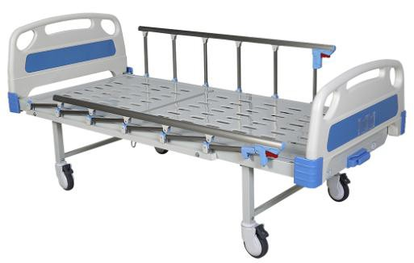 | Features:  - Overallsize (L*W*H):2100*970*500mm(±20mm), platform size:1940*900mm(±20mm)  - Frame: steel, treated by sand-balsting and electrostatic powder-coating  - Bedboard: steel, 4-part  - Headboard/footboard:ABS,Detachable  - Side rail: Foldable,6-rank al-alloy  8) Castors: four silent wheels with brakes, φ125mm 9)Weight load: 250kg  10)Standard accessories:I.V pole 1pc, IV pole holes 4pcs, Drainage hooks 2pcs  1-function:  1) Backrest max upward angle: 0-80°±5° | 2020*930*140  mm | 185<50pcs 176>50pcs
Flat Bed
Flat Bed | BT-AM401 | 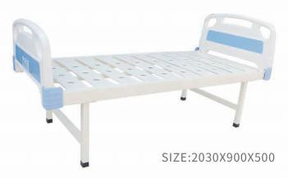 | Features:  - Overallsize (L*W*H):2030*900*500mm  - Frame: steel, treated by sand-balsting and electrostatic powder-coating 3)Bedboard: steel,flat  4)Headboard/footboard:ABS,Detachable 6)Weight load: 250kg  7)Standard accessories:I.V pole 1pc, IV pole holes 4pcs, Drainage hooks 2pcs | 2020*930*140  mm | 120<50pcs 99>50pcs
Home care bed

Electric nursing bed | BT-AE033 | 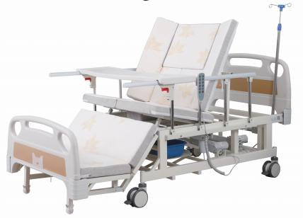 | Features:  - Overallsize (L*W*H):2110*960*520mm(±20mm); platform size:1980*900mm(±20mm)  - Frame: steel, treated by sand-balsting and electrostatic powder-coating  - Bedboard: steel, 4-part ,  - Headboard/footboard:ABS,Detachable, size:950*130*550mm  - Side rail: Detachable,ABS;Big rail size:1070*240*320mm, small rail size:850*240/320mm;  - Motor: Chinese motor  - Handset controller: Intelligent remote control, movable  - Castors: four silent wheels with brakes, φ125mm 9)Weight load: 250kg  10)Standard accessories:I.V pole 1pc, IV pole holes 4pcs, Drainage hooks 2pcs  ;dinning table 1pc;  3-function:  - Backrest max upward angle: 0-80°±5°  - Footrest max upward angle: up 25°±5°,down 60°±5°  - Rollover adjustment: 0-40°±5° | 2020*950*420 mm,N.W.:96KG  ; G.W.W:103KG | 463<50pcs 447>50pcs
Electric nursing bed |  | 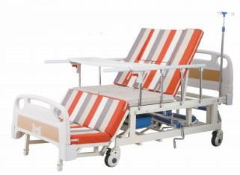 | Features: | 2020*950*420 | 247<50pcs 231>50pcs
 |  |  | 1) Overallsize (L*W*H):2110*960*520mm(±20mm); platform
 |  |  | size:1980*900mm(±20mm)
 |  |  | 2) Frame: steel, treated by sand-balsting and electrostatic powder-coating
 |  |  | 3) Bedboard: steel, 4-part ,
 |  |  | 4) Headboard/footboard:ABS,Detachable, size:950*130*550mm
 |  |  | 5) Side rail: Detachable,ABS;Big rail size:1070*240*320mm, small rail
 |  |  | size:850*240/320mm;  8) Castors: four silent wheels with brakes, φ125mm | mm,N.W.:96KG  ;
 |  |  | 9)Weight load: 250kg | G.W.W:103KG
 |  |  | 10)Standard accessories:I.V pole 1pc, IV pole holes 4pcs, Drainage hooks 2pcs
 |  |  | ;dinning table 1pc;
 |  |  | 3-function:
 |  |  | 1) Backrest max upward angle: 0-80°±5°
 |  |  | 2) Footrest max upward angle: up 25°±5°,down 60°±5°

4-Folding Foam Mattress | BT-AK001 | 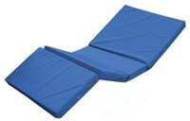 | Canvas cover with sponge padded, foam density 35kg/m3, 4-folding, 8cm thickness |  | 26<50pcs 24>50pcs
4-Folding Foam Mattress | BT-AK001 |  | Canvas cover with sponge padded, foam density 35kg/m3, 4-folding, 10cm thickness |  | 30<50pcs 28>50pcs
4-Folding Foam Mattress | BT-AK001 |  | Canvas cover with sponge padded, foam density 35kg/m3, 4-folding, 12cm thickness |  | 34<50pcs 32>50pcs
PU foam medical mattress | BT-AK010 | 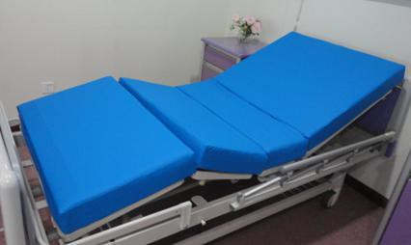 | PU cover with sponge padded,foam density 35kg/m3, 4-folding, 8cm thickness, the length and width can be customized as per your requirement |  | 30<50pcs 28>50pcs
PU foam medical mattress | BT-AK010 |  | PU cover with sponge padded,foam density 35kg/m3, 4-folding, 10cm thickness, the length and width can be customized as per your requirement |  | 34<50pcs 32>50pcs

PU foam medical mattress
 | BT-AK010 |  | PU cover with sponge padded,foam density 35kg/m3, 4-folding, 12cm thickness, the length and width can be customized as per your requirement |  | 39<50pcs 36>50pcs
Payment Terms: | 100% TT payment before production
Delivery Time: | Normally 35 days after payment arrival, please check with us when the model no. and quantity are confirmed.
Warranty: | The product that is damaged or fails to normal work really due to the manufacturing problem within one year after the purchasing date will gain free spare parts and assembling drawing from company.  Beyond the maintenance period, we will charge the accessories, but the technical service is still for free.

Remark:
- The above prices are based on MOQ 50 pcs
- The exchange rate is 1USD=6.4RMB,when it will be changed a lot, the above price will be changed.
- For home care bed, the prices are based on container load, if less quantity, please confirm price again with us.

