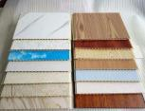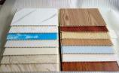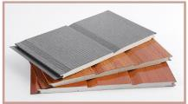
Specification for smart house
Project No.: |  |  |  | Area（㎡）: |  |  | Date:
No. | Part No. | Name | Description |  | Unit | Qty | Note
1 | I | Main Frame
2 |  | Frame structure | Steel frame structure | 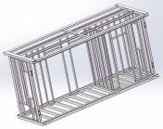 |  |  | Welded oil-free galvanized steel pipe ；Q355 material  ；yield strength is 345MPa ； surface painting treatment
3 |  |  | strengthen aluminium alloy wall frame | 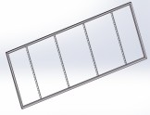 |  |  | 6063-T5 strengthen aluminum alloy ；  color：white、black、wood grain ；
4 |  |  | aluminium alloy hinge | 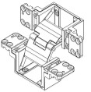 |  |  | 6063-T5 strengthen aluminum alloy ； color：aluminum color ；
 |  | Subtotal
 | II | Envelope System
5 |  | Roof panel | Roof panel |  |  |  | Aluminum magnesium manganese plate（t=0.8mm）  ，surface color is dark grey；
6 |  |  | Part of kitchen & bathroom | 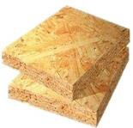 |  |  | OSB board （t=9mm）；
7 |  |  | Inside filler |  |  |  | PU foam ；
8 |  |  | Suspended ceiling board |  |  |  | Interior Integrated Waterproof decorative Wallboard  （t=8mm）；
9 |  | Wall system | Exterior wall board |  |  |  | PU Metal carved board （t=12mm）；
10 |  |  | Interior wall board 1 |  |  |  | Interior Integrated Waterproof decorative Wallboard  （t=8mm）；
11 |  |  | Interior wall board 2 | 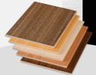 |  |  | Class A fireproof sound-absorbing board （t=8mm）
12 |  |  | Inside filler |  |  |  | PU foam ；
13 |  | Floor | Floor of kitchen and livingroom | 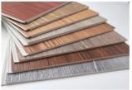 |  |  | Waterproof pvc vinyl flooring；
14 |  |  | bathroom floor board 1 | 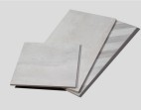 |  |  | Tile (300X300)；
15 |  |  | bathroom floor board 2 | 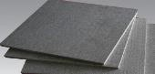 |  |  | Cement fiberboard （t=18mm）；

16 |  |  | livingroom and bedroom floor board |  |  |  | OSB board （t=18mm）；
17 |  | Window | 65 series bridge-cutoff  aluminum alloy | 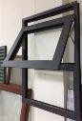 |  |  | ；  bridge-cutoff aluminum alloy frame + double glazing unit ；
18 |  | Door | 65 series bridge-cutoff  aluminum alloy | 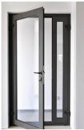 |  |  | ；  bridge-cutoff aluminum alloy frame + double glazing unit ；
 | A | FOB Unit House Price
 | B | FOB Unit House Price (Optimized)
 | C
 | Note | 1.This Quotation Just Include Above Items.
 |  | 2.This quotation is estimated for your reference.The final price should be based on the detailed drawing .
 |  | 3. This price based on the order quantity 3sets and the other house type. If only one set, price needs to be re-caculate.
 |  | 4.The price is in valid for 15days, otherwise we have the right to re-quote.

