The 2019-nCoV IgG/IgM Rapid Test Cassette is a lateral flow chromatographic immunoassay for the qualitative detection of IgG and IgM antibodies to 2019-nCoV in human whole blood, serum or plasma specimen, and also in Fingerstick Whole Blood specimen.

SUMMARY

The novel coronaviruses belong to the β genus. COVID-19 is an acute respiratory infectious disease. People are generally susceptible. Currently, the patients infected by the novel coronavirus are the main source of infection; asymptomatic infected people can also be an infectious source. Based on the current epidemiological investigation, the incubation period is 1 to 14 days, mostly 3 to 7 days. The main manifestations include fever, fatigue and dry cough. Nasal congestion, runny nose, sore throat, myalgia and diarrhea are found in a few cases.
Coronaviruses are enveloped RNA viruses that are distributed broadly among humans, other mammals, and birds and that cause respiratory, enteric, hepatic, and neurologic diseases.¹ Six coronavirus species are known to cause human disease.² Four viruses — 229E, OC43, NL63, and HKU1 — are prevalent and typically cause common cold symptoms in immunocompetent individuals.²

DIRECTIONS FOR USE

Allow the test, specimen, buffer and/or controls to reach room temperature (15-30°C) prior to testing.
1. Remove the test cassette from the foil pouch and use it within one hour. Best results will be obtained if the test is performed immediately after opening the foil pouch.
2. Place the cassette on a clean and level surface.
For Serum or Plasma specimen:
To use a dropper: Hold the dropper vertically, draw the specimen to the fill line
(approximately 10 μL), and transfer the specimen to the specimen well (S), then add 2 drops of buffer (approximately 80 uL), and start the timer.
To use a pipette: To transfer 10 uL of specimen to the specimen well(S), then add 2 drops of buffer (approximately 80 uL), and start the timer.
For Venipuncture Whole Blood specimen:
To use a dropper: Hold the dropper vertically, draw the specimen about 1 cm above the fill line and transfer 1 full drop (approx.20 μL) of specimen to the sample well(S). Then add 2 drops of buffer (approximately 80 μL) and start the timer.
To use a pipette: To transfer 20 uL of whole blood to the specimen well(S), then add 2 drops of buffer (approximately 80 uL), and start the timer.
For Fingerstick Whole Blood specimen:
To use a dropper: Hold the dropper vertically, draw the specimen about 1 cm above the fill line and transfer 1 full drop (approx.20 μL) of specimen to the sample well(S). Then add 2 drops of buffer (approximately 80 μL) and start the timer.
To use a capillary tube: Fill the capillary tube and transfer approximately 20 μL of fingerstick whole blood specimen to the specimen well (S) of test cassette, then add 2 drops of buffer (approximately 80 uL) and start the timer. See illustration below.

3. Wait for the colored line(s) to appear. Read results at 10 minutes. Do not interpret the result after 20 minutes.

Note: It is suggested not to use the buffer, beyond 6 months after opening the vial.

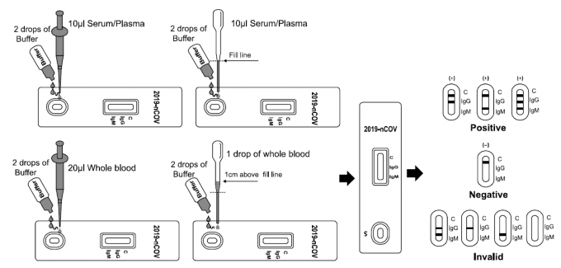

INTERPRETATION OF RESULTS

IgG POSITIVE:* Two colored lines appear. One colored line should always appear in the control line region (C) and another line should be in the IgG line region.
IgM POSITIVE:* Two colored lines appear. One colored line should always appear in the control line region (C) and another line should be in the IgM line region.
IgG and IgM POSITIVE:* Three colored lines appear. One colored line should always appear in the control line region (C) and two test lines should be in the IgG line region and IgM line region.
*NOTE: The intensity of the color in the test line regions may vary depending on the
concentration of 2019-nCoV antibodies present in the specimen. Therefore, any shade of color in the test line region should be considered positive.
NEGATIVE: One colored line appears in the control line region (C). No line appears in the IgG region and IgM region.
INVALID: Control line fails to appear. Insufficient specimen volume or incorrect procedural techniques are the most likely reasons for control line failure. Review the procedure and repeat the test with a new test. If the problem persists, discontinue using the test kit immediately and contact your local distributor.

PRICE:

Number | Name | Package | Quantity per package | Price per package $
1 | Set of reagents "Rapid  test cassette 2019-nCoV  IgG/IgM" for qualitative  immunochromatographic  analysis for the detection  of IgG and IgM antibodies to the new  coronavirus infection  2019-nCoV in a sample of whole  blood, serum or  plasma.  European Compliance: CE | Package contents:  25x express tests in  individual packaging with  desiccant;  25x pipettes;  1x buffer solution 3ml:  1x instructions for use  The package contains 25 tests. | 25 | 275.00$

Delivery Terms: CPT African countries
Delivery time: 1-2 weeks


