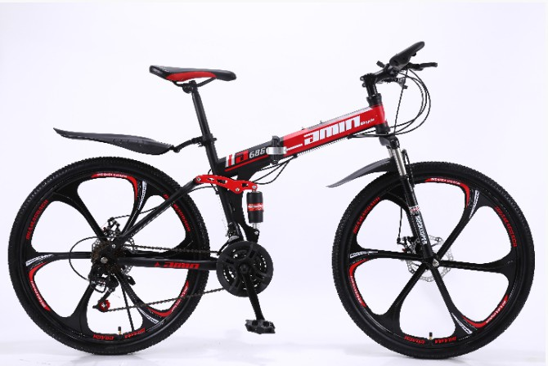
Picture | Model | Size | FOB | MOQ
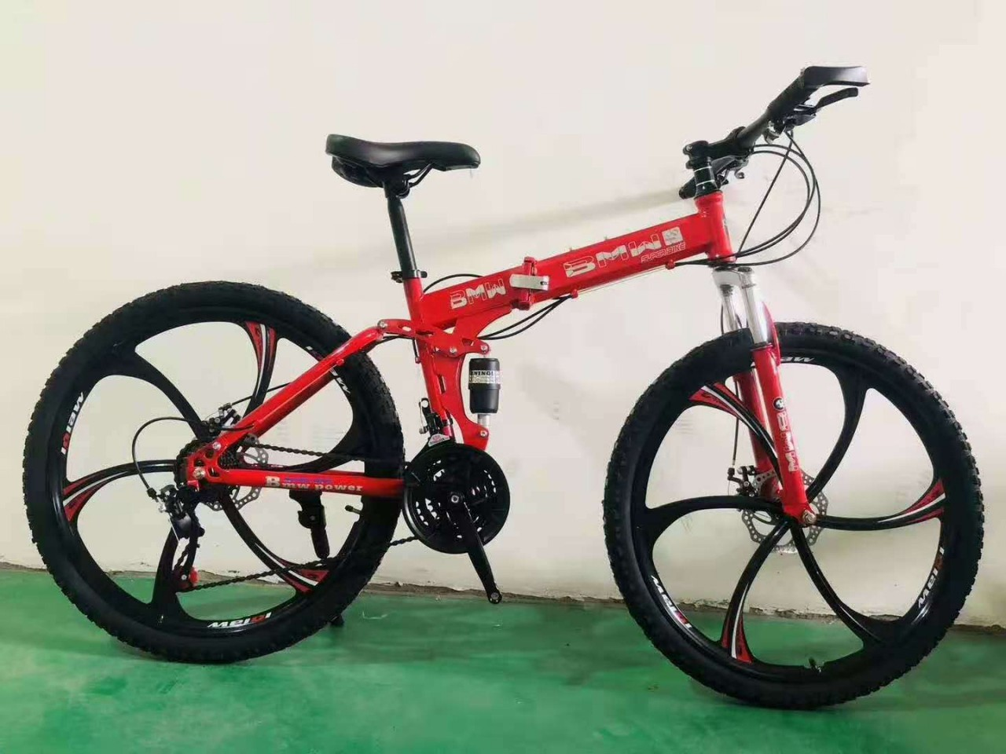 | ST-19-01 | 26" 21speed, alloy wheel folding bike  (3 knife, 6kinfe or 10 knife both aviliable) BMW,Landrover, Benz...a lot different brand  different color | $95.00 | 50
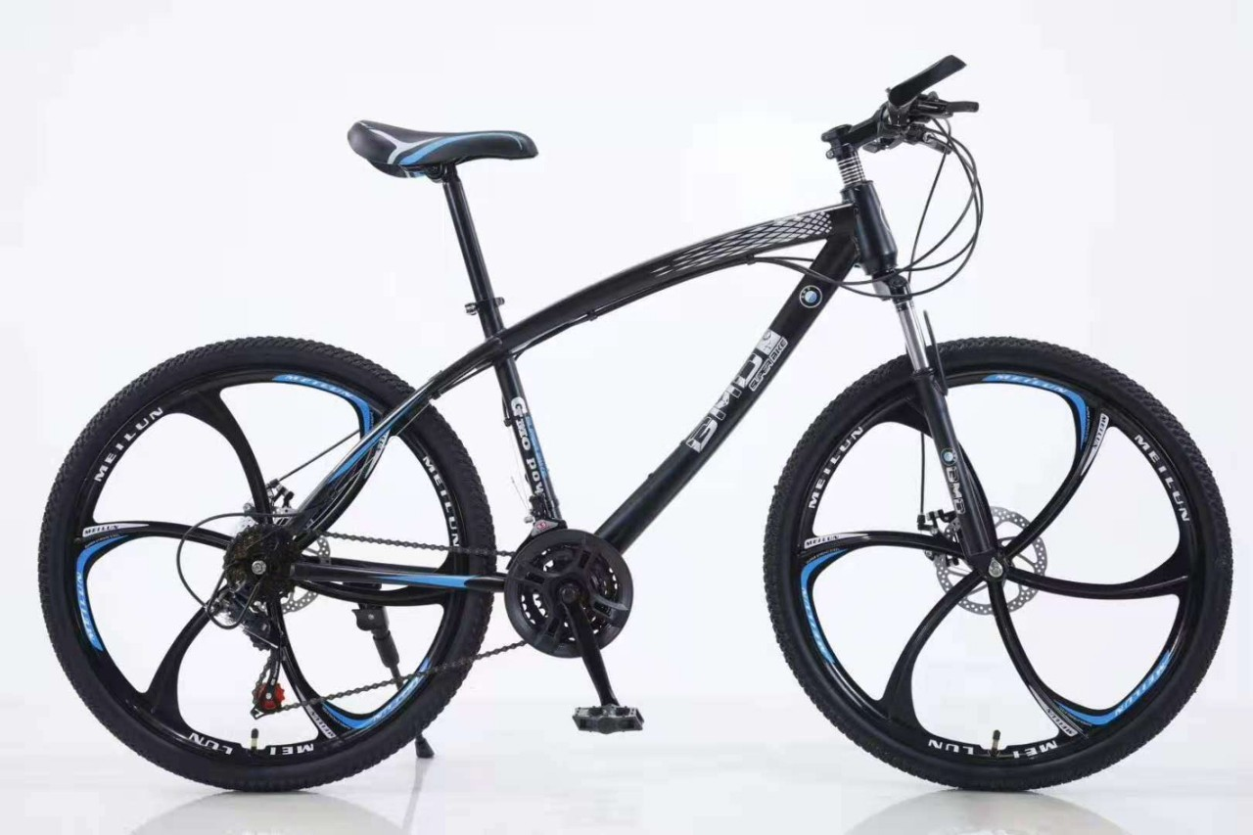 | ST-19-11 | BMW MTB BIKE 21SPEED, ALLOY WHEEL, SPOKE WHEEL,  6kinfe, 3knife different color | $85.00 | 50
 | ST-20-02 | 26" 18/21speed folding bike, disc brake, alloy wheel (different color,3knife, 6knifie,10kinife all aviliable) | $95.00 | 50
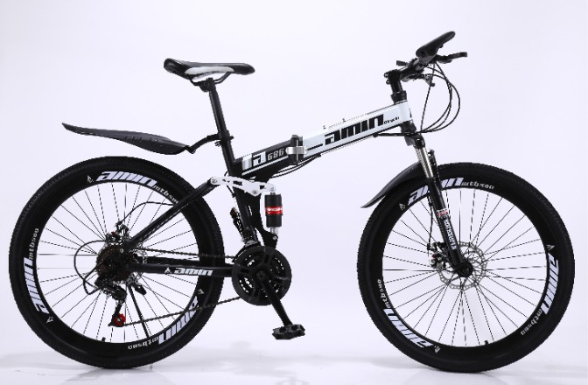 | ST-20-03 | 26" 21speed mtb bike, disc brake, spoke wheel | $75.00 | 50

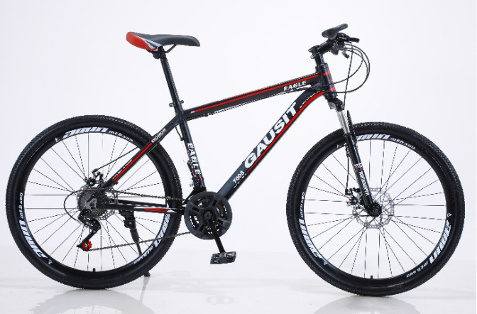 | ST-19-04 | 26" /27.5  21speed mtb bike alloy frame disc brake | $85.00 | 50
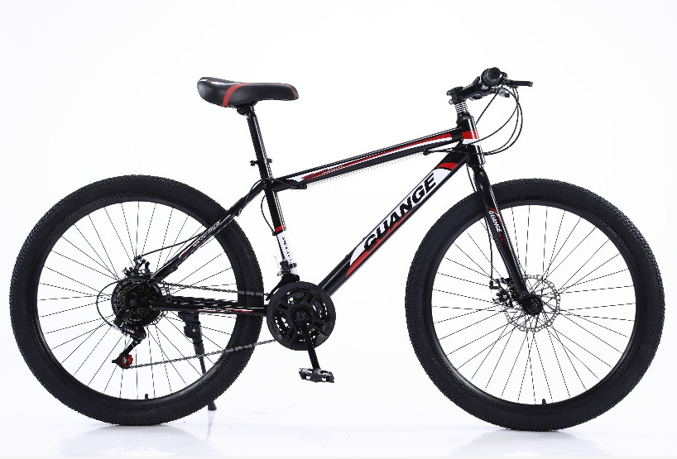 | ST-20-05 | 26" 29" mtb bike 21speed, 1:1shimano, PVC  pedal | $60(26")  $70(29") | 50
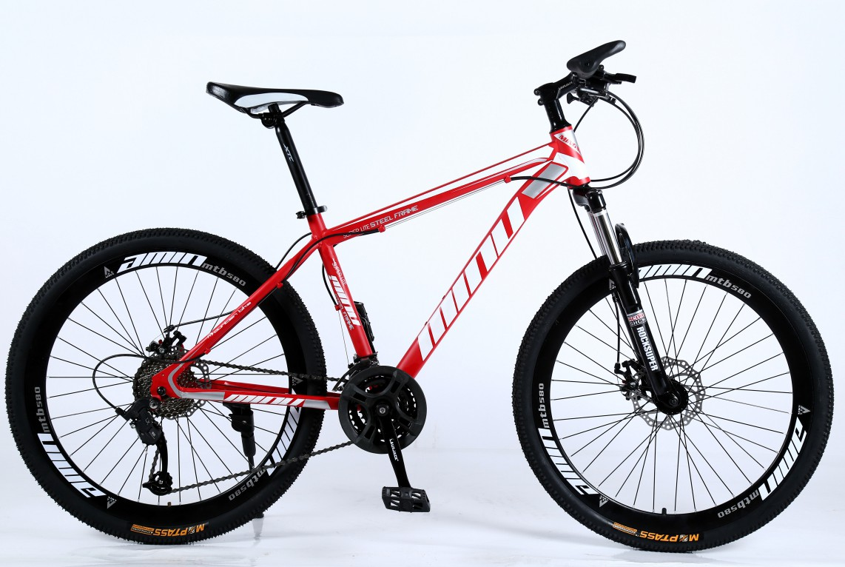 | ST-19-06 | 26" good mtb bike 21speed to 30speed aviliable | $70.00 | 50
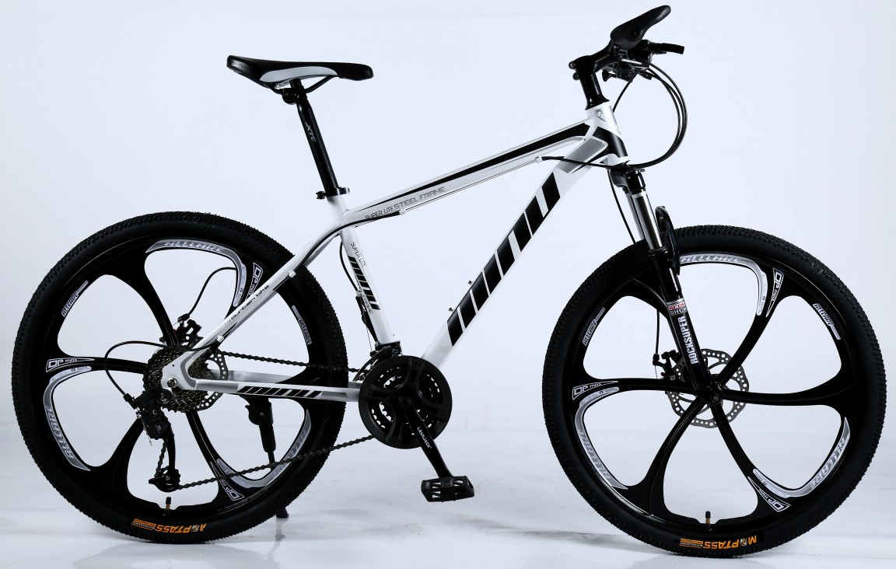 | ST-19-07 | 26" 21speed mtb bike, disc brake, alloy wheel(3 knife 6knife, the speed from 21to 30 different speed) | $85.00 | 50
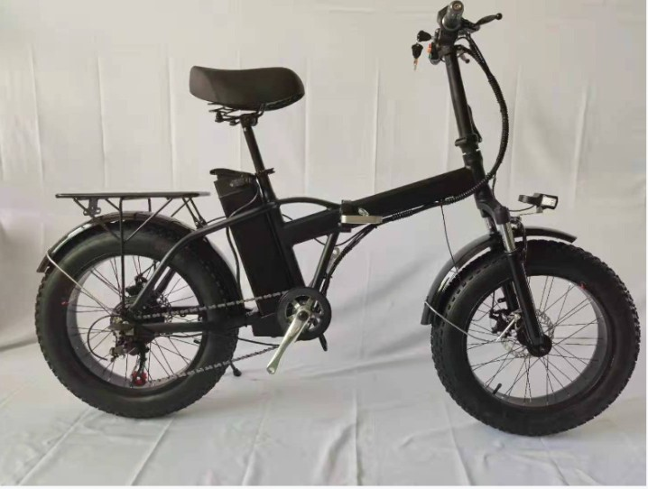 | ST-19-08 | 20"folding fat tire bike, alloy frame  7speed, 36V 48V 8A 250W  black, white, yellow | $399.00 | 20

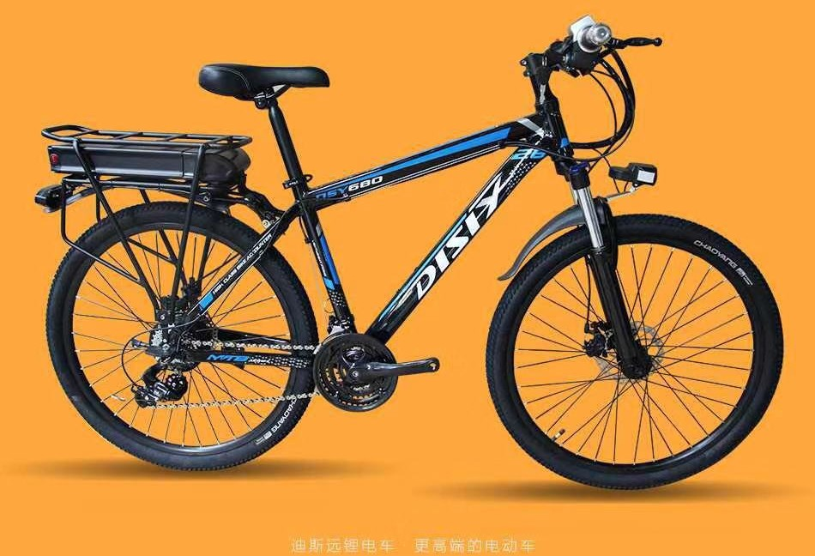
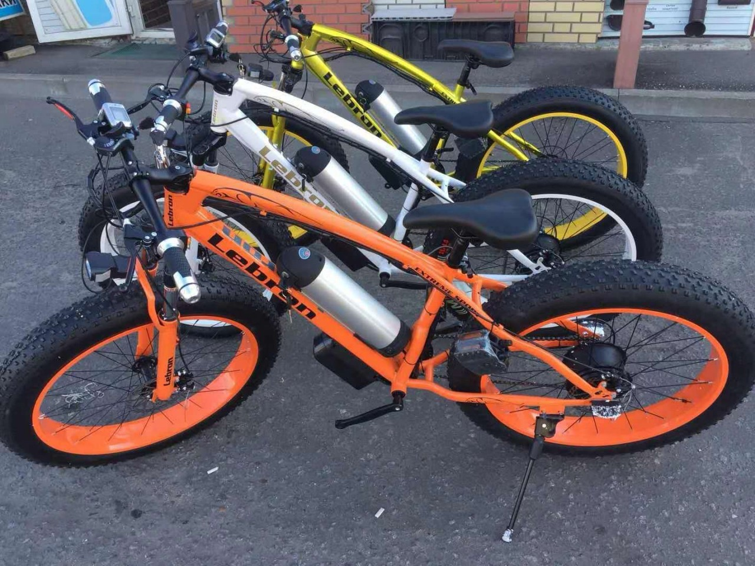 | ST-19-09  Hot | 26” 7speed fat tire electric bicylce, 36V 48V 8A  250W  black, orange, white color sale well  black color sale well | $319.00 | 20
 | ST-20-10  Hot | 26" alloy frame, 350W, 36V/48V,350W 10A | $349.00 | 20
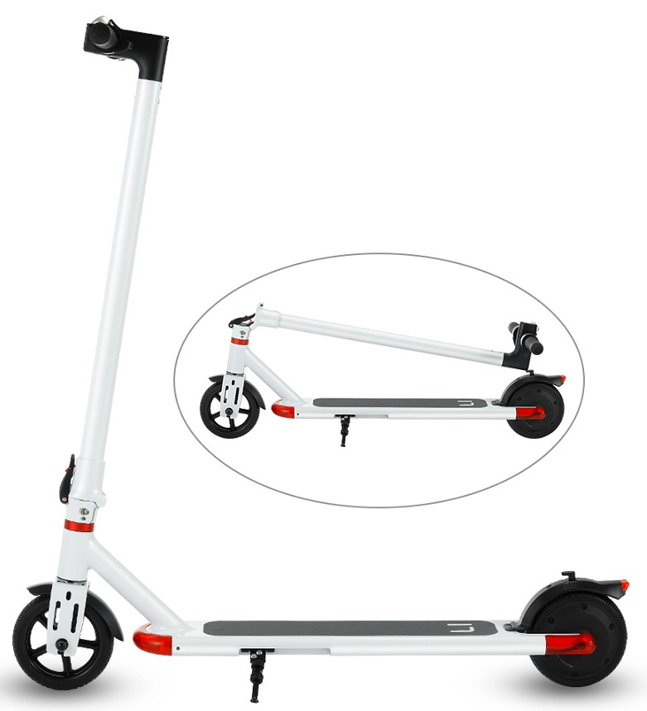 | ST-20-11  Hot | Chinese battery7.8 (18km)  electric scooter for adult white and black color | $229.00 | 30
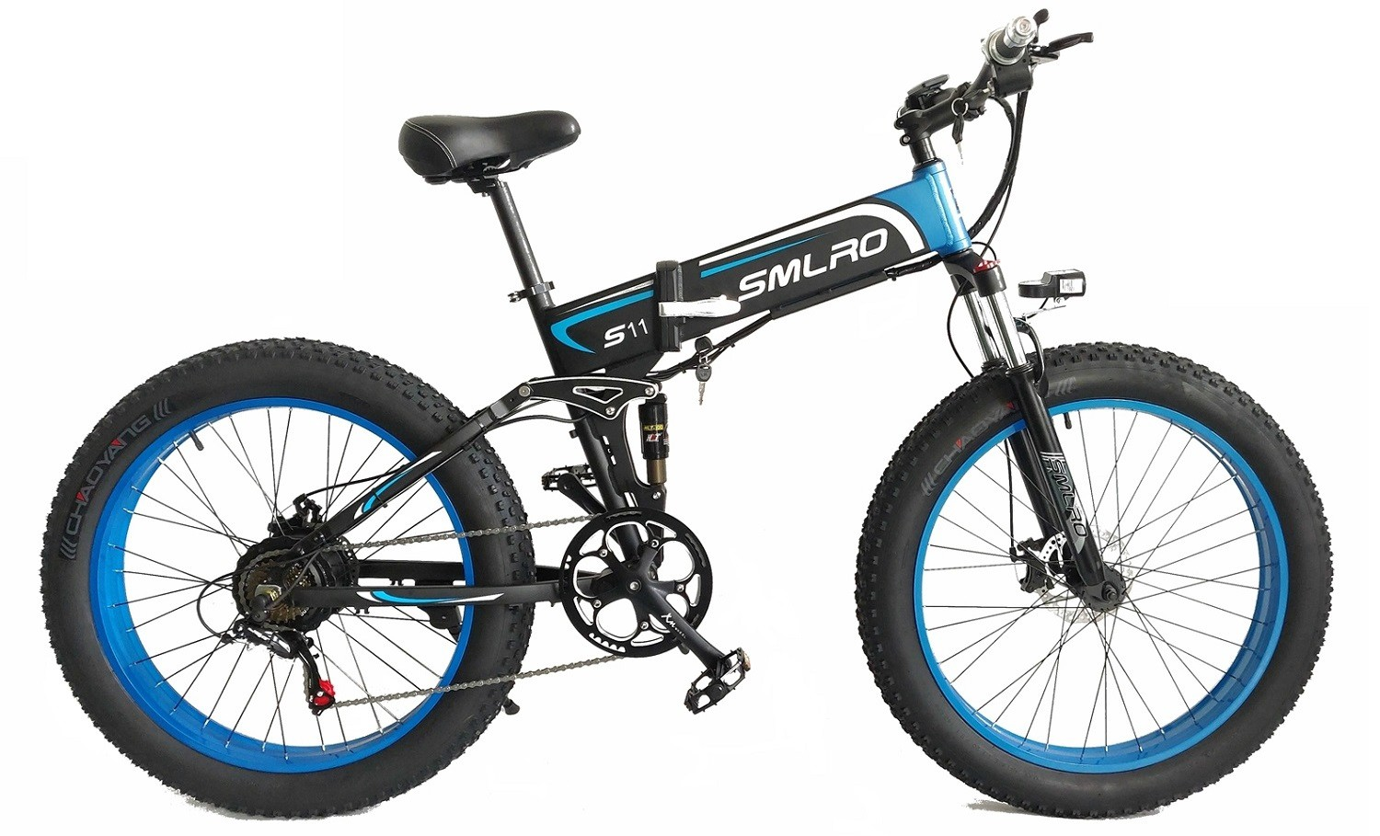 | ST-20-12 | alloy frame, fat tire model, 7speed shimano, 48V 350W 10A | $510.00 | 10

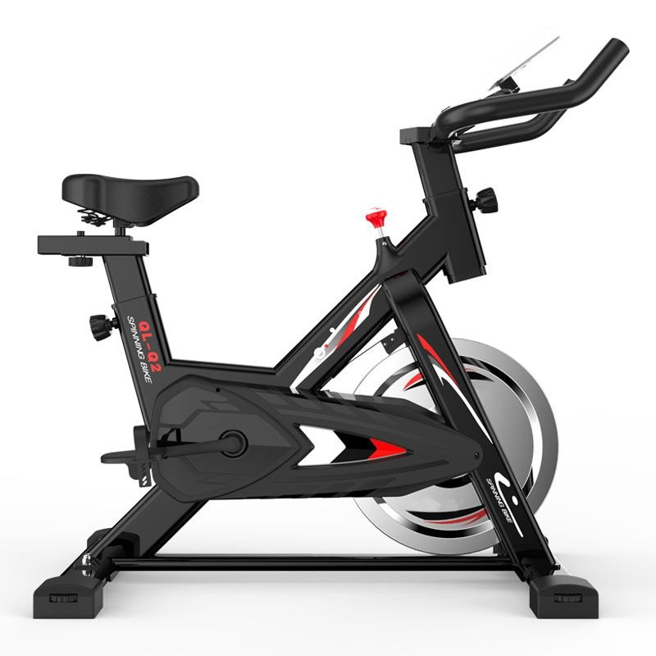 | ST-19-13 | SIZE：1100*480*1080mm PACKING：  940*21.5*840mm FLYWHEEL：6KG DISPLAY：POWER、 TIME、DISTANCE、 HEAT BEAT、SPEED、 CALORIE。  BELT, PLASTIC PEDAL WEIGHT：17/21KG | $89.00 | 50
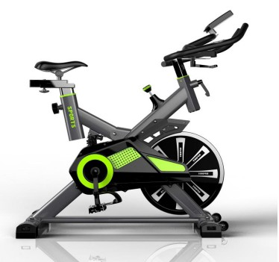 | ST-19-15 | Wheel Weight:15KG N.W/G.W:33KG/37KG  Product size:1200*480*1050MM Carton size:1050*230*830MM Belt transmission speed LCD display: time,speed,distance,calories  , heart rate | $169.00 | 50
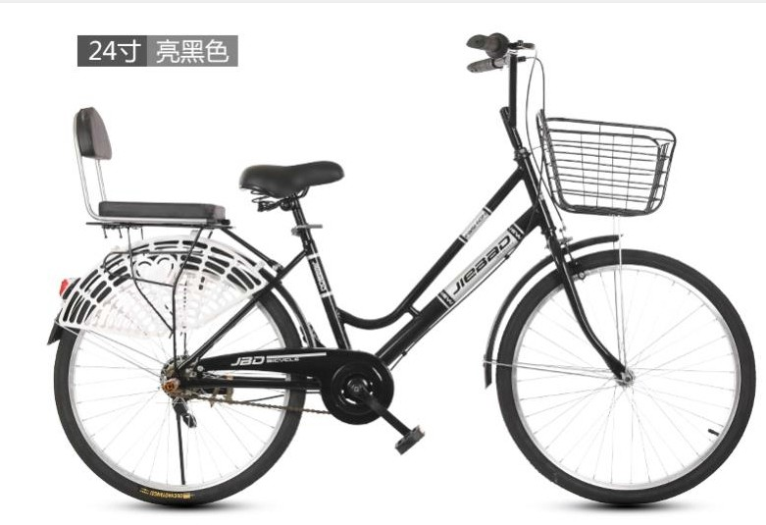 | ST-20-14 | city bike, black, white, yellow, blue, single peed or 7speed, with basket back seat, plastic pedal, caliper+hand band brake | $65  $70 | 50
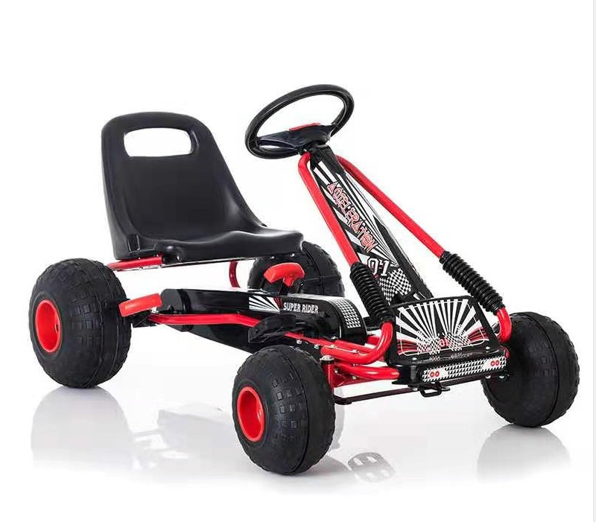 | ST-19-16 | kids go kart | $69.00 | 50

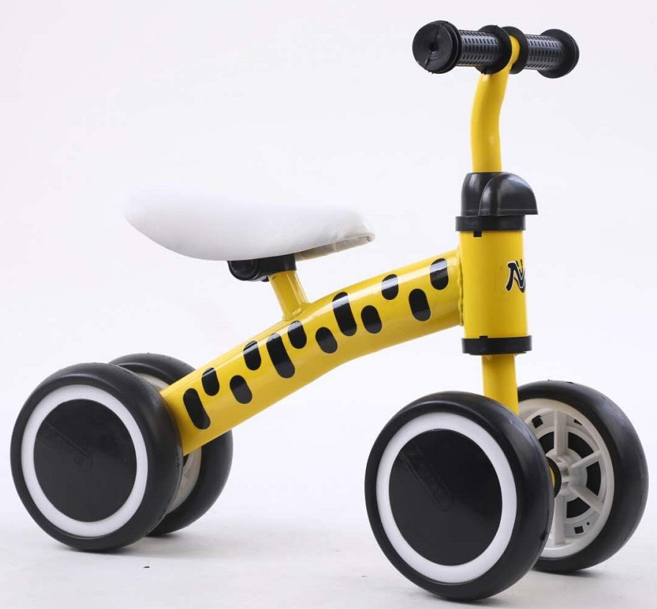 | ST-19-17 | kids 4wheel balanced bike different color | $8.00 | 1000
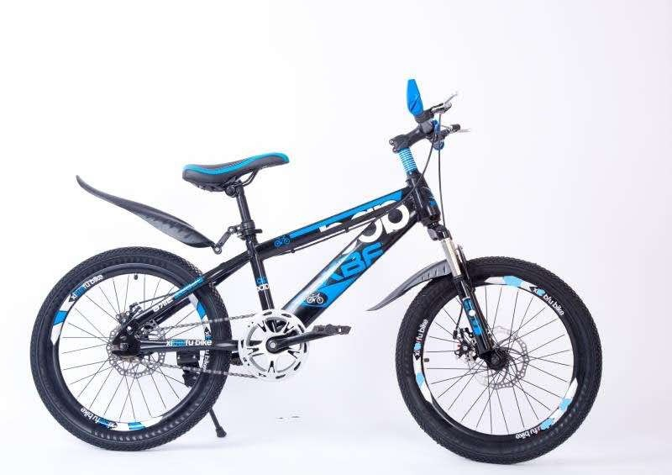 | ST-20-17 | teenager bike 18" 20" single speed or 6speed, disc  brake | $48  $53 | 100
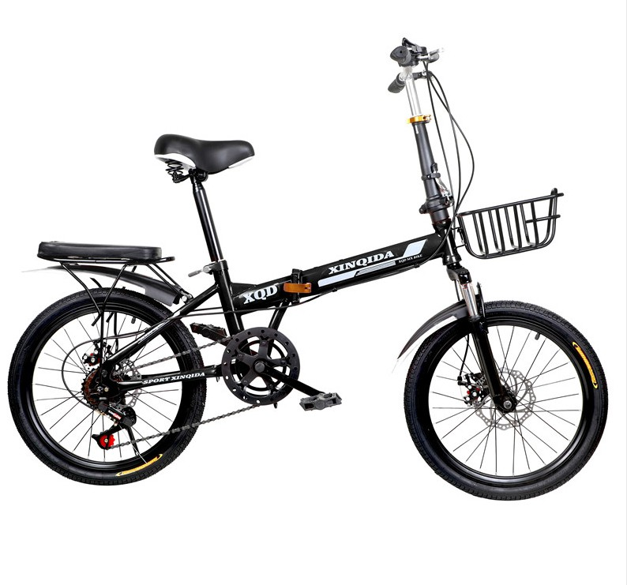 | ST-20-18 | folding bike 20" single speed,7speed red, black, white | $70.00 | 200
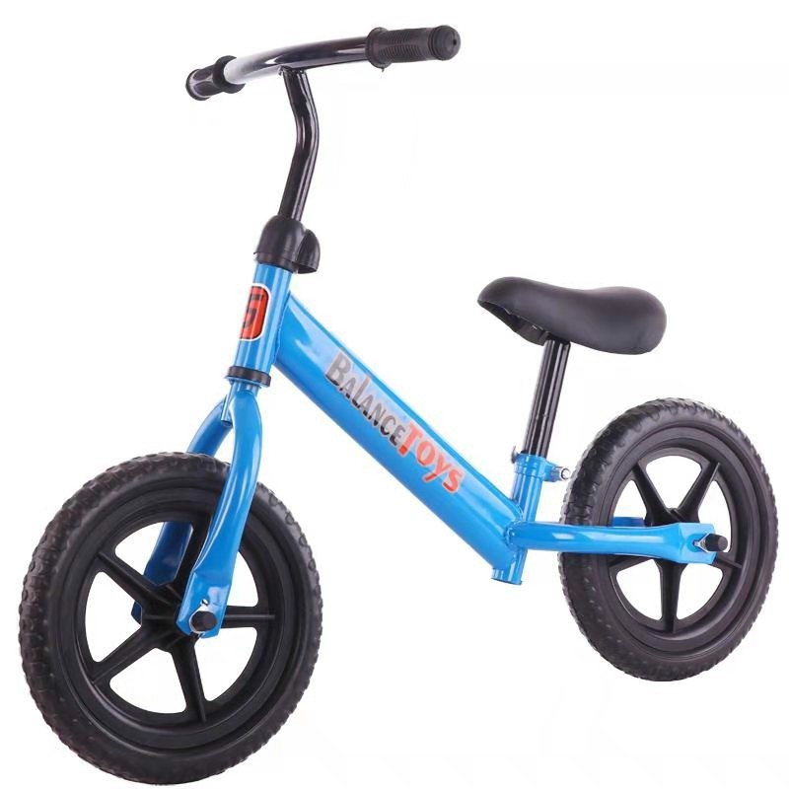 | ST-20-19 | balanced bike for kids different color | $9.00 | 1000

