SHORT EXPOSÉ

Datum: 29.10.2020

VINCENT VAN GOGH (1853-1890), Stilleben with Vase, Huile sur toile, 60 x 50 cm², Collection

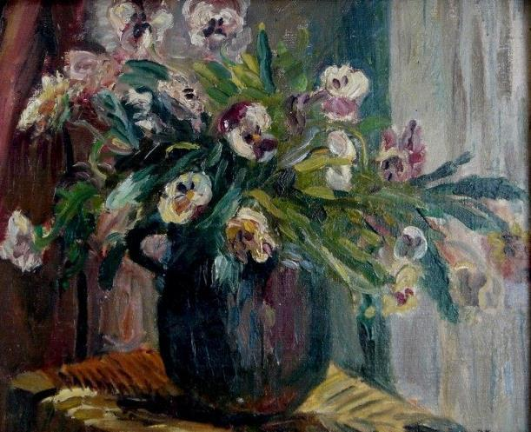

History
- In 1956 Mr. Jacques Leveillant inherited from his uncle Ernest Leveillant a comprehensive collection of works of arts from famous painters, amongst them the painting named above.
- In 1987 the well-known art connoisseur and antiquarian Mr. André Kammermann legally acquired the painting from Jacques Leveillant together with further works of the Impressionism in Geneva and had it identified and authenticated with the help of museums and experts.
- In February 2007 the ownership passed on to Mr. Ludwig M. Schneider by way of acquisition with clean and clear funds of commercial, non-criminal origin as stated in the attached notarized “Attestation of Ownership” letter.
- On 22.06.2018 the painting has been donated to Mr. Orrett Hyman, as stated in the attached “Confirmation of Transfer of Ownership” letter, for his charitable and social work.
The painting has been kept continuously in safekeeping with internationally recognized safe keeping companies in Switzerland.

1/5

ATTESTATION OF OWNERSHIP

Reference: 50315/0001-0005 - Lagervertrag Nr. 50315 MAT Zurich Date: 26th of February 2007
I, Andre Kammermann, residing in-t5J /2o o(' authorized sigJ atory, hereby, with full personal and legal responsibility and under penalty of perjui dorepresent, warrant, and attest the following: J
- I have transferred 5 Paintings (No. 50315/0001-0005 as per Lagerv rtrag Nr. 50315 from Via MAT Artcare- Zurich) for the agreed and paid value to Ludwig M. Schneider, c/o CMI Trust GmbH, Nymphenburger Str. 20a, DE-8033 Munchen and their Representative Sir Joseph Birch. Details to the 5 Paintings are attached to
this Attestation of Ownership with a History of the 5 Paintings. I
I
- I warrant and attest that the 5 Paintings are original and have been in my
possession since ,It/ 8 'I- with the attached history of the 5 Paintings and these 5 Paintings have been legally obtained by me, free and clear of any leans or encumbrances.

- I also warrant and attest that I ·have acquired these 5 Paintinis without any breach of money laundering regulations, as defined in the today's jurisdiction or
internationally regulated laws preventing money laundering. !
- I warrant and attest that Mr. Ludwig M. Schneider, c/o CMj Trust GmbH, Nymphenburger Str. 20a, DE-80335 Milnchen and the Represen ive Sir Joseph Birch by this Attestation of Ownership are sole legal owner of the Paintings and there are no claims whatsoever or from whatever reason wh ch are due or unserved to us.

- I warrant and attest that Mr. Ludwig M. Schneider, c/o CM Trust GmbH, Nymphenburger Str. 20a, DE-80335 Munchen and the Representaitive Sir Joseph Birch shall have full legal control over the 5 Paintings and are legally entitled to sell, mortgage, pledge or debenture the 5 Paintings. '
.. '
All statements herein are made under penalty of perjury.

Legally binding signature of Andre Kammermann. Passport No. _

Date: . ::? 2 O& f-

Witnessed by: _

D ate:

; ·I
Attachments: Pictures and Histories of the 5 Paintings I
I

I

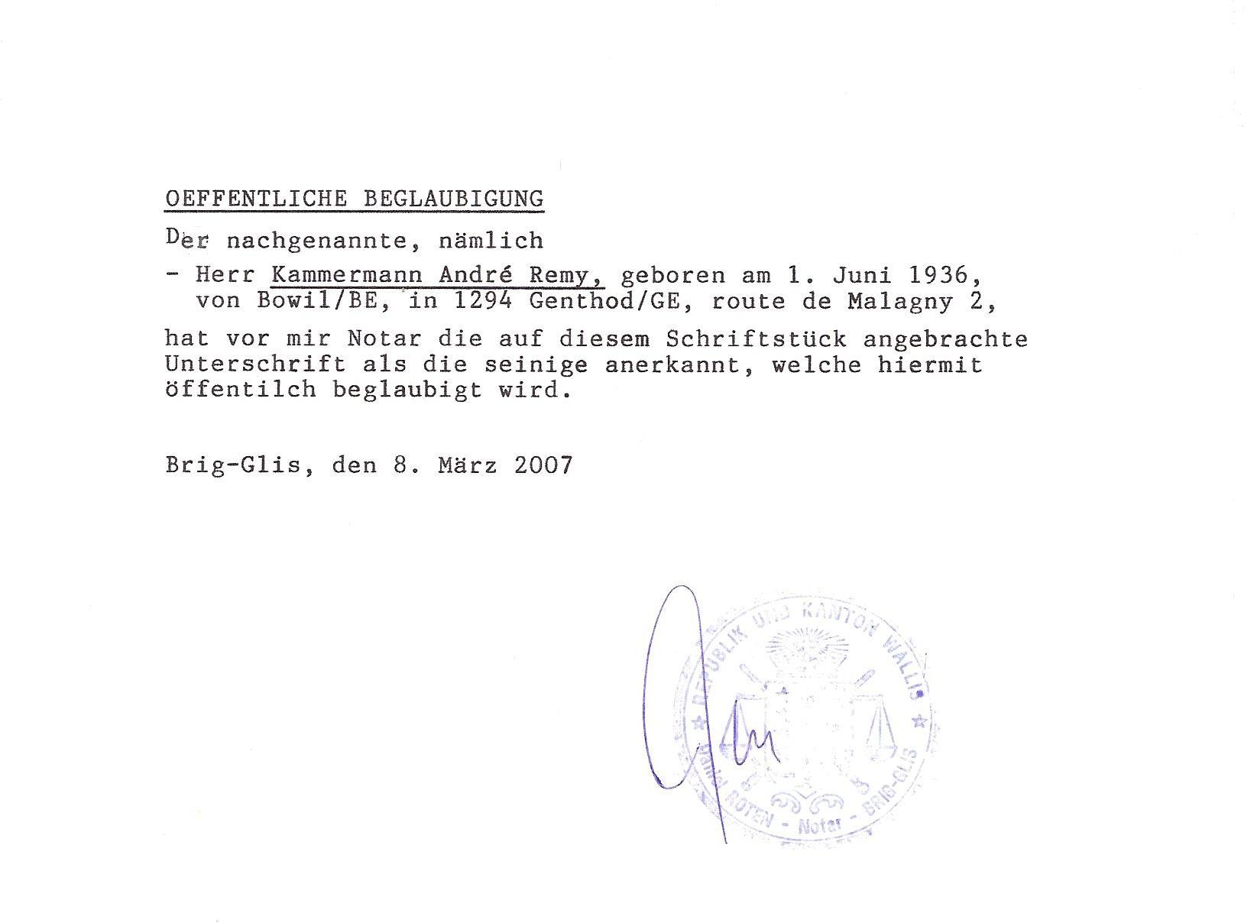
Roten Troger Klöppel
Advokatur und Notariat Kanzlei Brig-Glis
Sonnenstrasse 8, 3900 Brig-Glis, Schweiz

3/5

CONFIRMATION OF TRANSFER OF OWNERSHIP

I, Ludwig M. Schneider , with Aus trian passport with number AUT- U0076162, with full knowledge of the legal consequences and in lieu of oath hereby confirm the following:

I am the sole legal owner of four (4) paintings with (SKR) Safekeeping in Zurich / Airp ort, Switzerland. The four (4) paint in gs are:.

1.) VINCENT VAN GOGH (1853- 1 890), Stilleben with Vase, Huile suT toile, 60 x 50 cm² 2.) MONET, CLAUDE (1840-1926) Paysage de riviere et d ' arbres,
Huile sur toile , 60 x 81.5 cm²
3.) KLIMT, GUSTAV (1862-1918) Wagner et le nouveau rayonnement de Bayreuth, Huile sur toil e, 65 x 93 cm2,
4.) SISLEY, ALFRED (1839-1899) The Church, Huile sur toile, 61 x 45.45 cm²

  - I have transferred the ownership of these four (4) paintings in form of a donation for charitable purposes of any kind and other personal and business development to Mr. Orrett Hyman, British Passport Number 510962398, Resip.ent at Ross Hall, Rodley Lane, LS13 IBG, Leeds, GB. The details of these four (4) paintings and the history are enclosed with this confirmation of transfer of ownership.
  - The previous owners of these four (4) paintings have given me a written guarantee that these are originals that have been in their possession since 1987. The attached history of the four (4) images shows this. I vouch for the fact, that I, as the previous owner, have acquired the paintings in a legally correct manner, free and clear of any liens and encumbrances.
  - I vouch for this and confirm that, as the previous owner, I have acquired these four (4) images in perfect condition without violating the Money Laundering Act or the international regul ations of today's Money Laundering Act.
  - I represent and certify that Mr. Orrett Hyman, with British passport number 510962398, resident at Ross Hall, Radley Lane, LS13 1 BG, Leeds, GB, is the sole owner of the four (4) Paintings and there are no further claims against him, regardless of legal reason.
  - I represent and certify that Mr. Orrett Hyman, UK Passport Number 510962398, Resident
at Ross Hall, Radley Lane, LS13 1 BG, Leeds, GB, has full sole legal ownership and control of the four (4) images and can therefore sell, lend, donate or pledge them at his own discretion.

All of the above stat fuent·s are hereby made by me on oath.
. , °'1 .
Date: June 22, 2018
Name: Ludwig M. Schneider Passport Number: AUT-U0076162

1/2

5/5

