CSDS Aircraft Sales & Leasing Inc
2018 Airbus A330-343
THREE Aircraft.

MSN numbers and other information will be provided to buyer once the buyer is verified.
aircraft, will be delivered " Factory New" condition.

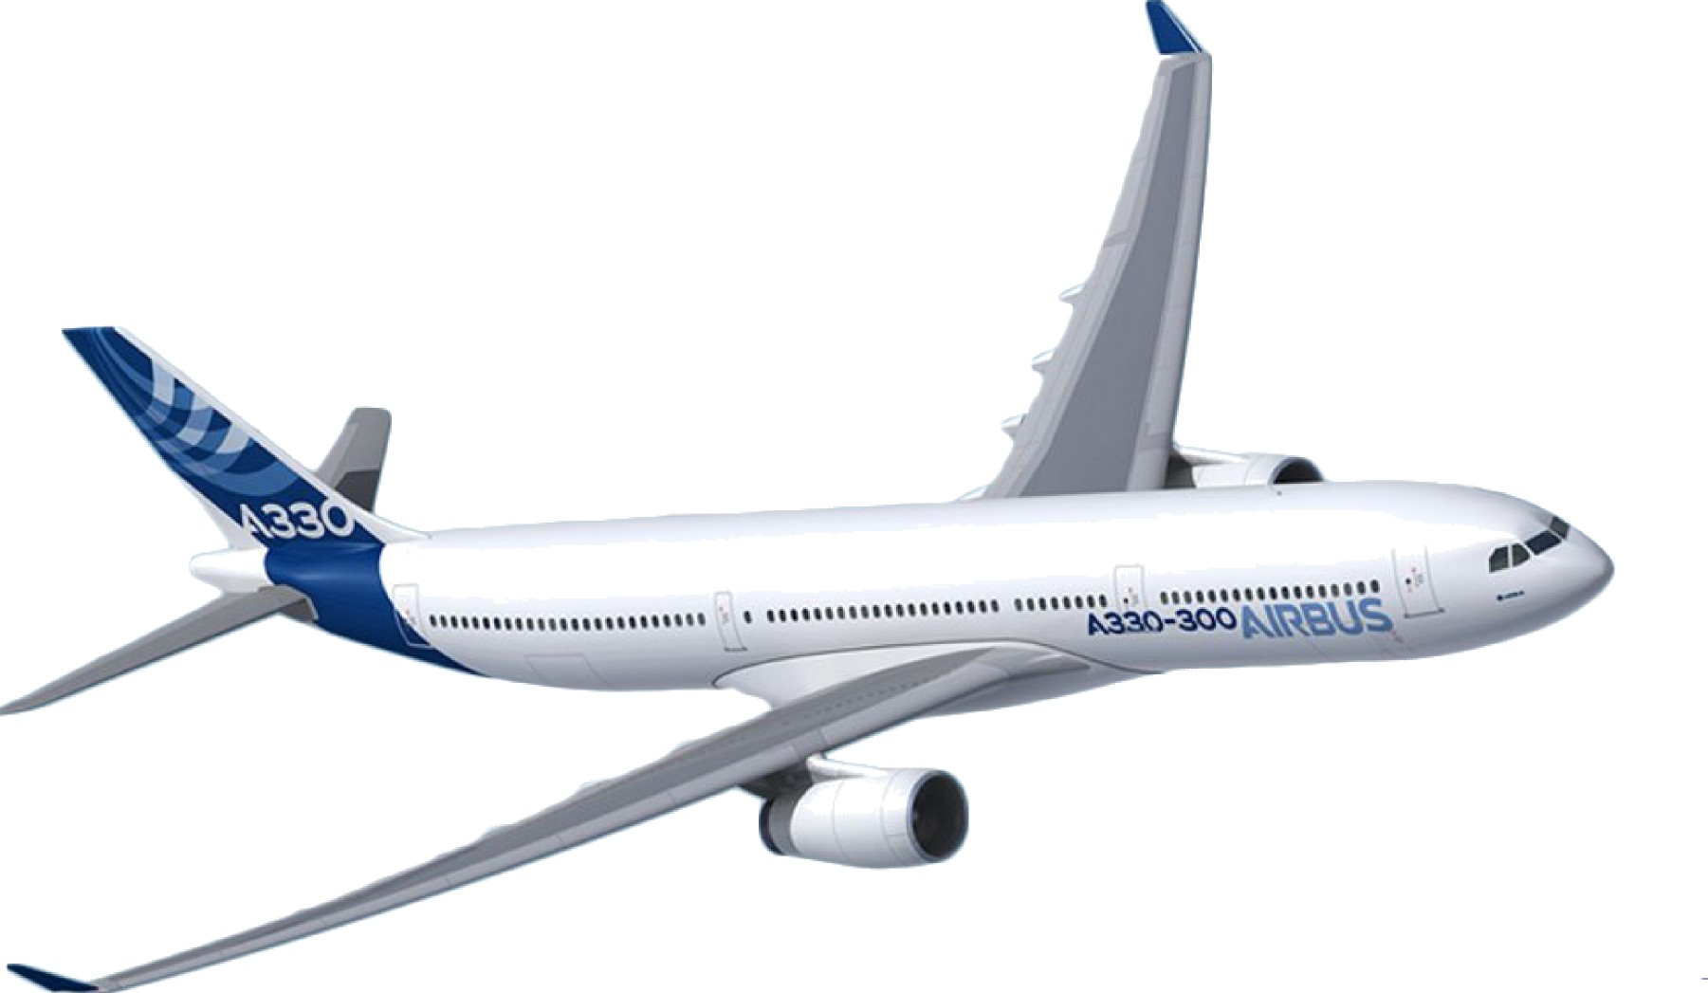
Introduction
This presentation describes the configuration agreed for A330s for deliveries in 2018.

AIRBUS

Overview

A330-343 at A330-300 standard specification issue 9.0 dated 31st July 2014

- Weight variant: Dynamic payload with MTOW 242 t / MLW 187 t and MZFW from 171 t to 175 t (WV082)

- WCT (wet center tank)

- Engine: RR TRENT 772B

- APU: HONEYWELL 3800454-6

- Cabin: 325 seats (18 B/C + 307 Y/C) in a 2-class configuration

Rich System configuration allowing operational flexibility with High rate Satcom, Dual Weather radar, RNP, etc. for optimised aircraft operations, cargo ventilation to allow perishable goods transportation…

  - General features

  - Cabin

  - System selection

  - Other

General features

- A330-300 standard Specification:
A330-300 Reference G 000 03000 Issue 9 dated 31st July 2014

- Design Weight Variant increased to WV082:
Dynamic payload with MTOW 242 t / MLW 187 t and MZFW from 171 t to 175 t (WV082)

- Airworthiness compliance:
EASA type certificate

- Engines:
Rolls Royce Trent 772B

- APU:
HONEYWELL 3800454-6

- General features

- Cabin

- System selection

- Other

Cabin Layout (LOPA ref. 330-25.56578)

Cabin LOPA with 303 seats (18 B/C + 307 Y/C) in a 2-class configuration with full-flat B/C (B/E AEROSPACE - DIAMOND) and Y/C (RECARO - CL3710)

- Advanced Entertainment system (THALES INFLYT EXPERIENCE) with full AVOD IFE

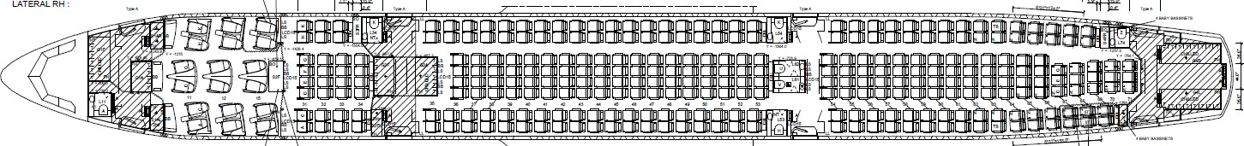

Cabin Layout : Business Class Zone

Modern, Spacious and Comfortable Business Class zone…

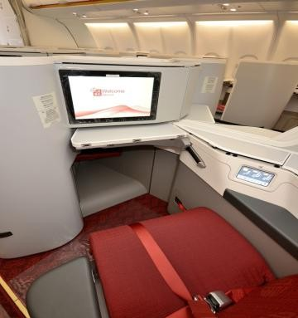
Note: the photo is not fully representative, to be updated in due time closer to delivery

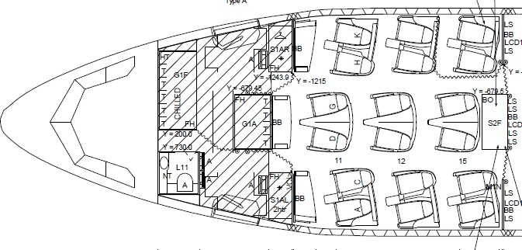
Cabin Layout : Business Class Zone
18 Full flat B/C seats 1 Lavatories
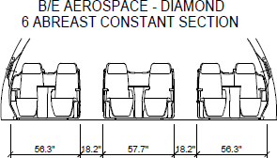
4 Cabin Attendant Seats Galleys
- G1F: wet, 5.5 trolleys (chilled)
- G1A: wet, 4 trolleys Stowage/closet: S1AL/S1AR/S2F

Cabin Layout : Business Class Zone

1 Business Class Lavatories
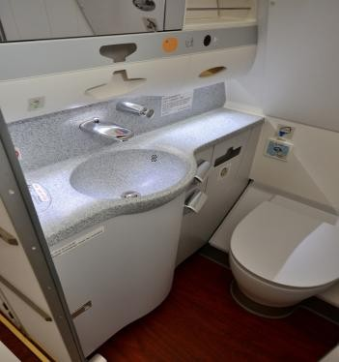
Note: the photo is not fully representative, to be updated in due time closer to delivery

Cabin Layout : Business Class Zone
Galleys
- G1F: wet, 5.5 trolleys (chilled)
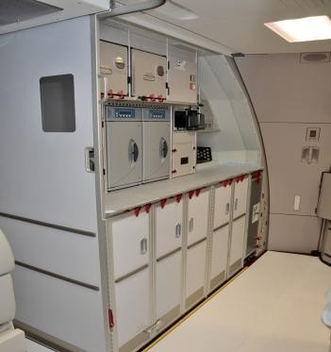
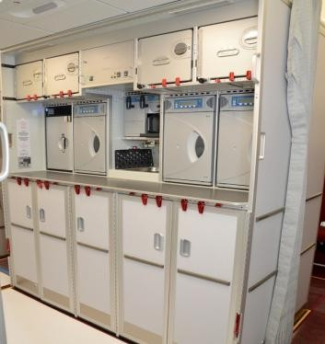
- G1A: wet, 4 trolleys Stowages: S1AL/S1AR/S2F

Note: the photos are not fully representative, to be updated in due time closer to delivery

Cabin Layout : Economy Class Zone
Rendering
Note: the photo is not fully representative, to be updated in due time closer to delivery

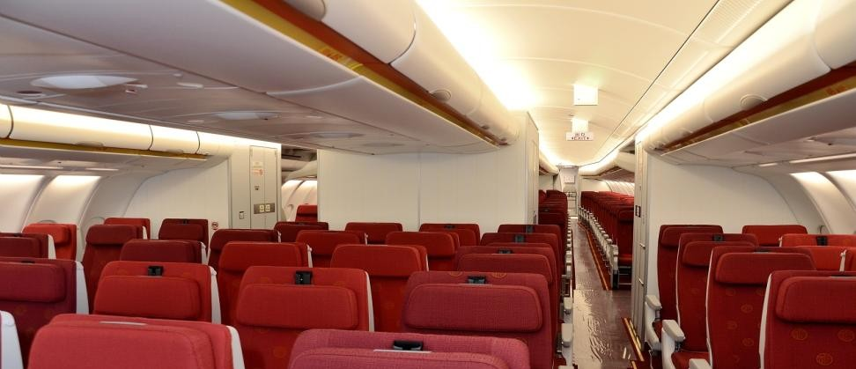

Cabin Layout : Economy Class Zone

307 Y/C seats (RECARO CL3710)
Galleys
  - G2F: wet, 5 trolleys
  - G2A: wet, 5 trolleys (chilled)
  - G4L: wet, 8 trolleys (chilled)
  - G4R: wet, 8 trolleys (chilled)
  - Stowages:
  - S2FL & S2FR;
  - S4FL & S4FR

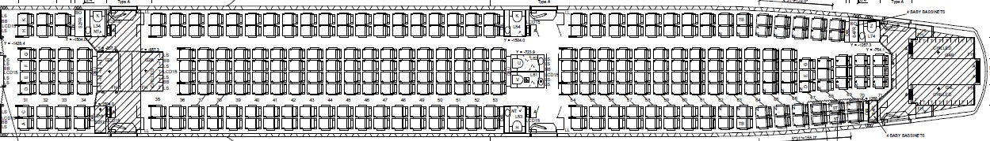
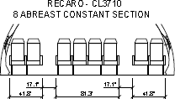
6 Lavatories including a center lavatory type U/V for passengers with reduced mobility
8 Cabin Attendant Seats

Cabin Layout : Economy Class Zone
Note: the photos are not fully representative, to be updated in due time closer to delivery

Modern, Efficient and Comfortable Economy Class zone…
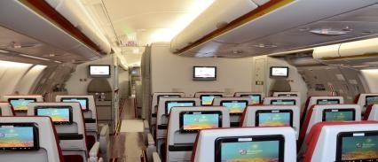
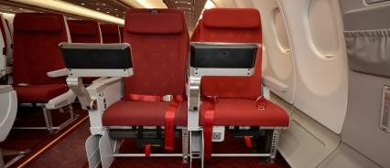
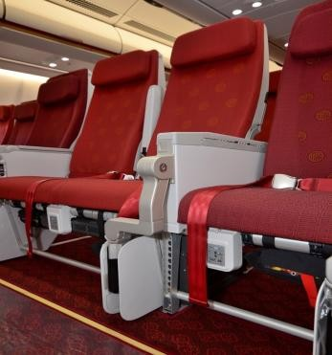

Cabin Layout : Economy Class Zone
Note: the photos are not fully representative, to be updated in due time closer to delivery

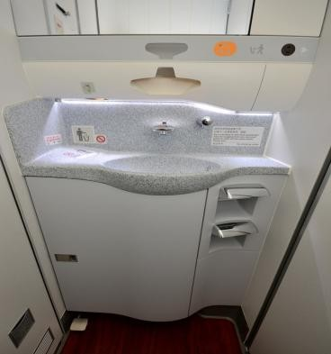
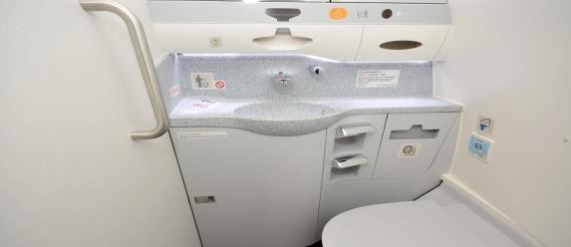
6 Economy Class Lavatories (including a center lavatory type U/V)

Cabin Layout : Economy Class Zone
Note: the photos are not fully representative, to be updated in due time closer to delivery
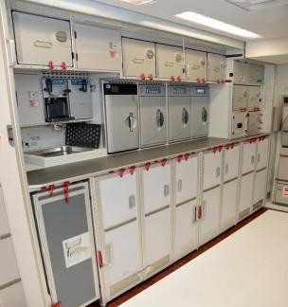
Galleys 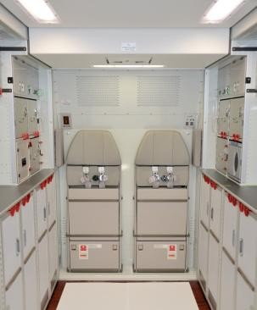 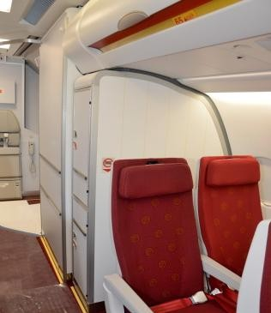
    - G2F: wet, 5 trolleys
    - G2A: wet, 5 trolleys (chilled)
    - G4L: wet, 8 trolleys (chilled)
    - G4R: wet, 8 trolleys (chilled)

Cabin Layout : Seat covers
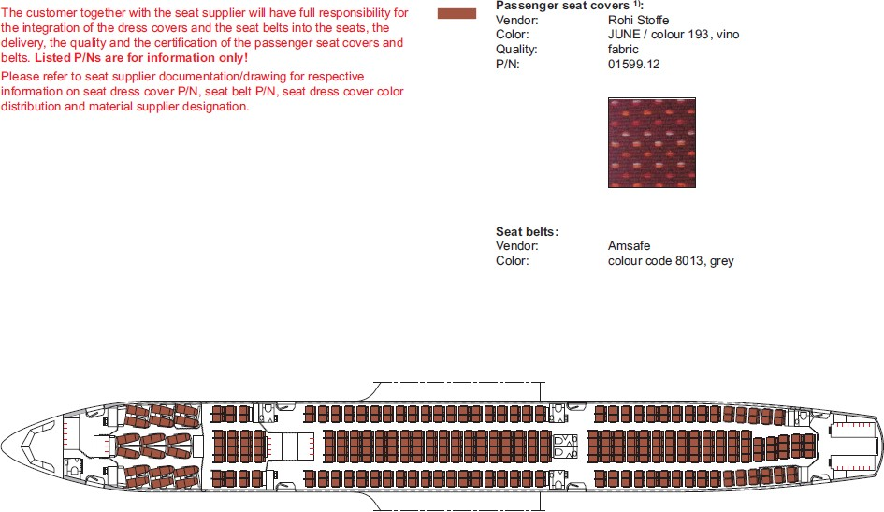

Lighting
Note: the photo is not fully representative, to be updated in due time closer to delivery

Self dimmed Lavatory Occupied Signs
  - In-seat reading lights in B/C
  - Inst. of colored EEPMS LUFTHANSA TECHNIK -900 in NFT & aisle areas
  - Exit identifier LSI

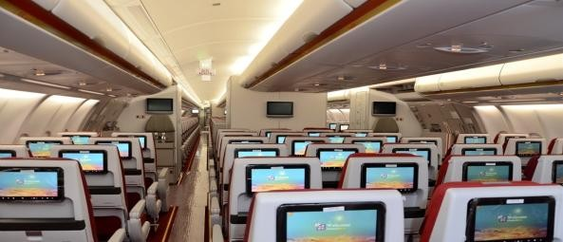

IFE: THALES INFLYT EXPERIENCE

The IFE system is supported by an integrated platform which provides following services :
    - Personal In Seat Video & Audio: Full AVOD B/C + Y/C
    - fixed 15-16 inches LCD (BFE) on partitions/lavatories/galleys/stowages
    - Passenger Flight Information System (PFIS)
    - PED outlets B/C + Y/C

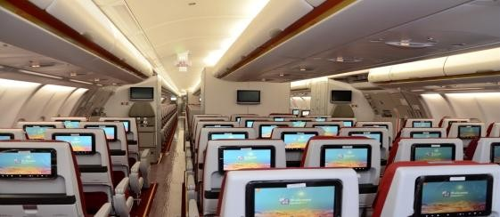
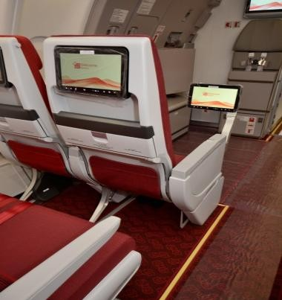
IFE: THALES INFLYT EXPERIENCE
Note: the photos are not fully representative, to be updated in due time closer to delivery

CIDS selections

- 2-Zone PA
- 2-Zone pax call
- 2-Zone cabin illumination
- PA priority for first attendant
- PA attention single chime
- Cabin and flight crew interphone
- Central reset of passenger calls zonewise for all zones from FAP, and zonewise from AAP
- Chime inhibit of passenger call zonewise from FAP
- Seat number indication on AIP for passenger call
- EVAC command on AAP door 4
- EVAC audio alert in addition through PA loudspeakers
- "CABIN READY" indication on ECAM (Timer 5 mn)
- Customer provided screensaver (picture)

Emergency equipment location

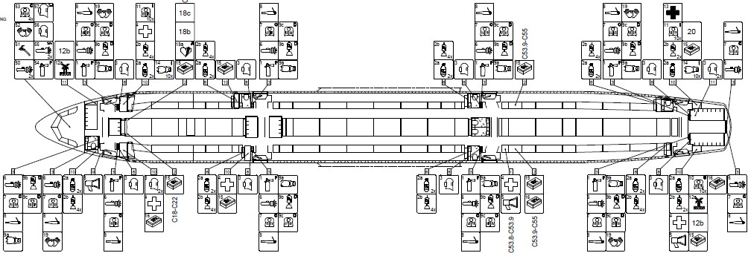

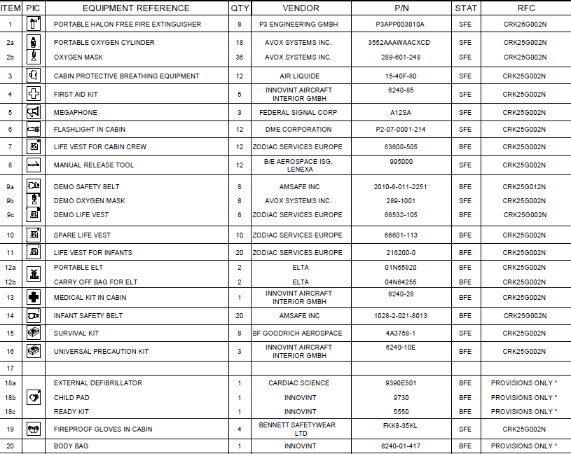
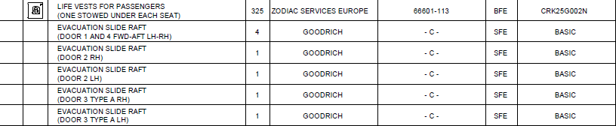
Emergency equipment
- Cabin

Emergency equipment - Cockpit

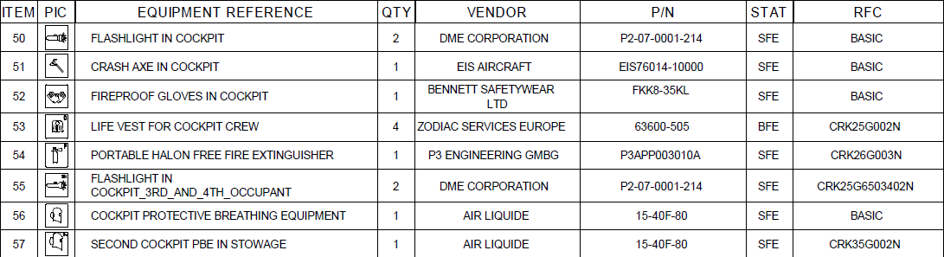

CIDS selections

Structural reinforcements for KA Band Antenna

  - System provisions for KA Band Antenna

  - Installation of provisions for Aircraft Communication Manager (ACM)

  - Installation of KA connectivity

General features

- Cabin

- System selection

- Other

Avionic system selection (1)

  - ATA 21 AIR CONDITIONING
    - Installation of lower deck fwd cargo compartment ventilation system and temp control (A330)
    - Particle filter element – PALL-GMBH, PN QB0408-01

ATA 22 AUTO-PILOT
    - FMS Release 1A (Genepi/T5BH3) and MCDU alternate eqpt - THALES AVIONICS/SMITHS

ATA 23 COMMUNICATIONS
    - Automatic ELT (406 AF Integra) with programming dongle and remote control panel - THALES AVIONICS)
    - Installation of Cockpit Door Surveillance System (CDSS) connected to the ECAM SD
    - Installation of swift Broadband Global Area Network (BGAN) - Honeywell (-77145)
    - Installation of headset for fourth occupant - SENNHEISER type HD 46-K1, PN 046-69-999-0931
    - Installation of Multiple VHF Data Radio (MVDR)
    - Boomsets alternate equipment - TELEX COMMUNICATIONS, PN 64300-210
    - CVR (90 days ULB), HONEYWELL, P/N 980-6032-023

ATA 24 ELECTRICAL POWER
    - Additional 15 kVA galley power supply in door n° 4 area
    - Battery discharge warning system

Avionic system selection (2)

ATA 26 FIRE PROTECTION – GENERAL
  - Cargo fire extinguishers - PACIFIC SCIENTIFIC
  - Cockpit portable fire extinguisher (SFE) - P3, PN P3APP003010A
  - Installation of halon-free fire extinguisher in cabin (SFE) - P3, PN P3APP003010A

- ATA 28 FUEL – GENERAL
  - Installation of Wet Center Tank (WCT)

ATA 29 HYDRAULIC POWER – GENERAL
  - Hydraulic Power - Ram Air Turbine (RAT) - Introduce RAT design standard P/N P/N 1702934F

ATA 31 INDICATING / RECORDING
  - Flight Data Recorder (FDR) (90 days ULB) (1024 w/s) - HONEYWELL, PN 980-4750-002
  - WGL-DAR (4 HSPA+ modules) equipped with 8Gb CF memory card - Teledyne (BFE) (ARINC 591/600)

ATA 32 LANDING GEAR – GENERAL
  - A330 - Wheels and brakes GOODRICH MESSIER (1 500 LPO)
  - A330-200/300 - Radial tires (MLG) - MICHELIN, PN M05102
  - A330-200/300 - Radial tires (NLG) - MICHELIN, PN M07601
  - A330-200/300/800/900 - Universal brake cooling fans on GOODRICH - MESSIER brakes

Avionic system selection (3)

ATA 34 NAVIGATION
  - RNP AR capability (Step 3)
  - Radio altitude automatic call-outs
  - Installation of dual Head-Up Display (HUD) - deactivated
  - TCAS (ch7.1) - HONEYWELL TPA100B (-005) / ATC - ACSS NXT-800
  - ISIS - baro setting in inches Hg
  - ISIS - display of metric altitude
  - Dual weather radar ROCKWELL COLLINS, MultiScan WXR-2100 - V2 with hazard function activation
  - Compliance with ADS-B OUT regulation for RAD & NRA operations
  - Installation of a dual ADF - ROCKWELL COLLINS (900 SERIES)
  - Activation of the Back-Up Speed Scale function

ATA 35 OXYGEN – GENERAL
  - In-situ replenishment facility for cockpit oxygen cylinder (A330) - EROS, PN DKR142
  - Installation of second PBE in cockpit (SFE) - AIR LIQUIDE, PN 15-40F-80
  - Introduce cockpit oxygen system segregation

ATA 38 WATER/WASTE – GENERAL
  - Statement of sanitary construction for water and waste system compliance with USPHSS
  - Installation of one water conditioner in potable water system - AOA APPARATEBAU

Avionic system selection (4)

ATA 46 INFORMATION SYSTEMS
  - Installation of provisions for a connectivity platform
  - Airbus AOC software for ATSU (Fans A+) (weights in kg) - HONEYWELL
  - Activation of ARINC 623 in the ATSU
  - Activation of VDL mode 2 function in the ATSU

ATA 51 STANDARD PRACTICES AND STRUCTURES - GENERAL
  - Water repellent fluid on wing strut well areas
  - Alternate paint systems (LOW VOC / CF primer) on nacelle - ANAC
  - Alternate paint system (CF primer, Base Coat/Clear Coat) on fuselage & vert. stabilizer – ANAC

ATA 52 DOORS
  - Type "A" door number 3
  - Electrical cockpit door locking back-up system (MMEL conditions)

ATA 55 STABILIZERS
  - Metal sheet cover on vertical stabilizer

ATA 56 WINDOWS
  - Front and side cockpit windows - SAINT-GOBAIN SULLY
  - Installation of Blind windows painted in dark grey

General features

- Cabin

- System selection

- Other

External Livery
External Livery customised in compliance with requirements:
    - Registration on wings
    - Bilingual placards and markings

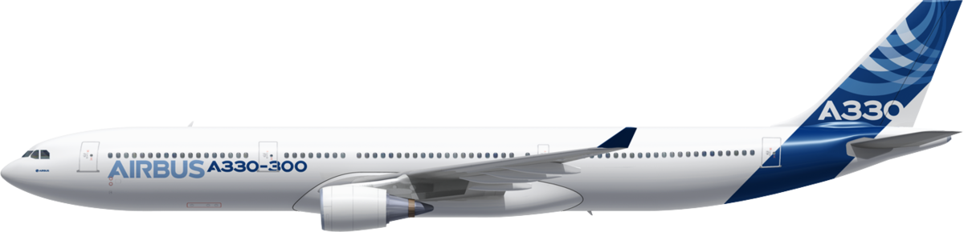

Thank you

