SEPTEMBER 2021
Soft Corporate Offer – SCO Argentinean Beef – Frozen Boneless Meat
- The following offer is been transported by MAERSK with arrival date estimated for the mid-November at Porto of Xingang, China.

- 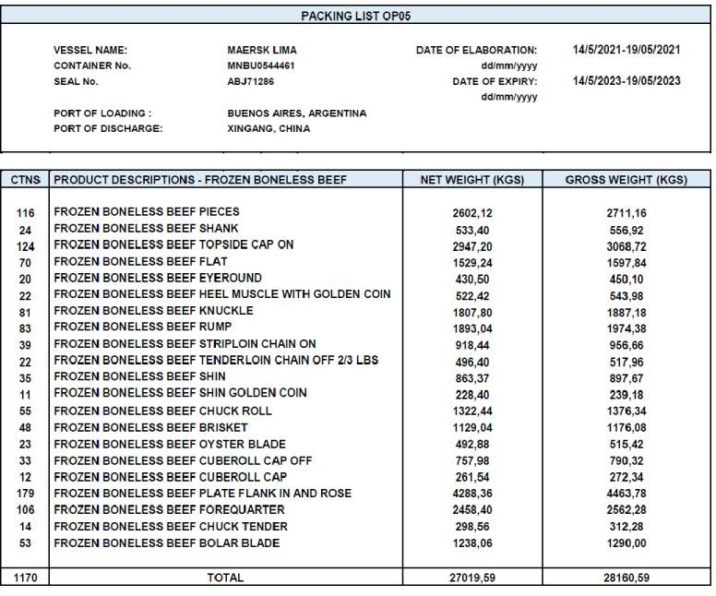The Buyer can confirm acceptance of the offer and secure the purchase through an irrevocable Bank Guarantee (or through an escrow account) to be released after local inspection in China.

Price per M/T – USD 6.330

- Quantity: 23 (twenty three) 40’ Containers – 52,699 Tons

- Payment Condition: Cash transferable to Seller’s account after inspection in China Port.

53 Primrose Place – Isleworth - Middlesex TW7 5BA – LONDON - United Kingdom
UK-Mob:+44-7770-900802-NL-Mob:+31-6-41 131313 - E-mail: janfabius@hotmail.com – Skype: janfabius

WorldSouroe lntematkm..t

PACKING UST OP08

VESSEL NAME: MAERSK UlllA DATE OF ELABORATION: 1110512021-13/05/2021
CONTAlNER tlo. MNBU3491998 dd/mmiwyy
SEALNo. ABJ71375 DATE OF EXPIRY: 1110512023-13/0512023
dd/mmtY/' YY
BUENOS AIRES,
PORT OF LOADING : ARGENTINA
PORT OF OISCHARGE: XINGANG,CHINA

CTNS | PRODUCT DESCRIPTIONS· FROZEN BONELESS BEEF | NET WEIGHT IKGSI | GROSS WEIGHT IKGSI
125 | FROZEN BONELESS BEEF PIECES | 2752,66 | 2870,16
22 | FROZEN BONELESS BEEF SHANK | 508,20 | 528,00
3 | FROZENBONELESS BEEF RIB FINGER | 74,16 | 76,86
87 | FROZEN BONELESS BEEF TOPSIDE CAP ON | 2128,80 | 2207,10
52 | FROZEN BONELESS BEEF FLAT | 1176,88 | 1223,68
24 | FROZENBONELESS BEEF EYEROUND | 561,10 | 5a2,70
22 | FROZENBONELESS BEEF HEEL MUSCLE WITH GOLDENCOIN | 530,98 | 550,78
58 | FROZEN BONELESS BEEF KNUCKLE | 1407,54 | 1459,74
63 | FROZEN BONELESS BEEF RUMP | 1522,84 | 1579,54
46 | FROZEN BONELESS BEEF STRIPLOIN CHAIN ON | 1081,66 | 1123,06
26 | FROZEN BONELESS BEEF TENDERLOINCHAINOFF LESS 2/3 LBS | 669,82 | 582,32
28 | FROZENBONELESS BEEF SHIN | 678,54 | 703,74
7 | FROZEN BONELESS BEEF SHINGOLDEN COIN | 178,60 | 184,90
51 | FROZENBONELESS BEEF CHUCK ROLL | 1265,58 | 1311,48
39 | FROZEN BONELESS BEEF BRISKET | 950,30 | 985,40
25 | FROZEN BONELESS BEEF OYSTER BLADE | 578,24 | 600,74
35 | FROZEN BONELESS BEEF CUBEROLL CAP OFF | 845,32 | 876,82
14 | FROZEN BONELESS BEEF CUBEROLL CAP | 325,00 | 337,60
6 | FROZEN BONELESS BEEF THIN SKIRT | 135,92 | 141 32
178 | FROZENBONELESS BEEF PLATE FLANK IN AND ROSE | 4317,85 | 4478,05
101 | FROZEN BONELESS BEEF FOREQUARTER | 2472,52 | 2563,42
18 | FROZENBONELESS BEEF CHUCK TENDER | 411,82 | 428,02
52 | FROZENBONELESS BEEF BOLAR BLADE | 1215,50 | 1262,30
1081 | TOTAL | 26679,83 | 26667,73

53 Primrose Place - Isleworth • Middlesex TW7 SBA - LONDO N ·United Kingdom UK·Mob:+44·7770 900802·NL·Mo b:+31 6·41 131313 ·E-mail: janfabius@hotmail.com - Skype: janfabius

