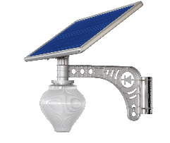
Model | Configuration | Lumen | Unit price MOQ≥500sets | Picture | Install height
Solar LED Garden light
10W Gold Apple Light | - Solar panel: 5V/18W, life time: 25years.  - LAMP: Common LED 10W, life time: 50000 hours.  - Battery: 3.2V/13AH LiFePO4 battery, life time: 8-12 years.  - Lighting time: All night lighting, the first 4hrs full power lighting, the rest night lighting is intelligent power control. | 810Lm | $30.00 | 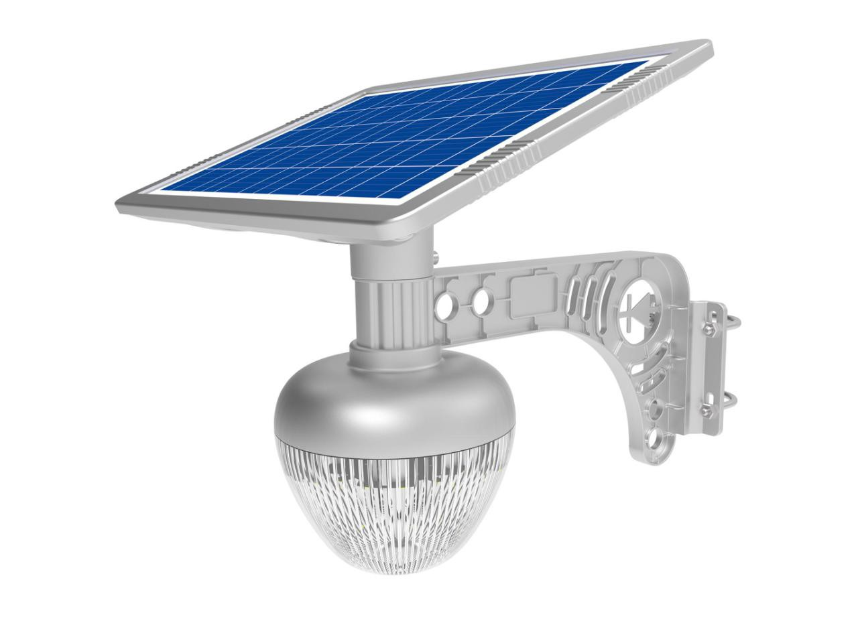 | 3-5m
15W Gold Peach Light | - Solar panel: 5V/30W, life time: 25years.  - LAMP: Common LED 15W, life time: 50000 hours.  - Battery: 3.2V/26AH LiFePO4 battery, life time: 8-12 years.  - Lighting time: All night lighting, the first 4hrs full power lighting, the rest night lighting is intelligent power control. | 880Lm | $38.00 | 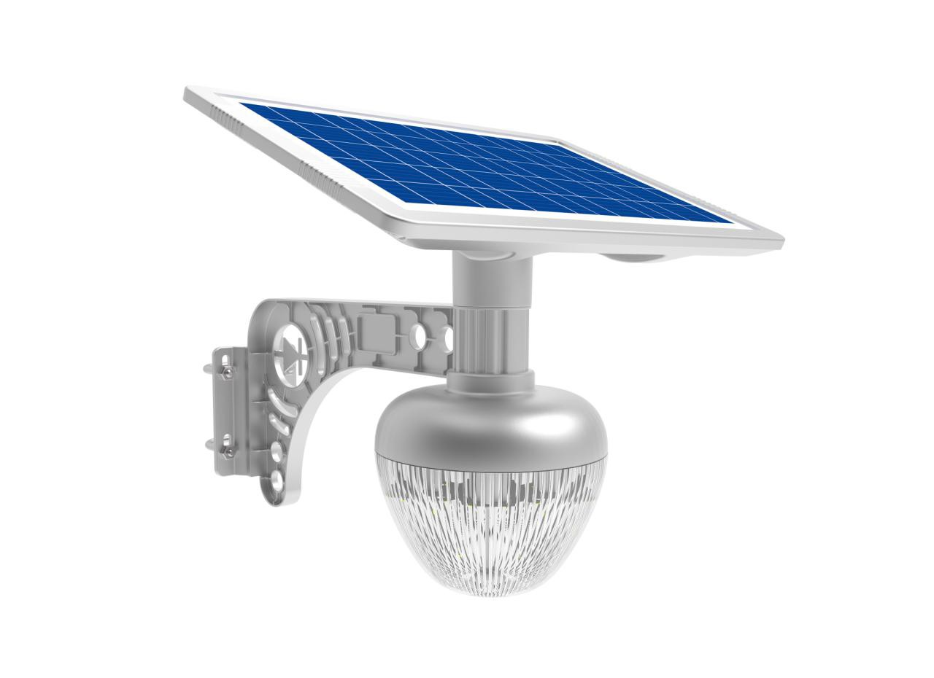 | 3-5m
7W Apple light 1.0S | - Solar panel: 5V/18W, life time: 25years.  - LAMP: Imported LED 450lm, common LED 7W,life time: 50000 hours.  - Battery: 3.2V/13AH LiFePO4 battery, life time: 8-12 years.  - Lighting time: All night lighting, the first 4hrs full power lighting, the rest night lighting is intelligent power control. | 450lm | $30.50 | 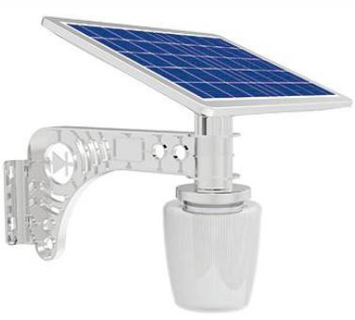 | 2.5-3.5m
7W Lotus light 1.0 | - Solar panel: 5V/18W, life time: 25years.  - LAMP: Imported LED 660lm,common LED 7W,life time: 50000 hours.  - Battery: 3.2V/20AH LiFePO4 battery, life time:8-12 years.  - Lighting time: All night lighting, the first 4hrs full power lighting, the rest night lighting is intelligent power control. | 660lm | $32.00 | 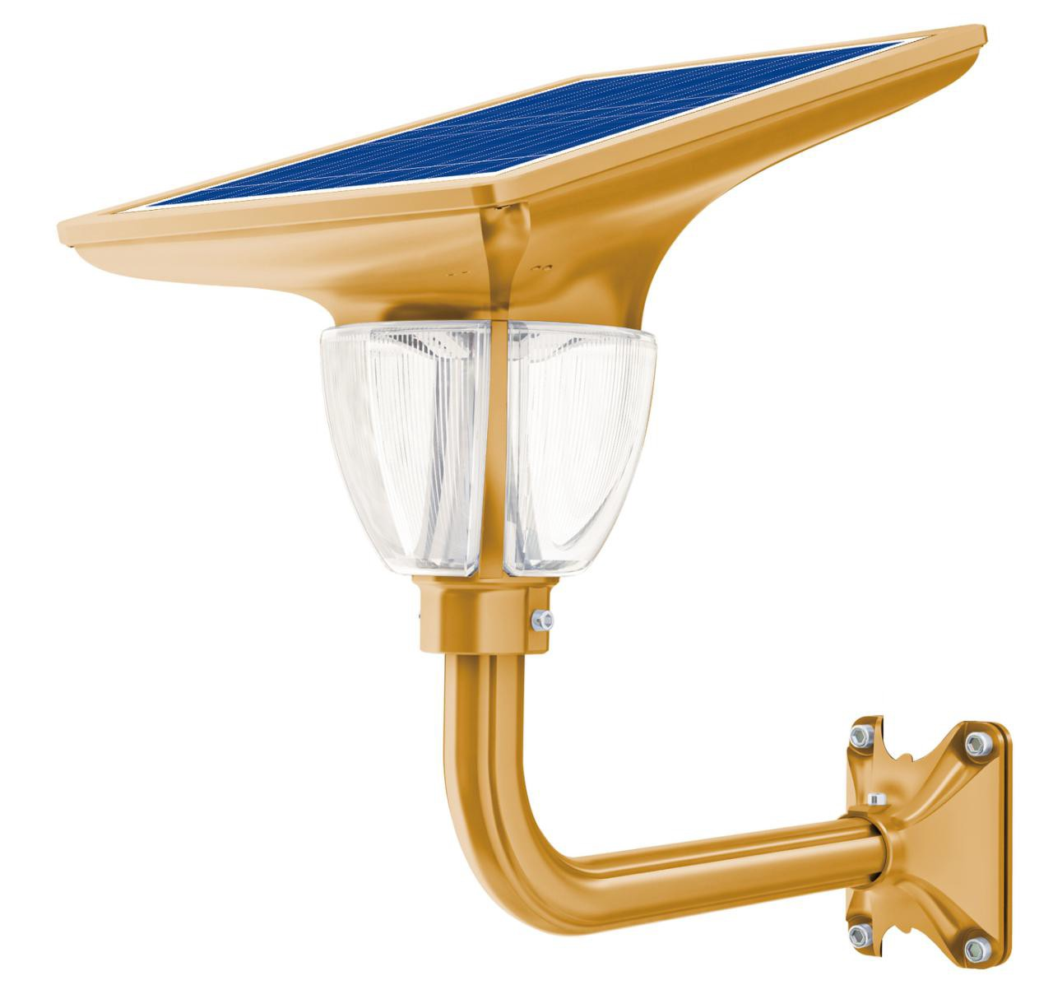 | 2.5-3.5m
15W Peach light 1.0 | - Solar panel: 5V/36W, life time: 25years.  - LAMP: Imported LED 880lm,common LED 15W, life time: 50000 hours.  - Battery: 3.2V/26AH LiFePO4 battery, life time: 8-12 years.  - Lighting time: All night lighting, the first 4hrs full power lighting, the rest night lighting is intelligent power control. | 880lm | $41.00 |  | 3-5m
7W Flat light 1.0S | - Solar panel: 5V/15W, life time: 25years.  - Lamp: Imported LED,common LED 15W, life time: 50000 hours.  - Battery: 3.2V/13AH LiFePO4 battery, life time: 8-12 years.  - Lighting time: All night lighting, the first 4hrs full power lighting, the rest night lighting is intelligent power control. | 450lm | $22.00 | 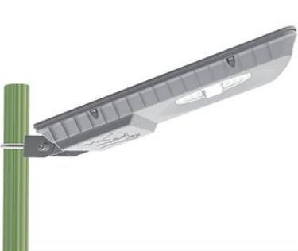 | 3-4m
Solar Lawn Light | - Solar panel: 5V/5W, life time: 25years.  - Lamp: Imported LED 270lm,common LED 2.5W, life time: 50000 hours.  - Battery: 3.2V/5.5AH LiFePO4 battery, life time: 8-12 years.  - Lighting time: All night lighting, the first 4hrs full power lighting, the rest night lighting is intelligent power control. | 270lm | $34.00 | 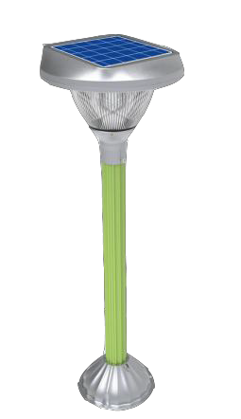
Solar Ceiling Light | - Solar panel: 5V/30W, life time: 25years.  - LAMP: Imported LED, 1080lm common LED 15W.  - Battery: 3.2V/25AH LiFePO4 battery, life time: 8-12 years.  - Lighting time: All night lighting, pre 4hrs full power lighting, then intelligent power control.use remote_controller switch on and off at any time | 1080lm | $33.00 | 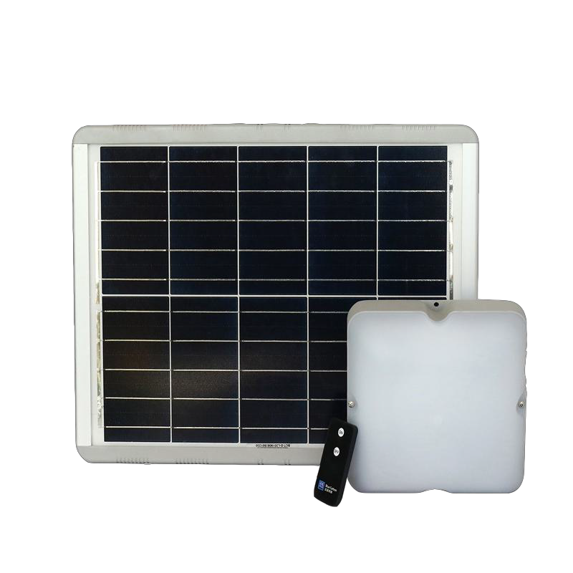
Solar LED Street light
20w Solar Jade Light | - Solar panel: 5V/45W, life time: 25years.  - LAMP: Imported LED1800lm,common LED 20W, life time: 50000 hours.  - Battery: 3.2V/35±5AH LiFePO4 battery, life time: 8-12 years.  - Lighting time: 6+x/Intelligent power control,and can use remote control to adjust brightness and working mode. | 1800lm | $41.00 | 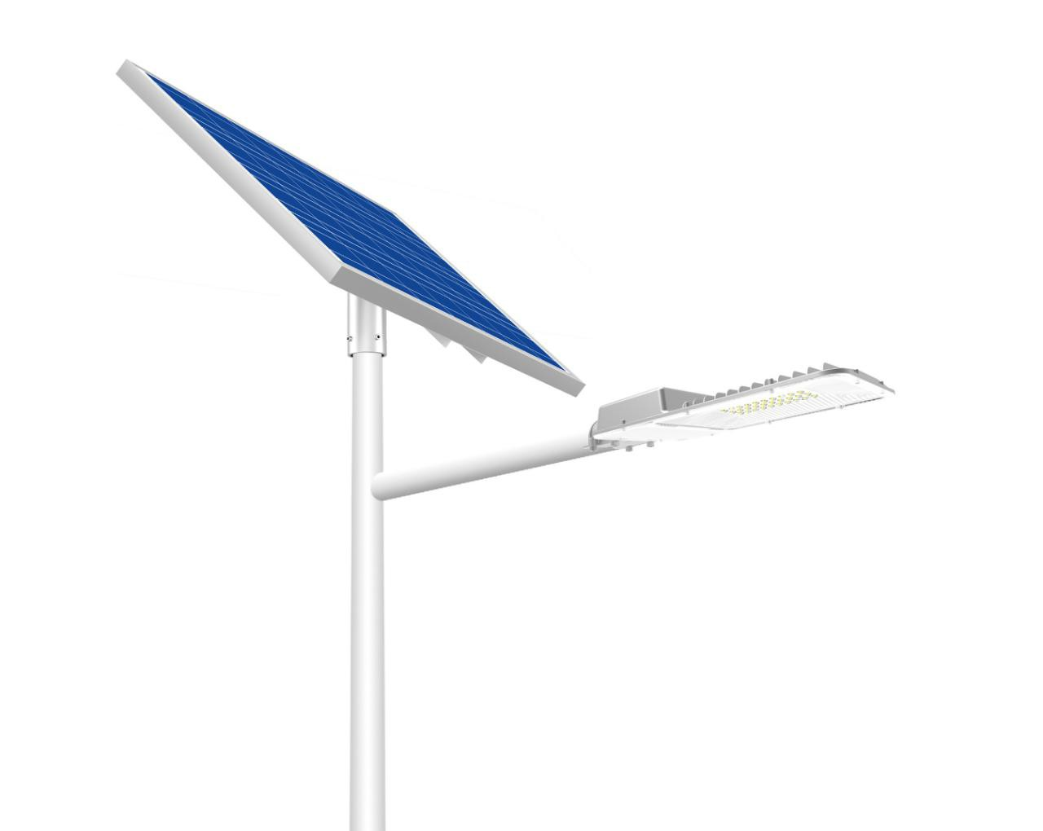 | 5-6m

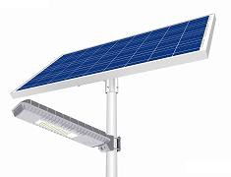
Model | Configuration | Lumen | Unit price MOQ≥500sets | Picture | Install height
30W Solar Jade Light | - Solar panel: 5V/80W, life time: 25years.  - LAMP: Imported LED3200lm,common LED 30W, life time: 50000 hours.  - Battery: 3.2V/50±5AH LiFePO4 battery, life time: 8-12 years.  - Lighting time: 6+x/Intelligent power control,and can use remote control to adjust brightness and working mode. | 3200lm | $60.00 | 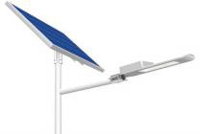 | 6-8m
50W Solar Jade Light | - Solar panel: 5V/120W, life time: 25years.  - LAMP: Imported LED5400lm,common LED 50W, life time: 50000 hours.  - Battery: 3.2V/65±5AH LiFePO4 battery, life time: 8-12 years.  - Lighting time: 6+x/Intelligent power control,and can use remote control to adjust brightness and working mode. | 5400lm | $88.00 |  | 8-10m
30W Pure precious light | - Solar panel: 5V/80W, life time: 25years.  - LAMP: Imported LED 3200lm,common LED 30W, life time: 50000 hours.  - Battery: 3.2V/50±5AH LiFePO4 battery, life time: 8-12 years.  - Lighting time: 6+x/Intelligent power control,and can use remote control to adjust brightness and working mode. | 3200lm | $58.00 | 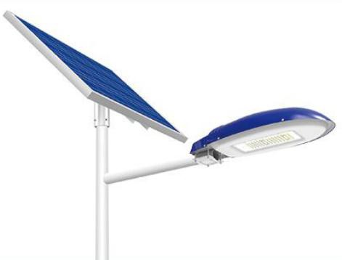 | 6-8m
50W Pure precious light | - Solar panel: 5V/120W, life time: 25years.  - LAMP: Imported LED 5400lm, common LED 50W,life time: 50000 hours.  - Battery: 3.2V/65±5AH LiFePO4 battery, life time: 8-12 years.  - Lighting time: 6+x/Intelligent power control,and can use remote control to adjust brightness and working mode. | 5400lm | $82.00 |  | 8-10m
50W  Blue Fire light 2.0 | - Solar panel: 5V/120W, life time: 25years.  - LAMP: Imported LED 5400lm, common LED 50W,life time:50000 hours.  - Battery: 3.2V/65±5AH LiFePO4 battery, life time: 8-12 years.  - Lighting time: All night lighting, the first 4hrs full power lighting, the rest night lighting is intelligent power control. | 5400lm | $115.00 | 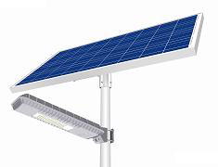 | 7-8m
70W  Blue Fire light 2.0 | - Solar panel: 5V/135W(Mono), life time: 25years.  - LAMP: Imported LED 7700lm, common LED 70W,life time:50000 hours.  - Battery: 3.2V/140±5AH LiFePO4 battery, life time: 8-12 years.  - Lighting time: All night lighting, the first 4hrs full power lighting, the rest night lighting is intelligent power control. | 7700lm | $166.00 |  | 7-8m
80W  Blue Fire light 2.0 | - Solar panel: 5V/160W, life time: 25years.  - LAMP: Imported LED 8000lm,common LED 80W, life time: 50000 hours.  - Battery: 3.2V/160±5AH LiFePO4 battery, life time: 8-12 years.  - Lighting time: All night lighting, the first 4hrs full power lighting, the rest night lighting is intelligent power control. | 8000lm | $188.00 |  | 8-10m
120W  Blue Fire light 2.0 | - Solar panel: 5V/180W(Mono), life time: 25years.  - LAMP: Imported LED 13600lm, common LED 120W,life time: 50000 hours.  - Battery: 3.2V/200±5AH LiFePO4 battery, life time: 8-12 years.  - Lighting time: All night lighting, the first 4hrs full power lighting, the rest night lighting is intelligent power control. | 13600lm | $235.00 | 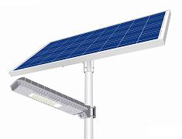 | 10-12m
80W Flat light | - Solar panel: 5V/80W(Mono), life time: 25years.  - LAMP: Imported LED 6000lm, common LED 60W,life time: 50000 hours.  - Battery: 3.2V/100AH LiFePO4 battery, life time: 8-12 years.  - Lighting time: 6+x/Intelligent power control,and can use remote control to adjust brightness and working mode. | 6000lm | $115.00 | 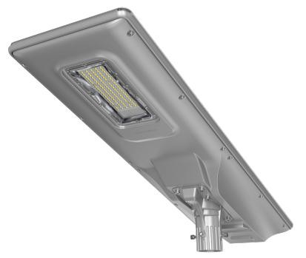 | 6-8m
100W Flat light | - Solar panel: 5V/100W(Mono), life time: 25years.  - LAMP: : Imported LED 8000lm, common LED 80W,life time: 50000 hours  - Battery: 3.2V/200±5AH LiFePO4 battery, life time: 8-12 years.  - Lighting time: 6+x/Intelligent power control,and can use remote control to adjust brightness and working mode. | 8000lm | $147.00 |  | 8-10m

Model | Configuration | Lumen | Unit price MOQ≥500sets | Picture | Install height
Solar LED Flood light
WaWa Light 1.0 | - Solar panel: 5V/12W, life time: 25years.  - LAMP: Imported LED, 600lm  - Battery: 3.2V/13AH LiFePO4 battery, life time: 8-12 years.  - Lighting time: 6+x/Intelligent power control,and can use remote control to adjust brightness and working mode. | 600lm | $18.00 | 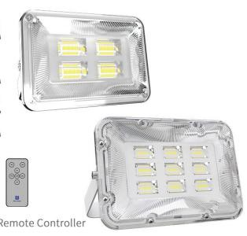
WaWa Light 2.0 | - Solar panel: 5V/36W, life time: 25years.  - LAMP: Imported LED, 1500lm  - Battery: 3.2V/20AH LiFePO4 battery, life time: 8-12 years.  - Lighting time: 6+x/Intelligent power control,and can use remote control to adjust brightness and working mode. | 1500lm | $32.00
WaWa Light 3.0 | - Solar panel: 5V/36W, life time: 25years.  - LAMP: Imported LED, 1600lm  - Battery: 3.2V/25AH LiFePO4 battery, life time: 8-12 years.  - Lighting time: 6+x/Intelligent power control,and can use remote control to adjust brightness and working mode. | 1600lm | $36.00 | 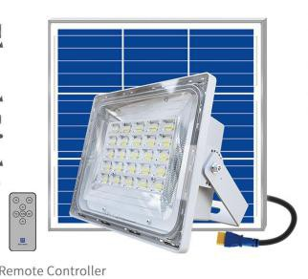
WaWa Light 4.0 | - Solar panel: 5V/50W, life time: 25years.  - LAMP: Imported LED,2200lm.  - Battery: 3.2V/45AH LiFePO4 battery, life time: 8-12 years.  - Lighting time: 6+x/Intelligent power control,and can use remote control to adjust brightness and working mode. | 2200lm | $44.00
WaWa Light 5.0 | - Solar panel: 5V/80W, life time: 25years.  - LAMP: Imported LED,3500lm  - Battery: 3.2V/60AH LiFePO4 battery, life time: 8-12 years.  - Lighting time: 6+x/Intelligent power control,and can use remote control to adjust brightness and working mode. | 3500lm | $67.00 | 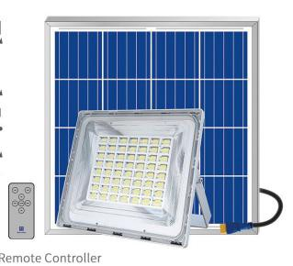
WaWa Light 6.0 | - Solar panel: 5V/120W, life time: 25years.  - LAMP: Imported LED, 5600lm  - Battery: 3.2V/80AH LiFePO4 battery, life time: 8-12 years.  - Lighting time: 6+x/Intelligent power control,and can use remote control to adjust brightness and working mode. | 5600lm | $77.00

Remark:
- The quotation is valid within 15days;
- The quotation date is 14th Oct, 2021;
- All prices are based on EXW;
- The Fob Shanghai price based on customer order quantity;
- 5 years warranty.

