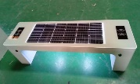
Quotation List
Commodity:Solar Bench Price validity: 30days
Model | Photos | Size | Terms: EXW | Unit price (10-  20 units) | Unit Price (More than 20 units) | Regular Configuration
GSSB200401 |  | L1600mm*H500mm*W470 mm | Foshan | 654.92 | 627.94 | Solar panel+battery USB socket *4pcs Wireless charge *2 pcs 4G router *1pcs Speaker *1pcs Bluetooth *1pcs  Led Light
GSSB200402 | 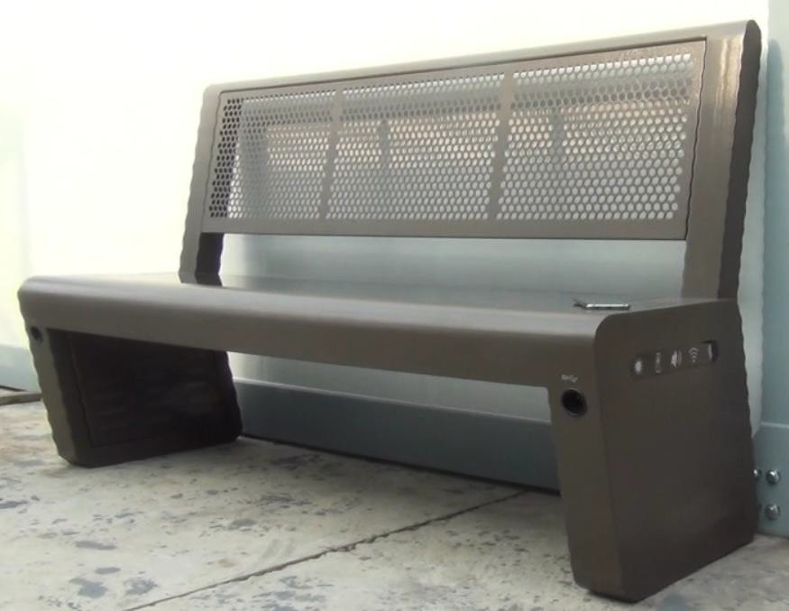 | L1700mm*H1005mm*W600 mm | Foshan | 810.48 | 796.19 | Solar panel+battery USB socket Wireless charge  4G router Speaker Bluetooth Led Light
GSGT191038-B | 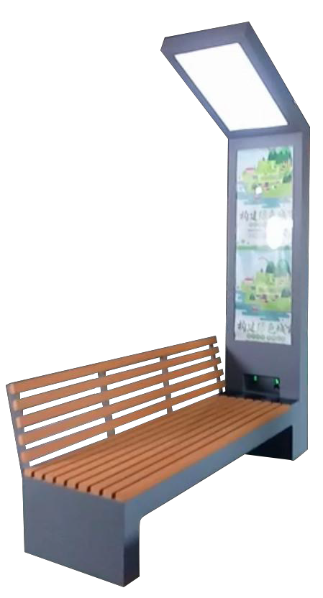 | L1750mm*H2400mm*W452 mm | Foshan | 889.05 | 872.86 | Solar panel+battery USB socket Wireless charge  4G router Speaker Bluetooth Led Light Led light box
GSGT191038-A  (with bracket) |  | L1750mm*H2400mm*W452 mm | Foshan | 907.30 | 890.63
GSSB200403-B | 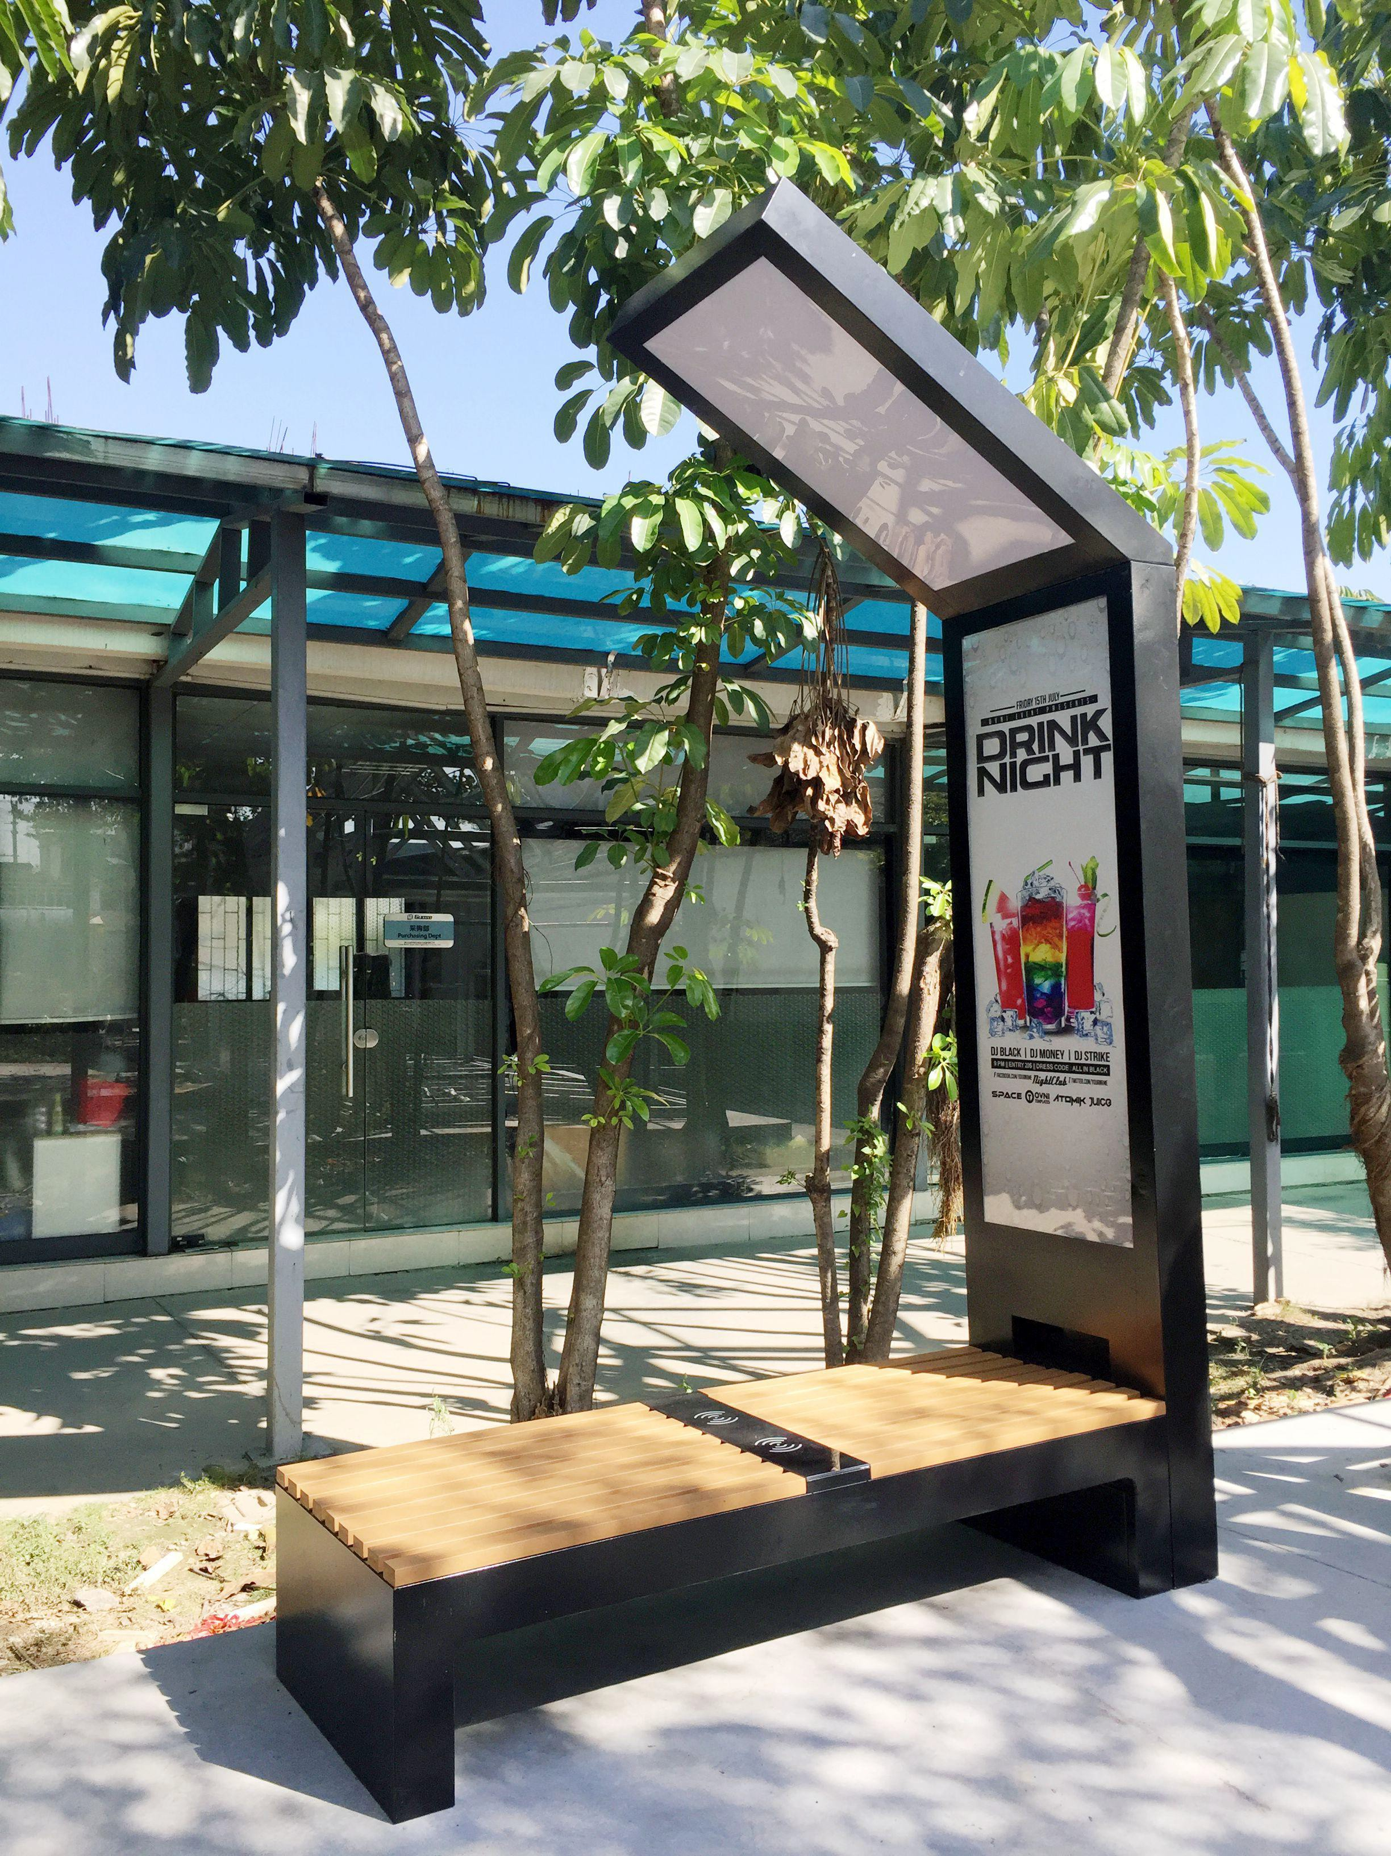 | L2030mm*H3095mm*W686 mm | Foshan | 1396.19 | 1362.86 | Solar panel+battery USB socket Wireless charge  4G router Speaker Bluetooth Led Light Led light box
GSSB200403-A  (with bracket) |  | L2030mm*H3095mm*W686 mm | Foshan | 1423.17 | 1397.78
GSGT202101-A | 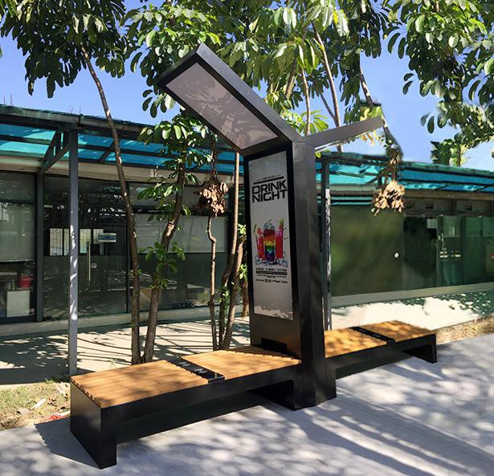 | L3500mm*H2400mm*W452 mm | Foshan | 1751.75 | 1727.94 | Solar panel+battery USB socket Wireless charge  4G router Speaker Bluetooth Led Light Led light box
GSGT202101-B |  | L4060mm*H3095mm*W686 mm | Foshan | 2621.59 | 2559.68
GSGT202102-B | 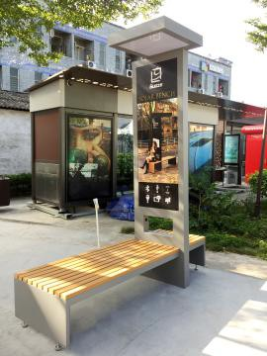 | L2030mm*H3095mm*W686 mm | Foshan | 1334.29 | 1300.95 | Solar panel+battery USB socket Wireless charge  4G router Speaker Bluetooth Led Light Led light box
GSGT202102-  A(with bracket) |  | L2030mm*H3095mm*W686 mm | Foshan | 1359.68 | 1326.35
Noties:The price is not including any transport charge, shipping freight and tax.
Remark | Arrived our bank total amount should same with the invoice amount, not including any transfer charge
Delivery Time: (need arrange production schedule) normally it is 5-10 days after confirm deposit received. Payment: T/T 50% as deposit ,50% balance before loading from our factory. 100%TT for sample.
US Dollar Exchange rate: 6.4

