Catalog
Helicopters

Mi-2 (after overhaul)

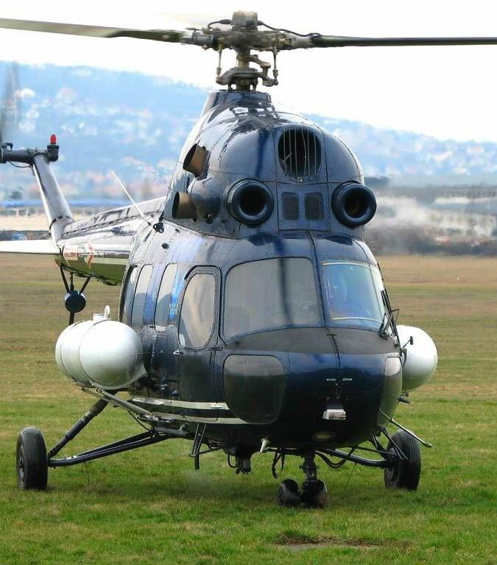General characteristics
- Crew : One
- Capaci ty: 8 passengers or 700 kg (1,543lb) internal, 800 kg (1,764 lb) external cargo
• Length: 11.40 m (37 ft 4¾ in)
- Rotor diameter: 14.50 m (47 ft 6⅞ in)
- Heig ht: 3.75 m (12 ft 3½ in)
• Disc area: 165.13 m² (1,777.44 ft²)
- Empty weight: 2,372 kg (5,218 lb)
- Loaded weight: 3,550 kg (7,826 lb)
- Max. take off weight : 3,700 kg (8,157 lb)
Powerplant : GTD- 350
Performance
- Maximum speed: 200 km/h (108 knots, 124 mph)
- Range: 440 km (237 nmi, 273 mi) (max
internatal fuel, no reserves)
- Service ceiling: 4,000 m (13,125 ft)
- Rate of climb: 4.5 m/s (885 ft/min)
- Disc loading: 22.41 kg/m² (4.59 lb/ft²)
Price: US$ 700’000.-

Mi-2(MSB-2) (After repair and of
modernization with new engines)

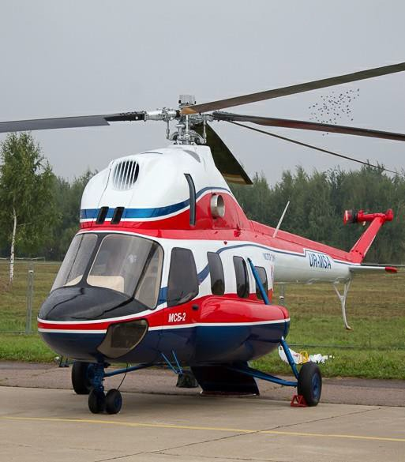General characteristics
- Crew : One
- Capacity ty: 8 passengers or 700 kg (1,543lb )
internal, 800 kg (1,764 lb) external cargo
• Length: 11.40 m (37 ft 4¾ in)
- Rotor diameter: 14.50 m (47 ft 6⅞ in)
- Height ht: 3.75 m (12 ft 3½ in)
• Disc area: 165.13 m² (1,777.44 ft²)
- Empty weight: 2,372 kg (5,218 lb)
- Loaded weight: 3,550 kg (7,826 lb)
- Max. takeoff weight: 3,700 kg (8,157 lb) Powerplant: ai-450m
Performance
- Maximum speed: 200 km/h (108 knots, 124 mph)
- Range: 750 km (237 nmi, 273 mi) (max
internatal fuel, no reserves)
- Service ceiling: 4,000 m (13,125 ft)
- Rate of climb: 4.5 m/s (885 ft/min)
- Disc loading: 22.41 kg/m² (4.59 lb/ft²)
Price: US$ 1’800’000.-

Mi-8T (after overhaul)

General characteristics
- 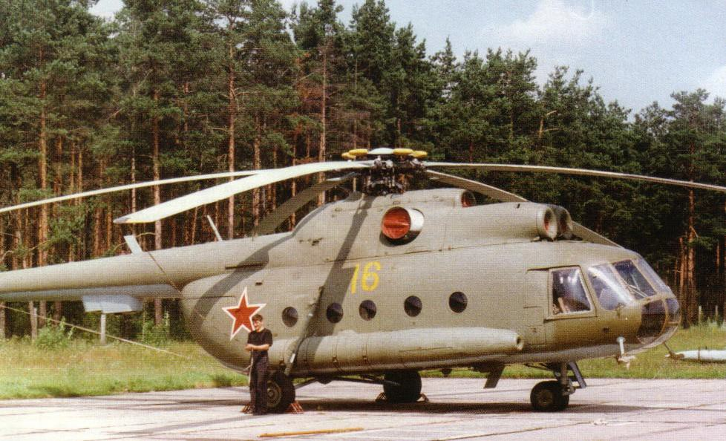Crew: 3 (pilot, copilot, flight engineer)
- Capacity:
- 24 passengers or
- 12 stretchers and seat for 1 medical attendant or
- 3,000 kg (6,600 lb) on internal/external hardpoints
- Length: 18.17 m (59 ft 7 in)
- Rotor diameter: 21.29 m (69 ft 10 in)
- Height: 5.65 m (18 ft 6 in)
• Disc area: 356 m² (3,832 ft²)
- Empty weigh : 7,260 kg (16,007 lb)
- Loaded weight: 11,100 kg (24,470 lb)
- Max. take off weight: 12,000 kg (26,455 lb)
- Powerplant: 2 × Klimov TV2 -117 turboshafts, 1,454
kW (1,950 shp) each
- Fuel ma x total capacity: 3,700 l (977 US gal) Performance
- Maximum speed: 260 km/ h (140 kt)
- Range: 450 km (280 mi)
- Ferry range: 960 km (596 mi)
- Service ceiling : 4,500 m (14,765 ft)
Price: US$ 2’200’000.-

Mi-8MTV -1(171) (after overhaul)

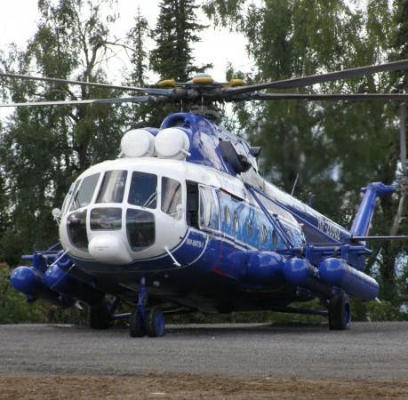General characteristics
- Crew: Three – two pilots and one engineer
- Capacity: 30 troops or 12 stretchers or 4,000 kg (8,820 lb) cargo internally /5,000 kg (11,023 lb) externally slung.
• Length: 18.465 m (60 ft 7 in)
- Rotor diameter: 21.25 m (69 ft 10½ in)
- Height: 4.76 m (15 ft 7¼ in)
• Disc area: 356 m² (3,834 ft²)
- Empty weight: 7,489 kg (16,510 lb)
- Loaded weight: 11,100 kg (24,470 lb)
- Max. takeoff weight: 13,000 kg (28,660 lb)
- Powerplant: 2 × Klimov TV3 -117VM turboshafts , 1,633 kW (2,190 shp) each
Performance
- Maximum speed: 250 km/h (135 knots, 155 mph)
- Range: 465 km (251 nmi , 289 mi) (standard fuel)
- Service ceiling: 6,000 m (19,690 ft)
- Rate of climb: 8 m/s [ c i t a t i on n e e d e d ] (1,575 ft/
min)
Price: US$ 6’250’000.-

Mi-8(MSB) (After repair and of
modernization with new engines)

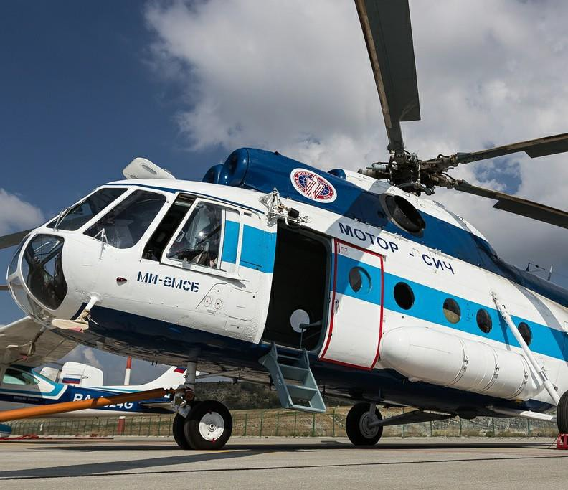General characteristics
- Crew: Three – two pilots and one engineer
- Capacity: 30 troops or 12 stretchers or 4,000 kg (8,820 lb) cargo internally /5,000 kg (11,023 lb) externally slung.
• Length: 18.465 m (60 ft 7 in)
- Rotor diameter: 21.25 m (69 ft 10½ in)
- Height: 4.76 m (15 ft 7¼ in)
• Disc area: 356 m² (3,834 ft²)
- Empty weight: 7,489 kg (16,510 lb)
- Loaded weight: 11,100 kg (24,470 lb)
- Max. takeoff weight: 12,500 kg (27,557 lb)
- Powerplant: 2 × Klimov TV3 -117VMA SBM1V 4E Performance
- Maximum speed: 260 km/h (140 knots, 161 mph)
- Range: 600 km (323nmi , 372 mi) (standard fuel)
- Service ceiling: 9,150 m (30,019 ft)
- Rate of climb: 8 m/s [ c i t a t i on n e e d e d ]
(1,575 ft/min)
Price: US$ 6’250’000.-

Mi-8AMT/Mi-171 (new)

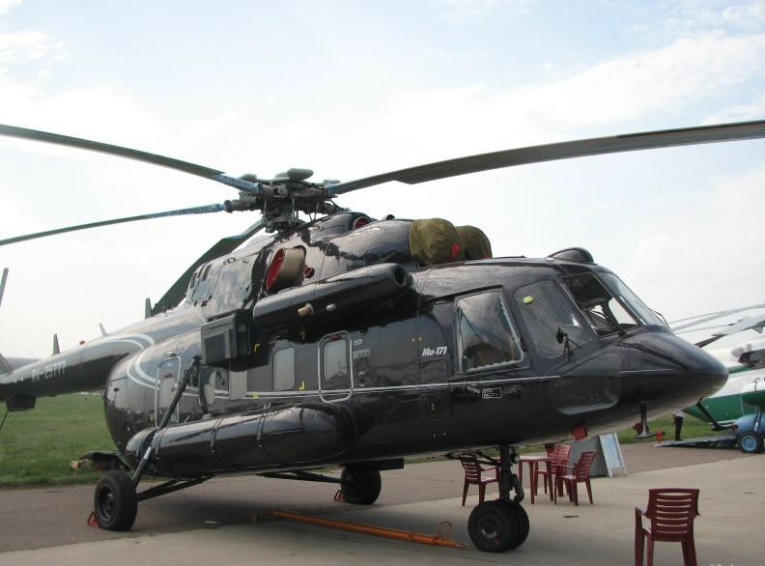General characteristics
  - Crew: Three – two pilots and one engineer
  - Capacity: 30 troops or 12 stretchers or 4,000 kg (8,820 lb) car go internally /5,000 kg (11,0 23 lb) externally slung.
• Length: 18.465 m (60 ft 7 in)
  - Rotor diameter: 1.25 m (69 ft 10½ in)
  - Height: 4.76 m (15 ft 7¼ in)
• Disc area: 356 m² (3,834 ft²)
  - Empty weight: 7,489 kg (16,510 lb)
  - Loaded weight: 11,100 kg (24,470 lb)
  - Max. take off weight: 13,0 00 kg (28,660 lb)
  - Powerplant: 2 × Klimov TV 3 -117VM turbo shafts , 1,633 kW (2,190 shp) each
Performance
  - Maximum speed: 250 km/ h (135 knots, 155 mph)
  - Range: 465 km (251 nmi , 289 mi) (standard fuel)
  - Service ceiling: 6,000 m (19,690 ft)
  - Rate of climb: 8 m/s [ citation needed ] (1,575 ft/min)
Price: US$ 13’500’000.-

Mi-14 amphibian(After repair and
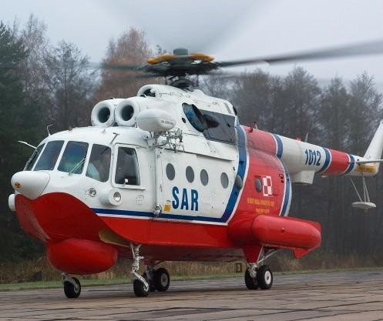modernization)
General characteristics
- Crew: 4
- Length: 18.38 m (60 ft 3 in)
- Rotor diameter: 21.29 m (69 ft 10 in)
- Height: 6.93 m (22 ft 9 in)
• Disc area: 356 m² (3,832 ft²)
- Empty weight: 11,750 kg (25,900 lb)
- Max. takeoff weight: 14,000 kg (30,865 lb)
- Powerplant: 2 × Klimov TV3 -117VM turboshafts,
1,454 kW (1,950 shp) each Performance
- Maximum speed: 230 km/h (124 kt)
- Ferry range: 1,135 km (705 mi)
- Service ceiling: 3,500 m (11,500 ft)
- Endurance with max fuel: 5 h, 56 min
Price: US$ 5’250’000.-

Mi-26T (after overhaul)

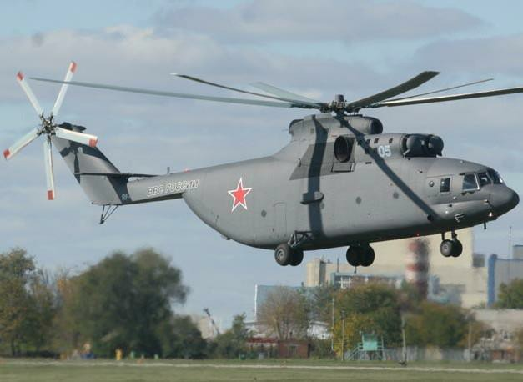General characteristics
- Crew: Five– 2 pilots, 1 navigator, 1 flight engineer, 1
flight technician
- Capacity:
- 90 troops or 60 stretchers
• 20,000 kg cargo (44,090 lb)
- Length: 40.025 m (131 ft 3¾ in) (rotors turning)
- Rotor diameter: 32.00 m (105 ft 0 in)
• Height: 8.145 m (26 ft 8¾ in)
• Disc area: 804.25 m2 (8,656.8 ft²)
- Empty weight : 28,200 kg (62,170 lb)
- Loaded weight: 49,600 kg (109,350 lb)
- Max. takeoff weight ht: 56,000 kg (123,450 lb)
- Powerplant: 2 × Lotarev D-136 turboshafts , 8,500 kW (11,399 shp) each
Performance
- Maximum speed: 295 km/h (159 kt, 183mph)
- Cruise speed: 255 km/h (137 kt, 158 mph)
• Range: 1,920 km (1,036nmi , 1,190 mi) (with
auxiliary tanks)
- Service ceiling: 4,600 m (15,100 ft)
Price: US$ 15’500’000.-

Ka-32A11BC (new)

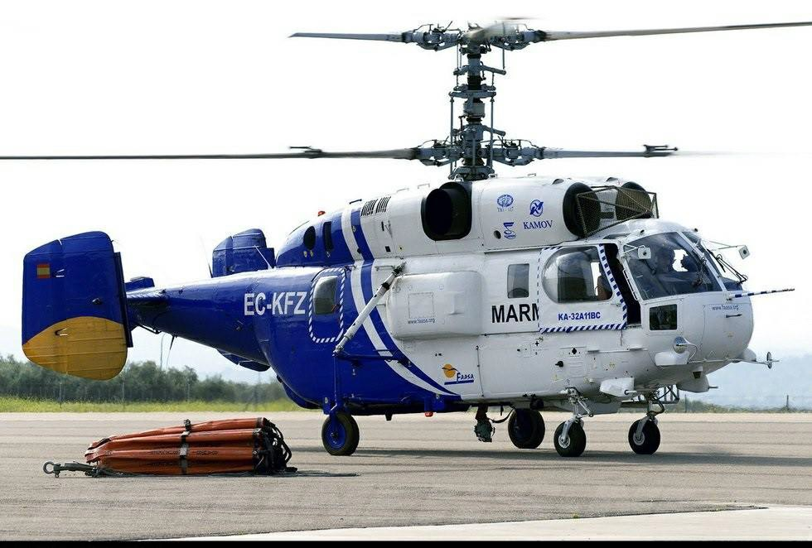Purpose:
•Transport helicopter
•The• helicopter has a Canadian type certificate
•Dimensions
•Main rotor diameter: 15.9 m
•Length from the rotation. Screws: 15.9 m
•Height from the rotation. Screws: 5.45 m
•Weight:
•Empty: ≈6800 kg
•Max. Take-off 11000 (12700 - with external load)kg
•Engine: 2 TV3-117 VMA
•Power: 2 x 2200 liters. from.
•Characteristics:
•Crew: 1-3 people.
•Passengers: up to 13 people.
•Cruising speed: 180-220 km / h
•Max. Speed: 260 km / h
•Range: 800 km
•Practical ceiling: 5000 m
•
•Lifting speed: 900 m / min
Price: US$ 12’500’000.-

