12/03/2022
22001
within 15 to 25 days

QUOTE

Date: Order #: Valid Time
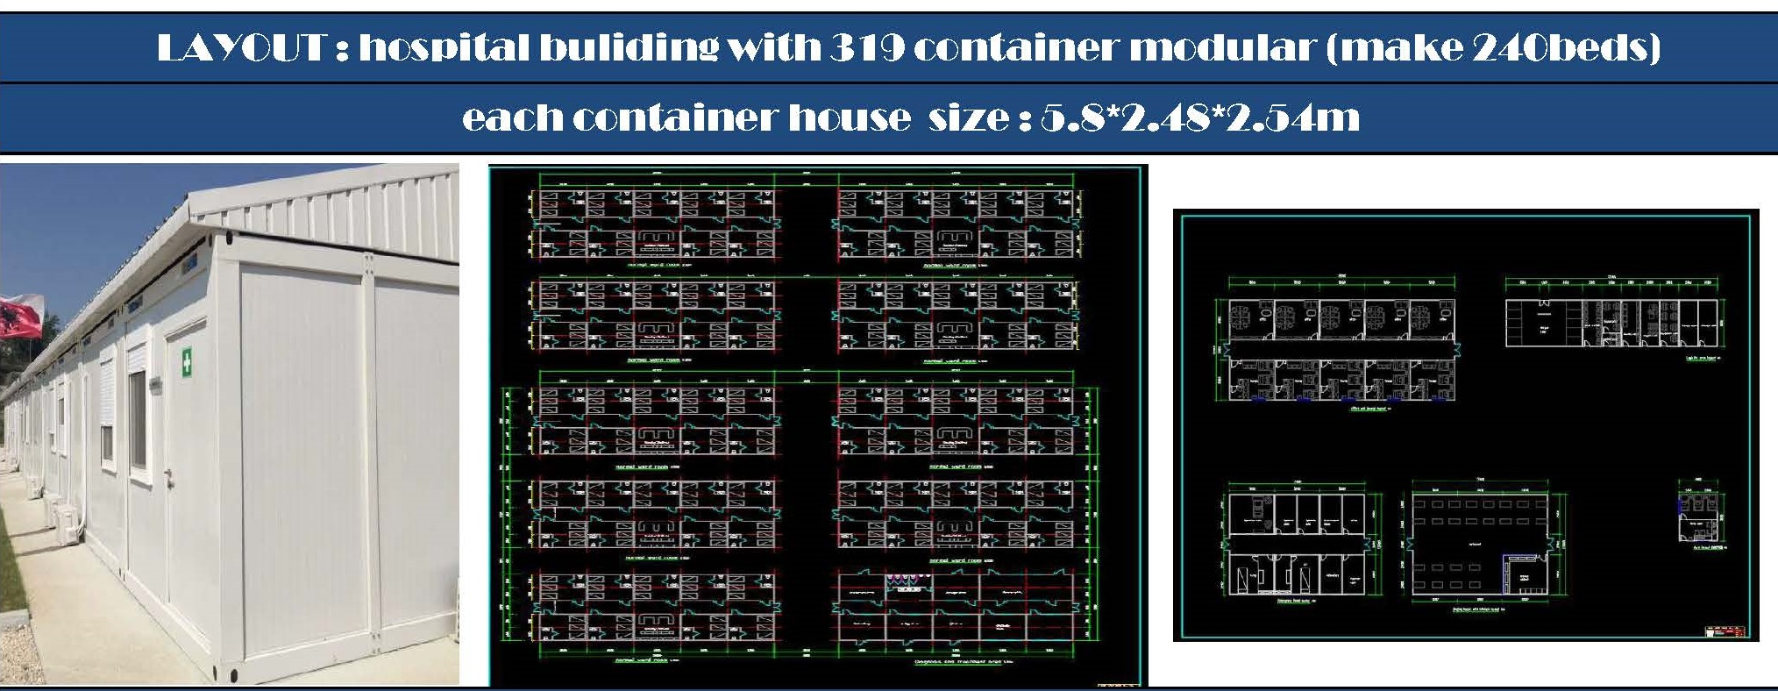
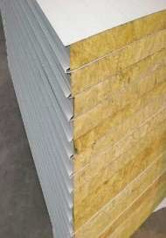
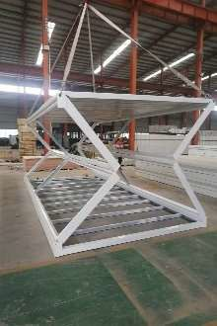
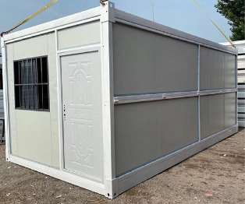
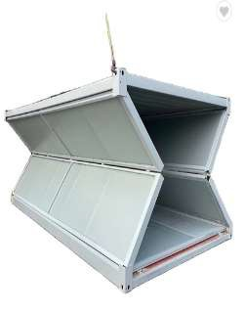
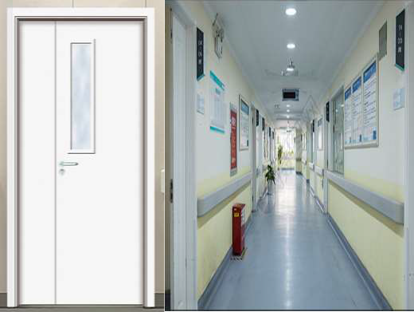
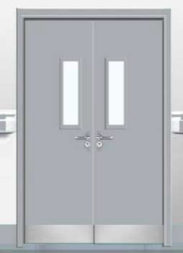
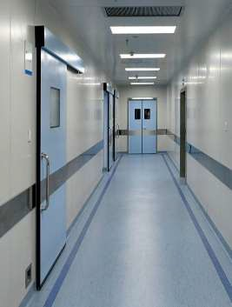
S/N | Material | Dimension | Specification | Quantity | Unit
1 | Integral folding room frame |  | glavanized steel & square tube welded & cement board floor 15mm &steel column & steel frame with glass wool roof and 50mm thickness rock wool sandwich panel wall 2480mm*5800mmx2540mm | 4588.5 | m2
2 | wall panel
3 | wood door for ward room |  | wood door 1200*2000mm | 110 | pcs
4 | metal double door for access |  | 1800x2000mm | 28 | pcs

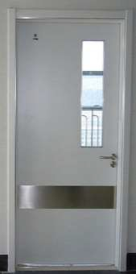
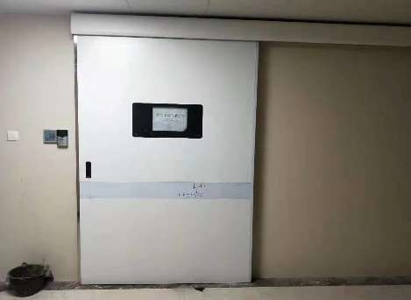
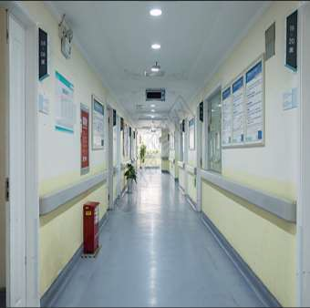
5 | wood single door |  | wood door 900x2000mm | 107 | pcs
6 | Sensor door Operating and ICU |  | metal with Auto-sensor 1800x2000mm | 15 | pcs
7 | PVC window for duty and house | 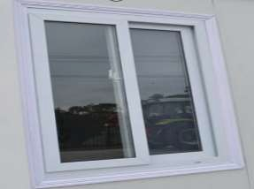 | PVC frame 930x925mm | 34 | pcs
8 | Iodine resistant rubber floor | 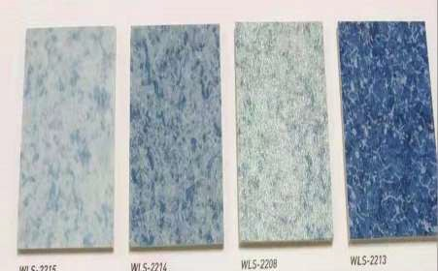 | 2mm thickness | 6882.7 | m2
9 | PVC ceiling | 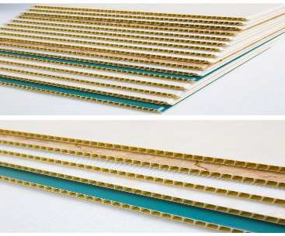 | for Access ceiling | 775.5 | m2

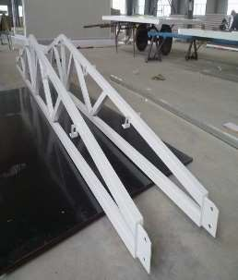
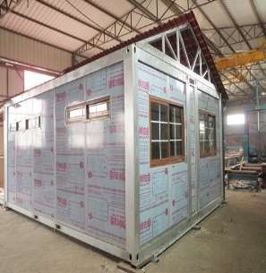

g
10 | truss and steel sheet of extra roof for each area |  | galvanized steel truss with galvanized steel sheet for extra roof |  | 5940.44 | m2
11 | accessories part and hard fitting |  |  |  | 319 | set
12 | FOB cost |  |  |  | 37 | set
Total 1set building FOB Xingang China |  |  | FOB USD |  | 991,476
Option quotation
S/N | Material | Dimension | Specification | Quantity | Unit | price USD
1 | Hospital Auxiliary Supplies and Equipment | see attachment |  |  |  | 1,727,846
 | TOTAL 1 set hospital price |  | FOB USD | 2,719,322
 | sea freight Xingang China to |  | USD |  | 55 x 40 HQ
 | insurance |  | USD
one hospital building is 319 units foldable container houses support 240beds |  |  | CIF USD
Terms and conditions
1.price terms: FOB

2. order quantity: 319 units container house with all equipment will fit in 55 x 40HQ.
3.payment terms: Total by TT ,50% IN ADVANCE , BALANCE PAYMENT BEFORE SHIPPING
4.delivery term: within 15-25days

