12/03/2022
22001
within 15days

Date: Order #: Valid Time:

Hospital Auxiliary Supplies and Equipment
S/N | Material | Dimension | Specification | Quantity
1 | Bedside tables | 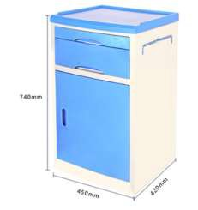 | L*W*H 480*480*760mm | 240
2 | locker | 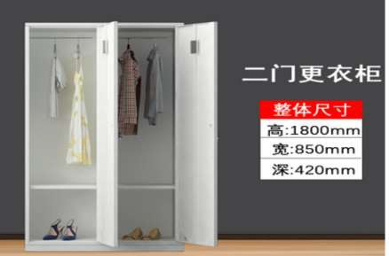 |  | 150

3 | Medical staff rest beds | 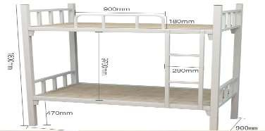  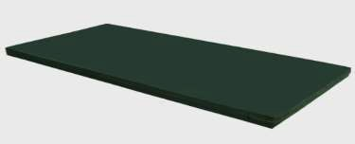 |  | 20
4 | hot water tank | 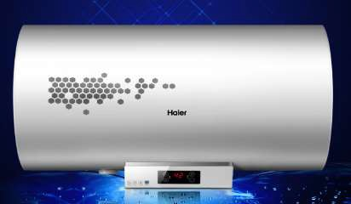 | 80L | 101
5 | water tank | 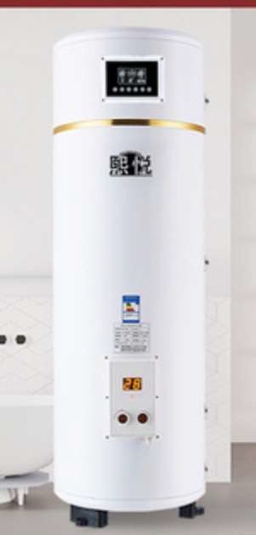 | 1000L | 2
6 | Complete bathroom | 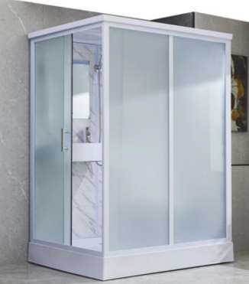 | 1.4x1.1m | 96

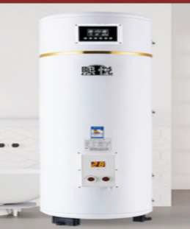
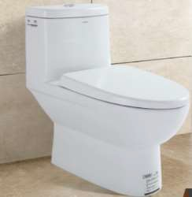
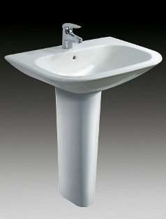
7 | Stainless steel washbasin for ICU operating room | 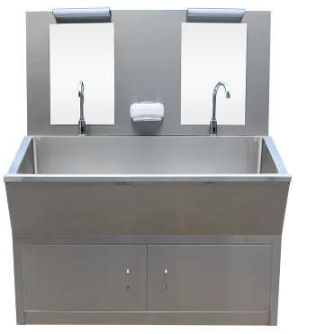 | 1.5x0.6x1.8m | 8
8 | Dunnage sink | 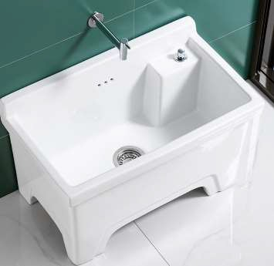 |  | 13
9 | toilet |  |  | 5
10 | basin |  |  | 3

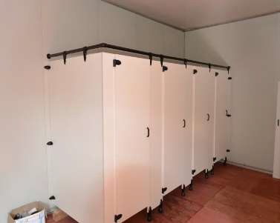
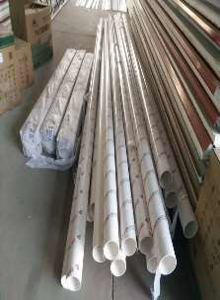
11 | partition for bathroom |  |  | 5
12 | air-conditioner | 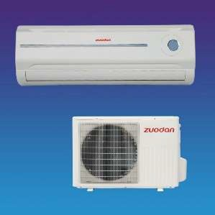 | 1.5bt | 136
13 | Dry powder fire extinguishers | 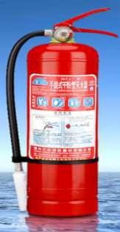 | 4KGS | 120
14 | CO2 fire extinguishers | 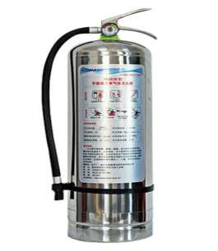 | 4kgs | 18

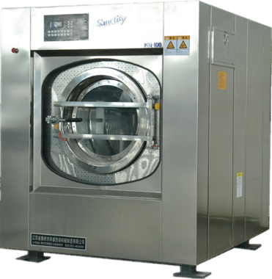
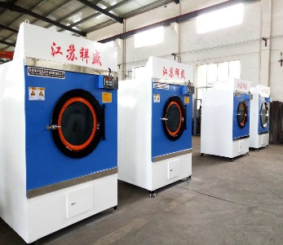
15 | Firefighting cabinet | 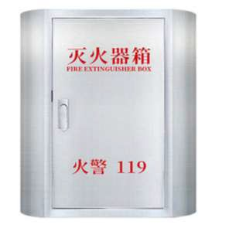 |  | 30
16 | screening | 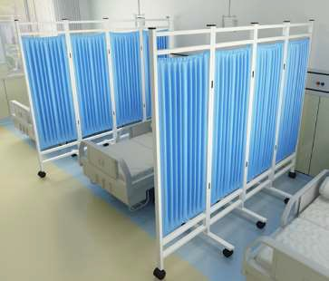 | l*h 2000x1800mm | 120
17 | Medical washing machines |  | 1750*1650*1830mm/50kgs | 2
18 | dryer |  | 1500*1700*2400mm | 2

19 | dining table with chair | 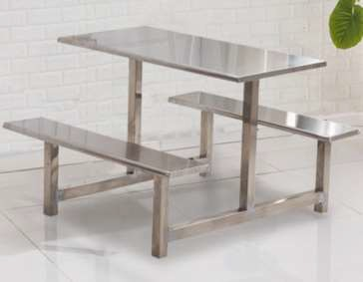 | one table with 4chairs size 1450*1200mm | 35
20 | kitchen basin | 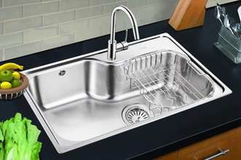 |  | 3
21 | kitchen cabinet | 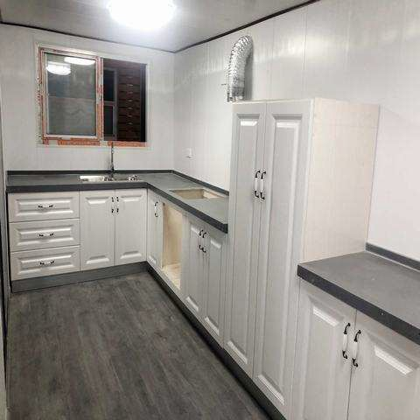 | 5x0.5x0.85m | 2
22 | Gas cooker | 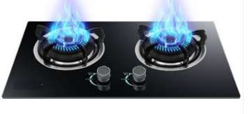 |  | 3

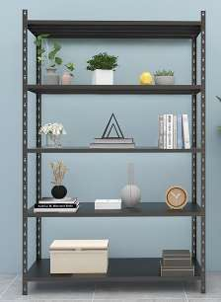
23 | Electric oven | 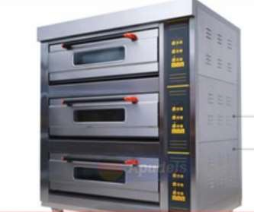 |  | 2
24 | Pharmacy shelves |  | 10m+20m | 30
25 | shelves |  | 30m | 30
26 | shelves |  | 10m | 10

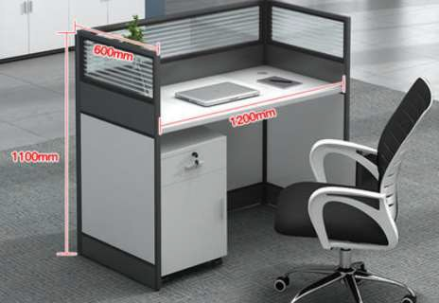
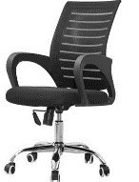
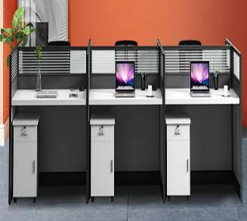
27 | File cabinet | 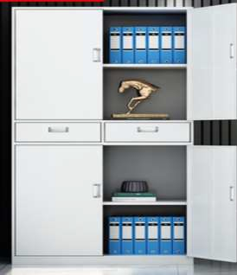 | 800x390x1800mm | 10
28 | Doctor's desk and chair |  |  | 30
29 | Ward chair | 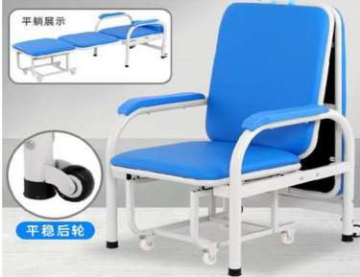 |  | 130
30 | Nursing station tables and chairs |  | 3 table joint for 1unit | 5

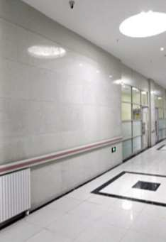
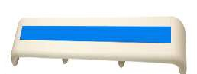
31 | Pagers | 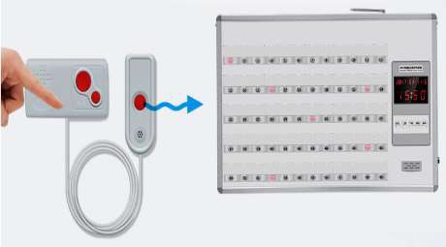
32 | Electrical Distribution Boxes | 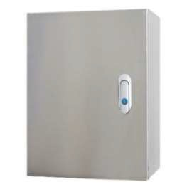 | 360m2
33 | Bed Equipment Strap | 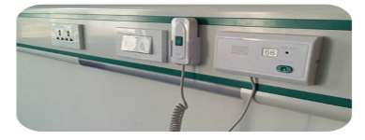  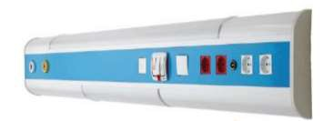 | 200x55x1.5mm -6m long | 240
34 | Access handrails |  | 1.4length | 696

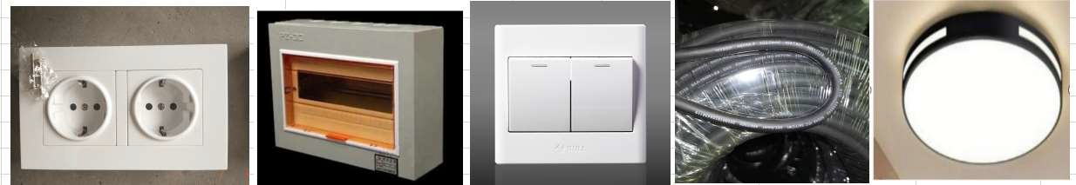
35 | socket and switch and wrie |  | each area 360m2 | 11
36 | Fire emergency light | 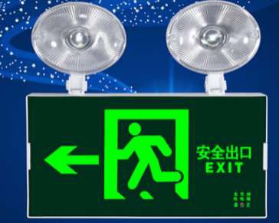 |  | 60
37 | Rechargeable emergency light | 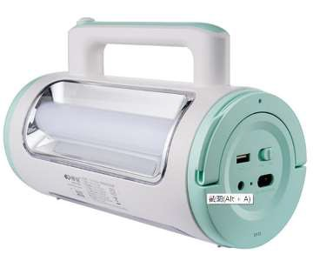 |  | 30
Medical equipment
1 | normal beds With dining table | 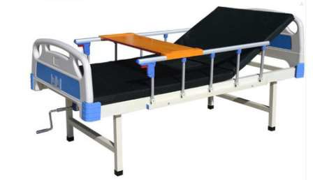 L*W*H 2000*900X500mm |  | 240

2 | Surgical bed | 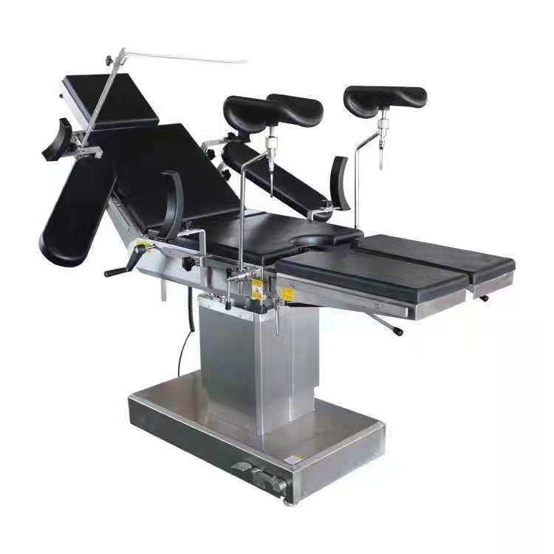 | 2010x500mm | 1
3 | Ultraviolet lightisinfection Cabinet | 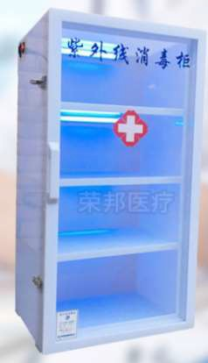 | 200L | 23
4 | Disinfection Cabinet | 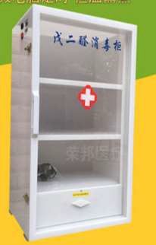 | 200L | 23
5 | Infusion stand | 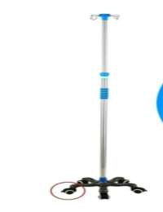 |  | 150

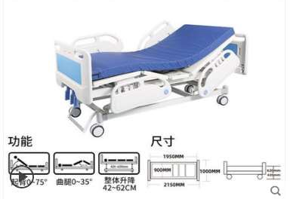
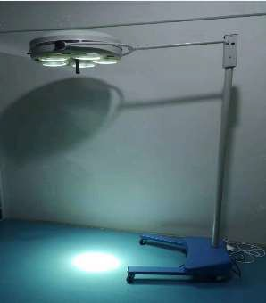
6 | ICU bed |  |  | 2
7 | Surgical lights |  | LED 5light | 25
8 | Doppler ultrasonography | 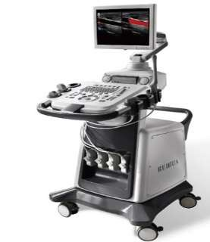 |  | 10
9 | General Ward Monitor | 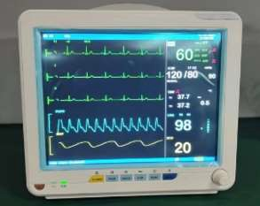 |  | 100

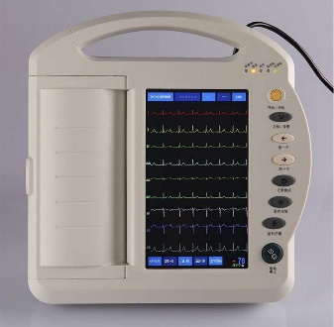
10 | ICU Monitors | 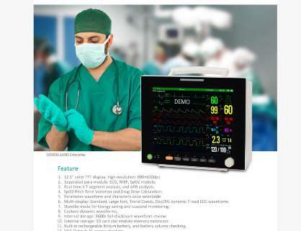 |  | 2
11 | 12 ICU 12-channel ECG machine |  |  | 100
12 | 3 | 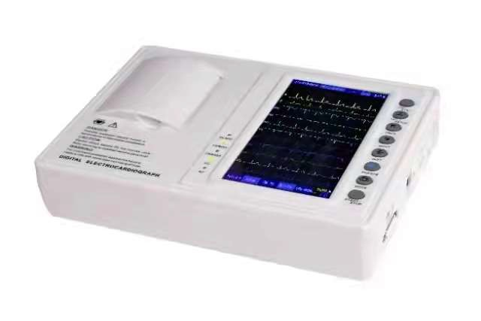 |  | 100
13 | Vertical towers | 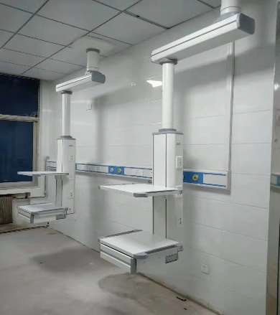 |  | 2

14 | Body freezers | 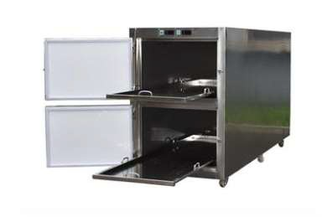 | 2480*810*1280mm | 5
15 | refrigerator | 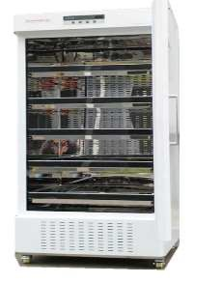 | 90*75*186mm 300 | 12
16 | 3 doors large capacity hospital medical blood bank refrigerator | 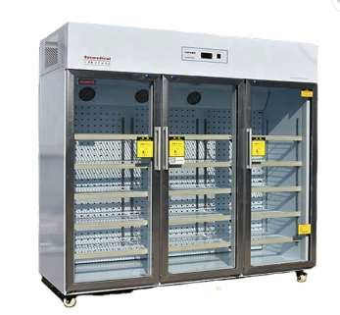 | 180X75X1860mm 1380升 | 2
17 | ventilator | 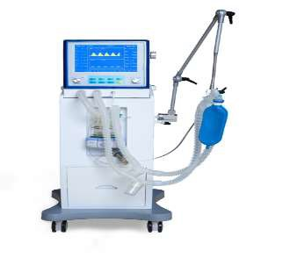 |  | 20

18 |  | 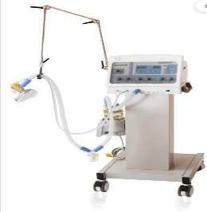 |  | 10
19 | Anaesthesia machines | 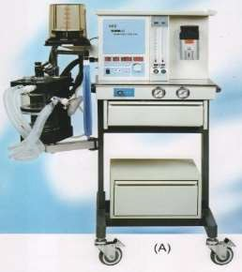 |  | 5
20 | Stretcher carriage | 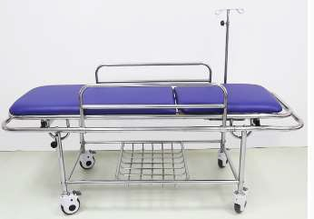 |  | 10
21 | Wheelchair | 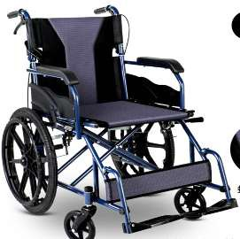 |  | 30
22 | Foot-operated aspirator | 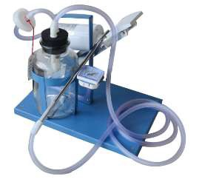 |  | 18

23 | Respirator | 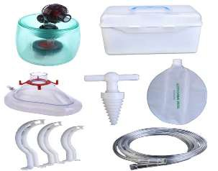 |  | 120

