Europe Supplier
- The PSGT Helmet @ Euro 295.00 each delivered by truck to Poland
- The Plates Level IV Standalone @ Euro 240.00 delivered by truck to Poland3 The Plate carrier @ Euro 234.00 delivered by Truck to Poland.
We can deliver 5000 of each, every 10 days, Absolute Top Quality manufacturer.

ANNEX A European Helmet

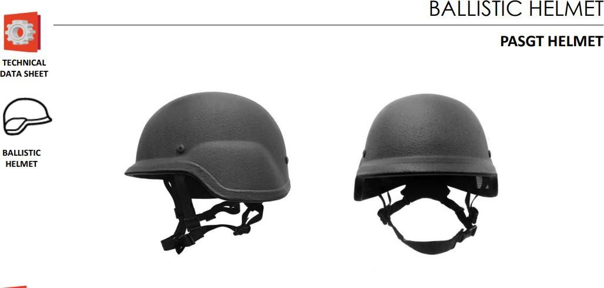

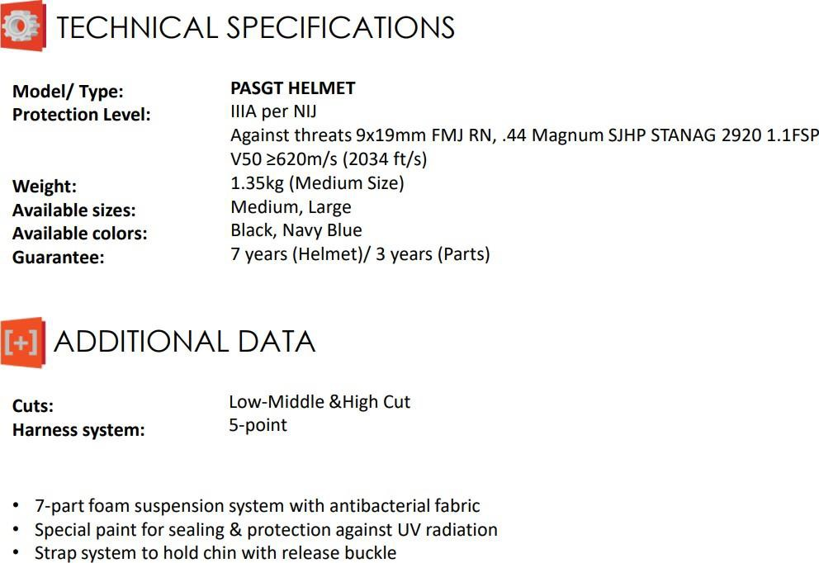

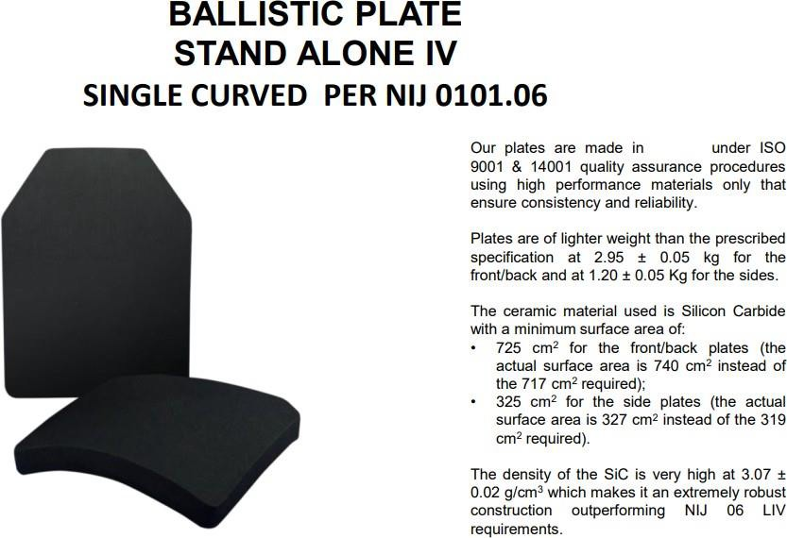
ANNEX B European Plate and Carrier

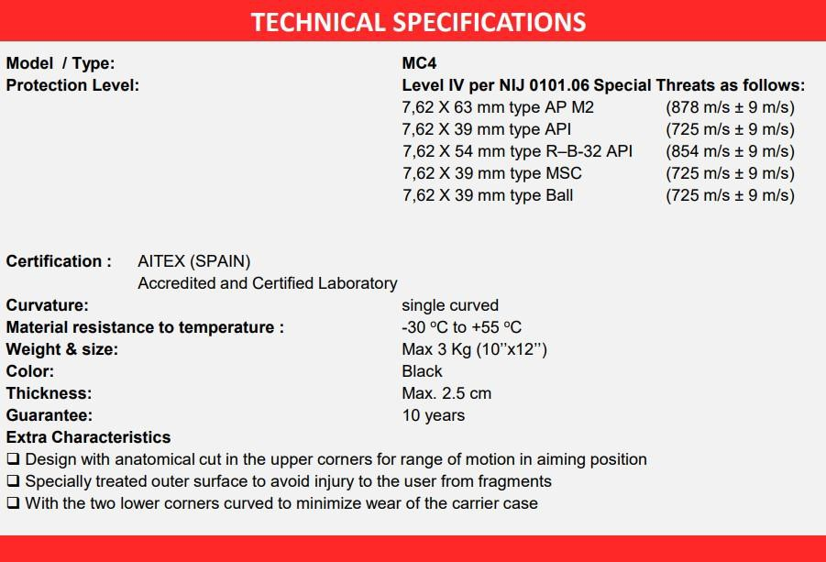
Plate Carrier

