QUOTATION
Product Picture | MODEL | Commodities and Specification | Quantity |  | Unit Price USD (FOB  Guangzhou)
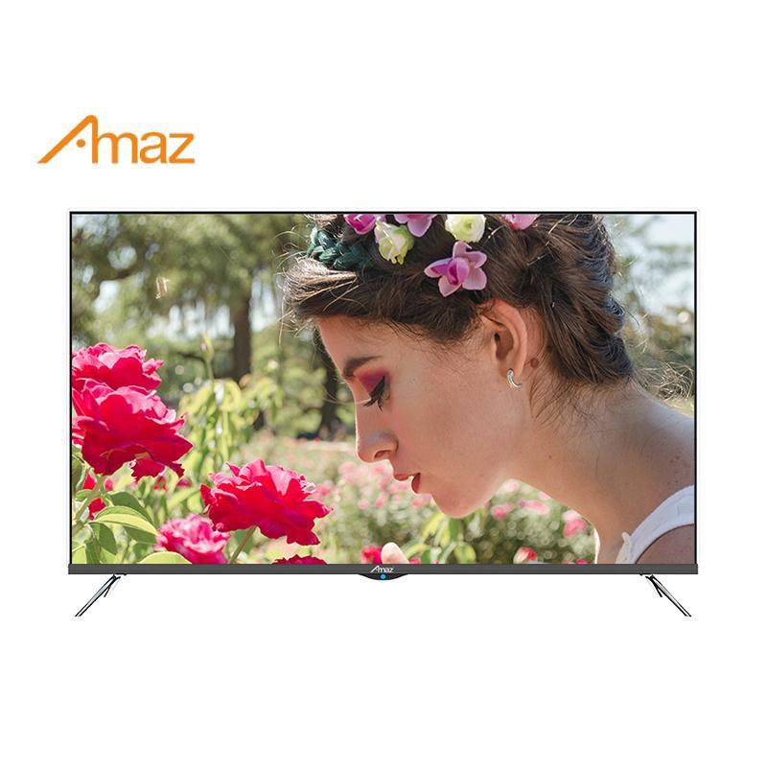 | AL912- 65 | Size: 65inch  Specification: OLED Smart function, HDMI, USB, AV  Carton: brown kraft carton | 500.00 | SET | $397.50
 |  |  | 500.00 | MOQ
REMARK
- Payment term: T/T 50% as deposit, balance should be paid before delivery(Less than we do EXW price);
- MOQ: 1*40'' HQ container,can mix 2 models, Price is based on full container;
- Delivery time: 45 days after received the deposit;
- Warranty: 1 year warranty from factory;
- Valid date of quotation : Within 7 days;
- Trade term: FOB Guangzhou/Shenzhen;
- Sample cost and delivery time:Sample fee will be 3times as order price, not including delivery fee; and sample delivery about 10-15days after full payment; the extra cost will be deducted from order
- If need to ship in batches, the goods will be shipped according to EXW.

