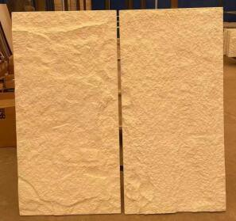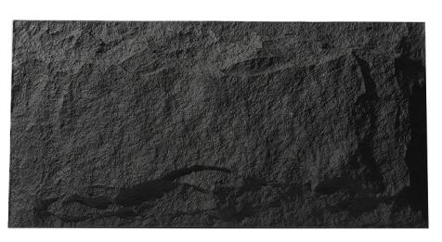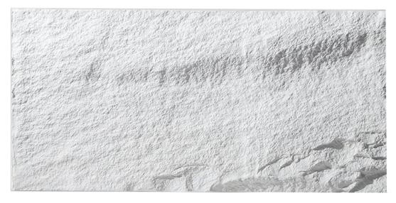
Quotation of PU Cultural Stone
 |  |  |  |  |  | Date: |  | Apr. 28,2022
Item | Product Name | Model | Pictures | Unit Price (USD/PC) | Specification(mm) |  |  | Packing Size |  |  |  | PCS/20'GP
 |  |  |  |  | Length | Width | Thickness | Carton Size | PC/ CTN | M² / CTN | KG / CTN
PU Stone | Mushroom Sonte | VJ-PUM08 |  | $30.00 | 1200 | 600 | 30-80 | 1240*630*500 | 5 | 3.6 | 18 | 260
 | Stone Veneer | VJ-PUS01 |  | $28.00 | 1200 | 600 | 20-40 | 1240*630*500 | 10 | 7.2 | 18 | 520
 | Stone Veneer | New Item |  | $26.00 | 1200 | 600 | 20-30 | 1240*630*500 | 15 | 10.8 | 27 | 900
 | Cultural Stone | VJ-PUW01 |  | $25.00 | 1175 | 300 | 10-30 | 1220*340*290 | 8 | 2.88 | 12 | 1757
Order Conditions |  |  |  | Remarks |  |  |  | Packing
1.MOQ: 100pcs per item |  |  |  | 1.The quotation on the basis of USD to RMB exchange rate:1:6.3 |  |  |  | Standard exporting packing (packed by quality carton and no-need-fumigating- wooden case)  Price: Negotiation /20'GP Notes: Above packing details is for your reference only, subject to our final packing list.
2.Lead Time: 10 to 14 working days after receiving prepayment. |  |  |  | 2.Period of Validity: before May. 30th, 2022 |  |  |  | 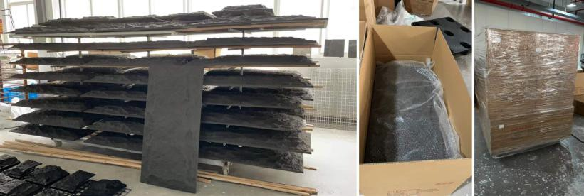
3.Price Terms: FOB China |  |  |  | 3.The quotation is base on free packing
4.Payment Terms: 100% TT in advance

