PHOTO | MODEL | BRIEF DISCRIPTION | UNIT PRICE FOB NINGBO(40HQ) | OPTIONS
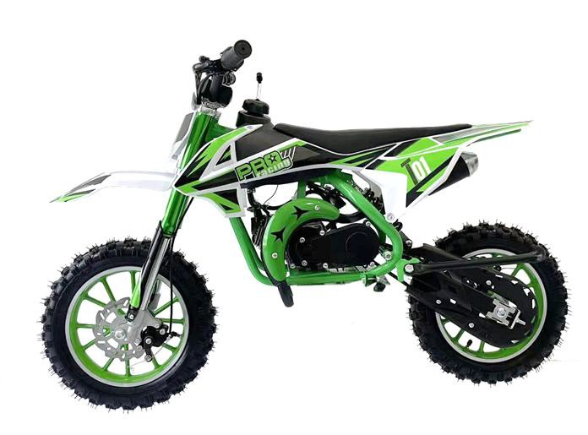 | MX10 | 49cc, 1 cylinder-2 stroke, air cooled Manual pull start only  Chain drive, full auto clutch Front 2.50-10, rear 2.50-10 Front and rear disc brake Parking Size:1110x300x560mm G.W/N.W: 27/25KGS  Loading(20GP/40HQ): 138/ 366PCS | $160
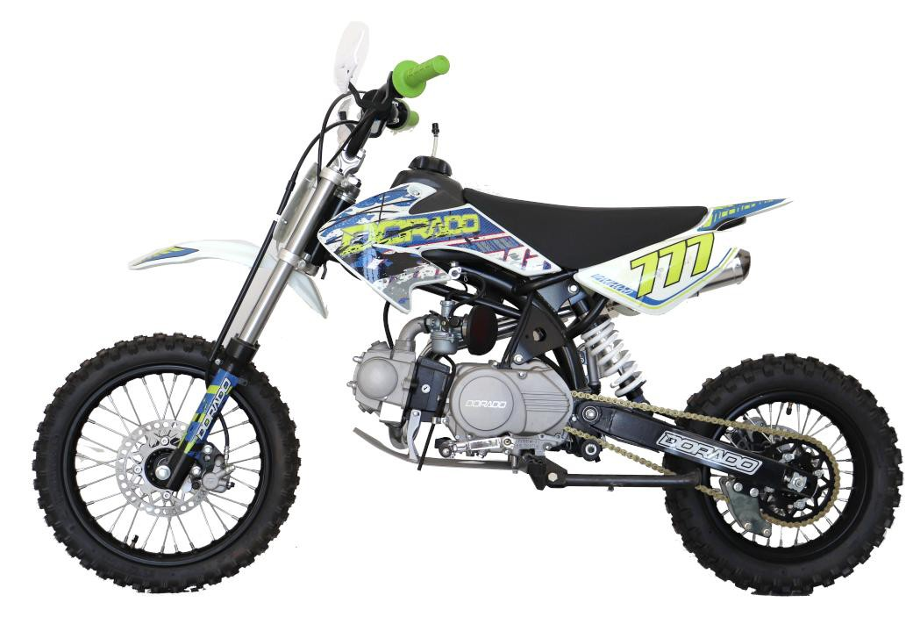 | MX12 (CRF50) | 125cc Zongshen engine,air cooled, manual clutch  ,kick starter  Steel rims and hubs Brake(F/R):Hydraulic disc brakes Wheel:Front 14'' rear 12'' G.W./N.W.: 72/57kgs Loading(40HQ): 114 PCS | $395
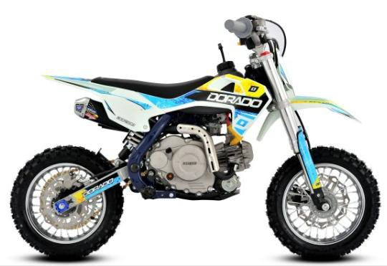 | DK60 | Engine: Zongshen Engine 60cc,Automatic Wheel: 10/10,  twin beans cast steel frame Electric stater,lithium battery Brakes(F/R): disc brake Upsitde down front fork Clearance: 210 mm  Seat height: 585 mm Wheel base:850 mm G.W./N.W. 54/44.5 kgs  Producion size: 1235x640x790mm Packing size:1110x380x525mm Loading(20GP/40HQ): 130/310 PCS | $475
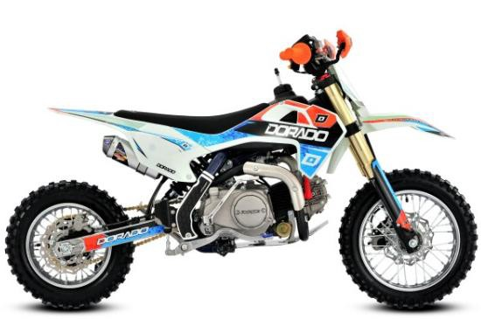 | DK90 | Engine: 90cc, Zongshen engine,Semi-Automatic clutch 1-2-3-4, , kick start,  Wheel:12/10,  twin beans cast steel frame Brakes(F/R): disc brake Upsitde down front fork Clearance: 280mm  Seat height: 600mm Wheel base:1090mm  Producion size: 1570x640x730mm G.W./N.W.: 74 /64kgs Loading(20GP/40HQ): 72/196 PCS | $486 | Electric starter: +23.5

 | DK110 | Engine: 110cc, zongshen brand, Semi-Automatic clutch 1-2-3-4, kick start,  Wheel:12/10,  twin beans cast steel frame Brakes(F/R): disc brake Upsitde down front fork Clearance: 280mm  Seat height: 600mm Wheel base:1090mm  Producion size: 1570x640x730mm G.W./N.W.: 74 /64kgs Loading(20GP/40HQ): 72/196 PCS | $486 | Electric starter: +23.5
 | DK125 | Engine: 125cc, zongshen brand, manual clutch 1- 2-3-4,kick starter  Wheel:14/12,  twin beans cast steel frame Carburetor: NIBBI  Chain: KMC Brakes(F/R): disc brake  Front shock absorber: SX660 Upsitde down front fork Clearance: 280mm  Seat height: 700mm Wheel base:1090mm  Producion size: 1570x640x950mm G.W./N.W.: 75 /65 KGS Loading(20GP/40HQ): 72/196 PCS | $499 | Electric starter: +29
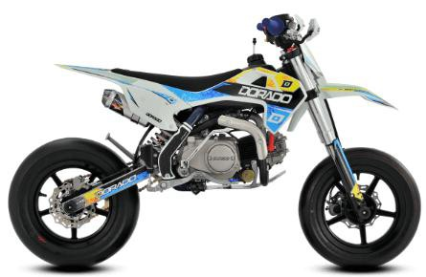 | DK125 MOTARD | Engine: 125cc, zongshen brand, manual clutch 1- 2-3-4,kick starter  Wheel:10/10 Motard  twin beans cast steel frame Carburetor: NIBBI  Chain: KMC Brakes(F/R): disc brake  Front shock absorber: SX660 Upsitde down front fork Clearance: 200mm  Seat height: 600mm Wheel base:1090mm  Producion size: 1570x540x950mm G.W./N.W.: 75 /65 KGS Loading(20GP/40HQ): 72/196 PCS | $544
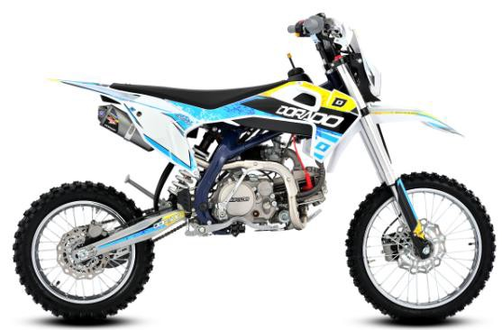 | DT125 | Engine: 125cc, zongshen brand, manual clutch 1- 2-3-4,kick starter  Wheel:17/14,  twin beans cast steel frame Carburetor:NIBBI  Chain: KMC  Front shock absorber: SX780, Upsitde down front fork Brakes(F/R): disc brake Clearance: 320mm  Seat height: 845mm Wheel base:1265mm  Producion size: 1810x760x1150mm G.W./N.W.: 83 /73 KGS Loading(20GP/40HQ): 72/196 PCS | $592 | 19/16 TYRE:+$8  Electric starter: +$29 14/12 TYRE: -$5  kunfu carburetor: -$8

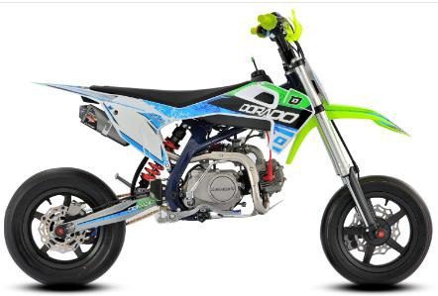 | DT125 MOTARD | Engine: 125cc, zongshen brand, manual clutch 1- 2-3-4,kick starter  Wheel: KENDA 12/12 motard twin beans cast steel frame Carburetor:NIBBI  Chain: KMC  Front shock absorber: SX780, Upsitde down front fork Brakes(F/R): disc brake Clearance: 250mm  Seat height: 715mm Wheel base:1265mm  Producion size: 1810x660x1150mm G.W./N.W.: 83 /73 KGS Loading(20GP/40HQ): 72/196 PCS | $650
 | DT140 | Engine: 140cc, zongshen brand, oil cooled ,manual clutch 1-2-3-4,kick starter  Wheel:17/14,  twin beans cast steel frame Carburetor:NIBBI PE24 Chain: KMC  Front shock absorber: SX780, Upsitde down front fork Brakes(F/R): disc brake Clearance: 320mm  Seat height: 845mm Wheel base:1265mm  Producion size: 1810x760x1150mm G.W./N.W.: 84 /74 KGS Loading(20GP/40HQ): 72/196 PCS | $658 | 19/16 TYRE:+$8
 | DT160 | Engine: 160cc, zongshen brand, oil cooled ,manual clutch 1-2-3-4,kick starter  Wheel:17/14  twin beans cast steel frame Carburetor:NIBBI PE28 Chain: KMC  Front shock absorber: SX780, Upsitde down front fork Brakes(F/R): disc brake Clearance: 320mm  Seat height: 845mm Wheel base:1265mm  Producion size: 1810x760x1150mm G.W./N.W.: 86 /76 KGS Loading(20GP/40HQ): 72/196 PCS | $752 | 19/16 TYRE:+$8
 | DT190 | Engine: W190, zongshen brand 190cc, oil cooled  ,manual clutch 1-2-3-4,kick starter &electric starter Wheel:17/14,twin beans cast steel frame Carburetor:NIBBI PE28  Chain: KMC  Front shock absorber: SX780, Upsitde down front fork Brakes(F/R): disc brake Clearance: 320mm  Seat height: 845mm Wheel base:1265mm  Producion size: 1810x760x1150mm G.W./N.W.: 91 /81 KGS Loading(20GP/40HQ): 72/196 PCS | $859 | 19/16 TYRE:+ $8

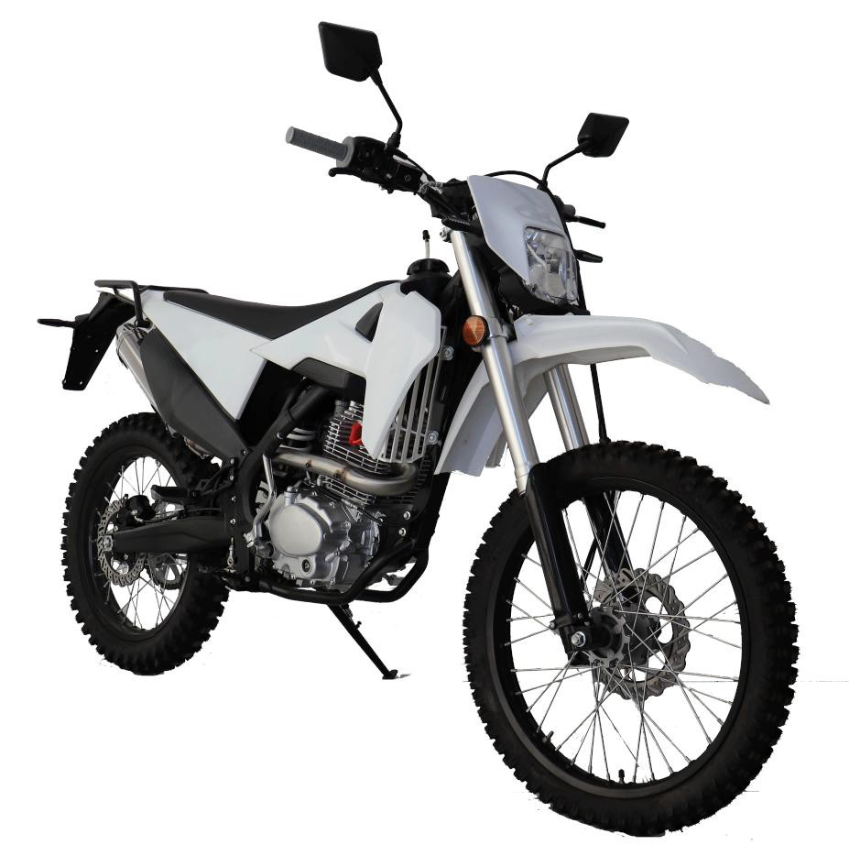 | DA250 | Engine: CB250cc, zongshen brand, air cooled  ,manual clutch 1-0-2-3-4-5,kick starter &electric starter  Wheel:18/21,  Fuel tank: 7.8L  twin beans cast steel frame Carburetor:NIBBI PE28 Chain: KMC  Front shock absorber: Upsitde down front fork Brakes(F/R): disc brake Clearance: 285 mm Seat height: 905 mm Wheel base: 1450 mm  Producion size: 2110x830x1185 mm G.W./N.W.: 127 / 112 KGS  Loading( 40HQ): 96 PCS | $930 | Racing model: $785 CB250-F +$35
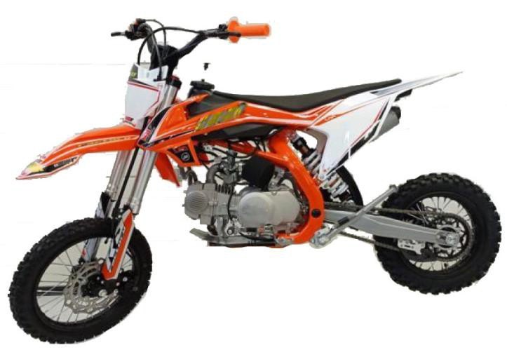 | MR21 (KTM65) | Engine: 125cc, zongshen brand, manual clutch 1- 2-3-4,kick starter  Wheel:14/12 Chain: KMC  Front shock absorber: SX780, Upsitde down front fork Brakes(F/R): disc brake Clearance: 320mm  Seat height: 835mm Wheel base:1260mm  Producion size: 1500x630x780mm G.W./N.W.: 90 /80 KGS Loading(40HQ): 172 PCS | $570 | TYRE: 17/14 +$5 TYRE: 19/16 +$13  NIBBI Carburetor: +8  Electric starter: +29
 | MR22 (KTM65) | Engine: 140cc, zongshen brand, oil cooled ,manual clutch 1-2-3-4,kick starter  Wheel:17/14 Carburetor:NIBBI PE24 Chain: KMC  Front shock absorber: SX780, Upsitde down front fork Brakes(F/R): disc brake Clearance: 320mm  Seat height: 835mm Wheel base:1260mm  Producion size: 1500x630x780mm G.W./N.W.: 91 /81 KGS Loading(40HQ): 172 PCS | $642 | TYRE: 19/16 +$8
 | MR23 (KTM65) | Engine: 160cc, zongshen brand, oil cooled ,manual clutch1-2-3-4,kick starter  Wheel:17/14 Carburetor:NIBBI PE28 Chain: KMC  Front shock absorber: SX780, Upsitde down front fork Brakes(F/R): disc brake Clearance: 320mm  Seat height: 835mm Wheel base:1260mm  Producion size: 1500x630x780mm G.W./N.W.: 91 /81 KGS Loading(40HQ): 172 PCS | $740 | TYRE: 19/16 +$8

NOTES: 1.The TB series dirt bike have 4 models of different frame and plastics.

They are DK60 , DK110 ,DT125,DA250
2.The normal engine use Zongshen best strongest and world reknowen.

