225 MWe Combined Cycle Plant (First Phase)

Purchase and Relocation

PREAMBLE

This Combined Cycle power plant description document is ‘still work in progress’. (See Annexure ‘Pending Information’)

All the technical data that is necessary to carry out a full evaluation and potential of the asset, as-is, has not yet been received from the current owner.

The receipt of information is slow and is dependent on the rate at which it can be retrieved from the mass of original project documentation, equipment specifications and drawings.

The plant, as described herein, is to be sold as-is.

Important
This document is intended to serve only as a guide for preliminary evaluation by the potential project developer and his engineer, and nothing within this document should be construed at this stage as a contractual or commercial commitment without the exchange of appropriate agreements.

INTRODUCTION

The powerplant was designed for local site conditions in India as a base load combined cycle with 225 MW nominal capacity constructed in a 1st phase and with intention to add an additional 133 MW as a 2nd phase expansion.

The 1st phase natural gas-fired plant described below has its equipment already 95% (by value) constructed. However, it has never been commissioned due to lack of availability of natural gas. Construction stopped in 2017. All installed equipment is still 100% unused and uncommissioned. The power plant remained uncompleted to this day due to inability of the state to provide the site with natural gas.

It is proposed that the plant be sold for dismantling and re-location.

Consulting Engineers
The project’s consulting engineer was one of the world’s leading independent engineering consultancy and project management Groups.

Dismantling and Relocation
It is proposed that the existing equipment be sold to a new Owner - Operator
- to be totally dismantled, relocated and installed on a new site as a fully operational combined cycle power plant, with modifications to optimize performance.

- The existing plant, as-is, should be dismantled under buyer’s supervision and in a controlled logical manner to facilitate equipment inspection during dismantling to minimizing damage and losses. Packaging and expediting should, as far as possible, be carried out in a sequence to minimize storage and to facilitate erection at the new site.

- The plant layout has been established and savings in design/engineering for relocating the plant may be achieved by retaining the current layout as mush as possible

Advantages
- The power plant has been fully engineered and all plant’s main units are compatible with the original design and operational objective.
- The Frame 6111+e gas turbines are designed for extended intervals between inspections and major overhauls.
- The supplier of the main plant and equipment is GE (General Electric) and a manufacturer’s performance warranty can be re-validated.
- Installation time for the relocated plant can be reduced by about 50% compared to newly ordered equipment and grass-roots design
- Overall CAPEX for the relocated plant can be reduced by 50% with respect to a new grass-roots project.
- combined cycle plant 1st phase has an ISO fuel efficiency of approximately 54% at MCR capacity. (2nd Phase not yet installed)
- Implementation of the 100 MW expansion in phase II by installing high efficiency aeroderivatives will mitigate the combined cycle short-comings during variable load operation.

Disadvantages
- For maximum economic benefit, the plant should operate at MCR as much as possible. The design of the plant does not lend itself to load-following or stop-start operation and, with respect to increased renewables energy being admitted into the European grid, ways of increasing the plant’s operational flexibility should be examined.

- Phase 2 would make provision for open-cycle aeroderivatives that have the ability to operate continuously at variable load and with multiple stop-starts and without any deleterious effects on performance, plant longevity or significant plant de-rating. Phase 2, would have the capacity to better ensure the efficiency of the phase 1 combined cycle operation.

- The original project design-point parameters are not yet known and so the off-design performance has not yet been determined. However, the cost of the much-diminished CAPEX together with good overall efficiency, may compensate for the lower capacity yield at site conditions.

- Apart from some lack of operational flexibility, this plant does not represent the latest technology, and this is reflected in the plant ISO efficiency of 54%. However, the technology is extremely well-proven and extremely reliable from past experience and may well be more advantageous than a more recent technology from a profitability aspect, given the present low cost of money and low price of fuel and expected low Capex.

Caveat

The operating regime of the plant after relocation is not yet known, but once disclosed, this is likely to impact certain plant design elements, and these may affect overall plant performance at the new site.

MAIN EQUIPMENT and Balance of Plant (BoP)

Main Equipment Groups (ISBL)
The main equipment of the 1st phase construction comprises:

- 2 77 MWe GE F6FA+e gas turbine generators (Mark VI control)
- 2 Generators, 95 MVA
- 1 74 MW GE Steam Turbine
- 2 Dual pressure HRSG with deaerators and feed pumps
- 1 Air-cooled steam condenser (ACC) by GEA
- 1 Water purification/demineralizing plant
- 1 Incoming Fuel gas conditioning and metering skid
- 2 Gas turbine fuel gas conditioning and metering skids

Balance of Plant (ISBL)
The balance of plant (BoP) consists of, but is not limited to:

- Switch yard with step-up transformers MV, HV for grid connection
- Station transformers, MV, LV switchgear
- Effluent treatment plant
- Fin-Fan coolers (for lube-oil and alternator cooling)
- HV, MV and
- Distributed control system and UPS (uninterrupted power supply)
- Fire water and CO₂ fire-protection system (Agnice)
- 500 kW black-start diesel generator
- Fuel Gas conditioning skid, oner per gas turbine
- Compressed Air System (Atlas Copco)
- Cooling water system
- Hot stacks with diverters
- Main cabling
- Generator circuit breakers (GCB) ABB
- Laboratory equipment
- Steam piping and instrumentation (not fully connected)
- Boiler feed-water pumps
- Condensate pumps
- 2 x HRSG stacks
- 2 x hot-stacks (by-pass stacks) with diverters
- 1 (one) ACC air-cooled condenser and steam ejector vacuum system

Buildings
A multi-story steel-framed building, still unclad, is also available for dismantling and relocation. It currently houses the steam turbine generator and can accommodate offices, the control room and laboratory.

Current Site Conditions

The current site is at 230 m elevation and the local climate is classified as humid sub-tropical.

Average maximum summer temperature is around 31 °C with winter being 14.5 °C.

Air quality at the present site is considered poor with CAQI Index at 80 or above, PM₁₀ particulates above 100 but with no desert dust. The gas turbine combustion air filtration system appears to be adequate

Land Area

The complete plant with evaporation ponds, water treatment facility, fire abatement water storage, extensive switch-yard and sufficient land area set aside for a Phase II expansion capacity of 100 MW expansion, occupies a total land surface area of approximately 420,000 m² (42 Ha) as evidenced by the attached plant layout plan.

Equipment Warranty

Warranties on main equipment groups by OEMs are available subject to negotiation.

Installed or Partially Installed Equipment (not exhaustive)

Gas Turbine Generators
No. of Gas Turbines 2 trains
Gas turbine model no. 6111 FA+e (extended inspection interval)
Control system advanced MK VI
Combustion system DLN with bleed heating
Inlet Guide Vanes yes
Place of manufacture GE Belfort, France
Gas turbine LHV ISO Heat rate 10,140 kJ/kWh
Gas turbine LHV Site Heat rate Dependent on elevation, output, air temp.
Exhaust gas temperature at ISO 600 C
Fuel Natural Gas
Fuel feed pressure
Air Flow rate 208 kgs/sec
Feed gas pressure 30 barg (maximum)

Generator Make BRUSH
Cooling Air/water
Capacity 95 MVA

Lubricating and Hydraulic system

- A.C. motor-driven dual lube oil pumps
- A.C. motor-driven dual hydraulic pumps used for jacking oil
- D.C. motor-driven, emergency lube oil pump
- AC/DC motor-driven auxiliary, generator oil-seal pump

Filters and Coolers
- Dual lube oil system filters
- Dual hydraulic oil filters
- Dual lube oil coolers
- Plate/frame type with stainless steel plates
- ASME code stamp
- Lube oil coolers
- Lube oil filters

Lube-Oil Piping

- 304L stainless steel lube oil feed pipe Carbon steel lube oil drain pipe
- Lube system valve stainless steel trim
- Lube system valve, stainless steel trim

Lube Oil Mist Eliminator

- Lube vent demister

HRSGs
Number 2 off, 2-pressure with integrated de-aerator
Make Thermax
Piping and instrumentation complete
Boiler Feed water Pumps 3 off at capacity 138 m³/hr., 1,325 mwc
Feed pump power requirement 685 kW
HP Steam production per HRSG 113.2 MT/hr.
HP Pressure 98.8 kg/cm²
HP steam temperature 540 °C
LP steam production per HRSG 14.2 m³/ hr.
LP steam pressure 9 kh/cm²
IP steam Temperature 275 °C

Water Purification and Demineralizing

n. 2 off Reverse Osmosis water purification lines.
n. 1 off Demin plant.
Power requirement pending

STEAM TURBINE
Manufacturer GE
Type/model SC2-23. 2-pressure, non-reheat
Inlet pressure (ambient °C) 95.9 barA (15), 95 barA (30)
Steam Flowrate kgs/s (ambient °C) 8.4 kg/s (15), 7.60 kg/s (30)

Steam Turbine Generator BRUSH
Volts 11.5 KV
PF 0.8 lag, 0.95 lead
Cooling Tewac, maximum cooling water temp. 40 °C
Exciter Brushless

Air-Cooled Condenser
Additional date still outstanding
16 fans
Fan redundancy not yet known
Fan power consumption not yet known

Vacuum system Steam ejectors
Steam Ejector type
Manufacturer
Steam conditions, flow, vacuum
Ejector steam condensation

Photographs

Various site photographs follow below.

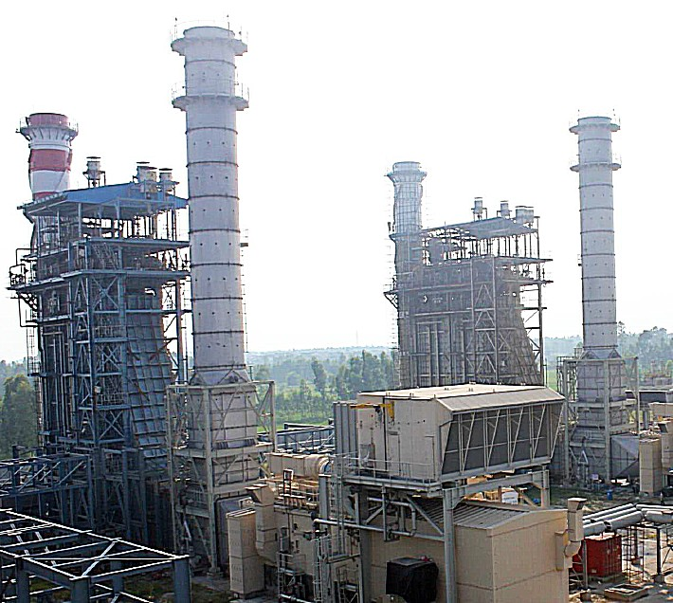

Fig.1 GT1 and GT2 and HRSG trains

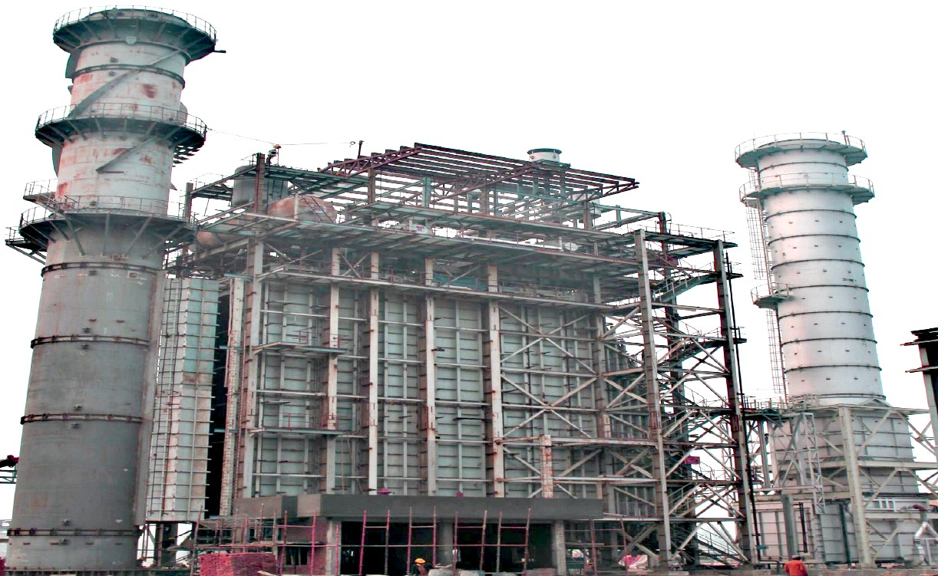
Fig.2 HRSG elevation with main stack and diverter stack

Fig.3 F6FA Gas turbine exhausting to HRSG on the right hand side.
Red container is the CO₂ container
Generator circuit breaker (GCB), left edge of the photo and bus-ducting to UAT
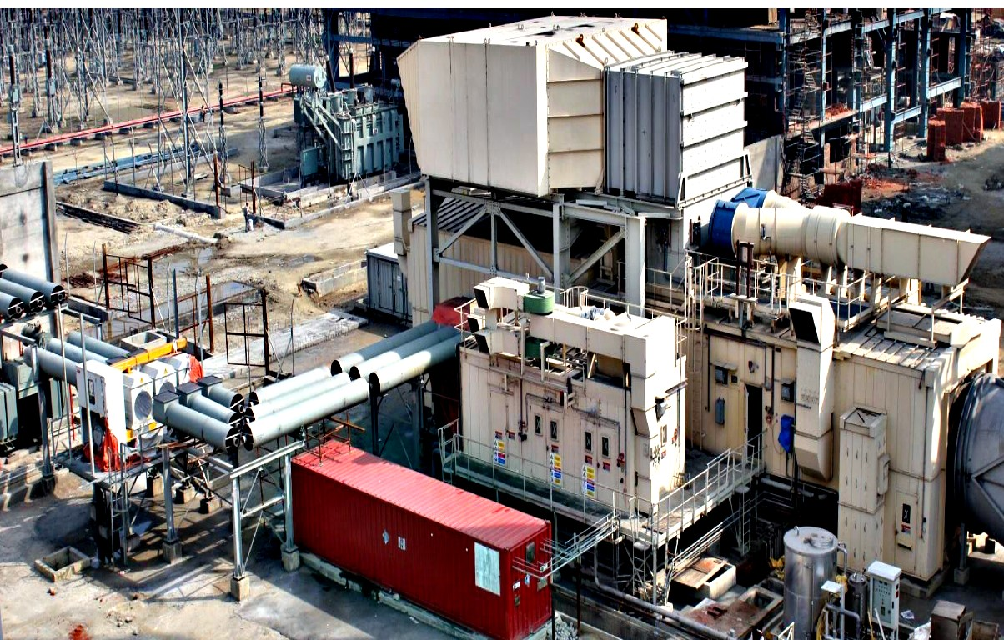
Lube-oil skid, bottom right-hand of the picture
(UAT – Unit Auxiliary Transformer)

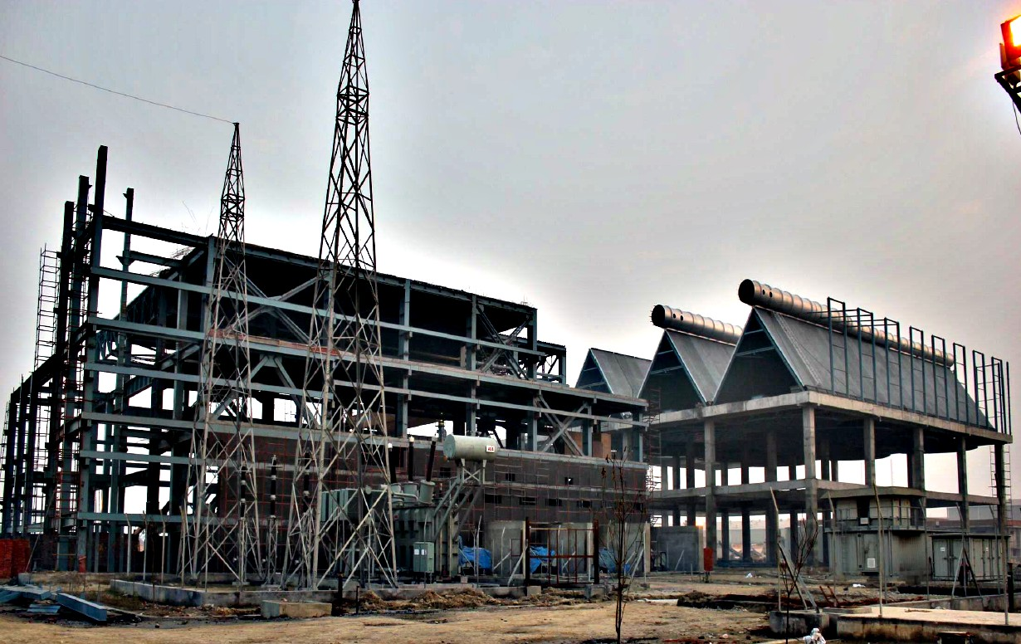
Fig.4 Steam Turbine Hall with ACCC

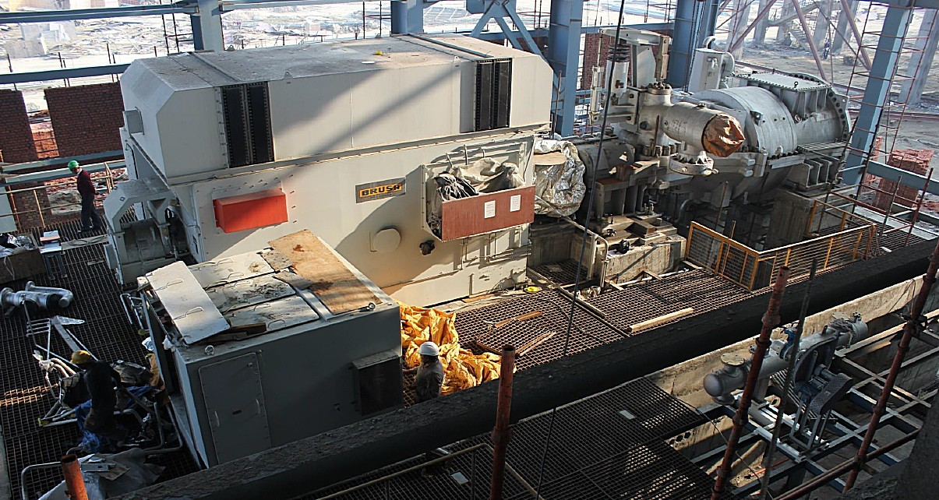

Fig.5 Steam turbine generator in the steam turbine building.

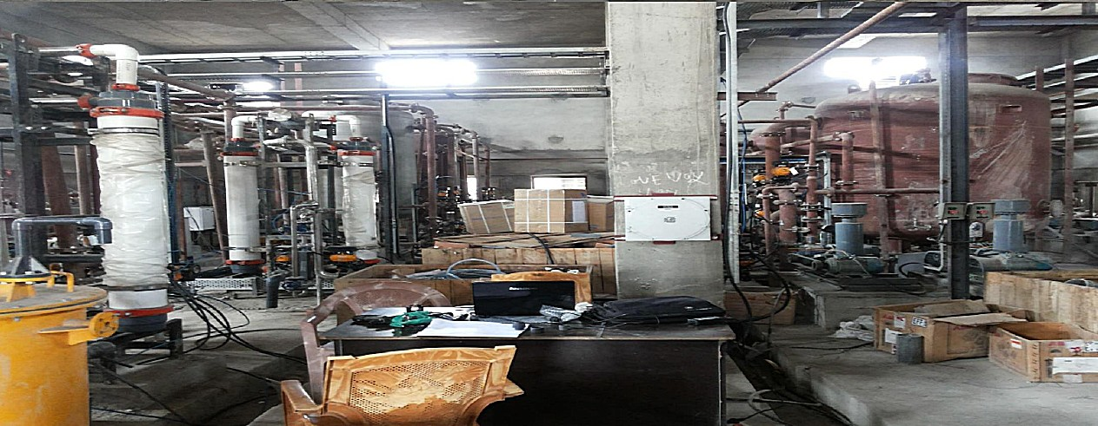

Fig.6 Water Treatment and Demin Plant

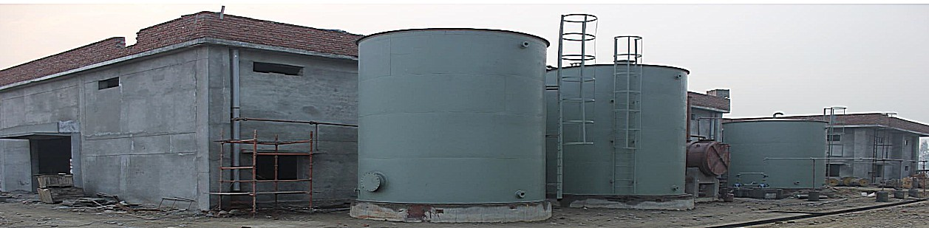

Fig.7 Water Treatment Plant Building and water storage tanks

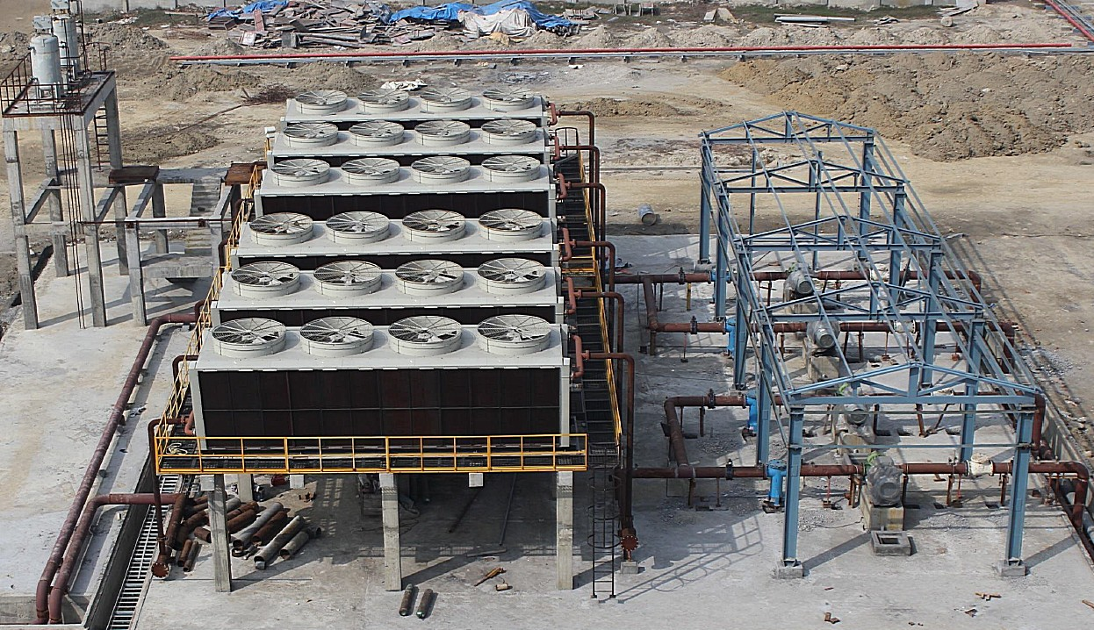
Fig.8 Turbine lube coolers

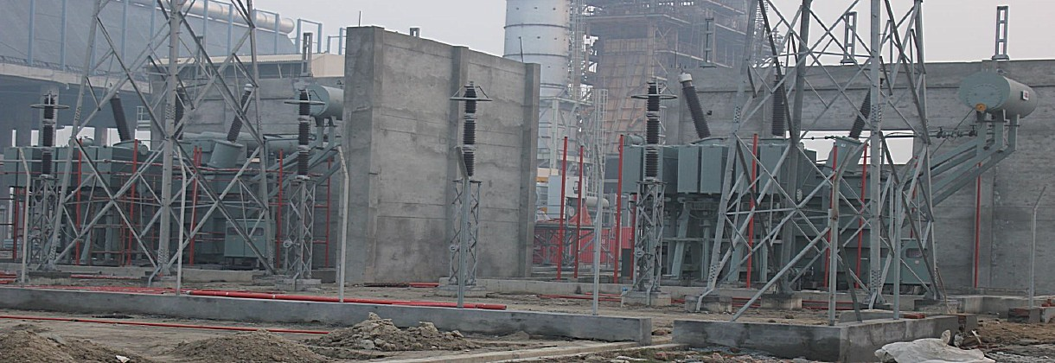

Fig.9 Step-up transformers

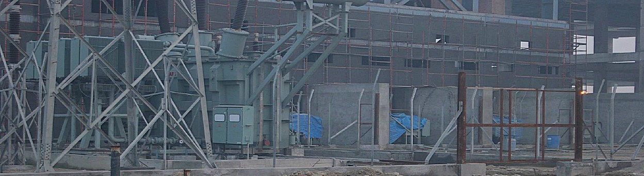

Fig.10 Auxiliary Transformers

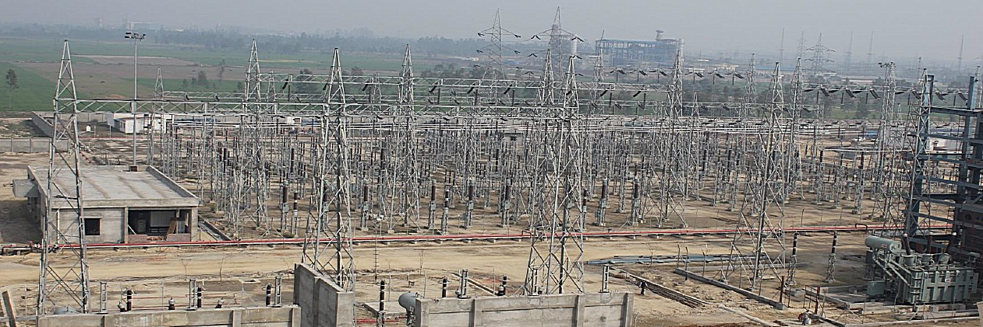

Fig.11 Power plant switchyard and grid connection

E&OE

Annexure

Information Pending

Item #

16.2 STG specification chart
16.3 STG Brochure
16.4 SC2-23 technical information

17 STG BRUSH Generator specifications

18 ACC vacuum steam ejector data sheet, steam conditions
18.2 ACC fans data sheet. Variable speed or fixed? Redundancy?
18.3 ACC fans operational ambient temperature range
18.4 ACC vacuum system description, steam usage, steam condensation

19 Condenser tank data. Condensate temperature

20 Condensate pumps; number, make, capacity power, data sheet

21 Water treatment plant description and specification, design parameters
Maximum feed-water salinity/contamination
Demineralization plant specifications, chemical usage

22.1 Gas Turbine generator BRUSH generator specifications
22.4 Fuel gas conditioning skid specifications
22.6 Gas feed-in pressure to gas turbine

23 HRSG, as-supplied by Thermax, technical description
23.1 HRSG design point and off-design point performance and operation
23.2 HRSG design code and expected serviceable life of HRSG (ref. Thermax)

50.
51. Power Plant General Construction standards

100.
100.1 Estimated total parasitic load

Annexure

Major OEM Company Information
(Pending)

GE General Electric, gas turbines, steam turbines
https://www.ge.com/about-us/history#

ABB Asea Brown Boveri, Switchgear
https://en.wikipedia.org/wiki/ABB

BRUSH Generators, electric motors, alternators
https://www.brush.eu/markets/company-history

THERMAX Thermax Limited
https://www.business-standard.com/company/thermax-4767/information/company-history

GEA GEA Energietechnik, Germany/ BGR Group India/Enexio
Cooled condensers

ATLAS COPCO

