 |  | QUOTATION |  | Date | 30/set/22
No | Picture | Description |  | FOB (USD) | Standard Features：
1 | 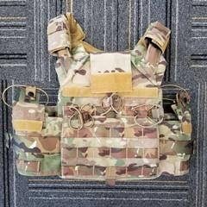 | PN: | One-button quick release JPC | 175 | ·One button quick release system.  ·Easy 2-step emergency doffing capability  ·Hidden vertical webbing loops on front carrier supports detachable chest rigs  ·High performance stretch material that allows for plates of varying thickness  ·Panel on the front of the carrier allows detachable MOLLE or mag pouch front flap  Zippers along the sides of the back carrier for zip-on panels  ·Low-profile cummerbund attachment that provides maximum adjustability and allows for chest expansion as needed  ·Webbing loops on the back of the shoulder straps to support back panels  ·Drag handle that supports up to 400 lbs.
 |  | Ballistic Material: | It depends on ballistic plate
 |  | Fabric Material: | 600D
 |  | Size: | S, M, L, customizable
 |  | Color: | White, Gray,Camouflage, customizable
 |  | Unit weight: | 1.2KG±0.05KG
 |  | Protective area: | Consistent with the area of the bulletproof insert
 |  | Brand: | CCGK, customizable
 |  | Ballistic Level: | NIJ IIIA.44, NIJ III, NIJ IV
 |  | Service: | ODM & OEM are available
 |  | Packing: | 1pc/Polybag, 5pcs/carton
 |  | Carton Size: | 51*49*25cm
2 | 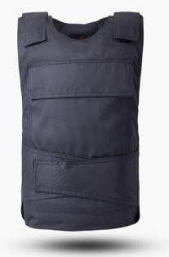 | PN: | Classic Police Usage bulletproof vest | 260 | ·Conform to NIJ Standard-0101.06  ·Level IIIA is threat tested against .357, 9mm, 45acp, .44 magnum  ·Water-resistant panel cover with heat-sealed seams Lightweight 4-way stretch ripstop shell fabric  ·Complementary lightweight spacer mesh liner for improved airflow  ·Front and back plate pocket for optional level IIIA, III, IV hard plates
 |  | Ballistic Material: | Aramid U.D.or Polyethylene(PE)
 |  | Fabric Material: | Polyester 600D
 |  | Size: | Regular, customizable
 |  | Color: | 99 type blue uniforms, camouflage,  customizable
 |  | Unit weight: | Aramid  NIJ IIIA9mm:2.35±0.05KGS NIJ IIIA.44:2.95±0.05KGS PE  NIJ IIIA9mm:2.55±0.05KGS  NIJ IIIA.44:2.85±0.05KGS
 |  | Protective area: | ≥0.28 ㎡
 |  | Brand: | CCGK, customizable
 |  | Ballistic Level: | NIJ IV
 |  | Service: | ODM & OEM are available
 |  | Packing: | 1pc/Polybag, 5pcs/carton
 |  | Carton Size: | 51*49*25cm
 |  | Warranty: | 5 years
3 | 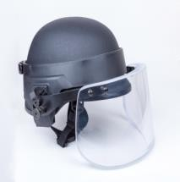 | Ballisitc Face Shield/ Ballistic Helmet visor |  | 195 | NIJ IIIA Ballistic Helmet visor/faceshield  - NIJ 0101.06 – Level IIIA  - Lightweight Design  - Match helmet that without side rails and NVG mount to use, improve the overall security;such as PASGT Helmet, FAST high cut helmet, etc.  - The glass has the highest light transmission, minimal the screenage distortional  - The glass height is adjustable
 |  | Material | PC+PU (1.0mmPC+1.25mmPU+12.0mmPMMA+1.25m mPU+6.0mmPC)
 |  | Size | Height 150mm, ARC length 375mm
 |  | Color | Transparent
 |  | Unit weight | 1.20kg
 |  | Protective area | 0.05 sqm
 |  | Thickness | 22mm
 |  | Ballistic Level | NIJ IIIA
 |  | Usage | Fit for Ballistic Helmet
 |  | Packing: | 2pcs/CTN
 |  | Carton Size: | 37*32*18cm/CTN
 |  | Warranty: | 5 years
4 | 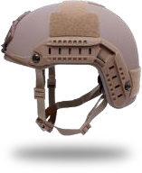 | FAST Ballistic helmet NIJ IIIA |  | 230 | FAST Ballistic Helmet  - USA High-Cut Ballistic Helmet  - NIJ Level IIIA with Above The Ear or High Cut Design.  - Protection Against:  9mm FMJ , 124gr  .44 MAG SJHP, 240gr  - Shell is made out of Aramid with maximum durability.  - Significant weight savings.  - Injection Molded Side Rails. Accessory rail connectors provide attachment points for quick attach or release, such as flashlights,camera ,visor...etc.  - Re-positionable Slow Rebound Memory Foam Padding  - Adjustable suspender straps and chin/neck pad for best fitting  - Loop panels around, provide extra place to unique your helmet with patch attachment.  - Shorter on the sides for better hearing and integration with headsets.  - Offers The Ideal Ballistic Helmets For Law Enforcement, Military, and Private Security Contractors.
 |  | Material | UHMWPE
 |  | Size | L:269*214*172mm XL:278*220*175
 |  | Color | Gray, Sand, black, customizable
 |  | Unit weight | 1.40KG 1.50KG 1.35KG
 |  | Protective area | 0.11㎡ 0.11㎡ 0.11㎡
 |  | Thickness | 6.7-7.0mm 7.8-8.0mm 6.7-7.0mm
 |  | Ballistic Level | NIJ IIIA(9mm) NIJ IIIA(.44mm) NIJ IIIA(9mm)
 |  | Accessory | chin strap, suspension system & pad
 |  | Packing: | 10pcs/ctn
 |  | Carton Size: | 51*49*30
 |  | Warranty | 8 years
5 | 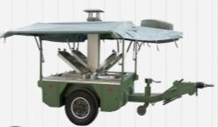 |  | The dining car | 25 000 | Overall dimensions：2.2(m) The net weight:800(KG)

