|  |  |  |  |  |  |  |
| --- | --- | --- | --- | --- | --- | --- |
| **QUOTATION SHEET** | | | | | | |
| Quote Date: | | 20th, Oct, 2022 | | Quote Valid Date: | 30th, Oct, 2022 | |
|  | | | | | | |
| **No.** | **Item Name** | **Image** | **Specification** | **Quantity** | **FOB Price**  **(USD)** | **Amount**  **(USD)** |
| 1 | Mich Helmet (Kevlar) |  | Material: Kevlar Protection Level: NIJ IIIA Can stop 9mm and .44mag  Color: Dark Green | 10,000 | 128 | 1180000 |
| 2 | Pasgt Helmet (PE) |  | Material: UHMWPE Protection Level: NIJ IIIA Can stop 9mm and .44mag Color: Dark Green | 2,000 | 99 | 178000 |
| 2 | Pasgt Helmet (Kevlar) |  | Material: Kevlar Protection Level: NIJ IIIA Can stop 9mm and .44mag  Color: Dark Green | 5,000 | 128 | 590000 |
| 3 | Bulletproof Vest |  | Material: UHMWPE Vest: 600D Polyester Protection Level: NIJ IIIA  Can stop 9mm and .44mag Protection area: 0.3m2 | 20,000 | 108 | 1960000 |
| 4 | Bulletproof Vest |  | Material: UHMWPE Vest: 600D Polyester Protection Level: NIJ IIIA  Can stop 9mm and .44mag Protection area: 0.3m2 | 15,000 | 100 | 1350000 |
| 5 | Bulletproof Plate |  | Material: SIC+UHMWPE Protection Ievel: NIJ IV Size: 250*300*24±1mm Single Curved  Weight: 2.4±0.05kg | 15,000 | 88 | 1170000 |
| 6 | Bulletproof Plate |  | Material: Alumina+UHMWPE Protection Ievel: NIJ IV Size: 250*300*24±1mm Single Curved  Weight: 2.7±0.05kg | 40,000 | 63 | 2120000 |
| **TOTAL** | | | | | | **8548000** |
| **TERMS AND CONDITIONS** | | | | | | |
| 1. Payment term | | 100% by T/T. 100% Prepayment. | | | | |
| 2. Exchange rate | | Quote is based on Current exchange rate of 6.9-7.0, Unit cost subject to change if exchange rate goes out of this range | | | | |
| 3. Valid time | | 10 days | | | | |

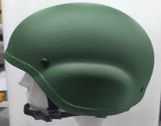

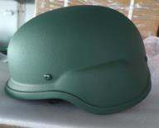



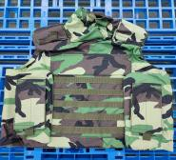

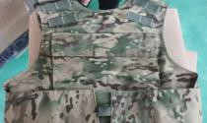

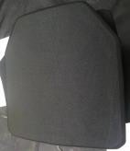



CONFIDENTIAL