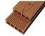
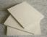
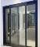
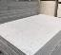
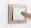
Quotation List
Contact |  | Myla Baracina |  | Date |  | 2022/11/27
Email |  | sales@asiandragonintl.com |  | Terms |  | EXW Foshan
We hereby confirm having sold to you the following goods on the terms and conditions stipulated below:
True Blue Cabin
Size :L5800*W2250*H2450mm
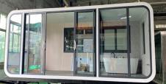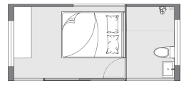
Picture | Item | Specification | Size |  |  | Unit | Qty(Sets) | Total price(USD)
 | Steel Structure | Galvanized Steel Structure | 5800 | 2250 | 2450 | mm | 1 | $8,964
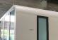 | Roof | Aluminum plate 2 mm | 13.05 |  |  | ㎡ | 1
 |  | Interior ceiling: Bamboo firber plate 7 mm | 13.05 |  |  | ㎡ | 1
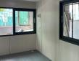 | Wall | Aluminum plate 2 mm | 25.24 |  |  | ㎡ | 1
 |  | Interior wall: Bamboo Firber plate 7 mm | 25.24 |  |  | ㎡ | 1
 | Floor | Based floor: 18mm MGO floor plate | 13.05 |  |  | ㎡ | 1
 |  | Decoration plate: SPC floor plate 3.7 mm | 13.05 |  |  | ㎡ | 1
 | Glass Wall/Door | One Sided Glass Wall and Silding Glass Door 5+9A+5 | 14.21 |  |  | ㎡ | 1
 | Glass windows | 1200*1000mm windows | 1.20 |  |  | ㎡ | 2
 | Electrical | 3-color ceiling light*6 electrical box*1 electrical switch*3 | 1 |  |  | set | 1
 | Pre Install | Pre-installed electrical wiring and drainage system | 1
Units cost for one unit (EXW Foshan) |  |  |  |  |  |  |  | $8,964
Terrace Size :L5800*W2250*H2450mm
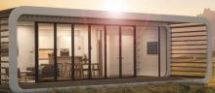
Picture | Item | Specification | Size |  |  | Unit | Qty(Sets) | Total price(USD)
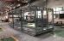 | Steel Structure | Galvanized Steel Structure | 5800 | 2250 | 2450 | mm | 1 | $3,142
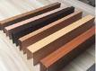 | Roof | 0.8 mm Galvanized Pipe 150*60*3 | 13.05 |  |  | ㎡ | 1
 | Wall | 0.8 mm Galvanized Pipe 150*60*3 | 5.51 |  |  | ㎡ | 2
 | Floor | 18 mm Cement Fiber Board+25 mm WPC | 13.05 |  |  | ㎡ | 1
Units cost for one unit (EXW Foshan) |  |  |  |  |  |  |  | $3,142
Total cost for one unit with terrace (EXW Foshan) |  |  |  |  |  |  |  | $12,106
True Blue Cabin
Size :L8500*W2250*H2450mm
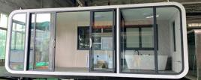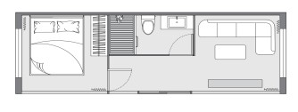

Picture | Item | Specification | Size |  |  | Unit | Qty(Sets) | Total price(USD)
 | Steel Structure | Galvanized Steel Structure | 8500 | 2250 | 2450 | mm | 1 | $11,995
 | Roof | Aluminum plate 2 mm | 19.13 |  |  | ㎡ | 1
 |  | Interior ceiling: Bamboo firber plate 7 mm | 19.13 |  |  | ㎡ | 1
 | Wall | Aluminum plate 2 mm | 31.85 |  |  | ㎡ | 1
 |  | Interior wall: Bamboo Firber plate 7 mm | 31.85 |  |  | ㎡ | 1
 | Floor | Based floor: 18mm MGO floor plate | 19.13 |  |  | ㎡ | 1
 |  | Decoration plate: SPC floor plate 3.7 mm | 19.13 |  |  | ㎡ | 1
 | Glass Wall/Door | One Sided Glass Wall and Silding Glass Door 5+9A+5 | 20.83 |  |  | ㎡ | 1
 | Glass windows | 1200*1000mm windows | 1.20 |  |  | ㎡ | 2
 | Electrical | 3-color ceiling light*6 electrical box*1 electrical switch*3 | 1 |  |  | set | 1
 | Pre Install | Pre-installed electrical wiring and drainage system | 1
Units cost for one unit (EXW Foshan) |  |  |  |  |  |  |  | $11,995
Terrace Size :L8500*W2250*H2450mm
Picture | Item | Specification | Size |  |  | Unit | Qty(Sets) | Total price(USD)
 | Steel Structure | Galvanized Steel Structure | 8500 | 2250 | 2450 | mm | 1 | $3,990
 | Roof | 0.8 mm Galvanized Pipe 150*60*3 | 19.13 |  |  | ㎡ | 1
 | Wall | 0.8 mm Galvanized Pipe 150*60*3 | 5.51 |  |  | ㎡ | 2
 | Floor | 18 mm Cement Fiber Board+25 mm WPC | 19.13 |  |  | ㎡ | 1
Units cost for one unit (EXW Foshan) |  |  |  |  |  |  |  | $3,990
Total cost for one unit with terrace (EXW Foshan) |  |  |  |  |  |  |  | $15,985
True Blue Cabin
Size :L11600*W2250*H2450mm
Picture | Item | Specification | Size |  |  | Unit | Qty(Sets) | Total price(USD)
 | Steel Structure | Galvanized Steel Structure | 11600 | 2250 | 2450 | mm | 1
 | Roof | Aluminum plate 2 mm | 26.10 |  |  | ㎡ | 1
 |  | Interior ceiling: Bamboo firber plate 7 mm | 26.10 |  |  | ㎡ | 1
 | Wall | Aluminum plate 2 mm | 39.45 |  |  | ㎡ | 1
 |  | Partition wall: 50mm Rock wool plate | 5.51 |  |  | ㎡ | 1
 |  | Interior wall: Bamboo Firber plate 7 mm | 50.47 |  |  | ㎡ | 1

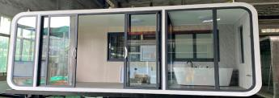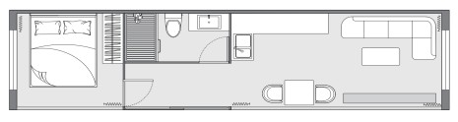

$15,284

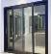
 | Floor | Based floor: 18mm MGO floor plate | 26.10 |  |  | ㎡ | 1
 |  | Decoration plate: SPC floor plate 3.7 mm | 26.10 |  |  | ㎡ | 1
 | Glass Wall/Door | One Sided Glass Wall and Silding Glass Door 5+9A+5 | 28.42 |  |  | ㎡ | 1
 | Glass windows | 1200*1000mm windows | 1.20 |  |  | ㎡ | 2
 | Electrical | 3-color ceiling light*6 electrical box*1 electrical switch*3 | 1 |  |  | set | 1
 | Pre Install | Pre-installed electrical wiring and drainage system | 1.00
Units cost for one unit (EXW Foshan) |  |  |  |  |  |  |  | $15,284
Terrace Size :L11600*W2250*H2450mm
Picture | Item | Specification | Size |  |  | Unit | Qty(Sets) | Total price(USD)
 | Steel Structure | Galvanized Steel Structure | 11600 | 2250 | 2450 | mm | 1 | $4,823
 | Roof | 0.8 mm Galvanized Pipe 150*60*3 | 26.10 |  |  | ㎡ | 1
 | Wall | 0.8 mm Galvanized Pipe 150*60*3 | 5.51 |  |  | ㎡ | 2
 | Floor | WPC 25 mm | 26.10 |  |  | ㎡ | 1
Units cost for one unit (EXW Foshan) |  |  |  |  |  |  |  | $3,823
Total cost for one unit with terrace (EXW Foshan) |  |  |  |  |  |  |  | $19,109
Trading Term: All Prices quoted are EXW Factory in USD,doesnot include tax,installation and transportation.
Validity: Within 30 days since quotation date.
Payment Term: T/T, 50% before production and 50 % before delivery from our factory.
Production time: 30-35 working days after confirming receipt of deposit and confirming production drawings.

